Redox
1. |  | Consider the chemical cell shown below:  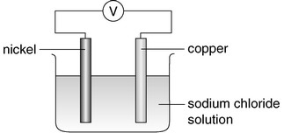  Which of the following combinations is correct?
   | Polarity of anode | Chemical change that occurs at the anode
  A | Negative | Ni(s) → Ni²⁺(aq) + 2e–
  B | Negative | Cu(s) → Cu²⁺(aq) + 2e–
  C | Positive | Ni²⁺(aq) + 2e– → Ni(s)
  D | Positive | Cu²⁺(aq) + 2e– → Cu(s)
2. |  | 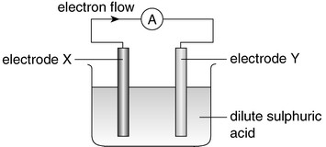  Which of the following combinations is correct?
   | Electrode X | Electrode Y
  A | Zinc | magnesium
  B | Copper | lead
  C | Iron | zinc
  D | Copper | silver
3. |  | 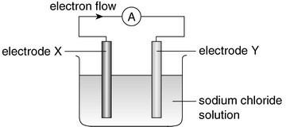  X and Y are two different metals.  Which of the following statements concerning the above chemical cell is correct?  A Both metals dissolve gradually.  B Electrode X is the negative electrode.  C Metal Y is more reactive than metal X.  D Metal Y loses electrons to form ions.
4. | Directions: Questions 11 and 12 refer to the following set-up which was used to investigate the tendency of four metals W, X, Y and Z to form ions.  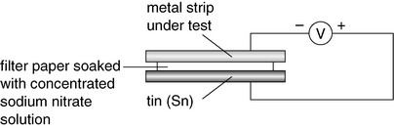  The voltmeter reading for each metal strip was recorded in the following table:
  Metal strip under test | Direction of electron flow  in the external circuit | Voltage recorded (V)
  W | W to Sn | +0.46
  X | Sn to X | –0.38
  Y | Y to Sn | +0.80
  Z | Sn to Z | –0.72
Which of the following pairs of metals will give the highest voltage when they are used as the electrodes in a chemical cell?
A W and X
B W and Z
C X and Y
D Y and Z
5. |  | 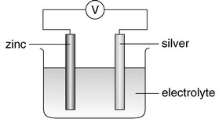  Which of the following solutions can be used as the electrolyte in the above chemical cell?  (1) Sodium nitrate solution  (2) Ammonium nitrate solution  (3) Orange juice  A (1) and (2) only  B (1) and (3) only  C (2) and (3) only  D (1), (2) and (3)
6. |  | X and Y are metals. X reacts with Y(NO₃)₂ solution according to the following equation:  X(s) + Y²⁺(aq) → X²⁺(aq) + Y(s)  Which of the following deductions are correct?  (1) X reacts with water while Y does not.  (2) X forms ions more readily than Y.  (3) When X and Y are used as the electrodes in a chemical cell, X acts as the anode.  A (1) and (2) only  B (1) and (3) only  C (2) and (3) only  D (1), (2) and (3)
7. |  | Consider the following chemical cell.  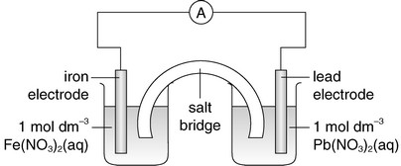  Which of the following statements about the chemical cell is correct?  A The mass of the iron electrode decreases.  B Positive ions in the salt bridge migrate toward the Fe(NO₃)₂ solution.  C The iron electrode is the cathode.  D The iron electrode develops a coating of lead.
8. | Directions: Questions 34 and 35 refer to the following chemical cell. X and Y are two different metals.  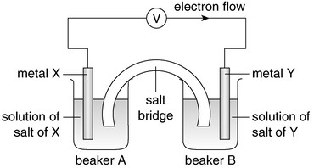
Which of the following combinations is correct?
 | X | Y
A | Cu | Zn
B | Ag | Cu
C | Mg | Ag
D | Zn | Mg

9. |  | Consider the set-up shown below:  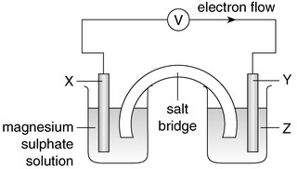  Electrons flow from X to Y in the external circuit. Which of the following combinations is correct?
   | X | Y | Z
  A | Carbon | copper | copper(II) sulphate solution
  B | Iron | magnesium | magnesium sulphate solution
  C | Magnesium | carbon | copper(II) sulphate solution
  D | Carbon | carbon | iron(II) sulphate solution
10. | Directions: Questions 37 and 38 refer to the following chemical cell.  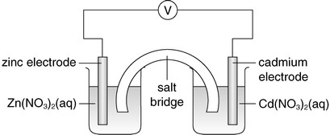
Which of the following combinations is correct?
 | Mass of cadmium electrode | Mass of zinc electrode
A | Decreases | increases
B | Decreases | decreases
C | Increases | decreases
D | Increases | increases

11. |  | 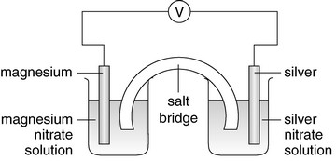  Which of the following solutions can be used to make the salt bridge of the above chemical cell?  (1) Potassium nitrate solution  (2) Potassium chloride solution  (3) Potassium hydroxide solution  A (1) only  B (2) only  C (1) and (3) only  D (2) and (3) only
12. |  | Reduction involves  A an increase in atomic number.  B a decrease in number of electrons.  C an increase in mass number.  D a decrease in oxidation number.
13. |  | The oxidation number of vanadium in VO₂⁺ is  A +3.  B +4.  C +5.  D +6.
14. |  | What is the oxidation number of chromium in the complex ion [Cr(H₂O)₄Br₂]⁺?  A –1  B +1  C +2  D +3
15. |  | In which of the following pairs of substances are the oxidation numbers of sulphur and nitrogen the same?  A H₂SO₄ and HNO₃  B H₂SO₃ and NO₂  C Na₂S and NO  D FeS and NH₄Cl
16. |  | Which of the following changes involves an increase in oxidation number of the underlined element?  A Cl₂(g) → ClO₃–(aq)  B SO₂(g) → SO₃^{2–}(aq)  C NO₃–(aq) → NO₂(g)  D O₂(g) → H₂O(l)
17. |  | Which of the following conversions is an oxidation?  A S → ZnS  B S₂O₃^{2–} → S₄O₆^{2–}  C MnO₄– → MnO₂  D CH₃COOH → CH₃CH₂OH
18. |  | Which of the following processes is a redox reaction?  A Na₂CO₃(s) + 2HCl(aq) → 2NaCl(aq) + CO₂(g) + H₂O(l)  B Cu(OH)₂(s) + 4NH₃(aq) → [Cu(NH₃)₄](OH)₂(aq)  C MnO₂(s) + 4HCl(aq) → MnCl₂(aq) + Cl₂(g) + 2H₂O(l)  D Ca(OH)₂(aq) + CO₂(g) → CaCO₃(s) + H₂O(l)
19. |  | Which of the following is NOT a redox reaction?  A 2KClO₃(s) → 2KCl(s) + 3O₂(g)  B Mg(s) + CuSO₄(aq) → MgSO₄(aq) + Cu(s)  C Pb(s) + PbO₂(s) + 2H₂SO₄(aq) → 2PbSO₄(s) + 2H₂O(l)  D ZnO(s) + 2NaOH(aq) + H₂O(l) → Na₂[Zn(OH)₄](aq)
20. |  | The equation below shows how hydrogen sulphide could be produced from sulphuric acid in a redox reaction.  9H₂SO₄(aq) + 8KI(s) → H₂S(g) + 8KHSO₄(aq) + 4H₂O(l) +4I₂(s)  Which of the following combinations is correct?
   | Species being reduced | Species being oxidized
  A | H₂S | I₂
  B | I₂ | H₂S
  C | H₂SO₄ | KI
  D | KI | H₂SO₄
21. |  | In which of the following reactions is the underlined substance oxidized?  A 2CuO(s) + C(s) → CO₂(g) + 2Cu(s)  B 3H₂(g) + N₂(g) → 2NH₃(g)  C Mg(s) + ZnSO₄(aq) → MgSO₄(aq) + Zn(s)  D CaCO₃(s) + 2HCl(aq) → CaCl₂(aq) + CO₂(g) + H₂O(l)
22. |  | Consider the redox reaction represented by the equation below:  Na₂O₂ + 2ClO₂ → 2NaClO₂ + O₂  Which of the following statements are correct?  (1) The oxidation number of oxygen does not change.  (2) The oxidation number of sodium does not change.  (3) The oxidation number of chlorine changes from +4 to +3.  A (1) and (2) only  B (1) and (3) only  C (2) and (3) only  D (1), (2) and (3)
23. |  | In which of the following reactions does nitrogen exhibit three different oxidation numbers in the species involved?  (1) NH₄NO₂ → 2H₂O + N₂  (2) 3NO₂ + H₂O → 2HNO₃ + NO  (3) Cu + 4HNO₃ → Cu(NO₃)₂ + 2NO₂ + 2H₂O  A (1) and (2) only  B (1) and (3) only  C (2) and (3) only  D (1), (2) and (3)
24. |  | Consider the reaction scheme shown below.  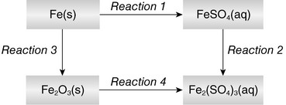  Which of the following statements is correct?  A Iron is reduced in Reaction 1.  B Reaction 2 can be brought about by adding acidified potassium permanganate solution to FeSO₄(aq).  C The oxidation number of iron increases by 2 units in Reaction 3.  D Fe₂O₃(s) is oxidized in Reaction 4.
25. |  | Consider part of the electrochemical series shown below:  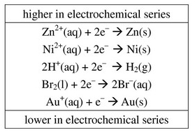  Which of the following species can reduce H⁺(aq) ions to H₂(g) in aqueous solution?  A Ni(s)  B Au(s)  C Br₂(l)  D Zn²⁺(aq)
26. |  | Which of the following solutions can react with acidified potassium permanganate solution?  (1) Hydrogen peroxide solution  (2) Potassium iodide solution  (3) Sodium nitrate solution  A (1) and (2) only  B (1) and (3) only  C (2) and (3) only  D (1), (2) and (3)
27. |  | Which of the following solutions can react with acidified potassium dichromate solution?  (1) Iron(II) sulphate solution  (2) Potassium iodide solution  (3) Sodium sulphate solution  A (1) and (2) only  B (1) and (3) only  C (2) and (3) only  D (1), (2) and (3)
28. |  | Which of the following is correct when aqueous chlorine is added to sodium iodide solution containing some starch solution?  A The solution turns brown.  B A purple vapour is given off.  C The solution turns dark blue.  D There is no observable change.
29. | Directions: Questions 102 and 103 refer to the following experiment.  Chlorine is formed by adding dilute hydrochloric acid to the chlorine bleach.  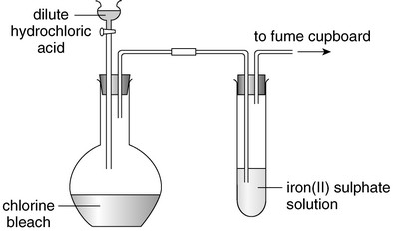
What would happen to the iron(II) sulphate solution?
A A green emulsion forms.
B The solution changes from pale green to yellow-brown.
C A brown precipitate forms.
D There is no observable change.
30. | Directions: Questions 111 and 112 refer to the following reaction:  2I–(aq) + Br₂(aq) → 2Br–(aq) + I₂(aq)
The reaction is a
(1) displacement reaction.
(2) redox reaction.
(3) substitution reaction.
Which of the following combinations is correct?
A (1) and (2) only
B (1) and (3) only
C (2) and (3) only
D (1), (2) and (3)
31. | Directions: Questions 111 and 112 refer to the following reaction:  2I–(aq) + Br₂(aq) → 2Br–(aq) + I₂(aq)
Which of the following statements about the reaction are correct?
(1) I–(aq) acts as a reducing agent.
(2) Br₂(aq) is a stronger oxidizing agent than I₂(aq).
(3) Br₂(aq) is reduced.
A (1) and (2) only
B (1) and (3) only
C (2) and (3) only
D (1), (2) and (3)
32. |  | Which of the following processes would give an obvious colour change?  (1) Adding aqueous chlorine to potassium bromide solution  (2) Adding acidified potassium permanganate solution to potassium iodide solution  (3) Adding dilute sulphuric acid to sodium chromate solution  A (1) and (2) only  B (1) and (3) only  C (2) and (3) only  D (1), (2) and (3)
33. |  | Which of the following statements about dilute nitric acid is INCORRECT?  A It turns moist blue litmus paper red.  B It reacts with sodium hydrogencarbonate to give carbon dioxide.  C It reacts with carbon to give carbon dioxide.  D It is a dehydrating agent.
34. |  | Which of the following is a suitable method for preparing the substance mentioned?  A Preparing copper from sodium and copper(II) sulphate solution  B Preparing nitrogen dioxide from copper and very dilute nitric acid  C Preparing hydrogen from calcium and dilute sulphuric acid  D Preparing carbon dioxide from calcium carbonate and dilute nitric acid
35. |  | A mixture contains only copper and copper(II) hydroxide. Which of the following methods can be used to separate copper from the mixture?  (1) Add dilute sulphuric acid to the mixture and then filter.  (2) Add dilute nitric acid to the mixture and then filter.  (3) Add water to the mixture and then filter.  A (1) only  B (2) only  C (1) and (3) only  D (2) and (3) only
36. |  | Which of the following substances can be used to distinguish between dilute nitric acid and dilute sulphuric acid?  (1) Copper  (2) Calcium carbonate  (3) Barium chloride solution  A (1) and (2) only  B (1) and (3) only  C (2) and (3) only  D (1), (2) and (3)
37. |  | Which of the following statements concerning the reaction of magnesium oxide and concentrated sulphuric acid is / are correct?  (1) Sulphuric acid acts as an acid.  (2) Sulphuric acid acts as an oxidizing agent.  (3) Sulphuric acid acts as a drying agent.  A (1) only  B (2) only  C (1) and (3) only  D (2) and (3) only
38. |  | A gas will be given off when concentrated sulphuric acid is added to  (1) sodium hydroxide.  (2) sodium hydrogencarbonate.  (3) zinc.  A (1) and (2) only  B (1) and (3) only  C (2) and (3) only  D (1), (2) and (3)
39. |  | Which of the following can be used to distinguish between concentrated hydrochloric acid and concentrated sulphuric acid?  (1) Barium nitrate solution  (2) Copper  (3) Sulphur  A (1) and (2) only  B (1) and (3) only  C (2) and (3) only  D (1), (2) and (3)
40. |  | Which of the following is NOT a property of sulphur dioxide?  A Its aqueous solution has a pH value smaller than 7.  B It dissolves in water to give an acidic solution.  C It turns moist blue litmus paper red.  D It can be reduced to sulphate ions.
41. |  | Which of the following CANNOT be decolorized by sodium sulphite solution?  A Acidified potassium permanganate solution  B Aqueous bromine  C Acidified potassium dichromate solution  D Iodine solution
42. |  | Which of the following statements about sulphur dioxide is INCORRECT?  A Sulphur dioxide is denser than air.  B Sulphur dioxide can turn dry blue litmus paper red.  C Sulphite ions are produced when sulphur dioxide is dissolved in water.  D Sulphur dioxide can be absorbed by sodium hydroxide solution.
43. |  | Which of the following reagents can be used to distinguish between sodium sulphite solution and sodium sulphate solution?  (1) Aqueous bromine  (2) Acidified potassium permanganate solution  (3) Barium chloride solution  A (1) and (2) only  B (1) and (3) only  C (2) and (3) only  D (1), (2) and (3)
44. |  | Consider the chemical cell shown below.  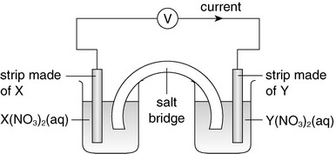  A current flows from X to Y in the external circuit. Which of the following statements is correct?  A In the electrochemical series, the position of X is lower than that of Y.  B The strip made of X is the anode.  C Reduction occurs at the strip made of Y.  D The mass of the strip made of X decreases while that made of Y increases.
45. |  | 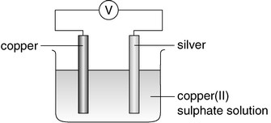  Which of the following combinations for the set-up is correct after a current has flowed through the external circuit for some time?
   | Oxidation occurs at | Colour intensity of CuSO₄(aq)
  A | Copper | no change
  B | Silver | no change
  C | Copper | decreases
  D | Silver | decreases
46. |  | 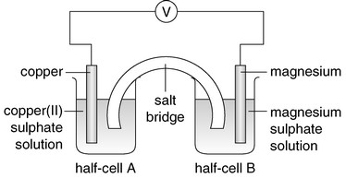  Which of the following are correct for the two half-cells?  (1) The colour of the solution in half-cell A fades.  (2) Reduction occurs at the copper electrode.  (3) The magnesium electrode gradually dissolves.  A (1) and (2) only  B (1) and (3) only  C (2) and (3) only  D (1), (2) and (3)
47. |  | 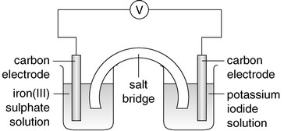  Which of the following combinations concerning the above chemical cell is correct?
   | At the cathode | At the anode
  A | 2I–(aq) → I₂(aq) + 2e– | Fe³⁺(aq) + e– → Fe²⁺(aq)
  B | Fe³⁺(aq) + e– → Fe²⁺(aq) | 2I–(aq) → I₂(aq) + 2e–
  C | I₂(aq) + 2e– → 2I–(aq) | Fe²⁺(aq) → Fe³⁺(aq) + e–
  D | Fe²⁺(aq) → Fe³⁺(aq) + e– | I₂(aq) + 2e– → 2I–(aq)
48. |  | 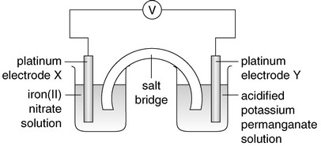  Which of the following statements concerning the set-up is correct?  A The salt bridge allows the passage of electrons between the two half-cells.  B A current flows from electrode X to electrode Y in the external circuit.  C Reduction occurs at electrode X.  D The purple colour of the acidified potassium permanganate solution becomes  less intense.
49. |  | 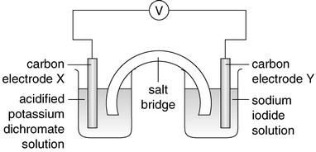  Which of the following statements concerning the set-up is correct?  A Electrons flow from electrode X to electrode Y in the external circuit.  B Oxidation occurs at electrode X.  C Electrode Y is the cathode.  D A brown colour develops around electrode Y after the cell has operated for some  time.
50. | Directions: Questions 35 and 36 refer to the following chemical cell. The digital multimeter gives a positive reading.  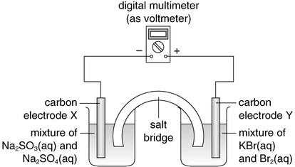
Which of the following statements is correct?
A A current flows from electrode X to electrode Y in the external circuit.
B Electrode X is the anode.
C The mass of electrode Y increases.
D The yellow-brown colour of the KBr(aq) and Br₂(aq) mixture becomes more
intense.
51. |  | 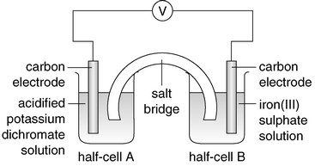  Which of the following statements concerning the above set-up are correct?  (1) The solution in half-cell A is decolorized.  (2) The mass of both electrodes remains unchanged.  (3) Fe²⁺(aq) ion acts as a reducing agent.  A (1) and (2) only  B (1) and (3) only  C (2) and (3) only  D (1), (2) and (3)
52. |  | The following diagram shows the set-up of a chemical cell.  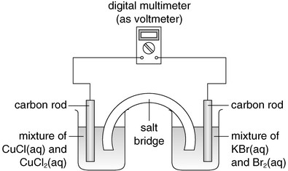  Given that Br₂(aq) is a stronger oxidizing agent than Cu²⁺(aq) ion, which of the changes represented by the following half-equations would occur if the cell is producing a current?  (1) Cu⁺(aq) → Cu²⁺(aq) + e–  (2) Cu²⁺(aq) + e– → Cu⁺(aq)  (3) 2Br–(aq) → Br₂(aq) + 2e–  A (1) only  B (2) only  C (1) and (3) only  D (2) and (3) only
53. |  | The following diagram shows a fuel cell. Hydrogen and oxygen are passed into the fuel cell.  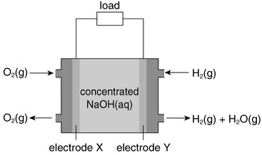  Which of the following combinations is correct?
   | Chemical change that occurs at electrode X | Hydroxide ions move towards
  A | O₂ + 2H₂O + 4e– → 4OH– | X
  B | 4OH– → O₂ + 2H₂O + 4e– | X
  C | 4OH– → O₂ + 2H₂O + 4e– | Y
  D | O₂ + 2H₂O + 4e–→ 4OH– | Y
54. |  | Which of the following processes does NOT involve a redox reaction?  A Electrolysis of sea water  B Displacement of copper from copper(II) sulphate solution using zinc  C Decomposition of hydrogen peroxide to form water and oxygen  D Thermal decomposition of limestone
55. |  | Some pacemakers use specialized lithium cells as a power source. The ionic half-equations for the chemical changes that occur at the electrodes are listed below:  at electrode X:  2SOCl₂(aq) + 4e– → 4Cl–(aq) + S(s) + SO₂(aq)  at electrode Y:  Li(s) → Li⁺(aq) + e–  Which of the following statements concerning the chemical cell is / are correct?  (1) Electrode X is the anode.  (2) Oxidation occurs at electrode Y.  (3) Electrons flow from electrode Y to electrode X in the external circuit.  A (1) only  B (2) only  C (1) and (3) only  D (2) and (3) only
56. |  | Lithium iodine button cells are widely used in pacemakers.  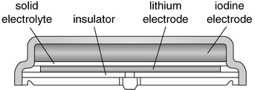  Which of the following statements concerning the cell are correct?  (1) The lithium electrode is the anode.  (2) Reduction occurs at the iodine electrode.  (3) Its voltage remains steady over discharge.  A (1) and (2) only  B (1) and (3) only  C (2) and (3) only  D (1), (2) and (3)
57. |  | Which of the following ions are reduced during the electrolysis of molten silver chloride?  A Silver ions  B Chloride ions  C Hydrogen ions  D Hydroxide ions
58. |  | Which of the following ionic half-equations represents the chemical change that occurs at the anode during the electrolysis of very dilute sodium chloride solution using carbon electrodes?  A 2H⁺(aq) + 2e– → H₂(g)  B Na⁺(aq) + e– → Na(s)  C 2Cl–(aq) → Cl₂(g) + 2e–  D 4OH–(aq) → 2H₂O(l) + O₂(g) + 4e–
59. |  | Which of the following is / are electrolyte(s)?  (1) Ethanol  (2) Lead(II) bromide  (3) Zinc  A (1) only  B (2) only  C (1) and (3) only  D (2) and (3) only
60. |  | Electrolysis of water in the presence of sulphuric acid can be carried out in the set-up shown below.  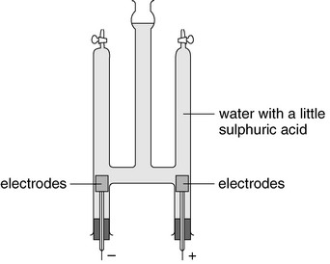  Which of the following statements concerning the experiment is / are correct?  (1) The sulphuric acid acts as a catalyst.  (2) The pH of the solution in the set-up decreases.  (3) After some time, volume ratio of gases collected at anode and cathode is  2 : 1.  A (1) only  B (2) only  C (1) and (3) only  D (2) and (3) only
61. |  | When very dilute sodium chloride solution is electrolyzed using carbon electrodes,  (1) both chloride ions and hydroxide ions migrate to the anode.  (2) hydrogen is given off at the cathode.  (3) the resulting solution becomes more concentrated sodium chloride solution.  A (1) and (2) only  B (1) and (3) only  C (2) and (3) only  D (1), (2) and (3)
62. | Directions: Questions 20 and 21 refer to the electrolysis of concentrated sodium chloride solution.  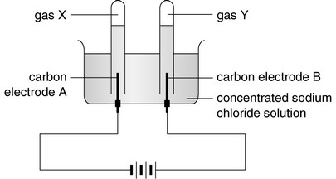
Which of the following statements is correct?
A Electrode A is the anode.
B Reduction occurs at electrode B.
C Gas X gives a ‘pop’ sound with a burning splint.
D Gas Y relights a glowing splint.
63. |  | In an experiment, concentrated magnesium iodide solution is electrolyzed using carbon electrodes. Which of the following combinations is correct?
   | Product at the cathode | Product at the anode
  A | Magnesium | iodine
  B | Magnesium | oxygen
  C | Hydrogen | oxygen
  D | Hydrogen | iodine
64. |  | Which of the following solutions, when electrolyzed using platinum electrodes, will liberate only one gaseous product?  A Mg(NO₃)₂(aq)  B KOH(aq)  C CuCl₂(aq)  D CaCl₂(aq)
65. |  | Which of the following processes will NOT produce a gas at the anode?  A Electrolysis of silver nitrate solution using silver electrodes  B Electrolysis of dilute sulphuric acid using platinum electrodes  C Electrolysis of dilute sodium chloride solution using carbon electrodes  D Electrolysis of concentrated sodium chloride solution using mercury cathode  and carbon anode
66. | Directions: Questions 41 and 42 refer to the following set-up.  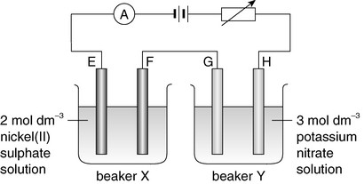  Electrodes E and F are nickel electrodes while electrodes G and H are carbon electrodes.
Which of the electrodes are cathodes?
A E and H
B E and G
C F and H
D F and G
67. |  | The same volume of 1 mol dm^{–3} KNO₃(aq), 1 mol dm^{–3} AgNO₃(aq) and 1 mol dm^{–3} Cu(NO₃)₂(aq) solutions are placed in three separate electrolytic cells using platinum electrodes.  Which of the following correctly indicates the relative number of moles of metal deposited at the cathode of each cell?
   | Potassium | Silver | Copper
  A | 0 | 1 | 2
  B | 0 | 1 | 0.5
  C | 1 | 1 | 0.5
  D | 0.5 | 0.5 | 1
68. | P and Q are two different metals. When a current flows in the external circuit of the set-up for some time, silver is found to deposit on the carbon electrode S.  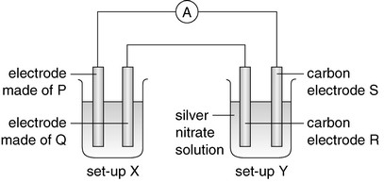
Which of the following electrodes are anodes?
A Electrode made of P and carbon electrode R
B Electrode made of P and carbon electrode S
C Electrode made of Q and carbon electrode S
D Electrode made of Q and carbon electrode R
69. |  | Which of the following are the advantages of using graphite electrodes in the electrolysis of concentrated sodium chloride solution?  (1) Graphite can conduct electricity.  (2) Graphite is inert.  (3) Graphite is cheap.  A (1) and (2) only  B (1) and (3) only  C (2) and (3) only  D (1), (2) and (3)
70. |  | Which of the following diagrams shows the correct set-up for coating the iron ring with zinc?  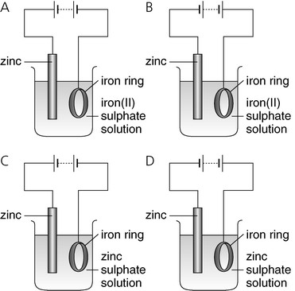
71. |  | The following set-up is used to refine impure copper containing iron and silver.  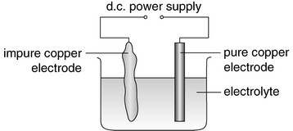  Which of the following statements about the above set-up is INCORRECT?  A The impure copper electrode is the anode.  B The iron in the impure copper loses electrons.  C The silver in the impure copper settles at the bottom of the container.  D The pure copper electrode is connected to the positive terminal of the d.c. power  supply.
72. |  | The wastewater generated from an electroplating factory contains dichromate ions. The wastewater is treated as shown in the flow diagram below.  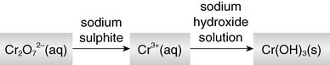  Which of the following combinations concerning the role of the reagents used is correct?
   | Sodium sulphite | Sodium hydroxide solution
  A | Oxidizing agent | precipitating agent
  B | Oxidizing agent | reducing agent
  C | Reducing agent | precipitating agent
  D | Reducing agent | reducing agent
73. |  | Electrolysis is used in the extraction of  (1) copper.  (2) sodium.  (3) silver.  A (1) only  B (2) only  C (1) and (3) only  D (2) and (3) only
Assertion-reason questions
Directions: Select one option from A to D according to the following table:
A | Both statements are true and the 2nd statement is a correct explanation of the 1st statement.
B | Both statements are true but the 2nd statement is NOT a correct explanation of the 1st statement.
C | The 1st statement is false while the 2nd statement is true.
D | Both statements are false.

 | 1st statement | 2nd statement

1.
  Lemon juice can be used as the electrolyte for a simple chemical cell. | Lemon juice is acidic.
2.
  When copper becomes copper(II) ions, reduction occurs. | During the process mentioned, the oxidation number of copper increases.
3.
  The reaction between copper(II) oxide and dilute hydrochloric acid is a redox reaction. | Copper(II) ion is reduced in the reaction.
4.
  Chlorine has an oxidation number of –1 in all its compounds. | A chlorine atom gains one electron to achieve a stable electronic arrangement.
5.
  A redox reaction occurs when aqueous chlorine is added to acidified potassium permanganate solution. | Acidified potassium permanganate solution is a strong oxidizing agent.
6.
  Potassium bromide solution turns yellow-brown on the addition of aqueous chlorine. | Bromide ions are oxidized by chlorine to give bromine.
7.
  Chlorine gas can turn iron(II) sulphate solution from pale green to yellow-brown. | Iron(II) ions are oxidized by chlorine to iron(III) ions.
8.
  Hydrogen iodide can be prepared by reacting sodium iodide with concentrated sulphuric acid. | Concentrated sulphuric acid is a strong oxidizing agent.
9.
  The voltage of a zinc-carbon cell drops if a current is drawn from the dry cell rapidly. | Hydrogen is produced at the cathode which reduces the electrical conductivity of the dry cell.
10.
  Sodium ions are preferentially discharged at the cathode in the electrolysis of concentrated sodium chloride solution using mercury cathode. | The concentration of sodium ions is higher than that of hydrogen ions in concentrated sodium chloride solution.

