Part 1:
Changing
Your Focus
“Your imagination is your preview
of life’s coming attractions.”
-Albert Einstein

Day 1 & Exercise 1:
Eliminate Those Distractions

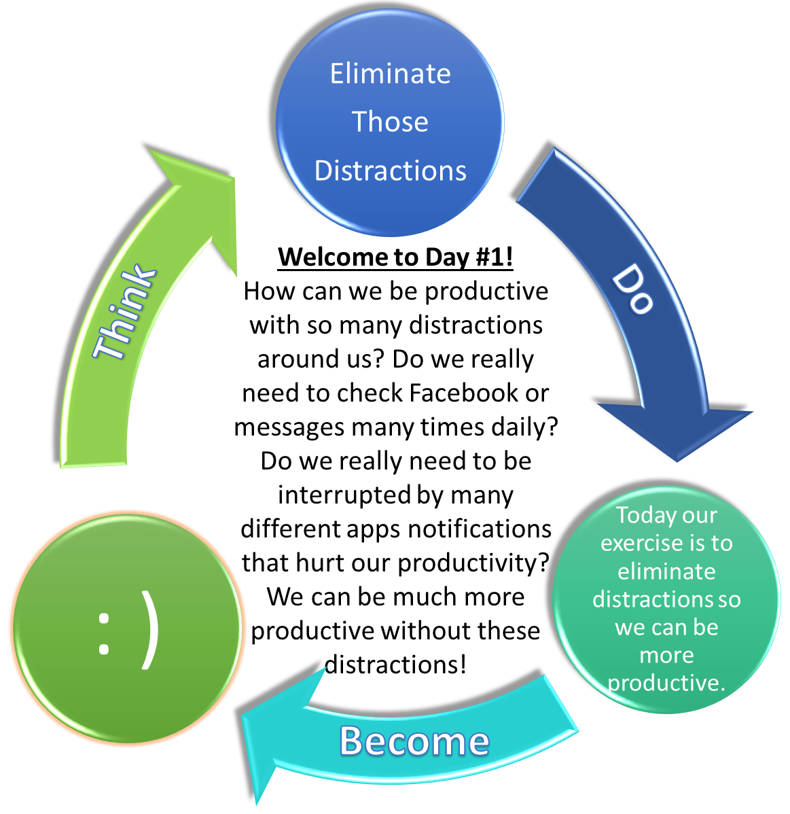
Do you ever think “how the heck did we function in the past without emails, texts, the internet, radio, the television and darn it better Wi-Fi?”
Were we more productive then? I think that there are so many technology influenced distractions in our life now that we don’t see the bigger picture of our life and our long term goals. We have become too focused on the individual trees, instead of thinking from a higher level and seeing the entire forest.
How can we get anything done if we get so many distracting alerts. 20 years ago it was a novelty to hear “you’ve got mail.” Now we get alerts to tell us that somebody clicked the like button on a picture! What did we possibly do with our free time before we had the luxury of getting disturbed many times to tell us that somebody like a picture! It gets worse because we all use more than 5-10 apps daily and we let these 5 apps interrupt our life multiple times each during the day!
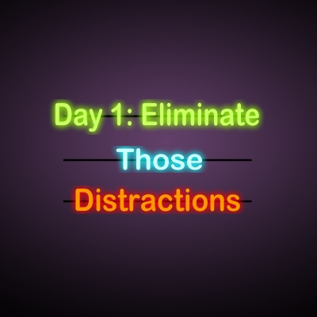
What is more puzzling is that when these 5-10 apps don’t interrupt us for a while, we open up those apps and think – hey why didn’t you disrupt me in the past 60 seconds? In the past for me I had one notification device and one only – it was my answering machine and I would check it to see “did she call?” (She never did)! If I had 5-10 answering machines like that but in my pocket back then, I would never have time to think about what direction I want to go in life in the long run or how can I be more productive today! It is only going to get worse as more voice based operating systems will be another distraction for us.
Try not using your smartphone for just one day. My most productive times are when I am flying and the Wi-Fi doesn’t work on the flight. I challenge you and me respectfully to try to have at least 1 day per week with no screens. Growing up my parents used to make Sundays a family day where we had to spend time together. It was kind of like “forced family fun,” but my fondest memories were of times I spent with my brother and sisters and parents on Sundays.
In my house I do this now as well but I found that we were all still not connected to each other as we had our screens to disturb us like we are plugged into the Matrix. As a result, I created Screen Free Sundays in my house. My kids hated it at first and I have to admit that I would go into the washroom and close the door to check my 5-10 apps like texts, emails, Facebook etc. Ridiculous that I would check Facebook – why do I care about other people’s lives when I have my life right here in front of me! Many people that check Facebook end up becoming less happy because people only post positive stuff to Facebook and many of us believe that our happiness is only a relative reflection of our life verses our peer group.
Try to have screen free Sundays so you can reconnect with your family and yourself. In addition, turn off as many notifications as you can forever and schedule times when you can check your notifications and apps later in the days – like when you are in the gym.

We will cover optimal daily scheduling that will change your life in the last couple days of this 30-day course. Please do the whole course in order and please finish it as I promise you that you will have a life altering productivity and happiness breakthrough by the time you complete this course. Thanks
Quotes About Distractions:
“Never pay attention to the distractions in life. Focus on possibilities.” – Lailah Gift Akita
“More data means more information, but it also means more false information.” – Nassim Nicholas Taleb
“You have to be so disciplined that even your distractions become focused.” ― Onyi Anyado
Today’s Exercise: Please turn off as many notifications as you can on your smart phone or just turn your smart phone off entirely for at least a few hours every day. Also, on Sundays eliminate screens so you can reconnect with family.
Please list apps to turn off notifications for (i.e., Facebook, Twitter, etc):
1: ____________________ 2: ____________________
3: ____________________ 4: ____________________
5: ____________________ 6: ____________________

