Suggested creative resources
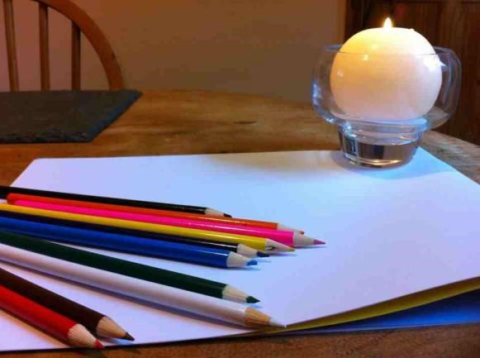
As we work through this course together I will refer to some creative resources that you may find helpful. As always, use the things you are drawn to and leave the things that don’t appeal. You do not have to use everything. As in all of life, you choose.
Consider:
- Nourishing hand cream to help you develop positive habits
- A journal to keep track of your reflections on your learning
  - To use daily?
  - As a success diary?
  - As a gratitude diary?
- Magazines or newspapers, for making a vision board or different ways to reflect
- Colouring pencils and pens
- Paper, scissors, glue
- Modelling clay
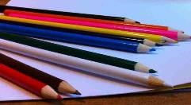
Whatever you decide, you have all the resources you need. Create the space and welcome change into your life. What inspires you right now? Enjoy! You will be inviting others to get a different perspective. The best way to start is by looking for opportunities to get a different perspective yourself.
You can use the creative resources mentioned, or any others that you would like to use, in any way that suits you. Try different things. Start with something that seems familiar and each time you use them, try something slightly different. Doing things differently will help you to get a different perspective. Sometimes the bits we fear the most, we need the most. Be brave. Be daring. And be astounded. Small creative changes can lead to significant results.
You could try:
- Cutting pictures you like out of the magazine and putting them together – what do you notice?
- Cutting out words or phrases – what stands out?
- Writing in different colours
- Writing some in pen and some in pencil
- Noticing which colours seem important – what is that telling you?
- Combining your own words and picture with magazine cut outs
- Going 3D with modelling clay
- Going 3D with modelling clay and picture / words from the newspaper
- Using poetry to express how you feel – no one else need ever see this – it can be for your eyes only and the experimentation can unlock hidden compartments in your soul!
- Mind mapping can help you consider options
- Take photos of things that stand out and add your pictures to your journal
- Record you voice expressing what is important and play it back to yourself – what do you notice?
- Record a short video of something that grabs your attention and decide how you can incorporate this into your creative process
- Notice how your body feels, where you are holding tension and what feels good
- Use your senses to fully experience your world – what would your ideal situation smell like and sound like?
- What else do you want to try?
Be willing to give new things a go, and see where they lead you. Refer back to this list as you progress through the course, to provide you with even more inspiration for the activities.
