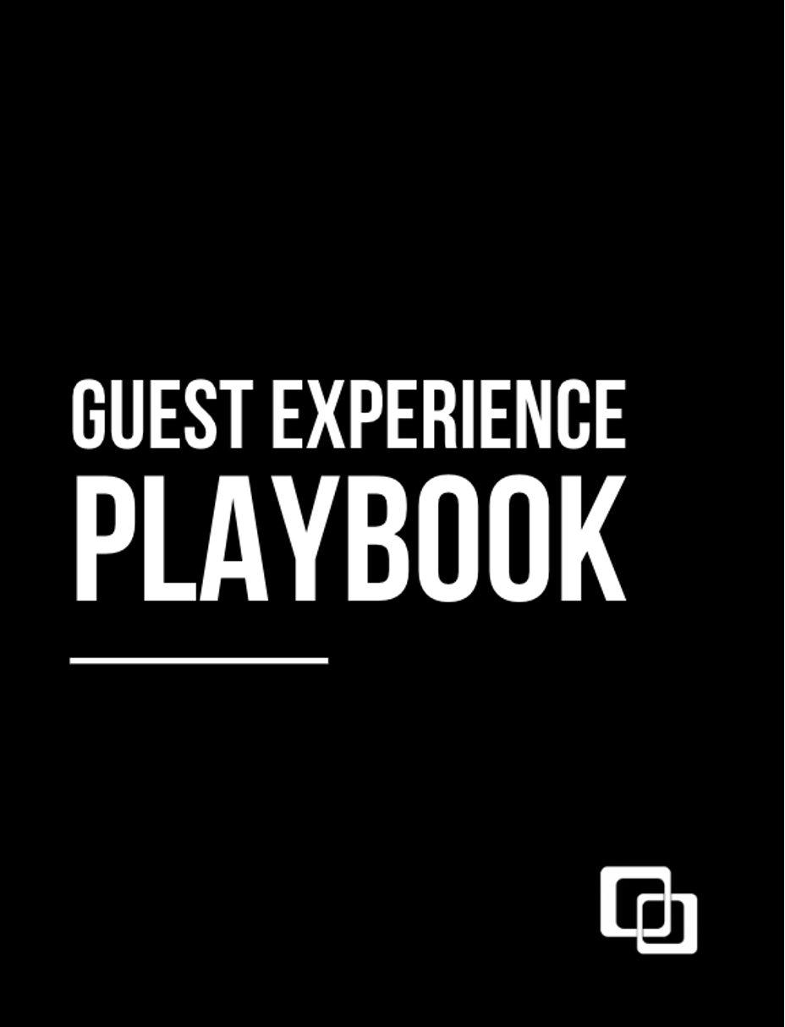

Welcome To
The Party

Saying, “Yes!” to joining the Guest Experience Team is saying yes to becoming a host at our weekly party where we celebrate and praise our guest of honor, Jesus.

Once you join the team, you are no longer just a partygoer, you are a party thrower! It’s way more than parking a car, opening a door, saying hello, or making a cup of coffee. You’ll be an important part of creating the right environment where the Holy Spirit moves in the lives of our church family.

Our guests will encounter the love and kindness of Jesus through you, and we celebrate that by saying, “Welcome to the party!” We couldn’t do this without you!

Pastor CJ Johnson
LEAD PASTOR, NORTHVIEW CHURCH

"If we lose our why, we will lose our way.”
- Pastor CJ Johnson

Here at Northview, we serve for the ONE.

We serve for Jesus! And if Jesus is above us, then nothing is beneath us. We serve with a heart to do whatever it takes to help our guests encounter Jesus.

We also will serve for JUST ONE.

“What do you think? If a man owns a hundred sheep, and one of them wanders away, will he not leave the ninety-nine on the hills and go to look for the one that wandered off? And if he finds it, truly I tell you, he is happier about that one sheep than about the ninety-nine that did not wander off. In the same way your Father in heaven is not willing that any of these little ones should perish.
Matthew 18:12-14

Take one moment to think of someone who is far from God or has never encountered the radical love of Jesus. If that person showed up for church today, how would you want them to be welcomed? You would want every interaction to be engaging and intentional – from the street to their seat. The reality is that every weekend, new guests are coming through our doors at Northview.

- Who is my ONE?
- Write down another team member's ONE and begin praying for that person.
- Are you ready for their one to show up at your campus?

Why We
Are Here
Northview exists to Make Jesus Known.

Our Ministry Philosophy

We Believe:
- The sermon starts in the parking lot.
- We are thermostats not thermometers. We set the temperature for the room.
- If Jesus is above us, then nothing He did is beneath us.
  - We see a need and fill it. We are willing to do anything to serve our guests.
  - Enjoyment leads to engagement.
  - Church should be something we enjoy, not endure.
- Everybody is welcome.
  - The Church is the most attractive when grace is most apparent.
    - If Jesus came for sinners, why shouldn’t sinners come for Jesus?
- Guest experience is greater than our convenience.

Do nothing out of selfish ambition or vain conceit. Rather, in humility value others above yourselves, not looking at your own interests but each of you to the interests of the others.

Philippians 2:3-4
______________________________________________________________________________

How We Carry
Out Vision

Gatherings
Worship Weekly: Worship reminds your soul of who God is.

Groups
Engage Relationally: Christian life without Christian friends is difficult, confusing, and boring.

Generosity
Generous Living: One of the best things you can do for yourself is to do something for someone else.

Serving is a delight, not a duty.

A Look Into a
Weekend Serve

- Guest Experience team members are scheduled to serve on a _______________ basis.
- Please arrive at least _____________ minutes before your scheduled service time begins to check-in with your Service Team Lead and come together for Team Huddle. At Team Huddles we’ll celebrate wins, cast vision, and pray.
- Park away from the building to leave the best spots for our guests.
- Print and wear a name tag.
- Guest Experience shirts and/or lanyards will be available to you. Please ask your Service Team Lead where they are located.
- If you cannot serve, please communicate with your Service Team Lead in advance so they can find substitutes. This will ensure that our teams are best prepared to serve our guests.
- We ask that you not leave the service early to help keep it as distraction-free as possible.
- You are the hands and feet of Jesus to our guests. That may mean picking up trash, changing positions, carrying a diaper bag for a mom, holding an umbrella for a guest when it is raining, or any other opportunity the Lord brings your way. If you see a need, please meet it!

THE 10. 5. 2. Rule

10 Feet Away (Smile, Wave, Make Eye Contact)

5 Feet Away (Verbal Hello, Good Morning)

2 Feet Away (Handshake, Fist Bump)

Emergency
Procedures
Each campus will have a unique safety plan for its building layout, security presence, and other factors. Due to the sensitive nature of safety/security, we do not make our protocol available outside of our Safety Team.

Radios – Each campus has its own specific emergency procedures that may include radios. Please see your Guest Experience Coordinator for details on radio usage.

Police Officers and Campus Security – Please notify the police present during weekend services if any emergencies arise. Trust your instincts. We believe in the “see something, say something” philosophy.

First Aid
The First Aid Team uses their gifts to meet basic ﬁrst aid needs at services, conferences, and special events.

Before Service

- Arrive on time, check-in, and attend Team Huddle to celebrate wins, hear vision, and pray before our serve.
- Be prepared to serve with empty hands by securely storing personal items such as purses/bags, etc.
- Ensure the First Aid bag is stocked and radios are accessible and ready to be utilized.

During Service

- We are “on-radio” (with earpiece) and on-channel with Safety team, at least one on-site oﬃcer, and a staﬀ member.
- We are positioned in the lobby in a standard high-visibility area (preferably at or next to the Hub).
- We respond, assess, and facilitate basic ﬁrst-aid to emergency and non-emergency incidents.
- We partner with Police and/or Northview Staﬀ to make any calls to EMTs and stay onsite until the person is treated and/or transported by EMTs.
- We ensure guests are treated privately unless they cannot or should not be moved.
- We limit disruption to services/events during medical emergencies or incidents.
- We maintain and submit a secure report to Northview Staﬀ of any injury or treatment that takes place.
- We adhere to HIPPA laws.

After Service

- We ensure the First Aid bag is stocked, radios are placed on chargers, and all supplies are ready for the next team to utilize.

How We Win
the Weekend

We win the weekend when each team member works to create a welcoming environment that leads guests to connections. This is done when we Exalt God, Exceed Expectations, and Express Joy as we engage with guests.

Guest Experience Roles

Team Coach – Page 14
Team Trainer – Page 16
Service Team Lead - Page 18
Auditorium Host – Page 20
Coffee/Capstone – Page 22
Welcome Team (Check-in & Inside Greeters) – Page 24
Connections – Page 26
Outdoor Experience (Parking & Outside Greeters – Page 28
Set Up/Tear Down – Page 30

Team Coach

Purpose
- Provide weekend oversight for the Guest Experience Team.
- To grow in their own servant leadership and spiritual development.
- This role is unique to each individual and works with the Guest Experience Coordinator to develop a personal growth plan by being personally discipled.
- Works closely with the Guest Experience Coordinator or Teams Director to move ministry forward through the Guest Experience team.

Preparation
- Works closely with the Guest Experience Coordinator to move ministry forward through the Guest Experience Team.

Running the Play
- Ensure the team is trained, receives applicable communications, and is supported.
- Focuses on personal discipleship of your Service Team Leads
- Ensure the team is prepared and staffed every week.
- If a team member cannot serve, ensure coverage has been arranged and confirmed.
- Provide updates to your team members as needed.
- Ensure everyone feels welcome.
- Stay alert for issues that may require assistance.
- If a guest asks where anything is located, guide them, as opposed to pointing.

Post Service
- Relationally connect with Service Team Leads on a regular basis.
- Assist Guest Experience Coordinator to recruit team members for weekend serving opportunities.

Team Trainer

Purpose
Meet with new team members on their first day of serving to teach them the ins-and-outs of their new role and to train them so they are effective in their ministry and feel confident and well-prepared.

Preparation
- Respond in a timely manner to any dates requested for training a new team member.
- Connect with new team member to introduce yourself and establish a time and location to meet prior to service.
- Arrive 30 minutes before service when training a new team member.
- Prepare their welcome to the team gift.

Running the Play
- Follow the checklist of items/topics to cover during training with each new team member.
- Sign off on that checklist at the end of the service

Post Service
- Communicate any relevant information to the staff member afterwards.
- Send a “thank you” email to the new team member 3-5 days after the weekend.

Service
Team Lead

Purpose
Development relationships by connecting with your team members. Get to know them and be familiar with their families, ask them questions and listen, pray for them, and invite feedback.

Preparation
- Schedule the team - You will be given a set team and will be responsible for scheduling them in services at least two weeks in advance. You will check the schedule for your services weekly and adjust as needed. Though we have set teams, your team may still need help finding subs. If you need support filling a position, your Team Coach can help. You should be following up with your team a couple of days before scheduled services. This helps to ensure attendance.
- Recruit for your team - You will be responsible for helping to build the team. You should recruit for your service, team, and the overall Teams to help people discover their purpose and make a difference here.
- Team Huddles - You will get to attend a weekly pre-service huddle to prepare, receive position assignments and pray. This is essential for unity and clarity.
- Attend a Monthly Meeting - Once a month all our Team Service Leads meet for training, updates, community, and to celebrate wins. Some of these meetings may take place online.

Running the Play
- Lead during service - During your service time, you will lead your team to know their position and serve our church well. Make sure that your team is checked in and is wearing their name tag. As a Service Team Lead, you will not have a scheduled position. This allows you to float around and assist wherever needed, and during slow times you can connect with the team.
- Serve one, Worship one - We are to live a life fully devoted to Jesus, first and foremost. The team incorporates a “serve one, worship one” motto, which allows individuals to worship God by attending a service and to worship God by serving during a service. Both our attendance and serving are worship to God. As a leader, you are expected to model this motto to your team.
- Offer Support - It is your responsibility to help lead the way by offering support and guidance to your team. Remember that we are all on our own journey, with different past experiences that have molded our present character. Let us love each other as Jesus loved us and encourage spiritual growth and positivity. Offer support privately when necessary and address problems during the week.

Auditorium Host

Purpose
Prepare each person’s heart for what the Holy Spirit wants to do in and through the worship experience. The best way to do that is through meaningful connection with every guest who walks through your door. Auditorium hosts don’t just say, “hi”. They set the atmosphere through connection, encouragement, and letting guests know they belong.

Preparation
- We assist guests with seating, facilitating communion, and helping to secure a distraction-free worship environment.
- Arrive on time, check-in, and attend Huddle to celebrate wins, hear vision, and pray before our serve.
- Be prepared to serve with empty hands by securely storing personal items such as purses/bags.
- Ensure the auditorium is clear of any debris or personal belongings (including bibles, jackets, drinks, etc.).
- We introduce ourselves to families with small children to learn the parents’ and kids’ names and to preface our ongoing assistance before, during, and after the service to be a resource and an extra set of hands for them.
- Before service, we identify and plan seating for guests with physical limitations and disabilities.
.
Running the Play
- We welcome and direct each guest to an Auditorium Host who will walk them to a seat.
- With a diligent, gentle spirit, we seek to ensure that our guests can worship in a secure, distraction-free environment.
- We notice guests who may be struggling, and we are proactively assist them.
- We go the “extra mile” with ongoing assistance before, during, and after the service for families with children. We ensure they know about Northview Kids, Northview Students, the Mother’s Room, and other resources.
- We are mindful of our movements and are sensitive to not distract guests during the message.
- We limit all movement during salvation prayers and other prayer moments.
- For select services, we facilitate Communion by providing Communion elements.
- We provide timely and accurate attendance counts to our Service Team Lead.

Post Service
- Check the auditorium for debris, personal items, and cleanliness to always “leave it better than we found it.”
- Review any specific instructions needed with the next team.

Coffee/Capstone

Purpose
To make our guests feel welcome by providing delicious coffee with warmth and enthusiasm. Coffee is our medium for ministry. The fact that we have free coffee out and available during services makes people feel comfortable and at home. No matter what is going on in their life or their finances, they know they can get a great cup of coffee for free at Northview.

Preparation
- Setup the Capstone area: coffee, water, tea, chai tea, etc.
- Each campus has instructions in the café area. Your Service Team Lead will contact you for training.
- We freshly grind beans each morning. Instructions for measurements will be in your Capstone area (Carmel and Kokomo campuses).

Running the Play
- Create a conversation/connection, as everyone enjoys that personal connection when getting coffee, tea, water, etc.
- Never lose sight of how just a simple smile or hello can change someone’s day. We know that every weekend is someone’s first weekend!

Post Service
- Clean the carafes thoroughly and leave them open to dry.
- Make sure the grounds are disposed of properly.
- Wipe down counters.
- Turn off lights

Welcome Team

Purpose
We provide a personable, authentic, and encouraging atmosphere for guests by welcoming them at doors, walking individuals to their destination, and cultivating a spirit of joy in our lobby and outdoor spaces. The Welcome Team creates a positive ﬁrst impression by welcoming, greeting, and encouraging each guest as they enter and exit Northview Church.

Preparation
- Arrive on time, check-in, and attend Huddle to celebrate wins, hear vision, and pray.
- Be prepared to serve empty-handed by securely storing personal items such as purses/bags.
- Be sure the entryway is unlocked, and any signage in proximity is in excellent condition and displayed correctly.
- Ensure the entryway is clear of debris or personal belongings (including bibles, jackets, drinks, etc.).
- After the Welcome Team assembles, prepare Welcome Guides, pens, and other service materials to be distributed.

Running the Play
- We look for familiar and unfamiliar guests, understanding that our greeting and farewell make a diﬀerence.
- We greet everyone with “Welcome to Northview” and “We’ll see you next week!” as we open/close doors for each individual guest or family.
- We are empowered to walk with guests to help them ﬁnd their destination (service, kids’ area, restrooms, etc.).
- We embody an “extra mile” culture, such as walking guests to/from the building with umbrellas on rainy days.
- Once service is well underway, your Service Team Lead will “release” the team to a break before reassembling it for an “exit serve” to create the same excellent experience for guests as they depart.

Post Service
- Check your serve area for debris, personal items, and cleanliness to always “leave it better than we found it.”
- Continue welcoming and bidding farewell to guests until the next team exits their pre-service huddle.
- Ensure all supplies are accessible and ready for the next team.

Connections

Purpose
We are familiar with our campus’ service times, staﬀ team, upcoming events, and facility, and we are proactive in engaging guests, looking for those who need help, and going the “extra mile” to ensure that guests have everything that they need, and every question answered as we personally escort them to their destination. The Connections Team helps guests identify their next steps by providing resources and information about campuses, weekend services, Life Groups, and campus events.

Preparation
- Arrive on time, check-in, and attend Huddle to celebrate wins, hear the vision, and pray before our serve.
- Be prepared to serve with empty hands by securely storing personal items such as purses/bags.
- Ensure the Information area is clear of any debris or personal belongings (including bibles, jackets, drinks, etc.).
- Ensure Information Team iPads are charged, cleaned, and all relevant links/apps are current and active.

Running the Play
- We are watchful for new people who might have questions or may need accommodation.
- We are familiar with what is available for guests at our campus.
- We lead conversations with “I don’t think I’ve met you yet,” and “How can I help you?”
- We oﬀer direction and assistance in orienting guests with the building and diﬀerent ministry areas.
- We utilize our Team Lanyard QR Codes to help inform guests of speciﬁcs about all things throughout church life.
- We walk with guests to the location or individual they need and avoid pointing or shouting directions.
- Once service is well underway, your Service Team Lead will “release” the team to a break before reassembling it for an “exit serve” to create the same excellent experience for guests as they depart.
- Check FTG text, write cards, and prepare for returning guests.
- At least one team member needs to be present throughout the service.
- Ensure every guest, first-time and returning, feel comfortable and welcomed.

Post Service
- Check your serve area for debris, personal items, and cleanliness to always “leave it better than we found it.”
- Continue welcoming and bidding farewell to guests until the next team exits Huddle and arrives.
- Ensure the Information area is wiped down, debris-free, and fully stocked for the next team.
- Ensure Connections Team Lanyards are returned to their designated spot and available for the next team.
- Ensure all supplies are accessible and ready for the next team.

Outdoor Experience

Purpose
We provide a safe, fun and welcoming outdoor environment by engaging people the moment they drive onto our property and cultivate a spirit of joy throughout our outdoor spaces. The Outdoor Experience Team creates a positive first impression by welcoming and greeting, helping them to find a place to park and ensuring their safety as they enter and exit Northview Church property.

Preparation
- Ensure any necessary cones and A-frame signs are set and in place.
- Grab a walkie from your Service Team Lead prior to service.
- Wear a vest and use a parking wand.
- Pop signs are available for sedentary parking team positions.

Running the Play
Quarterback
- This person directs vehicles into the direction of available parking within the lot.
- Any time the driver approaches a touchpoint, a QB should be able to provide direction.
Wide Receiver
- This person oversees receiving vehicles and placing the cars in designated spots.
- Always try to fill empty spots in rows already filled.

Post Service
- Return to your post at the end of your designated service.
- Tear down any signage or cones that need brought in.
- Place walkie on charger and pop signs at their designated spaces.

Setup and Tear Down

Purpose
The Setup/Tear Down Team helps transform portable campuses and spaces for services, providing distraction-free, excellent environments where guests can experience God. The Setup team unloads, organizes, and sets up carts, equipment, supplies, and whatever else is needed to facilitate services. After services conclude, the Tear Down team gathers, organizes, and loads all supplies and equipment while taking inventory of needed supplies or worn equipment.

Preparation
- Arrive on time, check-in, and attend Huddle to celebrate wins, hear the vision, and pray.
- Be prepared to serve empty-handed by securely storing personal items such as purses/bags, etc.

Running the Play

- We understand our campus layout, set-up plan, and tear-down strategies.
- We load in all elements needed to host services.
- We load out and store all elements needed to host services.
- We work together to prepare all spaces of the campus efficiently.
- We lean into departments to support their vision for their area. For example: Northview Kids will lead our team to accomplish the set-up vision for their area.
- We take responsibility for unpacking and packing carts in an orderly and gentle manner to help maintain the longevity of supplies/equipment.
- We have eyes to see when supplies/equipment might have reached their full lifespan and report these to our Guest Experience Coordinator who can initiate the process for new items to be purchased/implemented.
- We are detail-oriented knowing that excellence breeds comfort for our guests.
- We complete ﬁnal walk-throughs before services begin to ensure excellence has been met in all areas.

After Service
- Check your serving area for debris, personal items, and cleanliness to always “leave it better than we found it.”

