Philip Trick
Explainly
7/1/2018
EXCEL BOOKMARKS ADDIN
TABLE OF CONTENTS
ABOUT | 2
WHY A BOOKMARKS ADD-IN? | 2
NAVIGATING THE RIBBON | 3
CREATING BOOKMARKS | 5
MANAGING BOOKMARKS | 8
CREATING BOOKMARK GROUPS | 9
THE BOOKMARK MANAGER INTERFACE | 10
BOOKMARK MANAGER GROUPS | 10
BOOKMARK MANAGER BOOKMARKS | 11
USING BOOKMARKS | 12
ADDITIONAL INFORMATION | 13
FURTHER HELP AND SUPPORT | 14

ABOUT THE ADDIN
A Bookmark is a location of special interest. This Excel Bookmarks Add-in extends Excel’s traditional interface with an extended type of named range designed for navigating and organizing these locations.
The add-in is built using Visual Studio Tools for Office (VSTO) in C# and can be purchased through the Microsoft Office Store or Eloquens.com.
The author is Philip Trick, an actuarial analyst for The Scruggs Group and founding member and significant contributor to Explainly.io.
Philip demonstrates usage of different Excel files on a regular basis and determined a type of “PowerPoint” functionality within Excel would facilitate this. As a result, he developed this extension to allow users to define bookmarks, organize them into groups, and navigate among them based on their group and workbook so as to provide a slide-by-slide type of viewing experience.
WHY A BOOKMARKS ADD-IN?
Excel workbooks can get quite large and unwieldy, making navigation from specific points difficult for users not completely acquainted with the workbook.
While Named Ranges can be used to help navigation through the upper left dropdown, too many named ranges become unwieldy and difficult to use in such a way, with no real organization usable outside of manipulation of names based on the alphabetical order they are shown in.
Enter my Bookmarks add-in, a way to identify specific ranges, organize them together, and then navigate across them in a specific order.
Activating a Bookmark immediately selects the specified range and aligns the selection with the upper-left most visible cell. In conjunction with the navigation functions included with the add-in, creating instructions and offering live demonstrations in Excel has never been easier.

NAVIGATING THE RIBBON
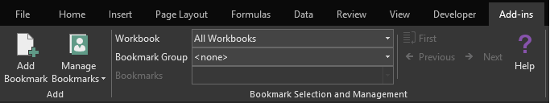
The Bookmarks add-in is primarily used through the Ribbon interface. These commands can be found on the Add-ins tab of your Ribbon.
From left to right and top to bottom, the commands are:
ADD BOOKMARK
Opens a form for creating a new bookmark.
MANAGE BOOKMARKS + DROPDOWN
The Manage Bookmarks primary button will open up the bookmarks management interface for managing both bookmark groups and individual bookmarks.
The dropdown list offers options for creating a new bookmark group, deleting a bookmark group, deleting a bookmark, or clearing all bookmark data.
SELECT WORKBOOK
The Select Workbook dropdown allows the user to filter the visible bookmarks down to those across all workbooks or only those that point to a range within a specific workbook.
SELECT BOOKMARK GROUP
The Bookmark Group dropdown allows the user to quickly choose which of the groups to select a Bookmark from.
SELECT BOOKMARK
The Bookmark dropdown allows the user to quickly choose a Bookmark to navigate to.

FIRST / RETURN
This button’s functionality depends upon whether a group has just been selected or if the user has recently travelled to a Bookmark.
PREVIOUS
The previous button activates and moves the user’s selection to the previous bookmark in the current Bookmark Group.
NEXT
The next button activates and moves the user’s selection to the next bookmark in the current Bookmark Group
HELP
The help button redirects the user to the Explainly support site for the Excel Bookmarks add-in.

CREATING BOOKMARKS
The Add Bookmark command along the Excel Ribbon will launch the Create Bookmark wizard, shown below.
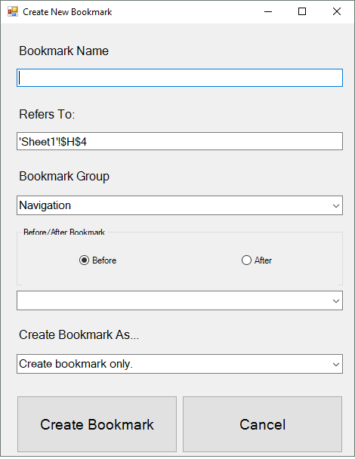

The Bookmark creation wizard allows you to specify the name of the bookmark, the range that the bookmark refers to, the bookmark group that it belongs to, where the bookmark belongs within the bookmark group’s order, and the rules for creating the bookmark.
There are few restrictions for Bookmark names; however, there are significant restrictions on a Named Range. For bookmarks that will be bookmarks only, this means fully featured names are possible. Bookmark names within a single Bookmark Group must be uniquely named. Bookmark names can be identical if each bookmark is in a different Bookmark Group.
The Refers To field supports links to named ranges but does not support links to dynamic named ranges. Initially, the Refers To field is populated with a reference to the currently selected cells.
The Bookmark Group dropdown allows the user to specify which bookmark group to add the new bookmark to. The selection will default to the current bookmark group selected within the Ribbon.
The Before/After Bookmark box allows the user to specify whether to insert this new bookmark before or after a specific bookmark. If left blank, the bookmark will automatically be appended to the end of the list.
The final box allows the user to specify additional rules for the bookmark.
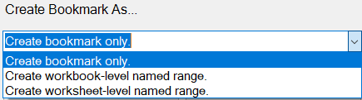
The bookmark only option simply creates a bookmark.
The two named-range options create named ranges with different scopes. The workbook-level scope or the worksheet-level scope. The scope of a worksheet-level range is defined by the sheet in which the bookmark’s range resides.
For bookmarks, there are few restrictions on the length of a name and the characters involved. For named ranges, there are significant restrictions.

When a named range is to be created with the bookmark, the name of the named range will be the name of the bookmark with the spaces removed and the length limited to 255 characters. If the bookmark has special characters that cannot be used in a named range, the bookmark will be rejected and will inform you that a new name is necessary.
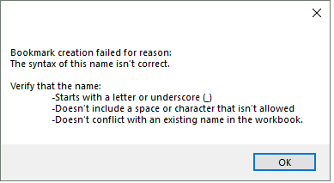
Creating a bookmark along with a named range does not change the functionality of the bookmark, it only adds the additional feature of creating a named range at the same time as your bookmark.
At this time, the bookmark is not directly linked to the named range so changing the named range refers to field manually will not update the bookmark’s location nor will changes to a dynamic named range propagate through to the bookmark.

MANAGING BOOKMARKS
Bookmarks can be managed simply from the Ribbon via the Bookmarks Manager dropdown list or, for more detailed control, within the Bookmarks Manager interface.
The dropdown list has some quick commands for basic requests such as creating new groups, clearing everything, deleting a single group, or deleting a single bookmark.
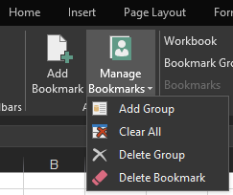
The Add Group command opens the Bookmark Group creation wizard.
The Clear All command clears all bookmarks that currently exist.
Do not use this unless you’re looking for a perfectly clean slate. This deletion cannot be undone.
The Delete Group command deletes the currently selected Bookmark Group along with any bookmarks associated with that group.
The Delete Bookmark command deletes the currently selected Bookmark.

CREATING BOOKMARK GROUPS
Using the Add Group command will open the bookmark groups creation tool.
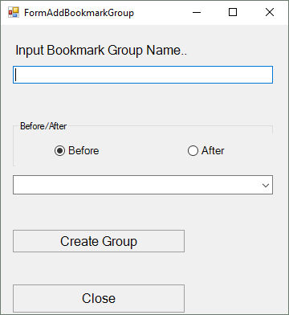
The wizard requests that you choose a name and specify which bookmark group to insert it before or after.
The name can have any number of spaces or characters.
All groups are added after the “<none>” group, you cannot insert groups prior to the default group.
The Create Group command does not close the window so the user can create multiple groups in one quick session before closing the window out.

THE BOOKMARK MANAGER INTERFACE
Clicking the “Manage Bookmarks” button, instead of the dropdown, will launch the extended Bookmark Manager interface.
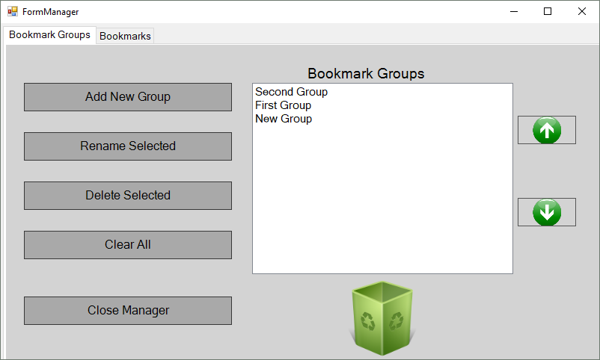
The manager consists of a tab for managing the bookmark groups and a tab for managing the individual bookmarks.
BOOKMARK MANAGER GROUPS
The Add New Group command opens the same Bookmark Group creation wizard as the “Add Group” command from the Ribbon.
The “Rename Selected” command will open a prompt that allows the user to rename the selected bookmark group.
The “Delete Selected” command will delete the specified group along with all of the associated bookmarks.
The “Clear All” command will reset the bookmarks add-in to an empty slate.
The Up and Down arrows will move a selected bookmark group up or down in the ordered list. Alternatively, bookmark groups can be dragged and dropped into a different order or dragged into the recycle bin to be deleted.
BOOKMARK MANAGER BOOKMARKS
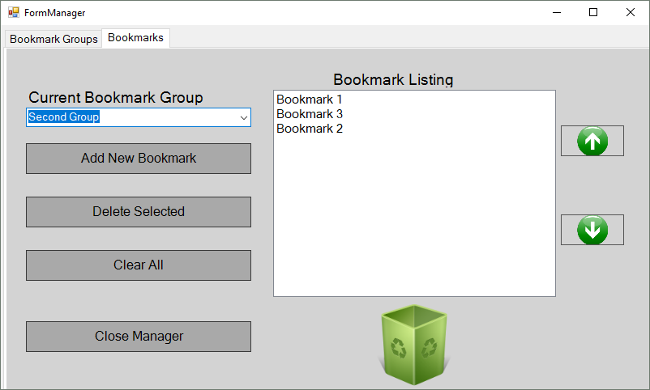
On the Bookmarks tab, the first dropdown specifies which Bookmark Group to look at and modify.
The “Add New Bookmark” button will launch the Create Bookmark wizard.
The “Delete Selected” button will delete the currently selected bookmark.
The “Clear All” button will delete all of the bookmarks within the currently specified group.
As with the Groups tab, the bookmarks can be reordered using the up and down arrows or by dragging and dropping the bookmarks in the desired order.
Dragging a bookmark to the recycle bin will delete that bookmark.

USING BOOKMARKS
The actions for using Bookmarks are currently restricted to the Ribbon.
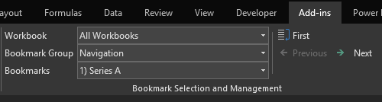
The first two dropdowns, Workbook and Bookmark Group, are for identifying the subset of bookmarks to make accessible.
The Workbook dropdown allows the user to specify whether to travel across bookmarks regardless of the Bookmark’s home workbook or restrict travel to a specific Workbook.
The Bookmark Group dropdown specifies which group of bookmarks to use.
The Bookmarks dropdown allows the user to pick a specific bookmark to activate and travel to. The bookmark must be different from the currently listed bookmark to activate.
If the Bookmark Group has recently been picked, the “First” button will take the user to the first bookmark listed in the bookmark group.
If a Bookmark has recently been activated – and so the chain is active – the “First” button will change to a “Return” button. The “Return” button will return the user to the last selected Bookmark, which will be the one displayed in the Bookmarks dropdown.
Prior to a Bookmark being activated, the “Next” command will function like the “First”, treating the initial bookmark as the next in the chain. Once a Bookmark is activated, both the Next and Previous commands will allow you to travel up and down the list of bookmarks.
Next will always go to the next bookmark in the group. If you are at the end of a group and there are further groups that contain bookmarks, the Next command will take you to the first bookmark in the next group in the list of groups. If there are no bookmarks past a given bookmark, the Next command will be disabled.
The Previous command will always go to the previous bookmark in the group. If you are at the beginning of a group and there are groups before that points that contain bookmarks, the Previous command will take you to the last bookmark in the previous group from the list of groups. If there are no bookmarks before a given bookmark, the Previous command will be disabled.
The Bookmarks dropdown, Previous, and Next commands filter their results based upon the selected Workbook.
ADDITIONAL INFORMATION
Can I save my Bookmarks to my workbooks so I don’t have to recreate them?
Yes, bookmarks are automatically saved with your Excel document whenever you save the workbook. These Bookmarks will automatically be loaded whenever the file is reopened on any PC with the Bookmarks add-in installed.
What happens to my bookmarks if a user opens the workbook without the add-in and saves my workbook?
Nothing. The Bookmarks are added directly to the XML manifest within your Excel workbook. As a result, if a user opens the workbook without the add-in and makes changes to the workbook the Bookmarks will remain unchanged so long as rows or columns are not inserted or deleted and sheets are not renamed or deleted.
Does this add-in collect or transmit any information about me or my machine?
No, this add-in does not transmit any information to any third-party. The “Help” button is the closest thing to an external connection and it simply acts as a hyperlink to www.explainly.io/courses/bookmarks-help-and-support/
What if there is a feature I’d like to see added?
Contact me through the Explainly website and I’ll be happy to look into it.
Some of your support videos have different Ribbon commands from those within this document, why?
The add-in has gone through some recent reworking such as making Bookmarks auto-save and auto-load. Previously, these were Ribbon commands. This document contains the current Ribbon interface for the initial release version 1.0.1.4.

FURTHER HELP AND SUPPORT
The final “Help” command along the Ribbon will take you to the Explainly course for this add-in. Enrollment in the course is free. Videos offering support with the tool as well as recommendations on how to use the tool are available and the author can be contacted directly for further support.

