**Resolving and Combining Vectors at the Olympics**

## **Yuko Difficulty:**

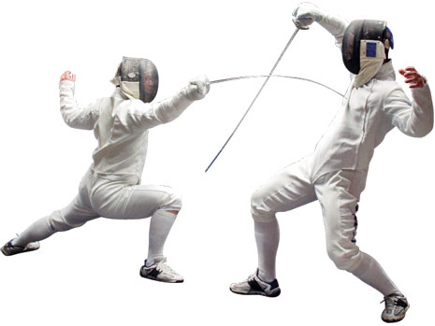*If you correctly completed all of the Online Questions, skip this stage.*

1. A boxer launches a jab-punch providing a force of 500N at 300 above the horizontal. **Calculate** the horizontal and vertical components of this force.
2. If a fencing athlete moves 1m North and 20cm east, **calculate** the Magnitude and the Direction of the resulting displacement *(Give direction between North and Resultant Displacement)*

## **Waza-Ari Difficulty:**

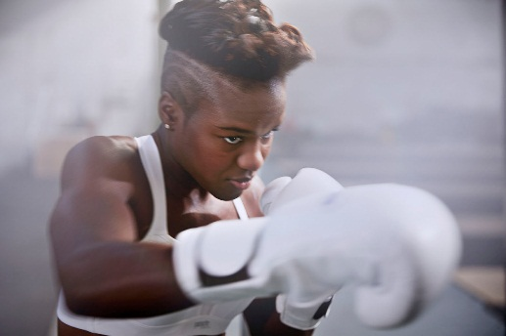A boxer launches a jab-punch providing a force of 200N at 300 above the horizontal followed by an uppercut of 400N at 700 above the horizontal.

**Calculate**

1. The resultant force experienced by the opponent from these 2 punches combined.
2. The angle of the resultant force to the horizontal.

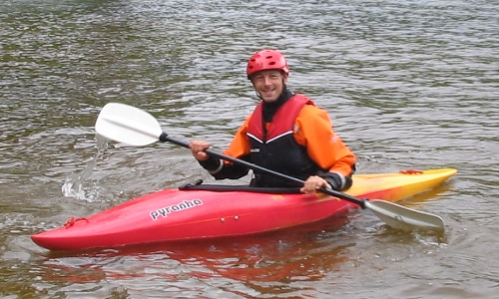A Kayaker has imbalanced power between the left hand stroke and the right hand stroke. If the left hand provides a force of 80N and the right hand 70N, both at 200 to the direction of travel but outwards from the boat.

1. **Calculate** the Resultant Force produced from 1 left and 1 right stroke.
2. **Calculate** the direction of the resultant force with respect to the direction of travel.

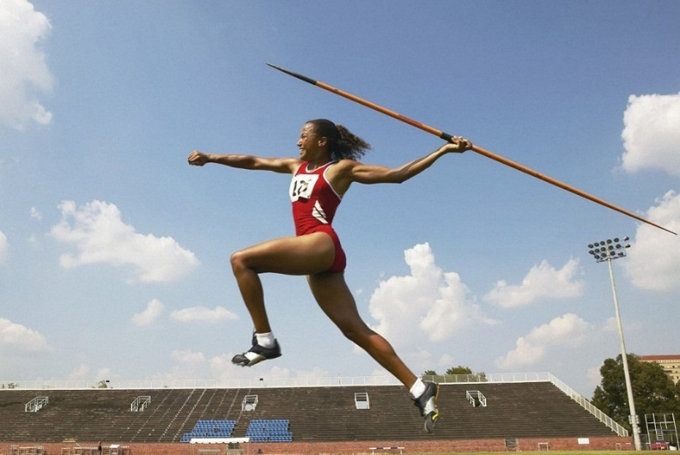A javelin thrower throws a 10kg javelin at an angle of 450 to the vertical with a force of 180N.

1. **Calculate** the Resultant Force acting on the javelin at the point of release. *(Make sure you remember all the forces!)*
2. **Calculate** the angle of the resultant force to the horizontal.

# **Ippon Difficulty:**

1. A 3kg block is placed on a slope at 600 to the vertical. It is accelerated by its weight force. **Calculate** the components of the force parallel and perpendicular to the slope.

600

3kg

parallel

perpendicular

1. A 2kg pendulum oscillates about a fixed point. **Calculate** the component of the weight force parallel and perpendicular to the string in terms of the angle (θ)
2. 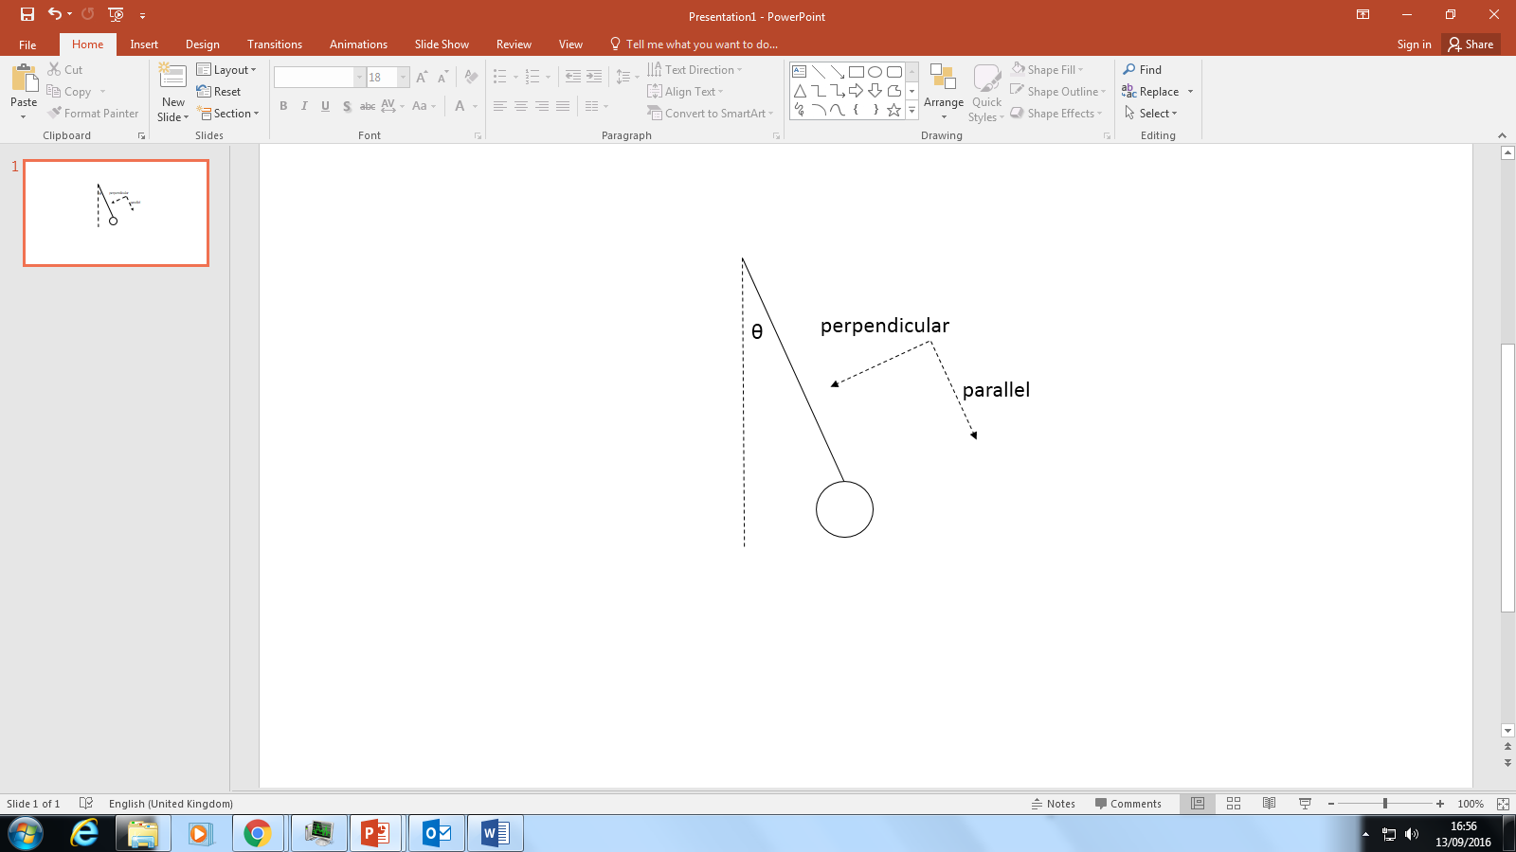**State** and **explain** the value of θ when the component perpendicular is maximised.