The SPARK Method Case Study

Course Title | Flawless Project Management with the SPARK Method
Course Learning Goals | - Know where to start with Project Management, communicate and cooperate effectively.  - Know how to lead a team.
Case Study Check List Area | - “R” - Reflect – Put Soft Skills in Action.

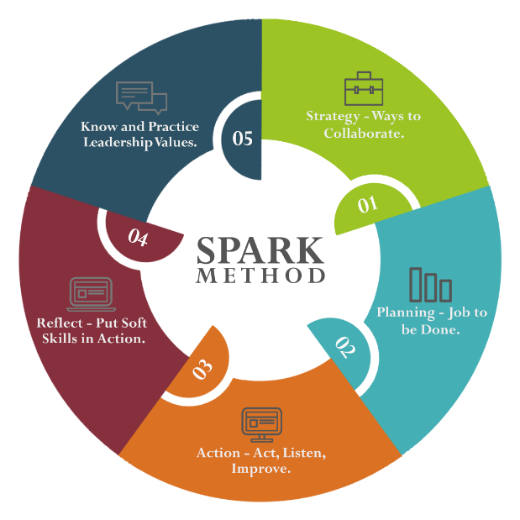
Case Study Section Title | Task Description | Training Lesson Completed | Case Study Task Completed | Tested on a Real Project | Feedback  Gathered | Wrote Comment How It Worked
“R” –  REFLECT  Put Soft Skills in Action | - Organize "A little bit about me" session with your team to get to know each other better.
- Gather anonymous feedback how you can improve.
“If you do not like it, do not defend, analyze how truthful and helpful it is.”
 | - Give recognitions to your team members.
 | - Ask your management what are different ways to get someone recognized.
  - Use all means possible: e-mails, badges and whatever you have in your company.
(It does not have to be a monetary award.)
 | - Let management know for a great job your team members are doing.
 | - Give at least two immediate feedbacks for a good work.
 | - Give immediate, constructive, 1-on-1 feedback, on not so great performance but listen to understand where the problem is. Do not judge!
 | - Write down into your plans that you should do this regularly!
 | - Find a mentor(s) in your company to explain you Customer’s point of view.
 | - How does communication with your clients look like and what are specifics?
 | - Understand business of your Customer(s) better, their point of view and why they need your services.

