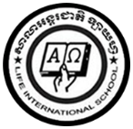

**LIFE INTERNATIONAL SCHOOL**

KHMER SUBJECT FOR KSL

TEACHER : **CHEN SOTHARY**

1. **Let ‘s learn to write your name in Khmer language below .**

Hui Seong Shim

ហ៊ី ស៊ុង ស៊ីម

……………………………………………………………………..

………………………………………………………………………

………………………………………………………………………

………………………………………………………………………

………………………………………………………………………