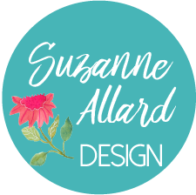 | Paint a Stunning Bouquet – Supply List  (clickable links at suzanneallard.com)
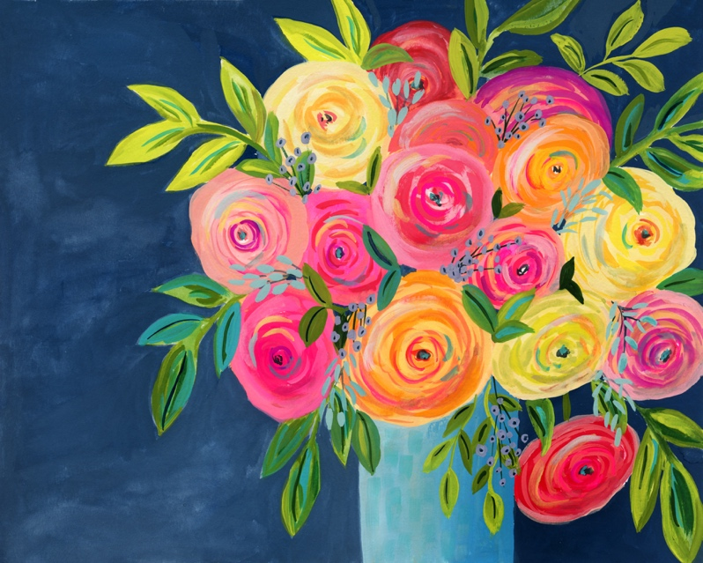

Paint: Gouache, can be mid-grade or lower grade. The higher the quality, the more vibrant the color. See color chart for colors, you will need most basic colors plus a good turquoise, and opera pink or red. The Winsor Newton Cobalt Turquoise Light is amazing. The Opera pink is too but any Opera pink or red will do. Acrylic paint is an option too, watercolor could work but would be more translucent and you can’t paint light over dark. Also, there is no white in watercolors so you have to use more water to lighten things.
Paper: Canson XL series 11x14 or any other mid-grade brand.
Brushes: Any decent brushes, I like the Princeton Velvetouch brand, # 4 or 5 round, #10 round and a #6 flat. Also, a number 1 or 2 for fine lines.
Palette: Palette or plastic or glass plate to use as a palette.
Finishing varnish spray if desired. I like the Krylon UV Archival from Amazon.
Links to most of these supplies can be found in the supplies page at suzanneallard.com.

