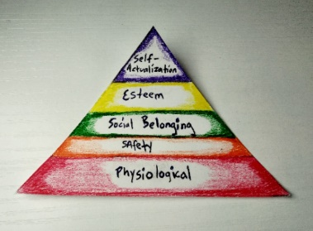

Maslow Hierarchy of Needs

Physiological Needs

Basic needs for an individual to survive. These includes food, water, clothing, housing, warmth/cooling sleep. Can be categorized as the essentials needed to survive in the world. Foundation of survival.

Safety Needs

These can be summed up to include protection of person or their living standard. Objective is to offer peace of mind and freedom from the elements as well as fear. Safety Needs is characterized by security and stability.

Social Belonging

This stage involves the emotional connections needed to form a healthy life. These emotional needs for social belonging is played out in individuals seeking acceptance in social groups and cliques.

Esteem

This relates to the need to have honor and recognition bestowed upon one’s self (lower esteem). It can be broken down into lower esteem and higher esteem. Lower Esteem is like social belonging, and higher esteem is similar to self-actualization (related to achieving self-respect for one’s self).

Self-Actualization

This stage of an individual’s development places emphasis on achieving your higher self. Chasing your ideal self or self-transcendence is the goal. However, it may be argued your ultimate self can never be achieved since one can always become better. Self-development is a never-ending process. “If you don’t move forward, sooner or later you begin to move backward- Mikhail Gorbachev

What are some characteristics of your ideal self? Are these any different than you exhibit currently?