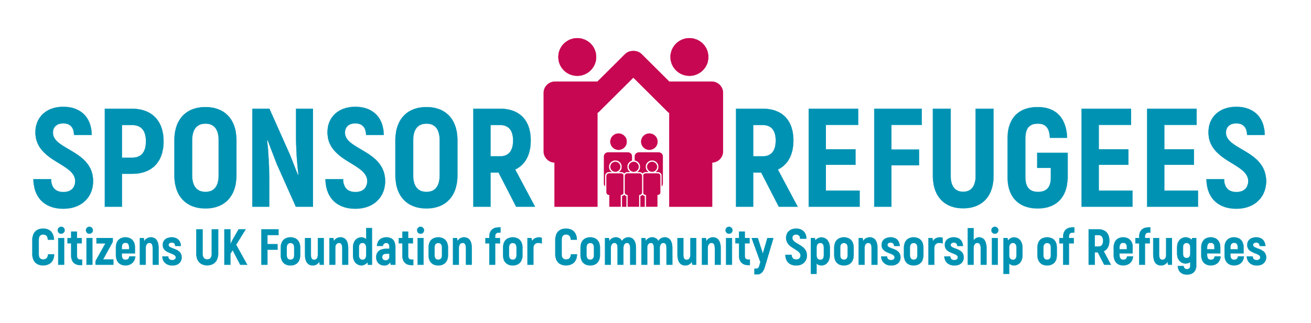
This budget allows you to plan ahead on the group’s finances.

BUDGET
Category | Amount (£) | Pro bono/donations available?
Group Expenses
DBS checks
Travel costs for group members
Public liability insurance
Initial Expenses For The Family
Payment to family upon arrival (£200/300 per person)
Clothing
Groceries
School start-up costs
Internet/wi-fi (if applicable)
Computer (if applicable)
TV license (if applicable)
Telephone/mobile phones (if applicable)
Accommodation
Furniture
Adaptations to property
Rent deposit
Utilities
Rent (all resettled families will be eligible for housing benefits)
Rent top-up*
Post-Arrival Costs
ESOL classes
Interpreters**
Childcare
Transportation (bus pass)
TOTAL | £

*Rent top op: If your group decides to cover the difference between the allocated benefits and the rent, please note that this may impact the amount the family will receive. Your Job Centre contact will be able to guide you.
** As part of your Community Sponsorship agreement, the Home Office will visit to evaluate progress. Interpreters will need to be present at this meeting.

