Stick Figure 3-Ring Circus
Pre-reading activity to use with Qui parle français?
CI Reboot, 2023, Carla Tarini

Goal: To use/preview the high-frequency language used in the QPF series and in specific bios in an engaging, pre-reading activity. Students demonstrate comprehension by nodding, gesturing, and answering questions.

Preparation: choose 3 people from one of the QPF? books and have the facts you want to focus on in mind or on a note card*.

Materials: Classroom whiteboard, markers, eraser, teacher's fact sheet.

Activity:
- draw one simple stick figure, talking/circling as you draw; add 1-3 details slowly
- continue basic circling; also compare students to the famous people/PQA; mention yourself
- check comprehension as needed
- draw 2nd famous person, add 1-3 similar details slowly, circle/compare to 1st person
- draw 3rd famous person, add 1-3 similar details slowly, circle/compare to 1st and 2nd person
- add new, similar details to all 3 people, circle/compare new details
- with all three people now on board, pepper students with questions
- restate student’s single word/short answers with fuller answers, including negation.
- encourage longer answers if students are ready

*NOTE: This is what I tend to draw/write:
-1st DETAILS: baby, name, birth year, place born
-2nd DETAILS: adult doing their preferred activity, with a heart showing that they love it
-EXTRA DETAIL: speech bubble or thought bubble, showing another detail from text

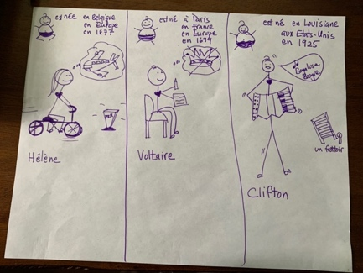 <-- This is what my board might look like at the end.

*TRADITIONAL 3-RING CIRCUS (can move to this activity the next class)
- Place three volunteers next to stick figure drawings; supply props if available. These students will pretend to be the 3 famous people.
- Review the previous day's details. Alternate between asking the ‘famous people’ questions about themselves (if ready for output) and asking the class about the famous people.
- Add some more details from text if desired.

*Note: there are a lot on demos of traditional 3-ring circus on-line.

