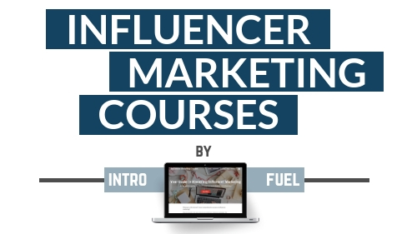

Templates by Influencer Marketing Courses.com
- in partnership with Intro Fuel

What you will find in this document

While you likely sit between a screen and the brand representative, you still need to make the right first impression. You want to come across as professional, well-spoken, and creative. The right brands will respect you for wanting to be careful about the partners you collaborate with.

The best collaborations will come from those professional, long-term relationships with brands you truly believe in. You actually use their products or service and find yourself talking about it to friends offline.

Although we truly believe that these relationships are worth far more than just the monetary compensation, we still want to send you into the lion's den prepared for battle.

With these templates, you’ll set the tone of the relationship early. It’s the first time the brand will hear from you, and if you stay consistent with the language you use and how you approach the content you create, you can expect to be in the driver’s seat throughout the entire relationship.

Why do you want to be in the driver’s seat? That’s easy. If you’re not, many brand representatives may take advantage of you. They’re typically salespeople by nature, so they’re ready to pounce on any opportunity to one-up you. They might ask for extra channels after you’ve already agreed to terms, or request videos when you only discussed photos before being paid.

By setting the tone, they’re far less likely to push your buttons. Be firm, but fair, polite and pro-business. It only takes one wrong email to spoil a relationship!

Alright, ready to get started?
Reply Template #1

Hi,

Thanks for your interest in working with me, I’d be happy to consider the opportunity provided it aligns with my personal brand and my beliefs.

Please send over more information on what this opportunity involves. I’d like to know what the deliverables will be, the length of the contract, and the compensation.

Looking forward to the possibility of working together.

Best,
Your Name

Reply Template #2

Hi,

Thanks for your email and apologies for the delay. I feel like I’m constantly weeding through these opportunities!

I’d be willing to hear more about what you have in mind. Please note that I don’t do one-off posts. The brands that are most successful in partnering with me have signed long-term deals across multiple channels.

Once I hear what your offer entails and how you anticipate us working together, I’ll get back to you with my level of interest and about how we could take next steps.

Kind Regards,
Your Name

Reply Template #3

Hi,

I appreciate your email, thanks for getting in touch.

I’d be interested to hear more about what you’re offering. I have a few initial ideas of my own on how we could execute a campaign.

What are your content requirements and what does the compensation structure look like?

Looking forward to hearing from you.

Cheers,
Your Name

Reply Template #4

Hi,

You’ve come to the right place! I’ve spent the last three years collaborating with A-List brands across all major social media channels, so something like this is right in my wheelhouse.

I will, however, inform you that I’m extremely particular about the brands that I partner with. The level of interest I have from brands allows me to only collaborate with those I can truly and confidently stand behind.

Once I hear more from you about the brand and what the offer entails, I’ll give it some thought before getting back to you.

Thanks,
Your Name

Reply Template #5

Hi,

Thanks for reaching out, hope you are well.

I get a ton of inquiries from brands like yours and I’d like to be upfront – I only collaborate with those I truly believe in and can see myself working with long term. Truth be told, there’s just too many brands out there looking to work with influencers to be accepting anything but the best opportunities for me as a content creator.

I don’t mean to scare you away, I just believe that honesty and transparency are what the best business relationships are built on. I hope you respect that.

I’m interested to hear more about what you have in mind. Please provide more info on deliverables, term, compensation and what makes your brand stand out from the rest.

Looking forward to hearing from you.

Best,
Your Name

Reply Template #6 - BONUS

This one is an auto-reply. We suggest only using it if you actually get a high volume of interest and want to use the ultimate pull-method card. Have it set up to an alias so that not every incoming email receives this auto-response. For example, you could have collaborate@yourname.com in your Instagram bio with the auto-response set up, which has emails directed to hello@yourname.com for you to reply when and if you’d like.

Hi,

Thanks for your interest in working with me. As I get a high volume of social media partnership requests, I ask that you allow for 24-48 hours for me to get back to you.

While I try to respond to most of my emails, please be aware that if I believe your brand is not a fit, I will not be able to reply.

Kind Regards,
Your Name

