The SPARK Method Case Study

Course Title | Flawless Project Management with the SPARK Method
Course Learning Goals | - Know where to start with Project Management, communicate and cooperate effectively.  - Know how to lead a team.
Case Study Name | NGO, TOUCH ltd.

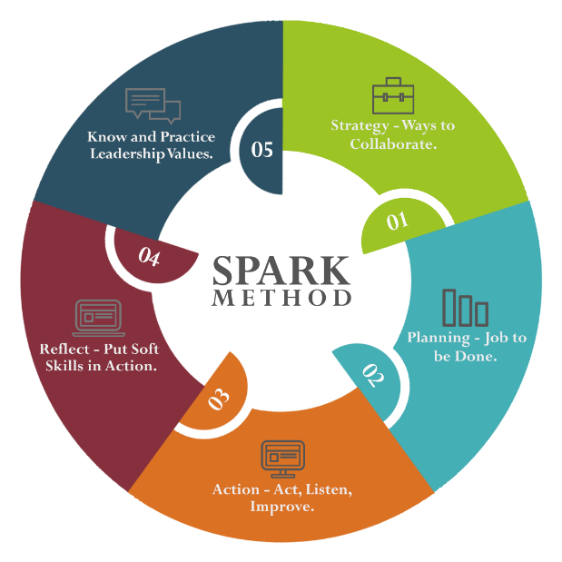

TOUCH Ltd. is an international NGO organization for anti-human trafficking action. Team of people working in TOUCH are from various support professionals (psychologist, social workers, doctors etc.) and, trough several of years working together, they seem to realize root cause of human trafficking in theirs and surrounding countries.

Therefore, they want to fight human trafficking with extensive preventive measures. However, it needs to be done without any impact on their already established projects for resocialization and re-integration of victims.

TOUCH Ltd. personnel realized that majority of victims comes from underprivileged groups, such as children without proper family care, immigrant or other undocumented people.

However, all of them had constant access to news and media reports and therefore core of this new project should be based on bringing more media coverage on possible support channels, and also empowering support groups in handling possible influx of victims.

NGO TOUCH Ltd. have clear idea on project outcomes, however they cannot commit their time and personnel so following deliverables need to be provided by Flawless Project Management (FPM) Company:

- Marketing campaigns creation (affecting popular media sources);
- Design and production of informational leaflets for victims;
- Printing and distribution of manuals for experts providing support on how to correctly approach victims avoiding further traumatization;
- Organization of education courses for professionals providing support 20 most affected cities as places of origin of human trafficking victims.

NGO TOUCH Ltd. is taking full responsibility for:

- Writing of manual for experts with all needed details in 2 months period;
- Hosting education courses for professionals in 20 most affected cities.

In addition:

- For this project TOUCH have third party (a Sponsor) which needs to have overview on all financial plans and has to approve every single cost.
- The Sponsor will also need to review and approve every third party cooperation and assessment might take up to 2 weeks.
- Also, a board of experts will participate on proposal, negotiate solution and to cooperate during the project delivery:
  - TOUCH Ltd. have donation of 60.000 USD for this project, and they cannot exceed this budget;
  - Due to sponsor demands, TOUCH Ltd. must implement needed to complete project in the next 2,5 months.

You work for Flawless Project Management (FPM) Company with the following tasks:

- Lead FPM Project Team and find solution for TOUCH Ltd. organization;
- FPM Company has great project planning experts, but not all of them have experience with Marketing;
- You will need to work with already provided solution (video/audio ads) given by 3rd party team of experts.
- In your FPM Project Team, you will have 3 project Experts but only one person with experience in Marketing.

