Day 2 Workout
EXERCISE | REPS | SETS | REST
A1. Squat Kicks  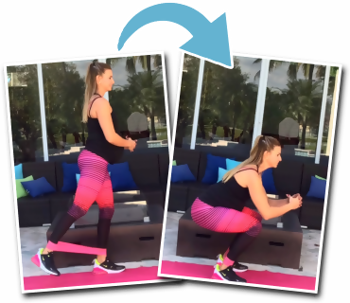 | 20 | 2-3 | 0
A2. Straight Leg Back Kicks  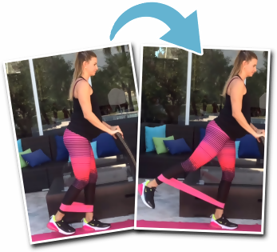 | 20 per side | 2-3 | 0
A3. Lying Hip Extensions with Abductions  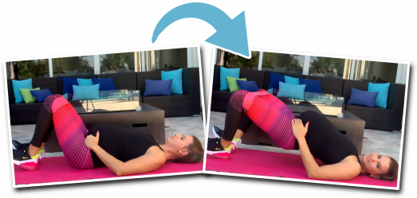 | 20 + 20 Abductions | 2-3 | 0
A4. Side Kicks  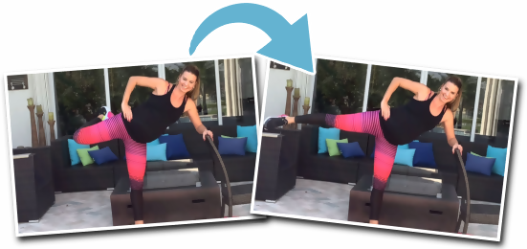 | 20 per side | 2-3 | 0
A5. The CAT  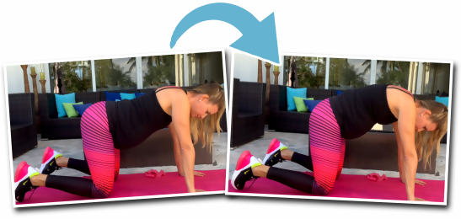 | 10 | 2-3 | 60-90 seconds

