**Resume Skills Assessment**

Using your resume as a reference, reflect on the categories below to get an idea of the work that you’ve done. The goal is for you to see the many ways you’ve contributed to an organization so that you can reflect on the ways you want to leverage those contributions for future career opportunities.

**Projects**

What are the core projects of your current job or past jobs?

What are some other important projects that you’ve done that are not a part of your day-to-day responsibility?

Which projects energize you the most or give you the greatest sense of accomplishment?

**Accomplishments**

Looking back at your past responsibilities and projects what are you most proud of? Why?

**Training**

What training or professional development have you acquired that is directly related to your current role or past roles?

**Skills**

What “hard” skills do you use in your current role or past roles?

What “soft” skill do you use in your current role or past roles?

Of the skills listed which of them energize you or give you a sense of accomplishment?

How would you describe your “area(s) of expertise?”

Of the skills listed are there any other jobs or industries that you can think of that you would be interested in considering?

**Skills Matcher Assessment**

1. Click [here](https://www.careeronestop.org/toolkit/Skills/skills-matcher.aspx) to take the 40-question assessment. The results will populate jobs that fit with your assessment as well as an overview of which skills you ranked the highest and lowest.
2. View the jobs that match with your results. Feel free to send a copy to yourself. You can sort the list of jobs in a number of arrangements.

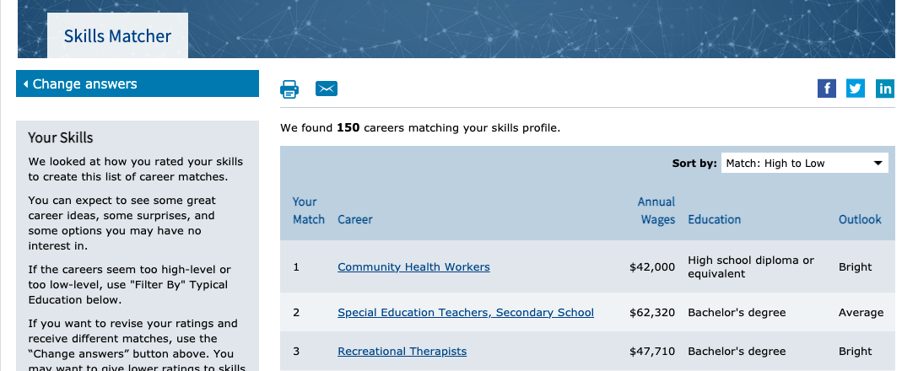

1. Click on the link that says “see your full list of skills.”
2. Download and save a copy of your top-rated skills and your lowest rated skills.

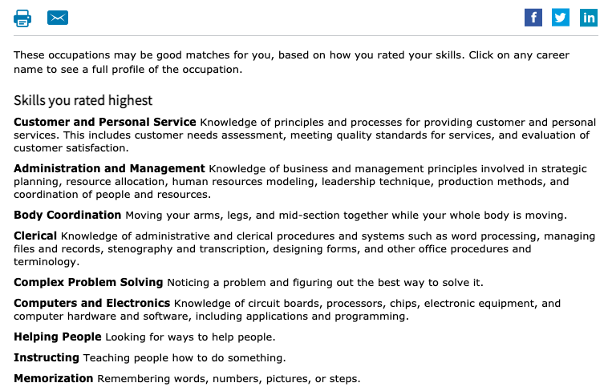

Based on the Skills Matcher Assessment, which skills resonate with you the most? Why?

Looking at the top-rated skills, are there any projects or accomplishments from your current job (or past jobs) that align with them?

Looking at the top-rated skills, what are your top 5 skills that you’d like to use in a future job?

Taking a look at the prescribed list of jobs generated from your assessment, are there any jobs that seem interesting that you’d like to explore?