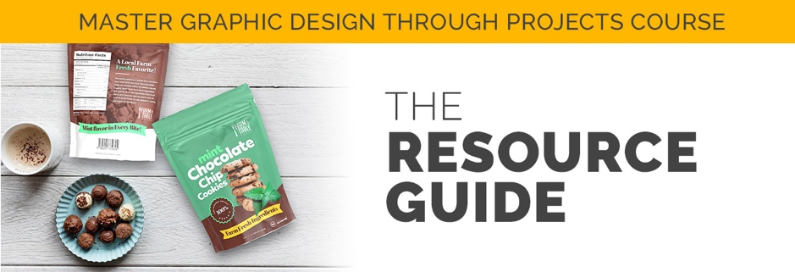

Best sites and external resources! Feel free to contact me with a suggestion, happy to add and expand this list! Make sure you download the other resources you come across as you move through the class. This list is for extra external resources found outside of the course such as links to free photos from pexels.com, unsplash.com and other free photo resources.

PACKAGE DESIGN PROJECT

Grunge Texture for logo
https://blog.spoongraphics.co.uk/freebies/9-free-washed-worn-aged-t-shirt-effect-textures

Fork for Farm logo
https://pixabay.com/vectors/fork-dishes-silverware-eat-149488/

Cookie Photo
https://unsplash.com/photos/04yMqTmUeHQ

Mint Leaves
https://pixabay.com/photos/leaves-herb-cat-nip-mint-plant-3519785/

Nutrition facts
https://www.vecteezy.com/vector-art/153554-nutrition-facts-eggplant-vector
Bar code
https://www.freepik.com/free-vector/barcode-vectors_547515.htm

Cookie Photos (Back)
https://unsplash.com/search/photos/cookie

BOOK DESIGN PROJECT

Roses
https://www.pexels.com/photo/red-roses-1187079/

Great Blog Post About Book Sizes
https://blog.reedsy.com/standard-book-sizes/

A great place to find Photoshop Layer Styles Just unzip the file, open the photoshop file and you can save the layer style in the layer styles panel just like we did in class. http://www.photoshoplayerstyle.com/

Book Cover Mockup I Used
https://graphicburger.com/hardcover-book-mockup-2/

YOUTUBE THUMBNAIL PROJECT

Woman crossing arms
https://www.pexels.com/photo/photography-of-a-beautiful-woman-smiling-1024311/

New York
https://www.pexels.com/photo/statue-of-liberty-2179602/

Paris
https://www.pexels.com/photo/eiffel-tower-2082103/

ALBUM COVER ART
Mockup https://mockuptree.com/free/plastic-cd-case-mockup/

EDITORIAL DESIGNS (InDesign)

Project #1
Pancake https://unsplash.com/photos/eeqbbemH9-c

Eggs
https://unsplash.com/photos/SKT320vO_Wk

Flat lay pancake
https://unsplash.com/photos/zLZR3SoTMIg

Magazine Mockup
https://graphicburger.com/photorealistic-magazine-mock-up/

Magazine COVER
Pancake Photo https://www.pexels.com/photo/appetizing-bread-breakfast-close-up-357573/

Cover mockup
https://graphicburger.com/a5-magazine-mockup/

CONFERENCE BRANDING
ADVANCED SECTION

Poster Mockup
https://graphicgata.com/portfolio/free-flyer-mockup/

Lanyard Mockup
https://www.psdmockups.com/breakaway-trade-show-lanyard-bulldog-clip-psd-mockup/

Postcard Mockup
https://www.freepik.com/free-psd/postcard-mock-up-design_1042460.htm

Vistaprint
https://www.vistaprint.com/signs-posters?xnid=TopNav_Signage+and+Trade+Show+Displays&xnav=TopNav

Banner Mockup
https://mockups-design.com/free-banner-frame-stand-mockup/

DIGITAL ASSETS
Link to social media sizes
https://www.dreamgrow.com/facebook-cheat-sheet-sizes-and-dimensions/

Helpful digital display ad sizes
https://blog.bannersnack.com/banner-standard-sizes/

