Instructions:
- Go to “File” → “Make a Copy”
- Save it in your “Shaping the Teacher Identity 101” folder on your Google Drive.
- NOTE: *If you go to "File" and your only option is to "Download as" that means you're not signed into a Gmail account. You can either:
- Sign into your Gmail account
- Create a Gmail account
- If you don't want to create a Gmail account, then click "Download as..." and reopen the file in MS Word or your preferred program.

Culturally Responsive Lesson Plan Template

Directions:
Use the template below to write out the details of your lesson plan. Feel free to visit the following websites to obtain informational sources (i.e. primary texts, articles, lesson ideas, etc.) for your lesson.
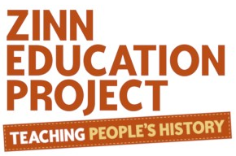
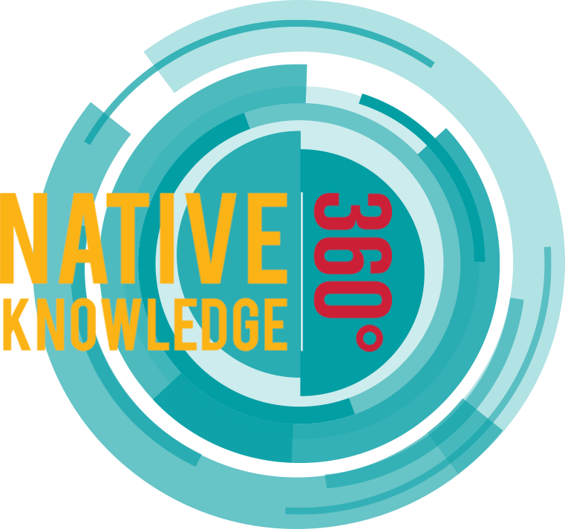
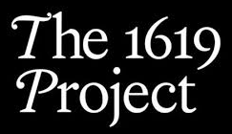

Click here Click here Click here Click here Click here

EXAMPLE

STEP #1 - SELECT THE TOPIC/ISSUE
Select a topic that is reflective of the racial and cultural composition of your class.
Racial Profiling - Can more diverse police forces prevent instances of racial profiling in America?
STEP #2 - IDENTIFY CONTENT-SPECIFIC SKILLS
What specific skills within your content area can you extract from the selected topic or issue?
- Stop & Frisk Statistics (by Zip Code)
- Population Data
- Police Violence Statistics
- Police Officer Data (by Race)
STEP #3 - CONNECT CONTENT-SPECIFIC SKILLS TO STATE STANDARDS
What specific Common Core Standards (or state standards) connect to the skills
you have identified in Step #2?
6.SP.4 - Display numerical data in plots on a number line, including dot plots, histograms, and box plots.

7.RP.3 - Use proportional relationships to solve multistep ratio and percent problems.

7.SP.1 - Understand that statistics can be used to gain information about a population by examining a sample of the population; generalizations about a population from a sample are valid only if the sample is representative of that population. Understand that random sampling tends to produce representative samples and support valid inferences.

7.SP.2 - Use data from a random sample to draw inferences about a population with an unknown characteristic of interest. Generate multiple samples (or simulated samples) of the same size to gauge the variation in estimates or predictions.

7.SP.3 - Informally assess the degree of visual overlap of two numerical data distributions with similar variabilities, measuring the difference between the centers by expressing it as a multiple of a measure of variability.

7.SP.4 - Use measures of center and measures of variability for numerical data from random samples to draw informal comparative inferences about two populations.

8.SP.4 - Understand that patterns of association can also be seen in bivariate categorical data by displaying frequencies and relative frequencies in a two-way table. Construct and interpret a two-way table summarizing data on two categorical variables collected from the same subjects. Use relative frequencies calculated for rows or columns to describe possible association between the two variables.

STEP #4 - SEARCH FOR RELEVANT INFORMATION SOURCES
What credible information sources are available to access the information necessary for this lesson?
“The Race Gap In America’s Police Departments” - New York Times
“Blacks remain focus of Boston Police investigations” - The Boston Globe
“When Boston Created An All-Black Police Unit”
Police take to streets to reject Trump’s “thugs” remark, celebrate community policing
U.S Census Bureau Quickfacts
STEP #5 - DETERMINE THE FINAL WORK PRODUCT
What type of task or summative assessment will students be completing to demonstrate mastery of the lesson?
OPTION #1 - A Letter to the Police Commissioner:
Students will will write a letter to Commissioner of the Boston Police Department, William Gross, presenting your concerns around the issue of racial profiling by law enforcement in Boston. Within your letter, you should include qualitative and quantitative data to support your argument.

OPTION #2 - Final Summary Paper:
Students will write a summary paper that details your statistical research on the issue of racial profiling and how it connects to the relationship between law enforcement and communities of color.

OPTION #3 - Socratic Seminar:
Students will engage in a Socratic Seminar where they discuss the following question: Can more diverse police forces prevent instances of racial profiling in America?

NOW IT’S YOUR TURN!!

STEP #1 - SELECT THE TOPIC/ISSUE
Select a topic that is reflective of the racial and cultural composition of your class.
STEP #2 - IDENTIFY CONTENT-SPECIFIC SKILLS
What specific skills within your content area can you extract from the selected topic or issue?
STEP #3 - CONNECT CONTENT-SPECIFIC SKILLS TO STATE STANDARDS
What specific Common Core Standards (or state standards) connect to the skills
you have identified in Step #2?
STEP #4 - SEARCH FOR RELEVANT INFORMATION SOURCES
What credible information sources are available to access the information necessary for this lesson?
STEP #5 - DETERMINE THE FINAL WORK PRODUCT
What type of task or summative assessment will students be completing to demonstrate
mastery of the lesson?

