Creating a Meditation Space

The most important aspects of a meditation space are the energy and your comfort. Your space should be where you leave behind the craziness of the world to heal and restore mind, body and soul. You should be able to settle and relax in this space.

Having a place where you can go to connect with yourself, explore, and heal is as important as any other space in your home. Look for a space that seems naturally quiet, soothing, restful and healing. It can be a corner, a closet, a wall space or somewhere outdoors - just follow your intuition.

For some people, this may mean creating a space with meaningful items on it, while for others it might just be a quiet space in your home with a meditation pillow or a peaceful spot outside in the garden. Over time, when you return to the same place to do whatever healing work calls to you, there’s an energy that builds up. Whenever you enter this space, your mind feels soothed because it subconsciously recognizes it as your peaceful space. Whatever photos, crystals, books or objects you place in this space will hold that energy for you. Make this space simple, clutter free and pleasing to your senses. When designing your space consider this question - What helps you feel calm, comforted, and at peace?

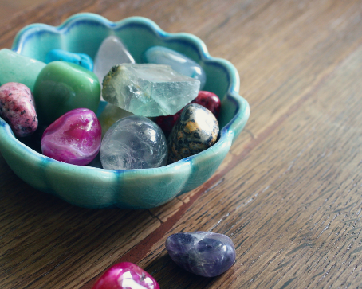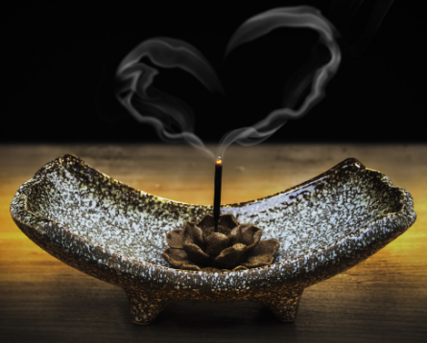

For your comfort, add pillows, cushions, chairs, heating pads or soft blankets to make the space physically supportive and soft. Being comfortable will make your meditation practice more sustainable and you will want to spend more time meditating.

Before you begin a session, perform a quick mental or physical cleansing ritual to clear and refresh the energy of the room. There are many energy-cleansing techniques you can use - burning white sage or Palo Santo wood, using a bell or a singing bowl to break up the stagnant energy, or setting an intention for this space to support you. Light a candle bringing soft light, positive energy, and focusing your intent.

Include uplifting and supportive books or journals with your favorite pens/pencils/markers. Feel comfortable writing out what comes to you during or after meditation or even drawing it out. You may feel you need to express what you are thinking or feeling to release it completely or simply write an inspiring idea down! This is YOUR space. Make it your own with whatever helps you feel safe, comfortable, peaceful, and inspired.

