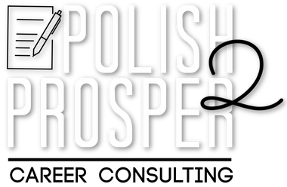
Job Search Strategy

Nurse

Utilization Review Nurse Consultant
A. Job Titles

Advancement Growth Training
B. Career Happiness

Healthcare Retirement Recognition

Base salary Payment process Incentives
D. Compensation
C. Benefits

Organization’s support Work environment
E. Company Culture
Team - building activities
polish2prosper.com

Indeed LinkedIn
A. Platforms
Nursing Job Board

Medical Necessity Advocacy Utilization Review
C. Potential Companies
B. Your Top Qualifications

Job Search Strategy
D. How am I being found?

Navihealth Local Hospital Kaiser

Making company connections LinkedIn
Networking

Tailored Resume Customized Cover Letter Optimized LinkedIn Profile
E. Tools I need to succeed
Continuing Ed/Courses

polish2prosper.com

