Yogic Anatomy & Physiology
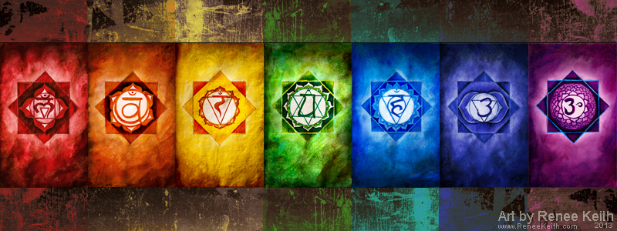
- Panch Mahabhut Tattva (Five Elements)
- Nadi’s (Astral Tubes)
- Prana & Pancha Prana
- Pancha Kosha
- Chakras
- Bandha

Panch Mahabhut Tatva (Five Elements)
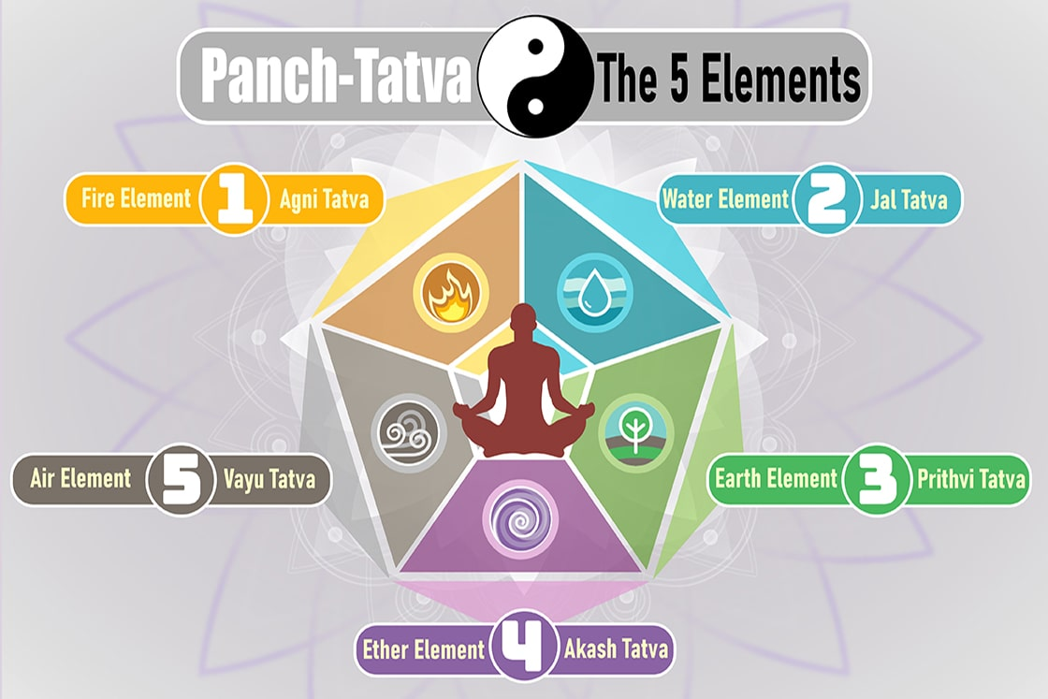
- The world around us, even our body is made up of all these five cardinal elements. From everything we eat to every substance that we excrete, these cardinal elements are the key component for every matter.
- The qualities of these elements are, in respective order sound which is the quality of space, touch which is the quality of air, form which is the quality of fire, taste which is the quality of water, and smell which is the quality of the earth. These are the qualities of the five elements.
- Only one quality can be seen in space. Space can reverberate sound, but we cannot touch it, taste it, smell it, etc. Space can only cause an atmosphere for creating a vibration of sound, and as nothing else is possible there, sound alone is the quality of space.
- Air has two qualities. Air can make sound, and also it can be felt. It can be touched. Sound is the quality of space; sound and touch are the qualities of air.
- Fire has three qualities. Fire has sound, touch, and form, so we can see it but we cannot taste fire, taste air & taste space.
- Water has four qualities, we can hear its sound, we can touch it, we can see it, and we can taste it.
- Earth has five qualities. It can create sound, it can be touched, it can be seen, it can be tasted, and it can be smelled. Smelling is the quality only of earth.
- Earth has five qualities, Water has four, Fire has three, Air has two, Space has only one quality.
- Space does not make sound by itself. It causes refraction and reverberation of sound—an echo. The echo is the sound that is produced by space.
- What kind of sound is made by air? It goes whoosh. The word ‘bees’ is used here. What is the touch of air? It is neither hot nor cold. Air has no quality of this kind; it is hot when it is charged with heat, and it is cold when it is charged with cold.
- Fire can also make sound. When its flames forth, it makes a sound like bhugu-bhugu. What is the quality of fire? It is heated. The touch of fire heats, and its form is radiance.
- What is the sound that water makes? Bulu-bulu. Its quality is cold when we touch it, and also its quality is white. White is the color of water, and its taste is very sweet. That is why we drink water.
- What is the sound that earth makes? Kada-kada is the sound that is made if something breaks if something falls. This is the earth's sound. Hardness is its touch, and its color is green, blue, yellow, etc. Varieties are the colors of objects made of earth. Earth's taste, such as sweetness, bitterness, and so on, are all qualities of objects, things made of earthly substance. It has also got a smell—a good smell, a bad smell, a fragrance, or a bad odor. These are the five qualities of the earth.
- This group of five elements can be perceived only through the sense organs, which are correspondingly connected with these elements, and the sense organs connected with these elements. Sound can be heard by the ear, touch can be felt by the skin, the form can be seen by the eyes, the taste can be felt by the tongue, and fragrance or smell can be received by the nose, through the nostrils. These are the five sense organs.

Reference: Swami Krishnananda

i. Akash
- Talking about the Akash (ether/ sky), it is related to the sense of hearing,
- T he jnanendriya is ear.
- The karmendirya is vocals or mouth.

ii. Vayu
- It has a role in existence as motion and is related to the sense of touch.
- The jnanendriya being skin.
- The karmendriya being hands, Vayu of outer world is experienced.

iii. Agni
- It is the element of high energy in existence
- It is related to the sense of sight or Rupa with jnanendriya being eyes.
- The karmendriya being feet.

iv. Jal
- This element exists in the universe as a force of attraction.
- The taste of sensation being it’s a key factor
- The jnanendriya being tongue (rasa).
- The karmendriya being genitals.

v. Prithvi
- The solid matter that we feel is the Prithvi itself.
- The sensation of smell is the core of this matter a the jnanendriya is the nose.
- The karmendriya is the anus.
Reference: yogamoha.com

Nadi’s (Astral Tubes)
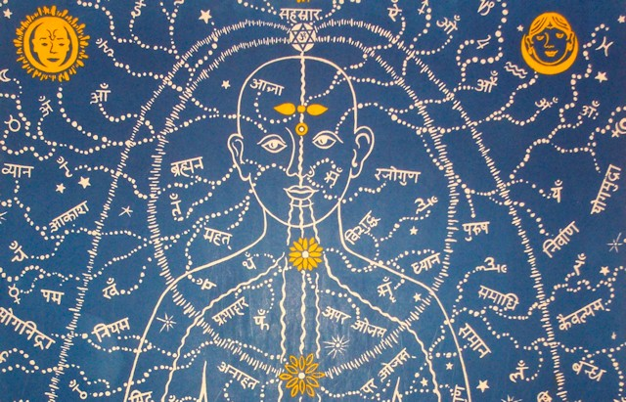

- Nadis are pathways of pranic, mental, and spiritual currents, which form a matrix throughout the physical body.
- They provide energy to every cell, organ, and part through their vast network, carrying prana back and forth in every direction.
- Nadis are not physical, measurable, or dissectible structures within the body, but channels of energy that underlie and sustain life and consciousness.
- In higher states of consciousness, the nadis can actually be seen as flows of energy, as described by the yogis.
- They can be perceived at the psychic level as distinct channels of light, color and sound. At the same time, the nadis underlie and are mirrored in all bodily functions and processes.
- Scientific research has been carried out to verify the existence of the nadis.
- Dr. Hiroshi Motoyama pioneered this research and found stable voltages of electromagnetic currents flowing within proximity to the nervous system, which he cited as evidence for the existence of nadis.
- The network of nadis is so subtle and vast that even the yogic texts differ in the calculation of their exact number. References in the Goraksha Samhita and Hatha Yoga Pradipika place the number at 72,000; the Prapanchasara Tantra gives the number of 300,000; while the Shiva Samhita states that 350,000 nadis emerge from the navel center.

Three main Nadis are Ida, Pingala &Sushumna
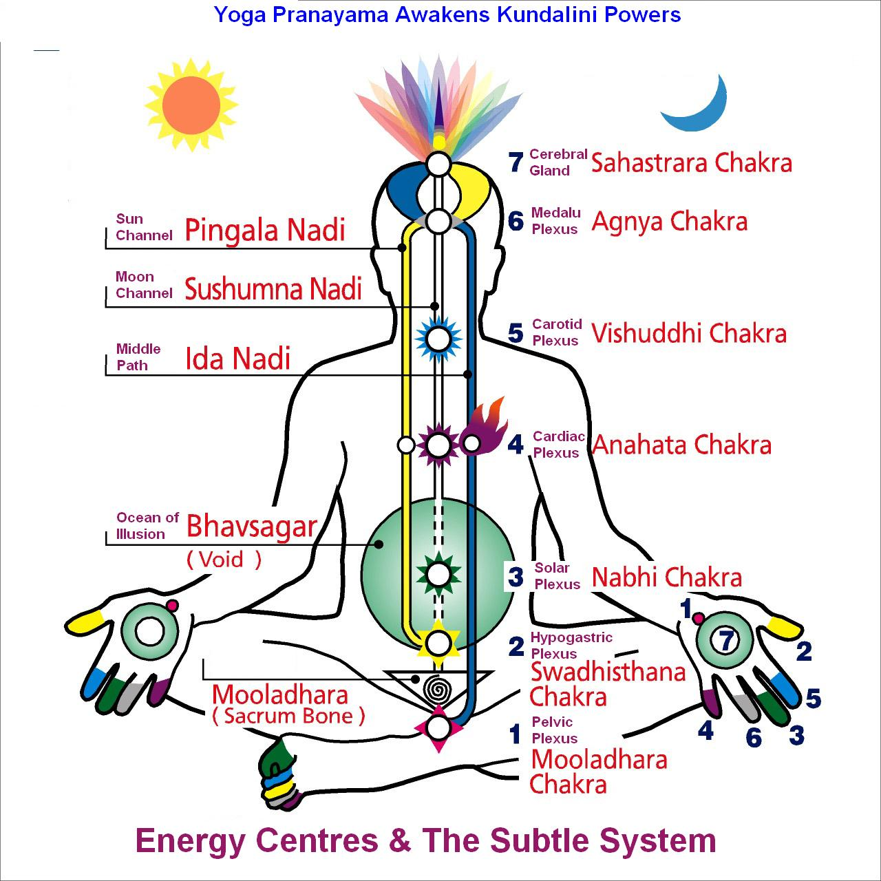

- These three major nadis are situated in the spinal column and pass through every chakra.
- Ida nadi is the mental channel, pingala nadi the vital channel, and sushumna nadi the spiritual channel.
- Ida, pingala and sushumna are the three main channels for the distribution of energy throughout the entire pranic network.
- Maximum pranic charges flow through them and they impact the entire network instantly; they are the high voltage wires that conduct the energy from the substations or chakras situated along the spinal column to all the other nadis.

Reference: Swami Niranjanananda Saraswati

- Ida is the left channel. Ida is white, feminine, cold, represents the moon, and is associated with the river Ganga (Ganges). Originating in Muladhara, Ida ends up in the left nostril.
- Pingala is the right channel. Pingala is red, masculine, hot, represents the sun, and is associated with the river Yamuna. Originating in Muladhara, Pingala ends up in the right nostril.
- Sushumna is the central channel and is associated with the river Saraswati. Within the Sushumna nadi there are three more subtle channels: Vajra, Chitrini and Brahma nadi through which Kundalini moves upwards running up the body from just below Muladhara chakra to Sahasrara chakra at the crown of the head.

Reference: Ancient Teaching of Tantra and Kundalini Yoga

Prana & Pancha Prana

Prana
- What makes any motion possible: the blink of an eye, the budding of a flower, the splitting of atoms, or the fall of a meteor? Thousands of years ago, the yogis living in the shadow of the Himalayas fathomed the inherent quality of motion in the creation and they called it prana.
- Prana is Life Force or Vital Energy. Prana is also the power that flows in all living forms and performs vital functions.
- Paramhansa Yogananda called this aspect of prana “life-force.”
- Often the word prana is translated as breath. However, prana is not the oxygen or the air that one breathes. Yogis have proved that one can stop breathing for long periods of time and yet continue to live.
- An experiment was conducted at the Menninger Foundation, USA, on Swami Nadabrahm- Ananda Saraswati, an initiated disciple of Swami Sivananda Saraswati of Rishikesh. Swami Nadabrahmananda had perfected Nada Brahma, attunement with the primordial sound vibration, and the experiment intended to verify his claim that lie could remain comfortably without breathing for extended periods. He was placed in an airtight glass chamber. A lighted candle and a live monkey were placed in similar chambers. Electrodes were connected to his heart, brain, and different parts of the body, and he was asked to play the tabla while instruments monitored his parameters. His nose and ears were blocked and his whole body was smeared with wax so that air would not pass through the pores. After three minutes the candle went out, and after fifteen minutes the monkey fell unconscious, but Swami Nada-brahmananda continued to play the tabla for more than forty minutes. During this period he was not breathing and when a coin was placed on top of his shaved head, it bobbed up and down. When a microphone was placed against any part of his body, a loud, constant sound like that of a waterfall was heard. He explained that this sound was the movement of prana, adding that one continues to live as long as the pranas are active, even if one stops breathing.
Reference: Swami Niranjanananda Saraswati

Pancha Prana
- Pancha Prana Vayu or the five energy flows enables the body and its organs to function. Essentially, the Pancha Prana Vayus are responsible for the entire physiology of the human system.
- We generate our physical energy from food. The food is converted to glucose which is broken down in the cells to produce energy. The five Prana Vayus are involved in assimilation, distribution, and managing this energy to make the body function.
- These five Pranas are called Prana, Apana, Vyana, Udana, and Samana.
- These five pranas or Pancha Prana Vayu are closely interlinked with our physical energy. But the actual source of these Pancha Prana is difficult to explain.
- The source of the Pancha Prana is Maha Prana. This Maha Prana is the cosmic energy and is manifest in each of us as the Kundalini Shakti.

The Panch Prana Vayu are

Prana
- This is the first and the main of the five pranas and functions between the throat and the diaphragm.
- All organs of the thorax including the heart and lungs are maintained by Prana.
- The basic function of respiration and pumping of the heart is controlled by Prana.
- Prana can be thought of as moving upwards.

Apana
- Apana is the second of the five Pranas and is primarily responsible for elimination.
- It controls organs situated between the navel and the perineum including, the small and large intestine, kidneys, urinary system, and reproductive systems.
- Elimination of waste as feces, gas, and urine is done by Apana Vayu.
- Also, the ejaculation of sperm, Monthly menstrual cycle for women, and expulsion of the fetus during childbirth are done by Apana Vayu.
- Apana Vayu flows downwards and stimulates the downward movement of the wastes.
- Disturbances in Apana Vayu can cause constipation, diarrhea, piles, etc.

Samana
- Samana Vayu operates between the navel and the diaphragm.
- It controls the function of organs like the stomach, liver, pancreas, spleen, small and large intestine.
- Samana Vayu travels sideways.
- Samana Vayu is the Prana that is responsible for digestion and assimilation of nutrients into the body.
- Disturbance of the Samana Vayu can cause indigestion and other stomach disorders.

Udana
- Udana Vayu functions above the throat, face, and head region.
- It is responsible for all the sensory organs and functioning of the brain.
- Apart from that, it controls the organs of movement including hands and legs.

Vyana
- Vyana Vayu pervades the entire body.
- It is Vyana Vayu that carries the nutrients needed to every cell of the body.
- The nutrients are carried via blood flow and the circulatory system to reach all the organs.
- Whenever there is a shortage of energy in any part of the body, Vyana Vayu immediately sends the required nutrients to the cells to produce the energy.
- It is like a dynamic reserve store of energy, available to the whole body.
- It also helps in muscular movements and carrying the sensory and motor impulses from different parts of the body.
- It also causes perspiration from the skin.

Pancha Prana Reference: Yogicwayoflife.com

Panch Kosha
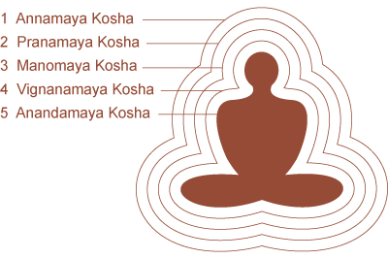
- The theory of Pancha koshas has been propounded by Adi Shankracharya taking a cue from the Taittiriya Upanishad.
- Taittiriya Upanishad speaks about five different manifestations of the ultimate reality or Brahman. These manifestations are Annamaya brahma, Pranamaya brahma, Manomaya brahma, Vijnanamaya brahma, and Anandamaya brahma.
- It never speaks about Koshas.
- Adi Shankracharya converted all these to Koshas to suit his philosophy. Thus, Annamaya brahma has been mapped as Annamaya kosha and so on.
- The theory of Pancha koshas asserts that the relative world, comprising microcosom and macrocosom, is made up of five sheaths that cover the Real Self (atman or purusa or soul).

Annamaya kosha or kosha made of food or the food body: This is the outermost sheath, the most superficial sheath, and is represented by our physical body made up of the five elements and constituted by the food that we eat. Kriyas, asanas, and pranayama help in strengthening this sheath.

Pranamaya kosha or the energy body: This is the pranic sheath which energizes or invigorates all other sheaths. It is responsible for all physiological and mental functions. It is mapped onto the physical body and extends slightly beyond the physical body. This extension is called the aura. The pranamaya kosha is in between the annamaya kosha (body) and manomaya kosha (mind). Thus, prana or our breath is the bridge between the body and the mind. Pranayama practices strengthen the pranamaya kosha.

Manomaya kosha or the mental body: This is the sheath of our thinking, feelings, and emotions. It is comprised of manas, ahamkar and the lower Buddhi. Pranayama and Pratyahar practices cater to this kosha

Vijnanamaya kosha or the wisdom/higher intellect body: This is the region where refined/higher-level thinking and intuition starts happening. Meditation practices cater to this sheath.

Anandamaya kosha or the bliss body: This sheath is closest to our Real Self. Spirituality reigns here. Transcending the body, mind, and intellect leads to bliss. Meditation strengthens this sheath.

Reference: Certification of Yoga Professionals official Guidebook
by the Ministry of Ayush, Government of India.

Chakras

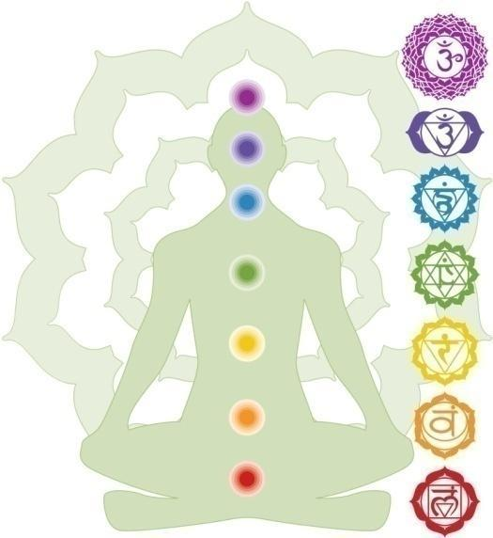

- ‘Chakra’ means ‘wheel’ or ‘circle’.
- In the yogic context it refers to a ‘vortex’ or a minor ‘whirlpool’.
- Chakras are pranic energy centers at specific areas in the body from where prana is supplied to all the parts of the entire human structure.
- It is to make a mention of the Shad Chakras when dealing with the Pranayamaya Kosha.
- The chakras represent the storehouses of prana within the pranic body of man. Because prana is a vibration, a force in constant motion, each chakra is associated with specific frequency levels and subtlety of prana.
- Also, in Kundalini Yoga or the Chakra system, Chakras represent specific levels of awareness – the higher the chakra, the higher the level of awareness. Thus, when prana is operated at a particular chakra level, it will induce a particular level of awareness. Also, a particular state of awareness means that prana is operating at the corresponding level of chakra. Thus, each chakra has two defining characteristics, i.e., prana and consciousness/awareness.
- Despite there being innumerable chakras only a few of them are utilized in yogic practices.
- The main chakras are Mooladhara, Swadishtana, Manipura, Anahata, Vishuddhi, Ajna and Sahasrara.
- Factually speaking Sahasrara is not really a chakra. It transcends all the chakras. Sometimes an eighth chakra called Manas Chakra or Bindu Chakra or Lalana Chakra is also referred.

Chakra Locations
- The chakras belonging to the pranic body of man cannot be identified with the physical organs in the body. However, each chakra can be assigned a definite location within the framework of the body.
- Most of the chakras lie within the spine; mooladhara is outside the bottom of the spine and ajna is at the top of the spine; Sahasrara is in the center of the crown of the head.

- Muladhara Chakra  (Root Chakra) | Represents our foundation and feeling of being grounded.  Color: Red  Location: Base of spine in tailbone area.  Emotional issues: Survival issues such as financial independence, money, and food.
- Swadhistana Chakra  (Sacral Chakra) | Represents our connection and ability to accept others and new experiences  Color: Orange  Location: Lower abdomen, about 2 inches below the navel and 2 inches in.  Emotional issues: Sense of abundance, well-being, pleasure, sexuality.
- Manipura Chakra  (Solar Plexus Chakra)  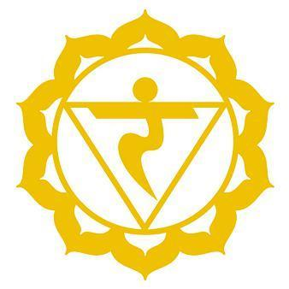 | Represents our ability to be confident and in-control of our lives.  Color: Yellow  Location: Upper abdomen in the stomach area.  Emotional issues: Self-worth, self-confidence, self-esteem.
- Anahata Chakra  (Heart Chakra)  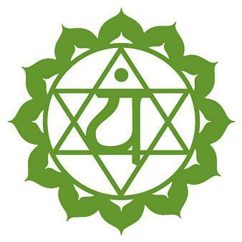 | Represents our ability to love.  Color: Green  Location: Center of chest just above the heart.  Emotional issues: Love, joy, inner peace.
- Vishudha Chakra  (Throat Chakra)  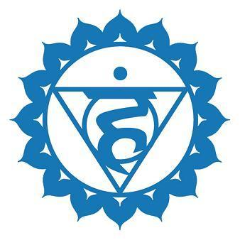 | Represents our ability to communicate.  Color: Blue  Location: Throat.  Emotional issues: Communication, self-expression of feelings, the truth.
- Ajna Chakra  (Third Eye Chakra)  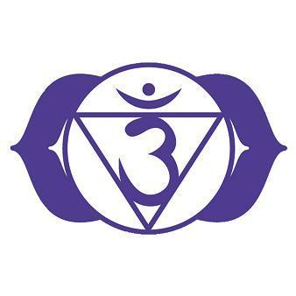 | Represents our ability to focus on and see the big picture.  Color: Indigo  Location: Forehead between the eyes.  (Also called the Brow Chakra)  Emotional issues: Intuition, imagination, wisdom, ability to think, and make decisions.
- Sahasrara Chakra  (Crown Chakra)  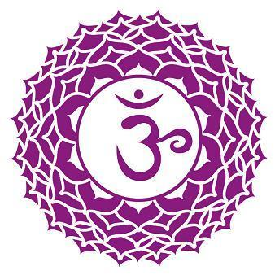 | The highest Chakra represents our ability to be fully connected spiritually.  Color: Violet  Location: The very top of the head.  Emotional issues: Inner and outer beauty, our connection to spirituality, pure bliss.

Reference: Certification of Yoga Professionals official Guidebook
by the Ministry of Ayush, Government of India.

Bandhas
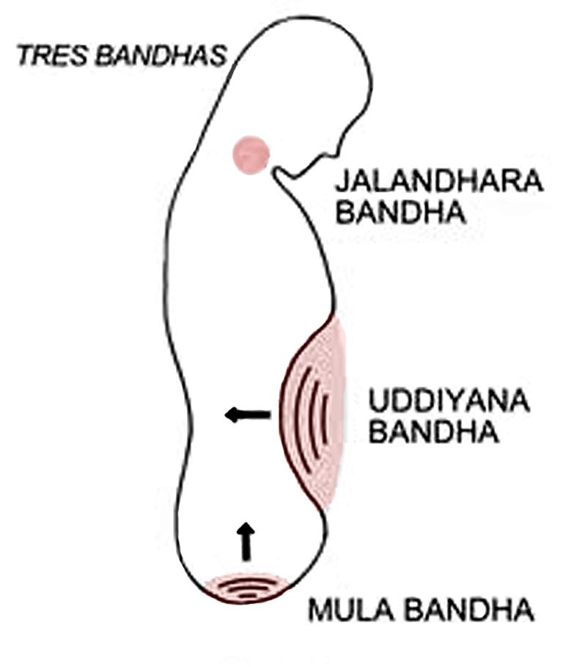
Bandha' literally means a lock, to tighten, to close-off and block.
Bandhas are psycho-muscular locks that re-direct the flow of energy in the body and are an integral part of many Asana & Pranayama practices.
In the practice of a Bandha, the energy flow to a particular area of the body is blocked. When the Bhanda is released, this causes the energy to flood more strongly through the body with increased pressure.
You know those little combinations locks you get when traveling, to keep the contents of your luggage safe and secure? Well, your body has similar locks, called bandhas. ‘
There are four main bandhas in the body
- Mula Bandha – the root lock
- Jalandhara Bandha – the throat lock
- Uddiyana Bandha – lifting of the diaphragm lock
- Maha Bandha – all three locks at the same time
Generally, the breath is held during the practice of the Bandhas. Mula Bandha and Jalandhara Bandha can be performed after the inhalation as well as after the exhalation. Uddiyana Bandha and Maha Bandha are only performed after the exhalation.

Benefits
- As the Bandhas momentarily stop the flow of blood, there is an increased flow of fresh blood with the release of the Bandha, which flushes away old, dead cells.
- In this way, all the organs are strengthened, renewed, and rejuvenated and circulation is improved.
- Bandhas are also beneficial for the brain centers, the Nadis, and the Chakras.
- The energy channels are purified, blockages released and the exchange of energy is improved.
- Bandhas alleviate stress and mental restlessness and bring about inner harmony and balance.

Caution
- Before attempting to perform the Bandhas, the breathing techniques of the previous levels must have been practiced regularly for a long period of time.
- Before proceeding with the breath exercise in this and the following levels, first, read and study the explanation given for the relevant Bandhas and Mudras as they are incorporated into the breathing techniques.

Jalandhara Bandha(Chin Lock)

Practice
- Inhale deeply and hold the breath. Place the hands on the knees, lift the shoulders and tilt the body forward slightly, keeping the back straight.
- Press the chin firmly against the chest or between the collarbones so that the windpipe and esophagus are firmly closed.
- Concentrate on the Vishuddhi Chakra and hold the breath for as long as comfortable.
- Raise the head and with a long exhalation return to the starting position.
- Breathing normally remain in this position for some time.

Benefits
- This exercise awakens the inner energy centers, especially the Vishuddhi Chakra
- Improves the ability to retain the breath for a long period of time and develops the ability to concentrate. Beneficial for throat diseases and regulates thyroid function.

Caution
- Consult a Doctor before practicing if there is an existing thyroid problem.
- The breath should only be held for as long as easily possible.

Uddiyana Bandha(Lifting the Diaphragm)

Practice
- Completely exhale and hold the breath out. Place the hands on the knees, raise the shoulders and tilt the body forward slightly, keeping the back straight. (To practice this Bandha standing, separate the legs a little and bend the knees slightly.)
- Concentrate on the Manipura Chakra, pull the abdominal muscles in and up into the abdominal cavity as far as possible.
- Hold the position as long as comfortable.
- Release the muscular tension and return to the starting position with a deep inhalation. Breathing normally remain for some time in this position.

Benefits
- Activates the Manipura Chakra and solar plexus.
- Stimulates intestinal activity and helps relieve constipation.
- Stimulates the pancreas and is helpful for diabetes.
- Strengthens the immune system.
- Balances the mind, soothes irritability and anger, and dispels a depressive mood.

Caution
- Perform only on an empty stomach! Do not practice this Bandha with high blood pressure.

Mula Bandha(Anal Lock)

Practice
- Inhale deeply and hold the breath. Place the hands on the knees, raise the shoulders and tilt the upper body slightly forward. Concentrate on the Muladhara Chakra and firmly contract the anal muscles.
- Hold the muscular contraction and the breath as long as possible and comfortable.
- With a long exhalation return to the starting position.
- Breathing normally remain in this position for some time.

Benefits
- Strengthens the pelvic floor, relieves hemorrhoids and congestion in the pelvic area.
- Calms the autonomic nervous system, calms and relaxes the mind.
- On the spiritual level, Mula Bandha activates and purifies the Muladhara Chakra.
- It awakens dormant consciousness and the Kundalini Shakti.

Caution
- A longer and more intensive practice of Mula Bandha should only be undertaken with the guidance of an experienced “Yoga in Daily Life” instructor.

Maha Bandha(The Great Bandha)

Practice
- Inhale deeply and exhale fully through the mouth.
- Hold the breath out.
- Place the hands on the knees, raise the shoulders and tilt the upper body forward slightly, keeping the back straight.
- Perform Jalandhara Bandha and concentrate on the Vishuddhi Chakra.
- Perform Uddiyana Bandha and concentrate on the Manipura Chakra.
- Finally, come into Mula Bandha and concentrate on the Muladhara Chakra.
- Remain in this position, with all three Bandhas maintained, for as long as the breath can easily be held.
- Release the Bandhas in the same sequence as they were applied.
- Inhale deeply and return to the starting position. Breathing normally remain for some time in this position.

Benefits
- Beneficial for the health of the whole body, especially the autonomic nervous system, internal organs, muscles, and nerves.
- Has a positive influence upon the mind.

Caution
- The precautions given for each of the individual Bandhas are also valid for Maha Bandha.

Reference: blissofindia.com

