Day 5 & Exercise 5:   
All You Need…



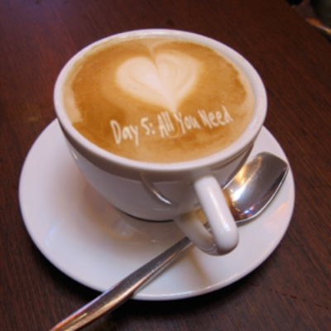I read an incredibly prophetic article in the New York Times a few years ago that had a big impact on me. It stated that many wealthy people that live in first world countries are very unhappy compared to those that have nothing. I felt the meaning of that article when one of my clients sent me to Mumbai to give a few business education presentations.

We drove through the slums and I had this sense of peace and calmness in my heart as I saw how happy they all were. Yet they had nothing. Imagine no possessions. It’s not that easy if you try. I wonder if you can. Of course I am quoting John Lennon.

I used to work on Wall Street and everybody was so miserable around bonus season because they compared themselves to those that made more. How crazy is that (and I am guilty of that too to be intellectually honest). This is the cancer of Western Society. We always want more. How much can we eat?

I read the Dalai Lama’s book called the Art of Happiness and he suggests that we compare ourselves to those that have less. He had this incredibly prophetic quote, which is: “Many sacrifice their health their entire lives in order to make money. Then at the end of their lives they sacrifice all of their money in order to maintain their heath. Then they look back on their lives and they realize that they never really lived.” All your wealth can’t buy you health.

I saw a quote recently that by the time your child is 12, you have already spent 90% of the time that you will ever spend with him or her. You’ll never be able to get that time back no matter how much money you have.

**3 Quotes About Material Possessions:**

*“There are two ways to be rich: One is by acquiring much, and the other is by desiring little.”*  
– Jackie French Koller

*“The only time you look in your neighbor's bowl is to make sure that they have enough. You don't look in your neighbor's bowl to see if you have as much as them.”*

― Louis C.K.

*“My riches consist, not in the extent of my possessions, but in the fewness of my wants.”*

– Joseph Brotherton

*“Sadly, when a person's possessions distract him from his or her purpose, he or she usually ends up losing both.”*― Orrin Woodward

**Today’s Exercise: Please don’t think about wanting anything except what you already have.**

What are [at least] 3 MAJOR material things you won’t focus on wanting to have today (and for the foreseeable future)?

1: _______________________________________________

2: _______________________________________________

3: _______________________________________________