

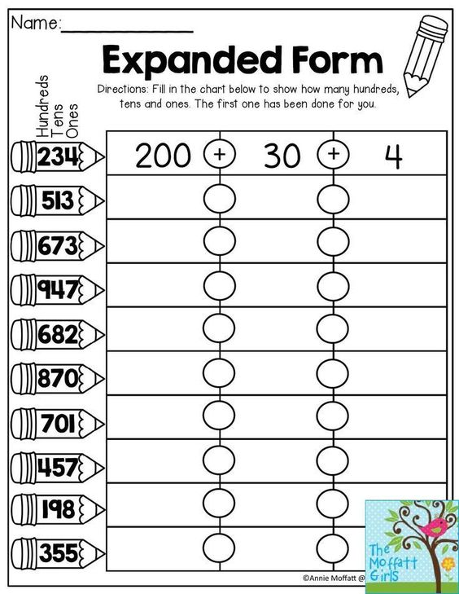



**Name: Date:**

**Teacher:**

|  |  |  |
| --- | --- | --- |
| **Number** | **Number Names** | **Expanded form** |
| 1.209 |  |  |
| 2.918 |  |  |
| 3.1,234 |  |  |
| 4.409 |  |  |
| 5.2,345 |  |  |
| 6.515 |  |  |
| 7.980 |  |  |
| 8.3,123 |  |  |
| 9.5,467 |  |  |
| 10.1,346 |  |  |



**Name: Date:**

**Teacher:**

