Connecting WinSCP to HDP Sandbox

Launch WinSCP
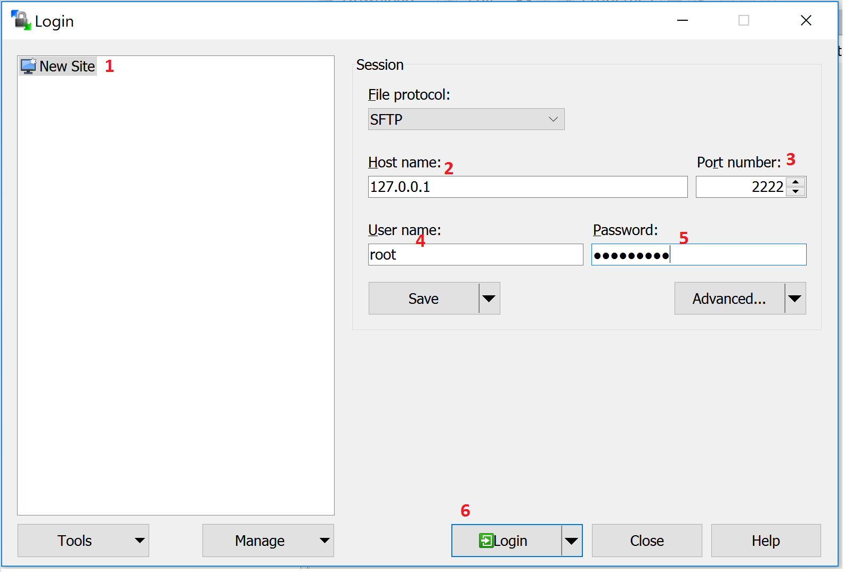
Successful Login
