What Does a YouTube Ads Sales Funnel Look Like?

ATTENTION > INTEREST > TRUST > PITCH

- Get your target audience's attention by getting in front of them with YouTube Ads
- Get them interested by offering something free, tangible, and of real value
- Build trust by delivering real value and genuinely trying to help others
- Finally, pitch your product or service once they know, like and trust you

Product / Service
What are you selling / promoting?
Ex: 3x5" index card holder

Customer
Describe who your typical customer is.
- Who is my target market?
- Are there multiple target markets?
- What is the mindset of my customer?
- What do I know about them?
- What fears or frustrations do they generally have?
- What motivates them to seek out solutions?
- What is their real pain-points?
- What do they care about most?

Benefits
Describe the benefits customers' get from you.
- What are the benefits you provide?
- What problems do you solve?
- What deeper issues are they really trying to solve?
- What would they feel like if they could solve them?
- What specifically do they get from you that they can't get anywhere else?
- What unique features make you better than the competition?
- What results can customers expect?
- What makes you unique, different or better?
- Why should someone buy from you?
- At the end of the day, what will someone walk away with after choosing you?
- If you were a customer, what would make you choose you in a crowded marketplace?

Objections
Marketing is about knowing the common objections or false preconceived notions and addressing them up-front!
- What major objections will people have?
- How will I handle these objections? What are my actual answers?
- If I'm honest with myself, are these objections valid and what could I change?
- What testimonials, proof or credibility do I have?
- If price is the objection, why is my pricing higher than somewhere else?
- What myths do people typically have that I could educate them about?
Offer
Think about what customers' want, create an offer around the thing to help them, and tell people where get it (landing page, website, etc.). They give you their email for your offer.
Define your offer or brainstorm potential offers below.
- What is my offer?
- What can I give away that my target market would actually want?
- How does this offer compare to others in my industry / niche?
- How could my offer be better?
- What free things could I do additionally to add more value?
- What information would help somebody researching?
- What are most customers interested in?

Below are a few great slides from Phil Ebiner's course about building a sales funnel. Sign up for his free course! I have nothing to gain by telling you this; I just learned a lot from him. A "lead magnet" is another way of saying "Offer".
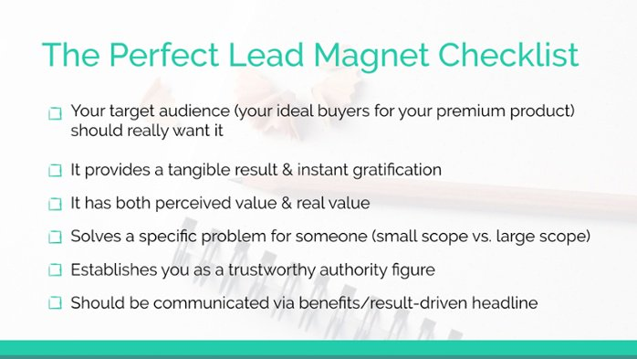
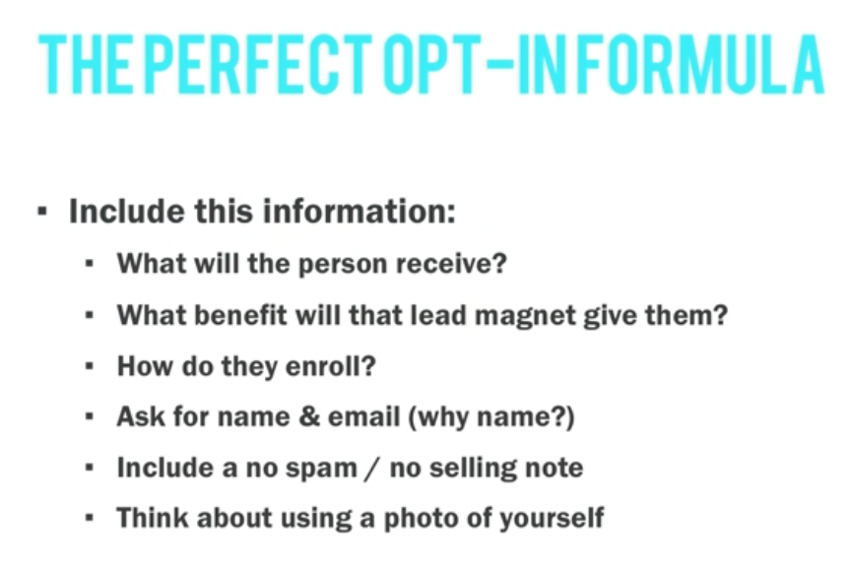
Email
Create a sales funnel email sequence. Below is an example. Write these as-if they were personal emails to friends (if possible). Really try to get into the mind of your customer and understand them and where they're at.
DAY 1: Welcome email, give offer, hint at what's to come
DAY 2: Provide value, build trust, authority, credibility
DAY 3: Provide value, build trust, authority, credibility
DAY 4: Provide value, build trust, authority, credibility (soft mention)
DAY 5: Hard sell
DAY 6: Address objections, answer questions
DAY 10: Follow-up (optional)
DAY 30: Follow-up (optional)

YouTube Ad(s)
With your offer and funnel in-place, create YouTube Ads telling your target market about your offer.
- Target the right audience in Google Ads
- Choose the right video ad format
- Really sell the value of your offer knowing what your customer's common concerns and objections are. Spark curiosity and interest!
- Direct viewers what to do next and how to get your offer

This is the general process that you should follow if you want to be successful with YouTube Ads.

Direct-response marketing with YouTube advertising will get you poor results. The reason is, you need more time to earn trust with people on YouTube if they don't know who you are or what you offer.

If you work at an agency and only manage paid advertising, implementing something like this can be hard because it requires going outside the scope of paid search job duties (requires setting up email marketing).

I would recommend sharing this document with your team to see if it's a game-plan your team-members can get behind in-efforts to generate more sales, leads or subscribers for your clients.

