* **Course Title** CI-Reboot 2024
* Course Number:
* **Course Instructor: Karen Rowan, instructor of record**
* Fluency Fast Language Classes
* Contact: Karen Rowan, karen@fluencyfast.com, 719-633-6000
* **Course Requirements**
* **Requirements for 1 credit:**
* Attendance at 15 hours of online conference sessions and pre-conference sessions live or as recordings, submission of list of hours, participation in online discussion and / or initiating and fostering online conversations in our Professional development community, <https://www.facebook.com/groups/iflttprsciteaching>
* = 1 credit
* Attendance at 30 hours of online conference sessions and pre-conference sessions live or as recordings, submission of list of hours, participation in online discussion and / or initiating and fostering online conversations in our Professional development community. <https://www.facebook.com/groups/iflttprsciteaching>
* = 2 credits
* Attendance at 45 hours of online conference sessions and pre-conference sessions live or as recordings, submission of list of hours, participation in online discussion and / or initiating and fostering online conversations in our Professional development community. <https://www.facebook.com/groups/iflttprsciteaching>
* = 3 credits
* Live attendance of the CI-Reboot plus all recordings of conference and pre-conference, plus participation in online discussion and active participation in the online forum initiating and supporting conversations on CI-Reboot topics that total 60 hours, turn content into lesson plans that are shared on the IFLT / NTPRS / CI Teaching listserv, <https://www.facebook.com/groups/iflttprsciteaching>
* submission of list of hours = 4 credit hours
* **Course Outline**

Live Dates: Conference:

July 7-11, 2024

Pre-conference:

June 24-28, 2024

**Demonstrations of CI Teaching**

Basic demo in Arabic of comprehensible input and storytelling for beginners to CI teaching and true beginners in Arabic **AbdelKader Khila**

Step into Your Students' Shoes: A Live Language Lesson Demo **Paulino Brener**

**The Core of Comprehension-Based Teaching Research and Implications**

Comprehensible Input, the Basics for Beginners - 30 minutes **Dr Stephen Krashen**

Research on Reading - Dr. Stephen Krashen

**Comprehension-based Methodology Sessions**

Reading: Why, What, and How **Elicia Cardenás**

Get Moving! TPR Techniques for Active Classroom Instruction **Jason Fritze**

TPR into TPR Storytelling by asking questions Jason Fritze

StoryAsking, Questions, Building a Class Story Other ways to provide Comprehensible Input **Jason Fritze**

Approach TCI Framework through Activities **Haiyun Lu**

Picturetalk

Movietalk

**Content / Sheltered Subject Matter Teaching**

Exploring Afro-Latino Identity Through Literature: A Comparative Study of Afro- Panamanian and Afro-Dominican Cultures. **Jennifer Saldaña Whyte**

Overlook Your Asian Students No More **Haiyun Lu**

Using Comprehensible Stories to Spark Change  
 **Carolina Gómez and Valentina Correa (Profe Valentina)**

**Sheltered Subject Matter Teaching (All content)** Sheltered Subject Matter Instruction **Adriana Ramirez**

Can we really teach culture? – An Intercultural Approach **Adriana Ramirez**

**P**anel discussion From Language to Liberation: Educating for Socio- Political Awareness **Adriana Ramírez, Ben Tinsley, Haiyun Lu, Margarita Perez García, Ben Fisher- Rodriguez, Dahiana Castro, Fadi Abughoush**

Voices Reclaimed: Exploring Identity and Language in Anzaldúa’s ‘How to Tame a Wild Tongue’ **Abelardo Almazán-Vázquez**

Cultivating Resources for the World Language Classroom **Kia London**

**Planning**

Seamless Classroom Routines that Empower, Connect, and Captivate **Dahiana Castro** From Words to Pages: Building Reading Skills in World Language Classes **Dahiana Castro**

From Input to Impact: Crafting Student-Centered Learning Experiences with CI, Criticality, and Joy **Bertha Delgadillo**

LGBTQ+ Life in Your Stories, Units, and Curriculum **Benjamin Fisher-Rodriguez** The ACTFL Proficiency Levels in Your Classroom, **Benjamin Fisher-Rodriguez**

**Classroom library**

**Backward Planning a novel**

**Free Voluntary Reading / Classroom library**

**Assessment of Acquisition**

Leading with Purpose: Student-Driven Conversations in the World Language Classroom **A.C. Quintero**

**Incorporating Technology**

AI time-savers for teachers **Claudia Elliot**

Save Time and Enhance Your Language Classes: Create Materials with AI **Paulino Brener**

**Other sessions**

Motivated Classroom podcast  
 **Dr. Liam Printer, Grant Boulanger and Tina Abour** "CI as a gateway for inclusion, joy and happiness:  
 The view from Europe versus the US”

The Growing with Proficiency Podcast **Claudia Elliott**

Raise $1000 for your classroom library this year **Adam Giedd**

Beyond “Classroom Management” to Student Self-Regulation **Helene Colinet**

From Input to Impact: Crafting Student-Centered Learning Experiences with CI, Criticality, and Joy **Bertha Delgadillo**

Culture in Context: Using Contemporary Resources to Explore Language and Society **Ben Tinsley**

Armando Bochinche podcast Adriana Ramírez, Margarita Peréz García

From Story-Listeners to Story-tellers: Supporting Self-Expression in Intermediate and Advanced Students **Margarita Perez Garcia**

With Frequent Reading Comes Great Responsibility: Strategies for Engaging Upper- Level Students that Your Administrator Will Love! **A.C. Quintero**

* **Course Expectations**  
  Reading required course material loaded into your personal Teachable account. All sessions live or as recordings. Participate in live streams and Zoom webinars by commenting and asking questions. If course is completed after the live sessions have ended, post any lesson created from content learned at the conference on the IFLT / TPRS / CI teaching Facebook page <https://www.facebook.com/groups/iflttprsciteaching>
* and open a discussion there. Total contact hours including sessions, reading and discussions are one hour for every 15 hours of contact time. Up to 4 credits could be attained with live attendance and watching sessions, reading and full participation in non-recorded sessions. The conference alone is a maximum of 2 credit hours.
* **Course Method of Evaluation**:   
  Participants will complete a practicum assignment demonstrating the application of a professional development plan/strategy presented by Fluency Fast. The practicum assignment will consist of 15 hours per semester credit attempted. Course participants will submit their credit application and payment through the online portal after completing the work.

**Textbooks / Resource Materials Utilized**

Webinars in Teachable account, daily discussions, readings in Teachable

ARTICLES, READING MATERIALS AND ON-DEMAND SESSIONS  
 Articles are loaded into your Teachable account on reading and comprehensible input.  
 On Demand sessions are loaded into your Teachable account upon registration.  
 All live sessions will be recorded and loaded to the Teachable platform.  
 All registrants are invited to create and join small group discussions in the IFLT NTPRS CI TEACHING PLC

The schedule of sessions and session descriptions which will serve as a syllabus. Total your hours in each section.

**Attendance at online live or recorded sessions. Participation in live discussions. Participation in online conversations.**

If you are applying for university credit, please read this entire thing before contacting

the University of the Pacific.

1. When you have COMPLETED the work, apply for and pay for your credits. https://teacherfriendly.com/university-credit-checkout/fluency-fast-graduate-level-credit/

2. Email [karen@fluencyfast.com](mailto:karen@fluencyfast.com) your totals with UOP course number and your name in the subject heading. Only registered attendees can apply for credit. This will trigger us to manually log in and approve credits.

**University Credits: Get University Credit for Attending CI-Reboot!**

<https://teacherfriendly.com/university-credit-checkout/fluency-fast-graduate-level-credit/>

**A University course number has been assigned to the #CIReboot**

**EDUP 9721: CI Reboot 2024**

1 credit = 15 hours of webinars plus participation and submission of checklist of sessions

2 credits = 30 hours of webinars plus participation and submission of checklist of sessions

3 credits = 45 hours of webinars plus participation and submission of checklist of sessions

4 credits = Live attendance, 45 hours of webinars plus 15 hours of outside work

 *If you participate in the CI-Reboot live and attend all live sessions and all pre- conference sessions live only (no recordings, no discussions), it is approximately 22 contact hours = 1 credit hour

It is also possible to get credit for your contributions to our professional development community, IFLT, NTPRS, CI Teaching. (Really.).

**$62 per credit hour.**

You can send administrators this page if you need permission. Your certificate of completion will be in your Teachable account at the very bottom. Max credits for registering AFTER the conference = 3.

If you sign up for hours, your work must correspond to that number of hours.

**The checklist of sessions will serve as a syllabus (this will be updated prior to the conference to reflect the real-time schedule)**

University Of the Pacific Course Credit Requirements

**Course Objectives**Participants will acquire a basic foundation in Comprehension-Based Teaching and practical resources for teaching a decolonized, equitable, inclusive curriculum.

* Our first objective is a deep understanding of Comprehension-based Communicative Language teaching through core sessions by Dr. Stephen Krashen and Dr. Bill VanPatten and Dr. Beniko Mason as a guest on the The Motivated Classroom podcast with Dr. Liam Printer on the nature of Comprehensible Input and the Comprehension Hypothesis and research implications for classroom instruction in World Languages. The core principles of Language Acquisition Theory will be acquired by participants along with session by classroom teachers on the application of the Comprehension Hypothesis through techniques such as MovieTalk / MovieAsk / Clipchat; Picturetalk; TPR Storytelling; Total Physical Response, Storylistening, ArtTalk, Personalized Questions and Answers, teaching music and lyrics, backward planning from a CI Reader, song or article and multiple approaches to developing literacy.

Participants will also see demonstrations in unfamiliar languages of these techniques modeled by classroom teachers experienced in Comprehension-Based teaching.

**The first goal** is a CI RE-BOOT, re-grounding teachers in the to the roots of comprehension-based teaching.  
**The second goal** is to change the conversation around the CONTENT of that Comprehensible Input. Any CONTENT can be taught using the same basics of comprehension-based teaching.

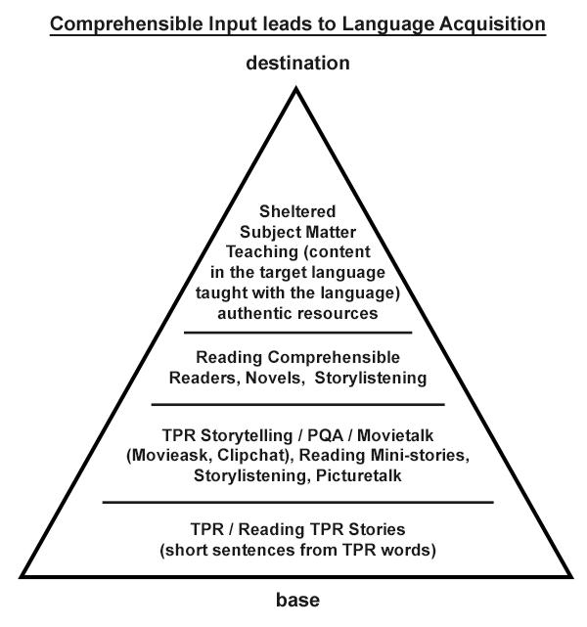

**Goal two is to, while grounding ourselves in the Comprehension Hypothesis, change the content we are teaching, which in some very fundamental ways also requires changing ourselves.**  
It does not mean that our sheltered subject matter has to be taught in English instead of the TL. It doesn’t mean that students should be producing output instead of receiving input. It doesn’t mean that meaningful content should be broken down to analyze its grammatical components. This is where we bridge both.

*We start at the bottom and build to the top.*

Our second objective is that teachers are exposed to and able to apply multiple approaches to the content that can be used to provide Comprehensible Input in Language Classes. This content includes sessions on decolonization, centering black and brown voices, centering Asian culture, products and processes in the curricula of any language class, current events and the difference between multiculturality and interculturality. (2023 panel discussion on positionally highlighted this fundamental difference.)

Participants will demonstrate their understanding of this content through live discussion groups throughout the online conference and / or initiating and fostering online conversations in our Professional development community.