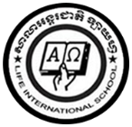**LIFE INTERNATIONAL SCHOOL**

KHMER SUBJECT FOR KSL

TEACHER : **CHEN SOTHARY**

**Name : …………………………………………………….**

1. **Learning the Khmer vowels from ុ to ៀ**

**ុ ូ ួ ើ ឿ ៀ**

**…………….. ……………. …………….. …………….. …………….. …………………**

**…………….. ……………. …………….. …………….. …………….. …………………**