

**Name: Date:**

**Teacher:**

Part II: Match the column A to column B

COLUMN A COLUMN B

1. 465 Two Hundred and eighty-four
2. 368 One Hundred and fourteen
3. 987 Four Hundred and sixty-five
4. 245 Seven Hundred and sixty-two
5. 123 Three Hundred and sixty- eight
6. 114 Nine Hundred and eighty- seven

1. 564 Three Hundred and fifty-four
2. 354 Two Hundred and forty-five
3. 762 Five Hundred and sixty- four
4. 284 One Hundred and twenty-three



Name: Date:

Teacher:

Part I. Find the number words on the box

**FOUR SIX SEVENTY THIRTY ONE THREE TWO TWENTY FORTY FIFTY TWELVE EIGHT ONE HUNDRED FIVE NINE HUNDRED**

|  |  |  |  |  |  |  |  |  |  |  |  |  |  |  |  |  |  |  |
| --- | --- | --- | --- | --- | --- | --- | --- | --- | --- | --- | --- | --- | --- | --- | --- | --- | --- | --- |
| **A** | **C** | **G** | **F** | **O** | **U** | **R** | **G** | **V** | **R** | **R** | **S** | **I** | **X** | **J** | **G** | **R** | **J** | **S** |
| **N** | **F** | **R** | **N** | **M** | **I** | **U** | **Y** | **T** | **M** | **H** | **Z** | **A** | **C** | **S** | **E** | **G** | **T** | **S** |
| **M** | **N** | **J** | **R** | **D** | **V** | **N** | **R** | **H** | **A** | **E** | **V** | **N** | **F** | **D** | **T** | **S** | **B** | **E** |
| **T** | **B** | **T** | **H** | **I** | **R** | **T** | **Y** | **J** | **A** | **G** | **H** | **G** | **D** | **D** | **W** | **D** | **B** | **V** |
| **G** | **N** | **N** | **F** | **B** | **G** | **S** | **G** | **G** | **E** | **S** | **C** | **D** | **E** | **H** | **O** | **T** | **E** | **E** |
| **H** | **O** | **N** | **E** | **H** | **U** | **N** | **D** | **R** | **E** | **D** | **R** | **T** | **H** | **W** | **T** | **G** | **R** | **N** |
| **H** | **D** | **F** | **B** | **N** | **M** | **D** | **G** | **J** | **G** | **S** | **Q** | **W** | **E** | **Y** | **E** | **J** | **H** | **T** |
| **H** | **D** | **A** | **W** | **F** | **E** | **G** | **H** | **W** | **R** | **E** | **W** | **Y** | **U** | **I** | **O** | **J** | **H** | **Y** |
| **M** | **W** | **H** | **S** | **S** | **T** | **G** | **D** | **S** | **T** | **W** | **E** | **N** | **T** | **Y** | **S** | **D** | **H** | **B** |
| **H** | **G** | **T** | **F** | **E** | **H** | **U** | **F** | **V** | **C** | **A** | **D** | **F** | **B** | **D** | **B** | **Y** | **W** | **D** |
| **Y** | **E** | **H** | **O** | **H** | **R** | **G** | **G** | **G** | **S** | **E** | **Y** | **E** | **G** | **F** | **F** | **F** | **V** | **G** |
| **K** | **L** | **N** | **R** | **B** | **E** | **H** | **T** | **W** | **E** | **L** | **V** | **E** | **H** | **D** | **T** | **I** | **Y** | **U** |
| **H** | **K** | **H** | **T** | **E** | **E** | **H** | **D** | **G** | **D** | **D** | **U** | **F** | **F** | **H** | **G** | **V** | **U** | **I** |
| **T** | **T** | **H** | **Y** | **R** | **Y** | **U** | **I** | **O** | **E** | **I** | **G** | **H** | **T** | **O** | **P** | **E** | **I** | **U** |
| **A** | **S** | **D** | **F** | **V** | **E** | **W** | **V** | **C** | **A** | **S** | **D** | **F** | **F** | **G** | **H** | **J** | **K** | **L** |
| **I** | **N** | **E** | **H** | **U** | **N** | **D** | **R** | **E** | **D** | **M** | **B** | **C** | **N** | **I** | **N** | **E** | **C** | **D** |
| **E** | **I** | **G** | **H** | **T** | **Y** | **G** | **F** | **I** | **F** | **T** | **Y** | **D** | **F** | **S** | **D** | **C** | **N** | **M** |



Part III. Write the number and names.

|  |  |
| --- | --- |
| Numbers | Written name |
| 1. **956** |  |
| 1. **456** |  |
| 1. **348** |  |
| 1. **987** |  |
| 1. **232** |  |

|  |  |
| --- | --- |
| Written name | **Number** |
| 1. **Nine Hundred and twenty-seven** |  |
| 1. **Three hundred and fourteen** |  |
| 1. **Eight hundred and forty-five** |  |
| 1. **Seven hundred and twenty-one** |  |
| 1. **Two hundred and twenty-two** |  |



**Name: Date:**

**Teacher:**

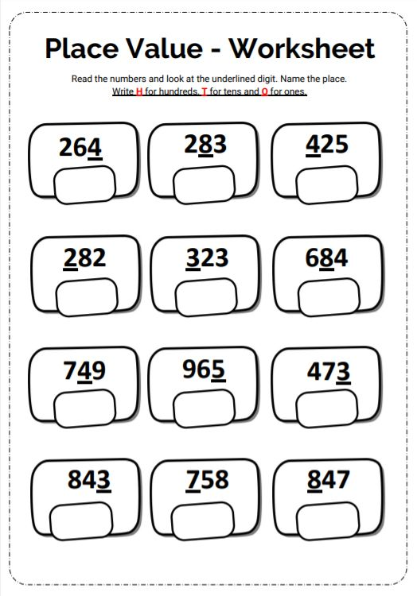



**Name: Date:**

**Teacher:**



**Name: Date:**

**Teacher:**

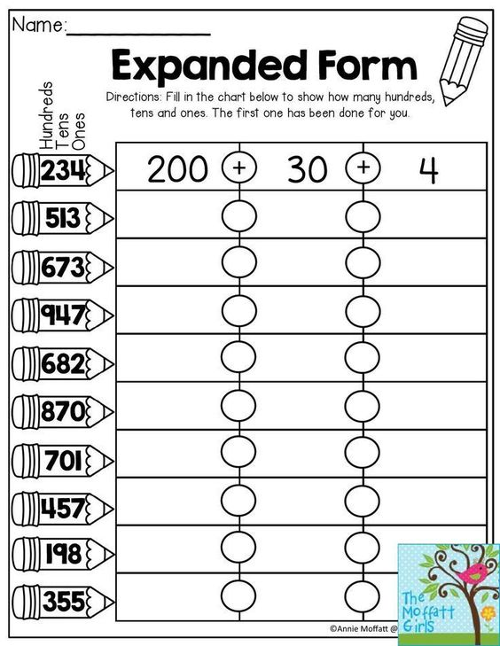



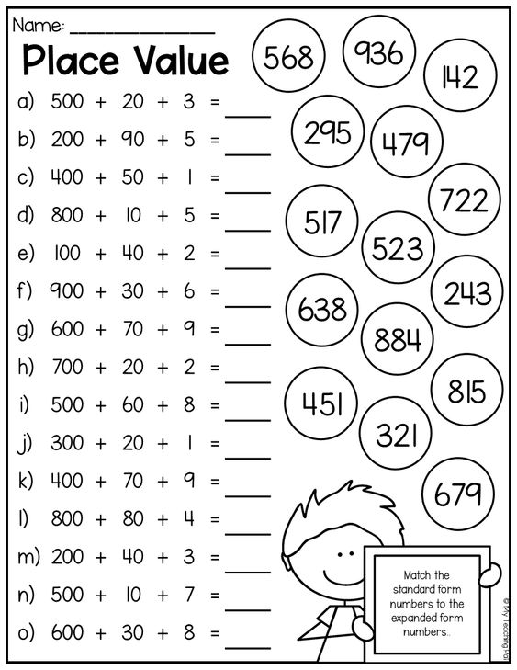



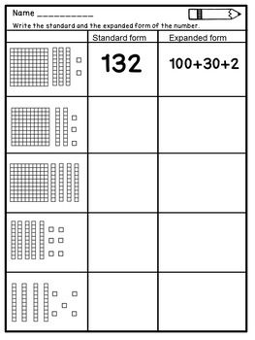



**Name: Date:**

**Teacher:**

Part III. Encircle all the short Oo and short Uu that you can see in the short story.

Bug can

Bug can jog and hum. Bug can run and won. Bug can hug. Bug can fix and hop in a rug. Bug can hop on a pod. Bug can see a hot s4big pot. Bug is not a mud bug. Bug is not a sad toy. Bug is a fun bug.