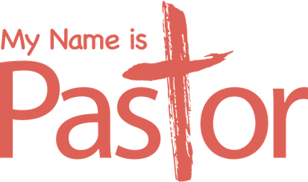

**WHAT MAKES YOU DIFFERENT?**

Sign 01

When you step into a room full of members of your congregation, what would you want them to see?

What makes you the same as everyone else in your congregation? What makes you different?

Tom said, “You’re not better than other pastors but you’re different.” To those in your congregation, how are you different from famous ministry leaders and preachers?

Tom said, “People *give* you the name, “Pastor”. You can’t take it or earn it.” What authenticates you as a pastor?

What words would you consider synonyms for the name, “Pastor”?