

VIRTUAL INTRODUCTIONS

* What drew you to this offering?
* What is your past experience with group coaching?
* What goals, visions, and intentions do you have for yourself during and after this course for group coaching?

|  |  |  |
| --- | --- | --- |
|  |  | |
|  | ***BUILD A THRIVING GROUP COACHING*** |
|  | ***PRACTICE: EVERYTHING YOU NEED TO SUCCESSFULLY RUN GROUPS ONLINE***  THERESA NUTT AND MICHELE RAE |
| Theresa Nutt | |

1



OBJECTIVES

* Translate the Four Pillars Model to Group Coaching
* Learn Ways to Manage the Online Environment
* Identify Logistics to Handle Ahead of Time
* Review Group Facilitation Hacks (Ways to Make the Coach’s Life Easier)
* Create a Structure While Staying Flexible

2



MOTIVATIONAL INTERVIEWING GUIDING PRINCIPLES

* Maximize participation
* Encourage member ownership
* Facilitate group cohesion and collaboration
* Tailor content to meet needs
* Focus on solutions

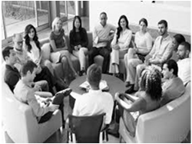

A DEFINITION

* Small groups of 4-20 participants
* Focus on coaching vs. education, support, therapy, or instruction
* All group members learn to provide positive affirmation, encouragement, nonjudgment, reflection, curious questions, deep listening

4



GROUP COACHING BENEFITS

* Create acceptance
* Instill hope
* Require self-disclosure which builds empathy and self-compassion
* Build group cohesion and synergy
  + Support of other members
  + Vicarious learning and

transformation

5

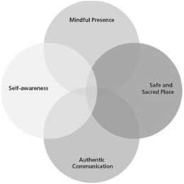

4 PILLARS OF HEALTH COACHING APPLIED TO GROUPS

* Safe and Sacred Space
* Mindful Presence
* Self-Awareness
* Authentic Communication

7



|  |  |  |  |
| --- | --- | --- | --- |
|  | | |  |
|  | SAFE AND SACRED SPACE |  |
| * Offers ways to welcome the participants to the group each week * Provides clarity about confidentiality as a group participant and reinforces when needed * Creates group agreements, norms, etc. to support the group process * Provides clear roles and responsibilities for all people involved |  |
|  | | |

8



|  |  |  |  |
| --- | --- | --- | --- |
|  | | |  |
|  | SAFE AND SACRED SPACE |  |
| * Manages participant behavior to maximize safety of group * Handles strong emotions or changes in group energy effectively * Connects with empathy and warmth to group participants and teaches participants to do the same with one another |  |
|  | | |

|  |  |  |  |
| --- | --- | --- | --- |
|  | | |  |
|  | SELF AWARENESS |  |
| * Reflects focus on those present in the group and their lived experiences * Pays attention to energy flow of both individual participants and the larger group and uses own self-awareness to respond to needs of group * Teaches participants to expand and utilize   their self-awareness to build group synergy |  |
|  | | |

10



|  |  |  |  |
| --- | --- | --- | --- |
|  | | |  |
|  | SELF AWARENESS |  |
| * Manages individual triggers and righting reflex and assists members of the group experiencing triggers or responding with the righting reflex * Engages with different learning styles and personalities while maintaining awareness of own preferences |  |
|  | | |

11



|  |  |
| --- | --- |
|  | |
| MINDFUL PRESENCE   * Operates mindfully present and extends this expectation to group participants * Creates structures to support the person speaking * Helps participants be present to their mind, body and spirit experiences that arise in the group coaching process |  |
|  | |

|  |  |  |  |
| --- | --- | --- | --- |
|  | | |  |
|  | AUTHENTIC COMMUNICATION |  |
| * Conveys nonjudgmental language and tone and facilitates participants doing the same in interactions * Demonstrates deep listening and helps participants gain skill in learning to listen to understand and validate * Uses curious open questions and powerful reflections, and also teaches participants to do the same in interactions with one another |  |
|  | | |

13



|  |  |  |  |
| --- | --- | --- | --- |
|  | | |  |
|  | AUTHENTIC COMMUNICATION |  |
| * Elevates group experience by noting themes, shifts, aha moments, and other powerful openings that arise from the group * Teaches group participants to capitalize on the synergy of the group by validating and bringing attention to participant’s statements that promote forward movement, or highlighting the inner wisdom of participants and the larger group |  |
|  | | |

14

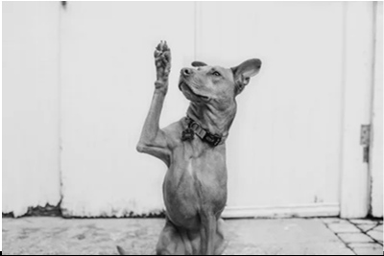

QUESTIONS? THOUGHTS?

|  |  |
| --- | --- |
|  | |
| ONLINE ENVIRONMENT   * Platforms   + What do you want it to do?   + Is it user friendly for the participants?   + What features best support the process you want to create? |  |
|  | |

16



|  |  |
| --- | --- |
|  | |
| ONLINE ENVIRONMENT   * Challenges –   + Encouraging cross talk   + Dealing with technical glitches   + Picking up on subtle cues   + Dealing with distractions of participant environments |  |
|  | |

17



|  |  |
| --- | --- |
|  | |
| ONLINE ENVIRONMENT   * Benefits   + Creates safety for some people   + Increases accessibility   + Ability to easily record and send replays   + Minimizes coach set-up time |  |
|  | |

|  |  |
| --- | --- |
|  | |
| ONLINE ENVIRONMENT   * Ways to Maximize   + Build agreements that include the virtual environment   + Have ways to prepare participants ahead of time for activities |  |
|  | |

19



|  |  |
| --- | --- |
|  | |
| ONLINE ENVIRONMENT   * Ways to Maximize   + Practice so you feel comfortable with the platform and features   + Stay in contact between sessions   + Housekeeping practices |  |
|  | |

20



LOGISTICS

* Welcome participants to the experience
  + Prescreening process
  + Common themes and requests
  + What information will help them feel prepared and engaged before they even arrive?
  + Platform instructions



QUESTIONS? THOUGHTS?

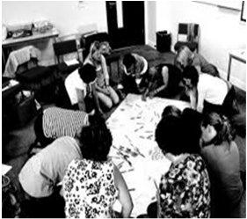

LOGISTICS

* Activities
  + Instructions
  + Preparation
  + Translation to the virtual environment

22



LOGISTICS

* Group wisdom and synergy
  + Promote cross talk with functionality

23



FACILITATION SKILLS AND TECHNIQUES

MAKE THE GROUP PROCESS VISIBLE

* Note energy shifts or challenges – be transparent
* Highlight the wisdom shared by others and weave it to support the entire group’s process



FACILITATION SKILLS AND TECHNIQUES

MANAGE BEHAVIOR

* Over talk
* Under talk
* Ramble
* Interrupt
* Know It All
* Yes, but
* Argumentative
* Angry and Hostile

25

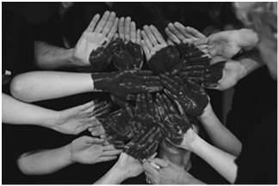

FACILITATION SKILLS AND TECHNIQUES

MANAGE ENERGY

* Create and maintain safety
* Refer to ground rules/agreements until group has really established
* Stay present to the energy of the dynamics as well as the coaching process

26



FLEXIBILITY AND STRUCTURE

* Amount of structure vs. organic
  + Helps with time management
  + Can help some participants feel they can let there guard down
* What structure let’s you optimize your coaching style?
* What makes your approach unique?



FACILITATION SKILLS AND TECHNIQUES

ENGAGE PEOPLE IN DIFFERENT WAYS

* Use of humor and levity
* Holding emotions of individuals and group
* Evoke wisdom and participation
* Multiple learning styles

28



FACILITATION SKILLS AND TECHNIQUES

BALANCE SPACIOUSNESS AND CREATIVE TENSION

* Keep attention to the overall momentum of the group
* Slow things down if a few participants need to catch up or process something
* Stay focused on forward movement but also make room for exploration that moves the entire group

29



QUESTIONS AND WRAP UP

31



CONTACT INFO

32