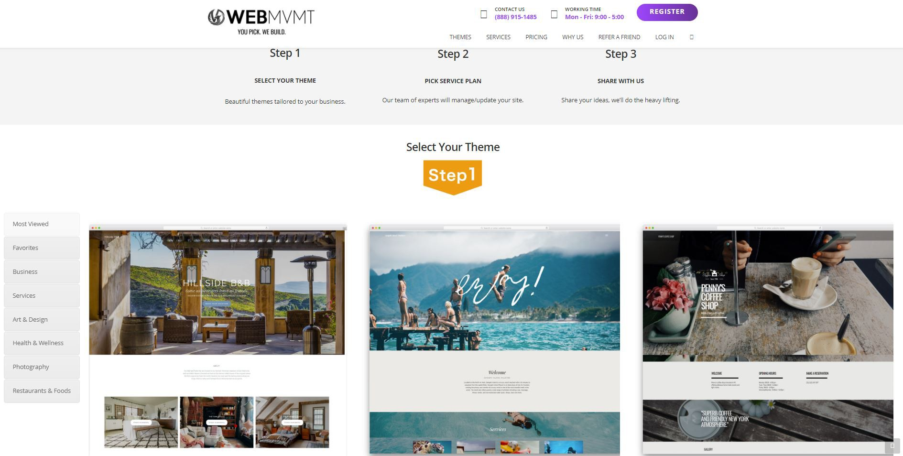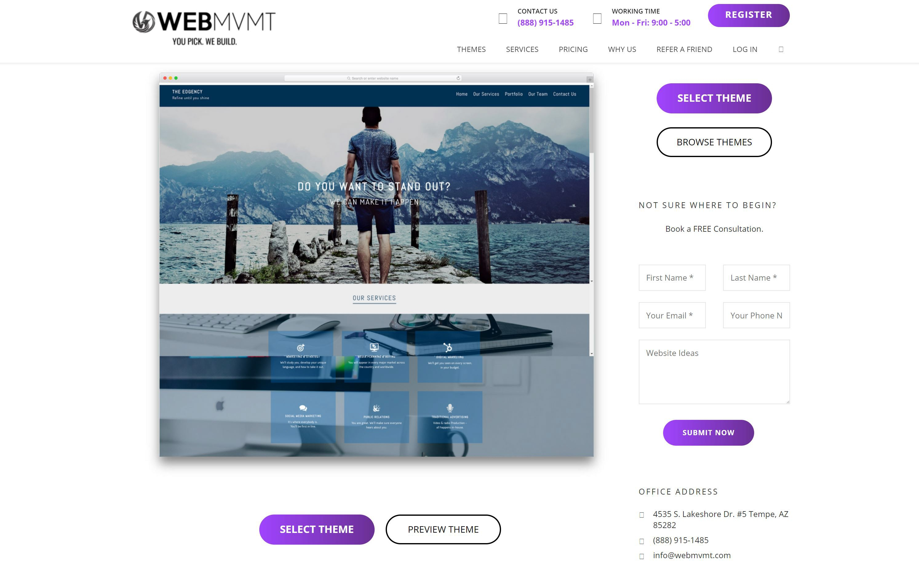

**You Pick We Build Checklist**

Awesome! You've signed on a new You-Pick-We-Build client! Here are some guidelines to help you get started! Before the initial consultation call, there are a few things that we would like you to start thinking about in order to complete the call quickly and efficiently.

* **1. Select a Theme - youpickwebuild.com**

To get started,

* + Visit **youpickwebuild.com**, scroll down to the "pick a theme" section.
  + To preview our variety of themes, click on the "browse more" button to get to the "theme" page.
  + You can browse themes by industry listed on the left side of the page.
  + If you would like to preview a live demo of the theme before selecting,

click the "preview theme" button.

* **2. Create an Account**

Once you have selected a theme, please create an account by clicking the "select theme" button. If you are undecided, you can still proceed by clicking the "get started" button at the top of the website. You will need to fill out the required fields. Please accept the terms of service, complete the recaptcha, and click "register" to create your account.

* **3. Select a Service Plan**

Let the experts handle the post build updates. Having us keep the website up to date allows our clients and their employees to focus on building their business. We keep the website on task through automated monthly reminders, and a customized content management plan.

* **4. Complete Payment & Schedule FREE 60 min Initial Design Consultation**

**What to Expect? -** Welcome to the WebMVMT. We are excited to get things started and we are here for you every step of the way, beginning with our initial design consultation to collect content.

* **Complete Payment:** Enter credit card details and billing information.

●

* **Schedule Initial Design Consultation:** Choose a date & time for the call or delegate to the person in charge of collecting content for website. During the consultation your project manager will be completing the **intake form.**