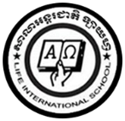**LIFE INTERNATIONAL SCHOOL**

KHMER SUBJECT FOR KSL

TEACHER : **CHEN SOTHARY**

**Name : …………………………………………………….**

1. **Learning the Khmer vowels from ា to ឺ**

**ា ិ ី ឹ ឺ**

**…………….. ……………. …………….. …………….. ……………..**

**…………….. ……………. …………….. …………….. ……………..**

**…………….. ……………. …………….. …………….. ……………..**