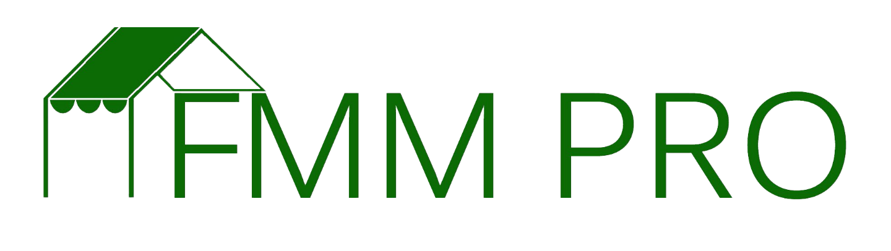

A farm inspection should always function as an opportunity to connect with the farmer on their home turf and as an information gathering mission. Consider using your phone to take pictures as an additional way to get information. Always ask before taking them, but most of the time the farmer will not mind as long as you give the context in which they will be used (i.e. marketing for the market, how to remind yourself of what you saw that day, etc…) Schedule these with your farmers when it is convenient for them, but after they have been in production and maybe even harvesting produce. Many markets also use these as a way to get to know new/potential vendors to gain a better understanding of their fit with the market and product mix.

If you already have a farm inspection report that you use, please utilize the below as a template to ensure you have similar fields of information being gathered. The goal of this homework assignment is to create and submit a template that can be used by yourself, or any other individual in management at the market, to conduct a farm inspection. Due to the confidentiality of information that would be included you do not need to submit a completed one, or you can submit one with redacted information that is identifiable in any way.

**Farm Inspection Report**

**Farm Name & Location:**

**Date of Site Visit:**

**Farm Representative:**

**Inspector:**

**Date Farmer Started with market:**

**Market(s) Attending:**

**Percentage of Sales from Market:**

**Staff:**

**Farm History and Description:**

**Land:**

**Owned:**

**Rented:**

**Infrastructure and Equipment:**

**Production Methods:**

**Production Schedule:**

**Crops:**

**Food Safety Processes in Place:**

**Application Updates:**

**Crop List Additions:**

**Special Challenges:**

**Farmer Question or Comments:**

**Follow Up Required:**

**Summary:**

***The contents of this report are confidential between the inspector, the inspected party, and (Market). This report does not constitute consultation, nor should it be used for promotional purposes. All compliance assessments are made in reference to the rules and regulations of the (Market) and are based on the inspector’s observations, review of documents and operator interview.***

**Inspector Name:**

**_____________________________________________ _________________________**

**Inspector Signature Date**

Once this has been completed, please keep it in a safe place where only you as the manager can access.