 | ESP Pre-Req 1:  Explaining ADHD to your Child | 

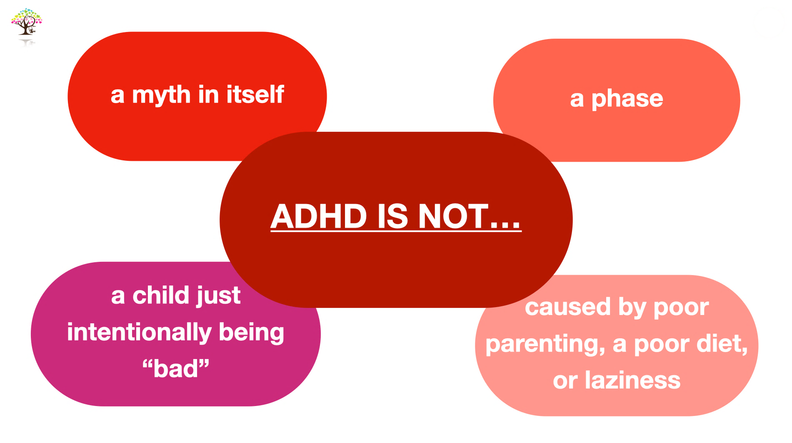

____________________________________________________________________________________________________________________________________________________________
____________________________________________________________________________________________________________________________________________________________
____________________________________________________________________________________________________________________________________________________________
____________________________________________________________________________________________________________________________________________________________

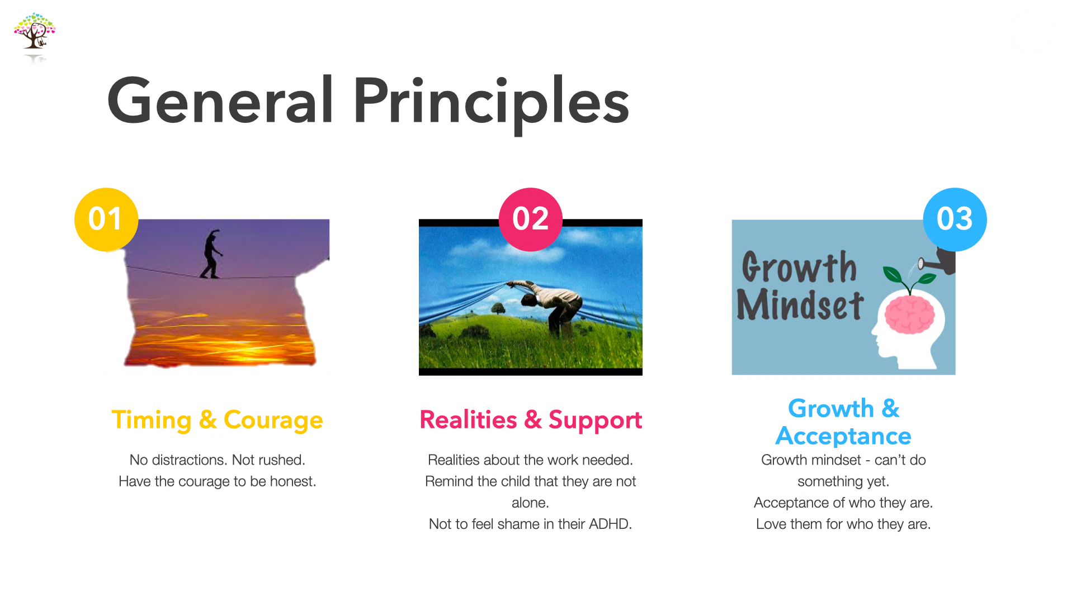

Plan out a time you wish to discuss ADHD with your Child…
____________________________________________________________________________________________________________________________________________________________
____________________________________________________________________________________________________________________________________________________________

What specific realities do you intend on sharing with your Child?..
____________________________________________________________________________________________________________________________________________________________
____________________________________________________________________________________________________________________________________________________________

What specific areas of difficulty for your Child will you focus on? How can you speak about these areas with a growth mindset?..
____________________________________________________________________________________________________________________________________________________________
____________________________________________________________________________________________________________________________________________________________

