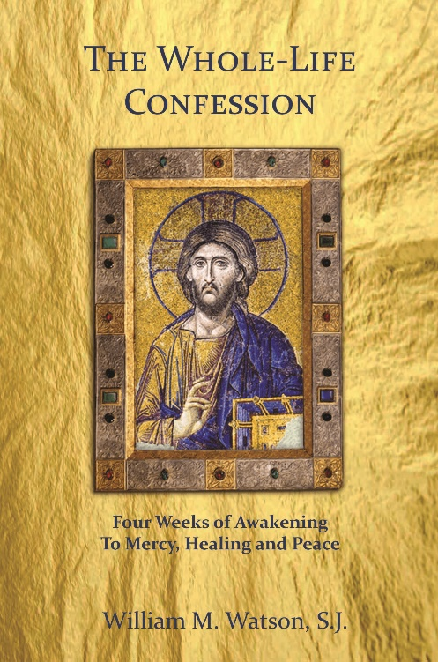
(St. Catholic Parish)
Whole-Life Confession Course
Registration Sheet
Program Starts: (Feb 14th)
Whole-Life Confession Service
(March 13th, 7 PM Parish Church)

(Provide here the essential information about the Whole-Life Confession Course so that registrants know all the specifics. Be sure to include the number of people that will be taken for the course cycle and when people will be notified of their acceptance to the program)
Name (First)_______________________(Last)__________________
Email _________________________________________________
Phone ( )__________________________________________

Offer a few short sentences why you feel ready to engage this four-week spiritual journey (offer no personal/confidential information)
____________________________________________________________________________________________________________________________________________________________________________________________________________________________________________________________________________

THANK YOU!

