FREE TRIAL

Dominate Your Day

Table of Contents

Course Goal 2

Lesson#1 - First Fifteen 3

Lesson #2 – Fighting For Five 5

Lesson #3 - Taking Control of Your Meeting Schedule 7

Lesson #4 - Why Spending Time Delegating is Worth It 10

Course Goal: 2 Extra Hours p/day

Over the course of five weeks, the lessons in this course build on one another and the process creates momentum in your time savings and productivity:

Week #1 Goal - 10 minutes p/day

Week #2 Goal - 15 minutes p/day

Week #3 Goal - 20 minutes p/day

Week #4 Goal - 30 minutes p/day

Week #5 Goal – 45 minutes p/day

Course Total – 2 Hours p/day
In this Free Trial you get my favorite lessons in each of the four categories of productivity and time management techniques:

T1 Lessons: Getting Things Done

Fighting For Five

T2 Lessons: Getting The Right Things Done

First Fifteen

T3 Lessons: Help Everyone Move Faster

Taking Control of Your Meeting Schedule

T4 Lessons: Investing Time

Why Spending Time Delegating is Worth It

Lesson #1 - FIRST FIFTEEN

"Well begun is half done" ~Aristotle

How many times a week do you accomplish what you set out to do in the morning?

1

2

3

4

5

When you get to work in the morning and the first thing you do is look at email, you’ve just made your priorities _________________________ to everyone else’s.

What are the three reasons to start with your priorities in the morning?

_____________________________________

_____________________________________

_____________________________________
____________________________________________________________________________EXERCISE
Checklist for First 15 success (Mark with “X” when complete).

Schedule it on your calendar _____

Notify your team _____

Notify your boss (optional) _____

Your goal over the next week is to get your First 15 in at least 3 times and notice the effect on your day. A few tricks to help with that:

Close out of e-mail on your computer the night before

Put your phone in a drawer when you arrive

Close the door to your office

Try not to read e-mail before arriving at work

Remember, if there’s an emergency, they WILL find you. :) And let them know that it is OK to interrupt for serious matters. That is part of the reason the goal is only to do this 3 times over the next week.

____________________________________________________________________________

KEY POINT OF LESSON

You cannot finish your priorities until you actually start them.

____________________________________________________________________________NOTES

___________________________________________________________________________________________________________________________________________________________________________________________________________________________________________________________________________________________________________________________________________________________________________________________________________________________________________________________________________________________________________________________________________________________________________________________________________________________________________________________________________________________________________________________________________________________________________________________________________________________________________________________________________________________________________________________________________________________________________________________________________________

Lesson #2 – FIGHTING FOR FIVE

"Productivity is never an accident. It is always the result of a commitment to excellence, intelligent planning, and focused effort." ~Paul Meyer

How many hours a day are you AVAILABLE to be interrupted by your staff (not in meetings, not on the phone, and at your desk/office)

_____ 1 hour

_____ 2 hours

_____ 3 hours

_____ 4 hours

_____ 5 hours

_____ More than 6 hours

How many hours a day are you UNAVAILABLE to be interrupted by your staff (in meetings, on the phone, or away from your desk/office)

_____ 1 hour

_____ 2 hours

_____ 3 hours

_____ 4 hours

_____ 5 hours

_____ More than 6 hours

Asking for a few minutes ISN’T rude or irresponsible if you _______________________.
____________________________________________________________________________

EXERCISE

Interruptions are one of the many constants for leaders, so there should be no lack of opportunities for you to practice this concept:

Practice this once a day this week

Practice this twice a day next week

Practice this three times a day the following week

____________________________________________________________________________

KEY POINT OF LESSON

Finishing what you start is vital to your productivity, and worth fighting for.

____________________________________________________________________________NOTES

_______________________________________________________________________________________________________________________________________________________________________________________________________________________________________________________________________________________________________________________________________________________________________________________________________________________________________________________________________________________________________________________________________________________________________________________________________________________________________________________________________________________________________________________________________________________________________________________________________________________________________________________________________________________________________________________________________________________________________________________________________________________________________________________________________________________________________________________________________________________________________________________________________________________________________________________________________________________________________________________________________________________________________________________
_________________________________________________________________________________________

Lesson #3 - TAKING CONTROL OF YOUR MEETING SCHEDULE

"Meetings are indispensable when you don't want to do anything.” ~John Kenneth Galbraith

What percentage of the time you spend in meetings do you feel is a waste?

_____ 10%

_____ 20%

_____ 30%

_____ 40%

_____ More than 50%

Meetings are a _____________________ and a _______________________ to get things done.

The first “Half” for taking control of your meeting schedule: Have half the ________________________.

The #1 technique for doing this is to ask the question: _____________________________________

The #2 technique: assess ________________________ meetings.

The #3 technique: try to replace ________________________ meetings.

Remember: Everyone knows that meetings are _____________________.

The second “Half” for taking control of your meeting schedule: Cut meeting _________________ in half.

The third “Half” for taking control of your meeting schedule: Cut meeting ___________________ in half.

Meetings ___________________ in value for each participant with every additional person that attends.

If they aren’t ____________________ to the discussion, then they can probably get the summary.

The fourth “Half” for taking control of your meeting schedule: _________________ half of meetings when you should.

Remember: This isn’t about just ____________________ meetings. It’s about making your time in meetings _________________________.

____________________________________________________________________________EXERCISE
List three meetings you could question whether you need to have, or still need to have?

__________________________________________

__________________________________________

__________________________________________
List three meetings you could ask if the time can be rescheduled for half?

__________________________________________

__________________________________________

__________________________________________
List three meetings you could ask whether participation can be cut by half?

__________________________________________

__________________________________________

__________________________________________

Now circle the easiest one on each of the categories above and work on it this week.

NEXT WEEK pick another one from each category and work on it.

THE WEEK AFTER NEXT work on the last meeting in each category.

____________________________________________________________________________

KEY POINT OF LESSON
There are a lot of "social norms" surrounding meetings that you can break with an application of logic.

____________________________________________________________________________NOTES

_______________________________________________________________________________________________________________________________________________________________________________________________________________________________________________________________________________________________________________________________________________________________________________________________________________________________________________________________________________________________________________________________________________________________________________________________________________________________________________________________________________________________________________________________________________________________________________________________________________________________________________________________________________________________________________________________________________________________________________________________________________________________________________________________________________________________________________________________________________________________________________________________________________________________________________________________________________________________________________________________________________________________________________________
____________________________________________________________________________________________________________________________________________________________________________________________________________________________________________________________________________________________________________________________________________________________________
_________________________________________________________________________________________

Lesson #4 - WHY SPENDING TIME DELEGATING IS WORTH IT

"Delegation requires the willingness to pay for short term failures in order to gain long term competency. ~Dave Ramsey

The common excuse for not delegating of “It’s quicker for me to do it myself” has a logical failure in that it sacrifices __________ term benefits for __________ term gain.

The Delegation Priority Matrix:
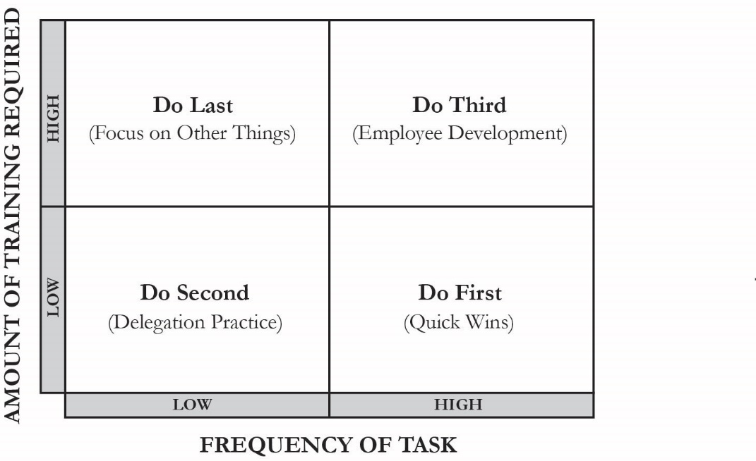

#1 Trick for determining what to delegate: What tasks were done while you were on _________________?

#2 Trick for determining what to delegate: What tasks should you _________________________ in the first place?

The simplest technique for delegating a task is:

______ Do

______ Do

______ Do
Delegating doesn’t ____________________ your value to the organization, it ____________________ it because you get more ____________________ things done.

____________________________________________________________________________

EXERCISE

Write down five things that you would like to delegate (or that you should delegate). If you’re having trouble coming up with ideas, look to the things that were handled when you were on vacation.

________________________________________

________________________________________

________________________________________

________________________________________

________________________________________

Pick the one that is easiest to train first, and do it TODAY

Pick the one that is most frequent, and do it TOMORROW

You will delegate one remaining item on this list (using the Delegation Priority Matrix) NEXT WEEK, and every week following until complete.

____________________________________________________________________________

KEY POINT OF LESSON

Most arguments against delegating are wildly shortsighted. When viewed with an eye to their long-term benefits, it is a no-brainer.

____________________________________________________________________________NOTES

_______________________________________________________________________________________________________________________________________________________________________________________________________________________________________________________________________________________________________________________________________________________________________________________________________________________________________________________________________________________________________________________________________________________________________________________________________________________________________________________________________________________________________________________________________________________________________________________________________________________________________________________________________________________________________________________________________________________________________________________________________________________________________________________________________________________________________________________________________________________________________________________________________________________________________________________________________________________________________________________________________________________________________________________
____________________________________________________________________________________________________________________________________________________________________________________________________________________________________________________________________________________________________________________________________________________________________
_________________________________________________________________________________________

