Sales page: https://www.optimizepress.com
https://www.russellnohelty.com/godsversecompletesales/
Alt-sales page: www.flodesk.com
https://fabulous-avocado-647.myflodesk.com

Opt-in: www.bookfunnel.com
https://dl.bookfunnel.com/zdyn1info6
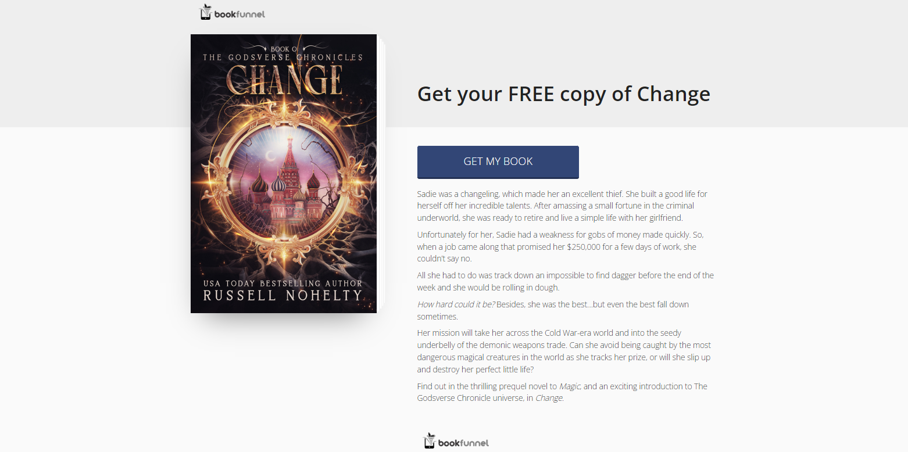
Checkout and bump: https://thrivecart.com/
https://wannabepress.thrivecart.com/godsversecomplete
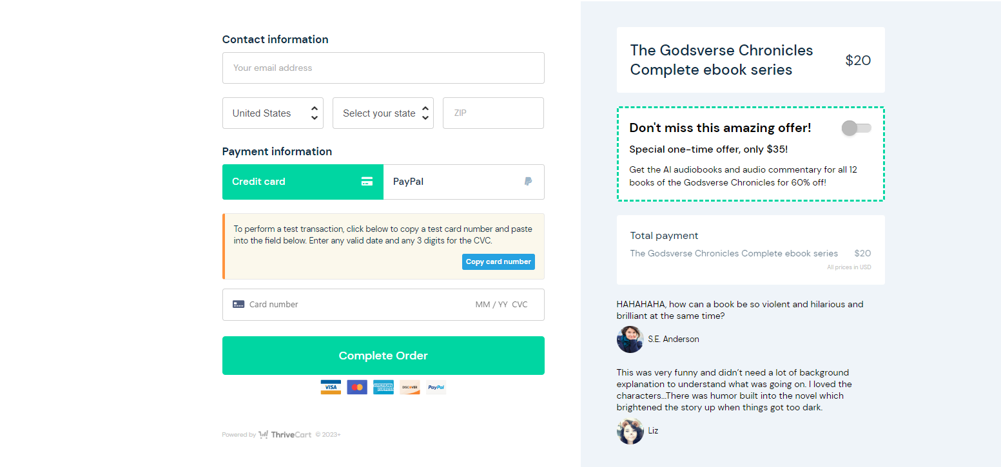

Upsell #1: https://wannabepress.thrivecart.com/godsversecomplete/upsell/

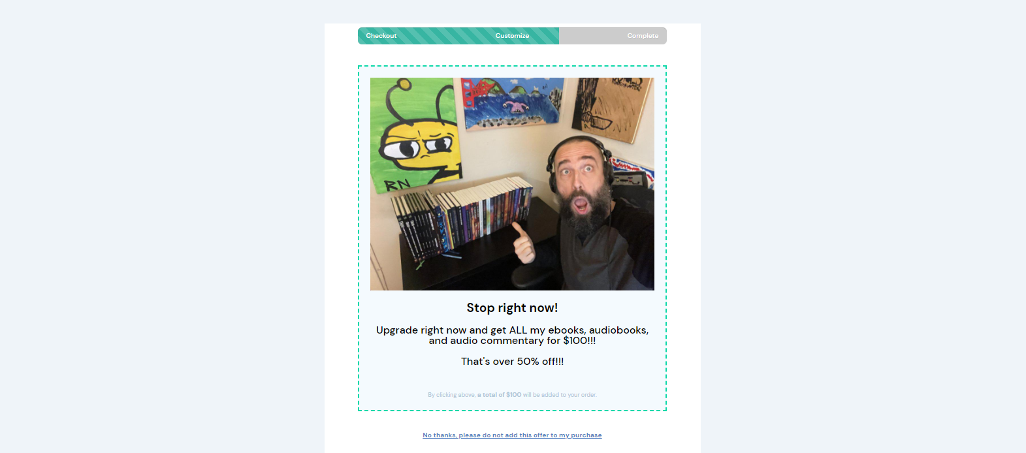
Downsell #1:


Upsell #2:
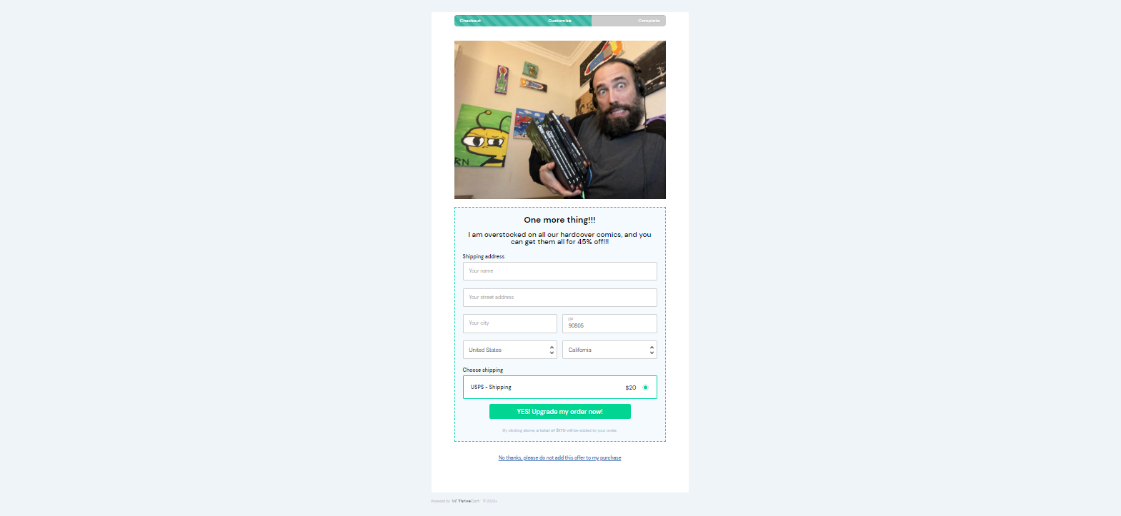
Downsell #2:


Email #1: Welcome to the Godsverse
Hi First name / there,
Thank you for entering The Godsverse Chronicles. What you read is part of my portal fantasy series that spans 12 books and 13,000 years.
So, what is the Godsverse?
It's a universe where all the gods from every religion are real, and all they...well they kind of suck.
The portal fantasy stories set in the Godsverse are filled with action, adventure, and humor, but the overall ethos is...that the gods kind of suck, which is why the universe kind of sucks.
In them, women take their fate into their own hands and travel between Earth, Heaven, Hell, Mount Olympus, across the cosmos, and even between universes. Each book is its own contained adventures that build on each other over time.
People love the Godsverse because they are fast-paced, fun portal fantasy thrillers set in a fantasy world and paced to an inch of their lives. The main characters of the story take agency over their own destinies and take their fate into their own hands.
If you love monsters, mythology, and magic, you're going to love The Godsverse Chronicles. I hope you dig the stories.
If you do, you can pick up the first story in the Godsverse, Change, for FREE, which is a great start to your journey through the cosmos.
Change link
I'll come back to tell you a little more about our heroines tomorrow.
Sincerely,
Russell Nohelty
The guy for what wrote these here books

—WAIT 1 DAY—

Email #2: The facilitator…
Hi First name / there,
The first heroine I want to introduce you to is OIllie, star of Magic.
So who is Ollie?
Ollie is a business-woman who is ruthlessly efficient. She can portal across the world and uses that ability to facilitate unseemly deals between the worst type of monsters in the world.
In her story, well, I'll let this teaser do the talking…
Ollie wasn’t looking for trouble, but after she saved the Antichrist from being slaughtered, it came for her.
Ollie lived by one rule. Never get involved with anyone for any reason; humans, demons, fae folk, it didn’t matter. They were all trouble. Keeping her distance was how she survived in the criminal underworld for so long.
Keep your head down and don’t piss anyone off. That was her motto, especially since her clients all had access to powerful dark magic.
She thought she had a flawless system for keeping her nose clean, so how did she wind up in a stolen car, with a demon spawn in her back seat, driving away from her ex-lover and a gang of demons ready to skin her alive?
That’s a good question.
And why did she agree to help save the demon’s life so she didn’t get sacrificed to open the gates of Hell?
An even better question.
She had one rule. One stupid rule. And tonight…it goes right down the toilet.
Now, the only way for Ollie to get her life back is to save the girl, prevent the Apocalypse, and track down the people who betrayed her.
They will pay. Oh yes, they will all pay.
The Godsverse Chronicles is currently not on any retailers as we work on a cover rebrand and Kickstarter launch, but you can get the whole series for 60% with the brand new cover, before anyone else.
You can find more information on this offer right here.
But hurry, this is a very limited time offer (and I really mean that). Once it's gone you won't be able to get it again.
Tomorrow, I'll tell you about another awesome character in the Godsverse tomorrow.
Until then,
Russell
—WAIT 1 DAY—
Email #3: The Antichrist…
Hi First name / there,
Next, let's get to know Anjelica star of Evil.
So who is Anjelica?
She was a simple cheerleader before she was kidnapped by demons and found out she was the Antichrist. It's a bit of a spoiler to say that she survives her adventure in the previous book, but I don't make a habit of killing kids in my books and it's okay for you to know that.
Also, in my books, the good guys almost always win in the end. So, what's her story about?
Anjelica’s mother never told her that she was a demon. Now, all she wants is her old life back, but that’s not possible for her. Not after what she’s seen.
Anjelica used to be a popular cheerleader with an awesome life, but that was before an evil cult of demons tried to use her blood to open a portal to Hell and start the Apocalypse.
She was rescued from that fate, barely, and because of the imminent threat to her life, her saviors ripped her from Los Angeles and brought her to a safe house in the middle of nowhere.
They said it was for her own good, but she would rather be dead than stuck in boring, old Bronard, Missouri. She was from the big city, so a sleepy, rural life wasn’t for her.
She longed for excitement.
So, when she met a young witch with a mysterious past who promised to show her everything she knew about opening portals and traveling between distant lands, they bonded immediatel
I mean, what’s the worst that could happen, right?
It’s not like they would open an intergalactic gateway to another planet and get thrown into a brand, new world with no way to get back to Earth, right?
Join Anjelica in her own solo adventure and find out what happened to her immediately after her time in Ollie's care.
I told you yesterday about a special offer to get all 12 ebooks in this series with their new retailer covers before ANYONE else for 60% off cover price.
That's just $20.
You can get that deal here for a very, very limited time.
I'll tell you a story about Anjelica's sister tomorrow.
Until then,
Russell
—WAIT 1 DAY—
Email #4: The foster sister…
Hi First name / there,
Let's now move to meet Anjelica's foster sister, Lizzie.
Who is Lizzie?
She is a pixie with magical powers, hunted until she was brought to the same safe house that harbored Anjelica for a time. She grew up happy until she was given a prophesy that sent her running away from her life.
What's her story about?
In the ashes of her past, she will rise up, and her death will save us all.
Lizzie ran from her past for ten years, zigzagging across the United States every few months, trying to outlast the prophesy that an oracle gave to her when she was just sixteen years old.
But nobody can run from their destiny forever.
After watching her friend brutally gunned down by a group of ruthless demons, she had no choice but to protect the woman’s child, and there was only one place where
Lizzie knew the girl would be safe.
Bronard, Missouri.
Home.
She stayed away to protect her parents, but the girl needed mystical protection.
Her parents had taken in magical strays their whole lives, including Lizzie. If anyone could save the poor child’s life, it would be her mother and father.
But will returning to her home doom Lizzie even as she works to save the child she has vowed to defend?
Are you excited about the series now? Are you dying to read it? Well, the ONLY place you can find it right now is through this special offer…
…and good news for you, it's 60% off for a very, very limited time.
Next, we'll move into what I consider the second “arc” of The Godsverse Chronicles and talk about Katrina and Death.
Until then,
Russell
—WAIT 1 DAY—

Email #5: The hothead...
Hi First name / there,
Next, I want to introduce you to is Katrina, star of Death.
So who is Katrina?
Katrina is a no-nonsense, snarky, funny, hotheaded woman who doesn't take any guff from anybody, even the gods. Here is a little bit of her story.
The Universe is the worst.
Katrina was just a normal person with a simple life. Then, the Apocalypse descended upon her, and she spent two years fighting with and living among monsters
They were neither pleasant nor polite neighbors, so she snapped and set out to Hell to kill the Devil.
That's when the carnage started.
Action, adventure, humor, and chaos abound in this portal fantasy action-adventure thriller that's paced for edge of your seat excitement
Join Katrina on a hair-raising adventure that pit her against God, the Devil, Zeus, Hera, and Cronos himself as she traipses across the universe breaking as many things as she fixes, fighting her way through Greek, Roman, and Judeo-Christian mythology, and causing trouble at every stop along the way.
You can join Katrina across the universe by taking advantage of our special, one time deal for the entire Godsverse Chronicles at 60% off the cover price.
But hurry, there's only a few days left to take advantage of this deal and then it goes away forever.
If you're not one who does post-apocalyptic stories, no matter how fun or funny they are, I'll tell you about another awesome character in the Godsverse soon and a series which is all space fantasy adventure.
Until then,
Russell
—WAIT 1 DAY—

Email #6: The sniper...
Hi First name / there,
Whether you like post-apocalyptic stories or not, I want to introduce you another character in the Godsverse.
Rebecca Lobdell is the main character in Doom Followed, where she is recruited to join the Godschurch, an intergalactic agency that protects the gods around the universe while a terrorist group called the Godless tries to kill them all.
The series sees her portal jumping around the galaxy, protecting gods not just of the Greek/Roman pantheon, but also the Norse and Egyptian pantheon as well.
Doom is all about the space fantasy and mixing new god pantheons into the Godsverse.
Here's a little bit of that book.
The Universe is a dangerous place…even for the gods.
Rebecca Lobdell survived her planet being attacked by a vicious alien race in Death, but now she has taken on her biggest challenge yet
Rebecca Lobdell has joined the Godschurch, an intergalactic agency that protects gods around the universe. For a time, their job was easy. However, a terrorist organization known as the Godless has found a way to kill gods, and they won’t stop until every seemingly immortal being is vaporized into oblivion.
Follow Rebecca Lobdell as she journeys from planet to planet to bring down the Godless and return peace to the universe.
There are only a few emails left, which means there's only a few days left to take advantage of our one-time, 60% off deal to get the whole Godsverse Chronicles.
That's just $20.
Next email will tell you about another of our heroines.
I hope you enjoy the books.
Russell
—WAIT 1 DAY—

Email #7: The pixie...
If you love the future, you're going to flip for the past, and the third main character in the Godsverse, Akta the Pixie, star of Hell.
Akta is the greatest monster hunter in King Odgeir's kingdom. When there is a monster too powerful or elusive to deal with, they call in the pixie, Akta.
She is faster and more powerful than humans, along with having access to magical pixie dust, which allows the bearer to travel anywhere in the world instantly.
When Akta is murdered by her adopted brother, the fearsome pixie swears a loyalty oath to the queen of the underworld for a chance to return to Earth and seek her revenge.
However, pledging her soul to the ruler of Hell means an eternity of perdition, being forever called upon to fight against those who wish to destroy the ruler's sovereign realm.
During her service to the throne, Akta battles angels, demons, dragons, orcs, and the most twisted beings in all of damnation as she works to keep the underworld safe from conspirators who threaten to upend the very gods themselves and sow chaos throughout creation.
Are you digging these characters? Then you can pick up the whole series for 60% off. That's a $55 value for just $20.
Next is the great great great great great great descendant of Akta, Julia Freeman, and her book Ruin, which takes place between 1970-1990.
I'll tell you about that one next time.
I hope you enjoy it!
Russell
—WAIT 1 DAY—

Email #8: The teacher...
Hi First name / there,
The next main character in our universe is Julia Freeman, the teacher. Julia is a descendant of Akta, who learns she is a pixie, that a bloody cult is after her blood, and that if they find her they'll use it to open a portal to Hell and unleash the Apocalypse on the world.
Julia never wanted to be a hero. She just wanted to escape her hometown.
But now she has no choice but to fight for her right to exist against deadly foes determined to destroy the world and slaughter her in the process.
Can Julie survive demonic cults, secret societies, and enemies of unimaginable horror, or will she succumb to the supernatural forces determined to kill her and bring about the end of the world?
This ends the second arc of The Godsverse Chronicles. There's a lot more, but there is not a lot more time to take advantage of our 60% off deal.
Next email will tell you about the last of our heroines
I hope you enjoy it!
Russell
—WAIT 1 DAY—

Email #9: The lynchpin…
Hi First name / there
I've been working on the Godsverse for a time (since 2011) and for most of its history there was not a focal character. There were character that were more popular than others, but when I went to finish this series, one character stood out above all the others; Kimberly.
Death consumed her, until she embraced it.
Kimberly hasn’t had an easy life.
It started when she was kidnapped by a banshee at the tender age of eight years old.
As a teenager, she watched in horror as her partner died in front of her.
In adulthood, she played a crucial role in saving the world from an angelic civil war.
Those unbelievable moments only scratch the surface of her incredible life. There is so much more to her remarkable story.
Darkness examines several other harrowing adventures from this heroic pixie's remarkable life.
Follow a college-aged Kimberly as she desperately tries to summon a beloved friend from beyond the veil of death.
Join Kimberly as she searches for the love of her life in the first days of the Apocalypse.
Explore the ramifications of Kimberly's perilous choices during Ragnarök, as she deals with her new place in the cosmos.
Few beings in the universe have had as significant an existence as Kimberly. Now, you can delver even deeper into her amazing journey.
I know it seems like this email sequence will never end, but it will in a couple days, and with it so will our 60% off deal. If you haven't checked it out here, now is the time.
Next, I'll share with you what readers just like you are saying about the series.
—WAIT 1 DAY—

Email #10: Readers really love the Godsverse…
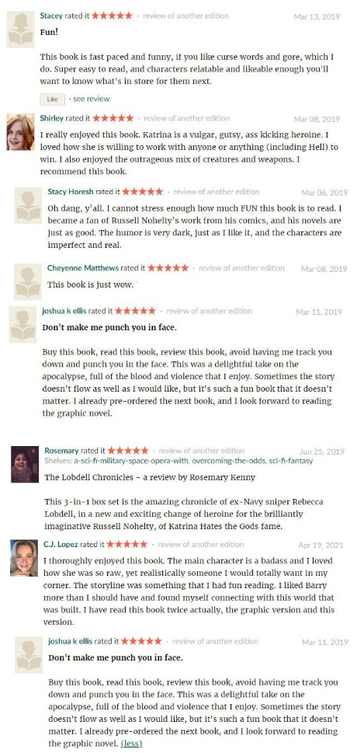
I thought today, instead of telling you why I love the Godsverse, I would let fans speak for me and give you some insight as to why they love it by sharing some of the reviews from the series.

If that sounds good to you, then I have better news, because you don't have to take their word for it, because I'm giving you Change for FREE.
I can't wait to hear what you think.
And if you're in love with the series, then dive in with both feet by collecting the whole series for just $20. That's 60% off the cover price and it's going away in a couple of days.
I hope you enjoy it!
-Russell

Email #11: Why should you pick up The Godsverse Chronicles?
Hi First name / there,
Now that you've met all the main characters in the Godsverse, I thought I would talk to you for a second about why you should give it a shot.
I've talked to thousands of fans of the Godsverse over the years, and they've basically said they loved the Godsverse for three reasons:
- The humor - I am told all the time how much people laugh out loud with my books.
- The pacing - I am also told that people can't put my books down once they start because I keep them on the edge of their seats.
- The mythology, magic, and monsters - I heavily research every part of the mythology and spent 5 years putting together the mythology of The Godsverse, intricately weaving every mythology together before showing it to anybody.
- The fantastical worlds - Throughout the series the heroines of The Godsverse Chronicles travel to dozens of worlds throughout the universe, deal with hundreds of magical creatures, and mix it up in multiple galaxies.
If you're looking for a series that will make you laugh out loud while hanging on the edge of your seat, then I really do recommend you check these books out, especially if you are a fan of mythology.
You can pick up the WHOLE SERIES, all 12 books, for just $20 until tomorrow, and then this deal goes away forever.
I'll see you out there among the stars, space cowboy.
I hope you enjoy it!
Russell
—WAIT 1 DAY—


Email #12: How often do you want to hear from me?

Hey First name / friend,
Now that you've learned more about my work, I wanted to give you the option to choose how often you would like to hear from me.
Before I do that, just one quick last plug that the 60% off deal for the Godsverse Chronicles ends today. PIck it up for $20 or it disappears forever.
As you can see in the graphic above, you can choose to hear from me weekly, monthly, or only during launches.
If you choose weekly, for instance, you will ONLY hear from me in my weekly Tuesday email (along with a resend to unopens some weeks).
If you choose monthly, then you will only hear from me ONE time a calendar month (along with a resend to unopens some months). You might hear from me at the end of one month and then the beginning of the next month, but it will only be once a month, in what I think is the most important email of the month.
If you choose only at launches, then I will only contact you during our book launches on Kickstarter or otherwise, which will be roughly five times a year. I plan to email you at launch and then a couple of days before the end of the campaign.
If you do not choose any of the above, you will be sorted into my standard group, which usually receives weekly emails but during launches I do send more often.
Of course, I hope you'll stay signed up to get all my emails, as I really do try to give brand new information every single time I email you, even if it's multiple times a week, or even a day.
However, I very much want to give YOU the choice of how you hear from me so you have a good experience.
If you want to change your preferences, you can click below where is says Manage preferences in blue. You will also see this in the bottom of every email in the future (unless my provider stops offering it) if you change your mind later.
I guess you can unsubscribe too, but I hope you don't.
-Russell
—MOVE BACK TO MAIN LIST—
IMAGERY: www.mockupshots.com
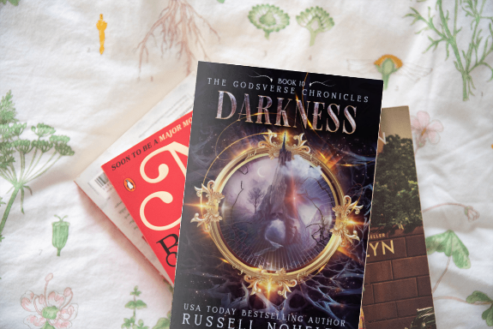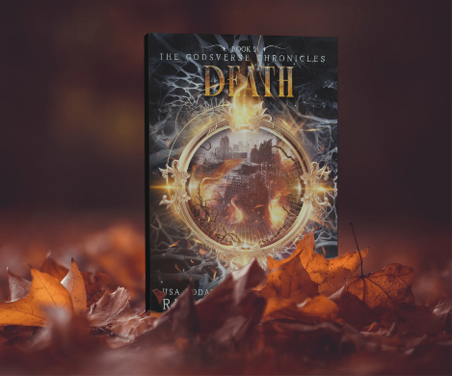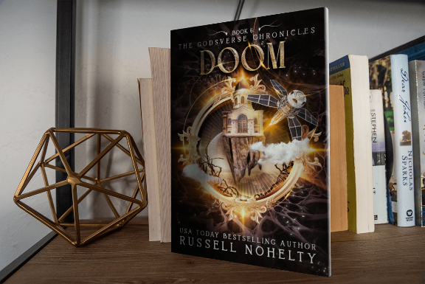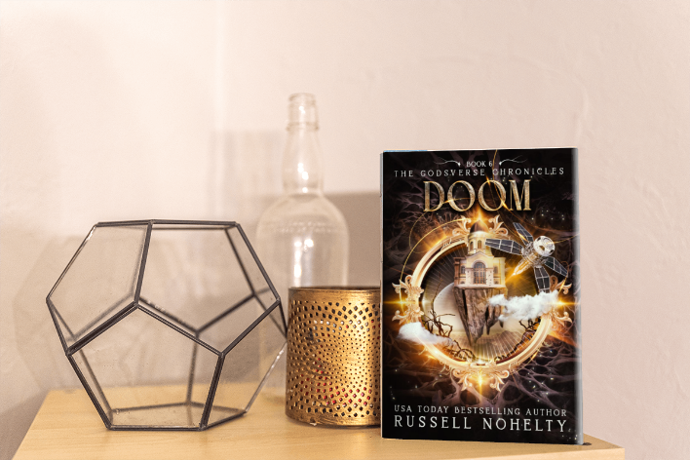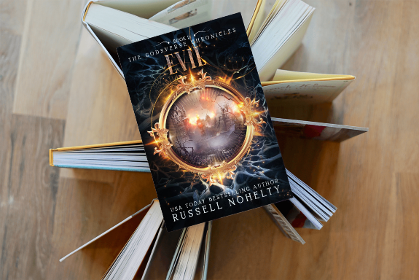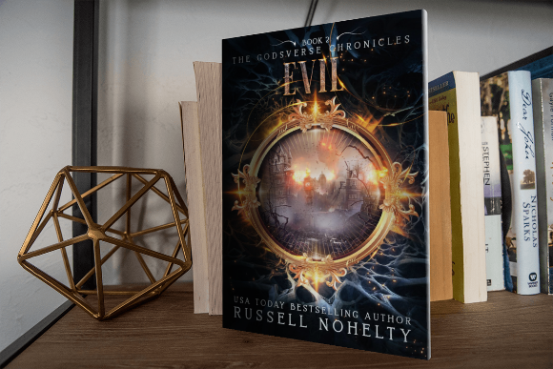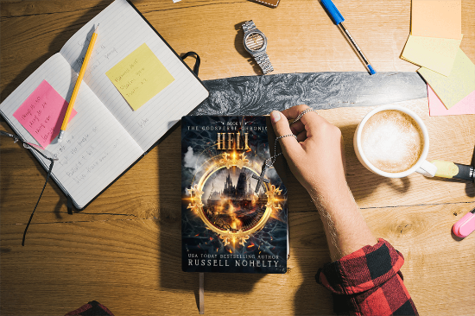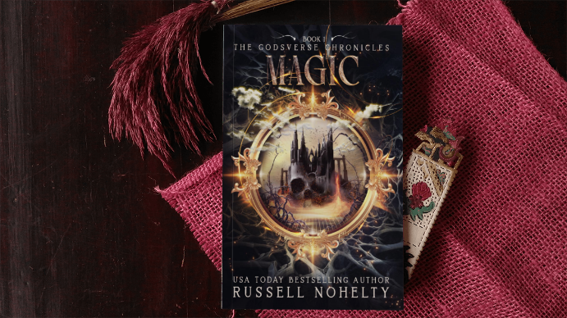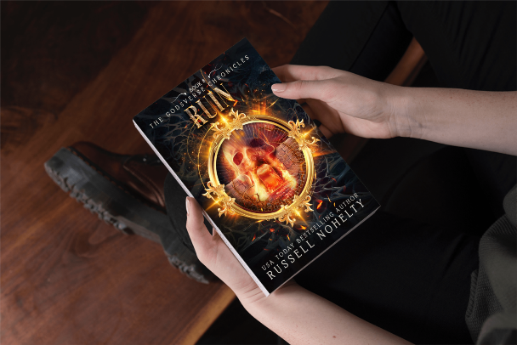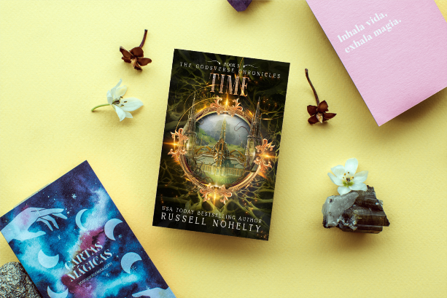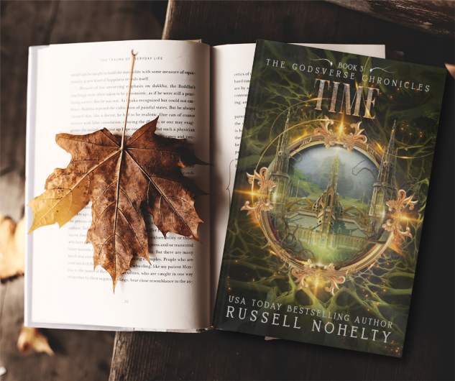

Sales page imagery: www.depositphotos.com


Other imagery:
