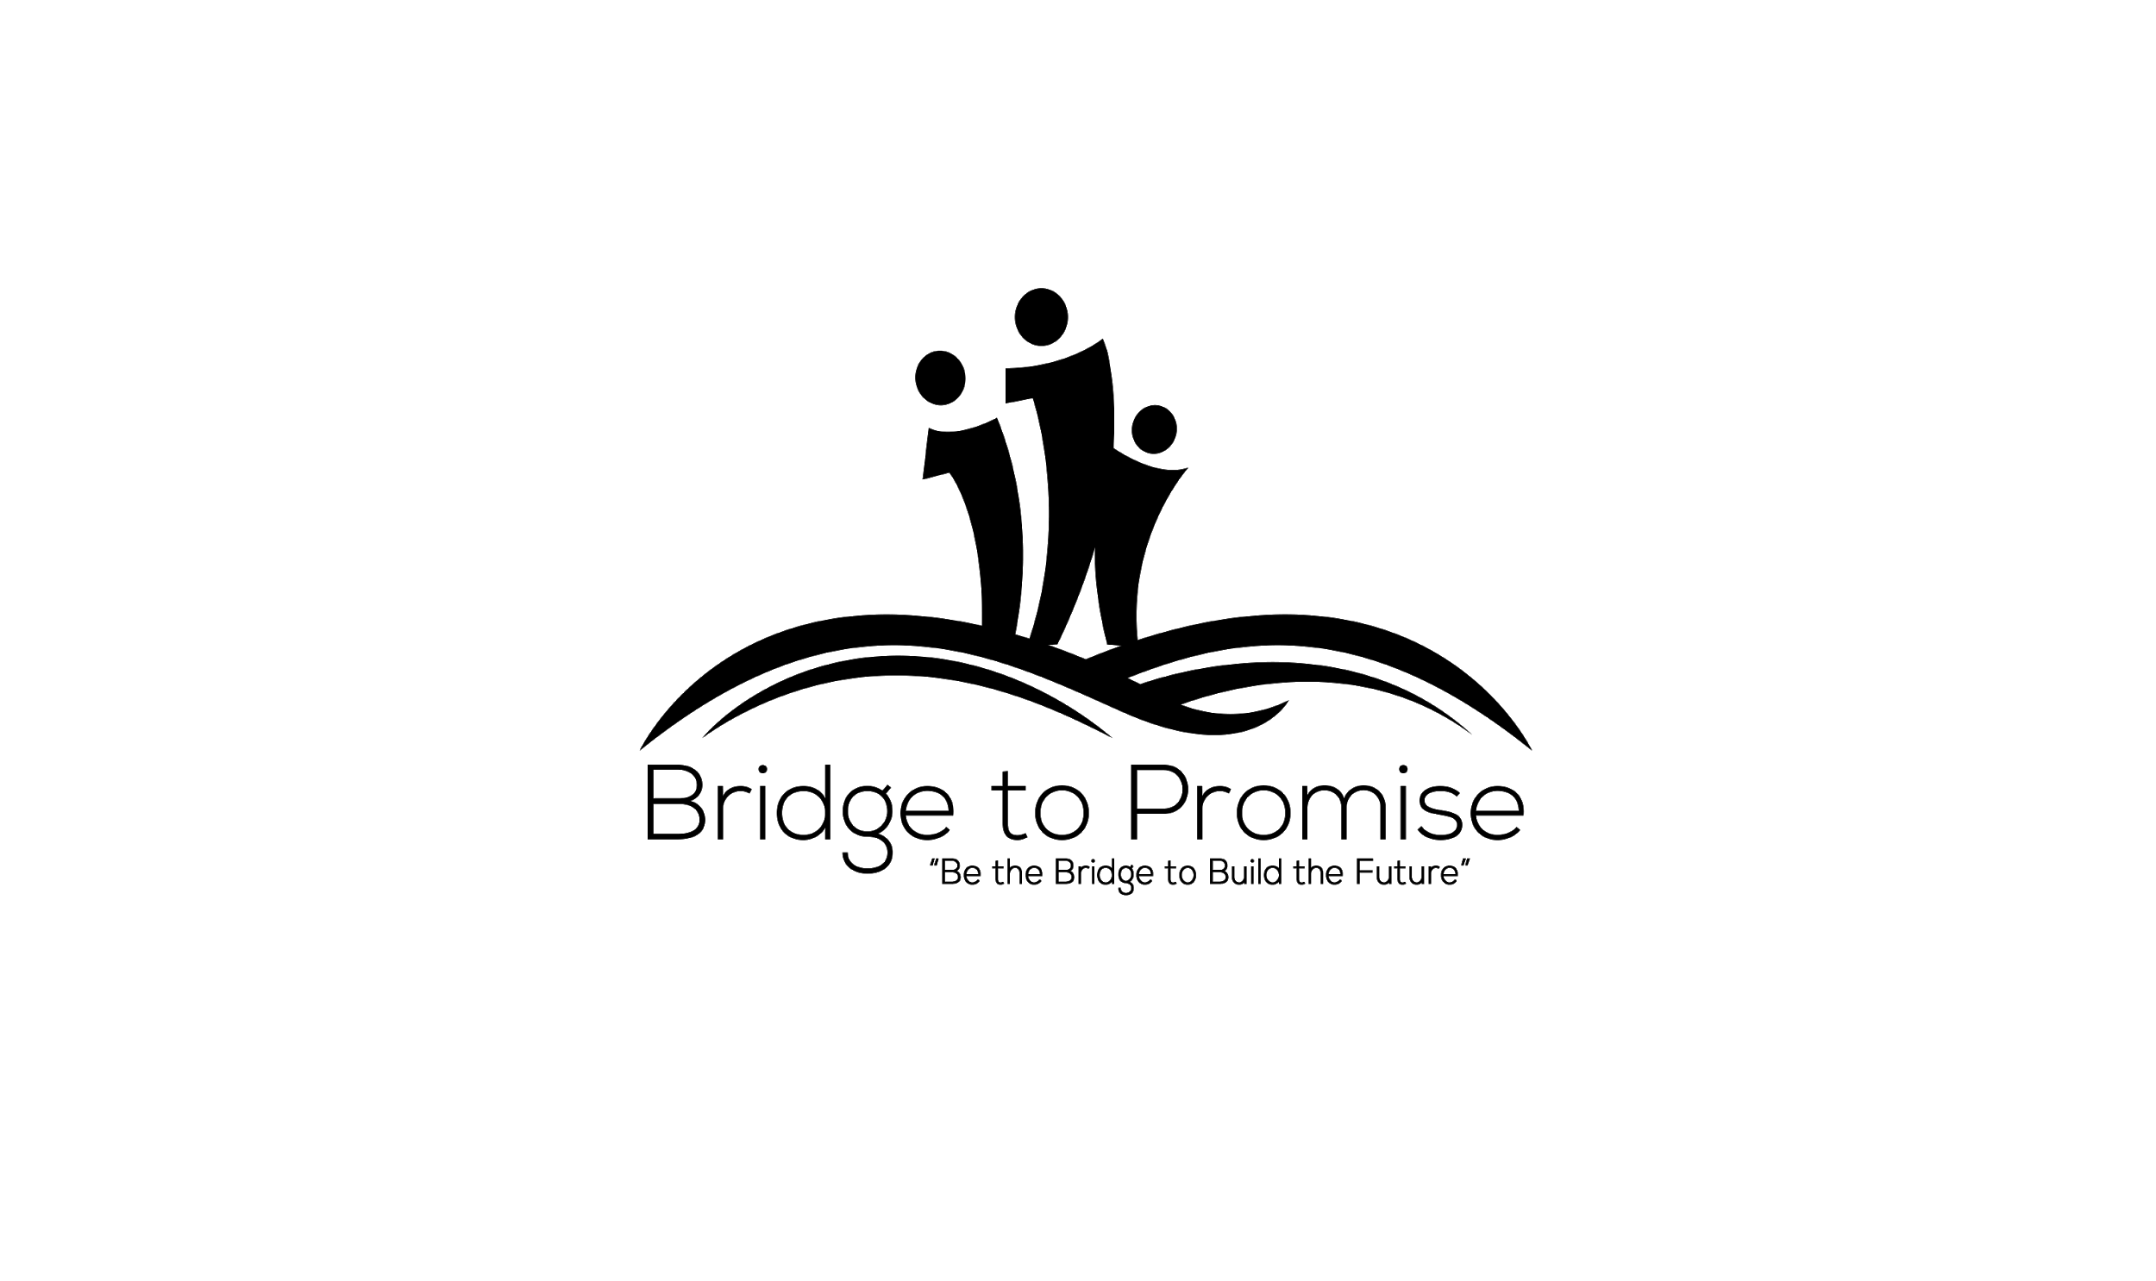

**SMART Goal Worksheet**

Today’s Date: Target Date: Start Date:

Date Achieved:

Goal:

**Make sure that your goal is SMART**

**Specific:** *What exactly will you accomplish?*



**Measurable:** *How will you know when you have reached this goal?*



**Achievable:** *Is achieving this goal realistic with effort and commitment? Have you got the resources to achieve this goal? If not, how will you get them?*



**Relevant:** *Why is this goal significant to your life?*



**Timely:** *When will you achieve this goal?*



# This goal is important to me because:



**The benefits of achieving this goal will be:**



**Action**

**Potential Obstacles Potential Solutions**



**Who are the people you will ask to help you? What are the resources that you will need?**



**Specific Action Steps:** *What steps need to be taken to get you to your goal?*

# What? Expected Completion Date Completed



**_**

