Nintex Forms for Office 365
Nintex provides Nintex forms for Office 365 which is very powerful for Office 365 SharePoint online sites. We can design forms in the browser itself and also it provides drag-and-drop functionality. Without any additional software, by using Nintex forms we can design rich and powerful forms in the browser itself.
Nintex Forms for Office 365 gives you the ability to build and customize Office 365 forms without code, including adding branding and presentation logic so your people can enter data quickly and correctly.
Design visually appealing forms with sophisticated business logic and rich HTML formatting. Customize predefined layouts for any device, form factor or screen size. Preview forms before publishing them to make certain you’re providing a great user experience.
Few Advantages of Nintex forms over Office 365.
- Nintex Forms allows you to design rich, engaging and powerful forms; all from within your browser. Access from anywhere without the need for additional software.
- Customize SharePoint list forms
- Browser based forms designer, complete control over the look and feel of forms without any coding
- Drag and Drop interface to design form
- Quick Deploy, one click Publish
- Extended form functionality above SharePoint’s own forms
- Pixel-level positioning for form layouts
- Simple publishing of forms for multiple devices
- Additional rules and conditions built into your forms
- Effortless re-branding of forms
- Seamless integration with SharePoint’s data structures
- Built-in extensibility for advanced customization
- Design forms for any device, Supports for multiple devices like Smart Phone, Tablet, and Desktop etc.
On the other hand there is no new enhancement and new features are coming in InfoPath. Though InfoPath is supported in SharePoint 2016 as well as SharePoint online but no new enhancements or features coming. Also Microsoft not yet disclosed about the alternative of InfoPath.
Supported most of the update browsers like IE, Chrome, and Firefox.

Nintex Forms for Office 365 Architecture:
Nintex Forms for Office 365 is cloud-based. Nintex Forms for Office 365 is hosted in Azure. Nintex Forms is entirely cloud-based and uses the new SharePoint App model to connect to your Office 365 environment. Nintex Forms designer is hosted directly in the cloud and streamed to users only when they need to customize forms. Being in the cloud, users benefit from always getting the most up-to-date version of the designer, taking advantage of the constant innovation Nintex delivers.
Once you’ve finished customizing your form, it’s published directly back into Office 365.

Prerequisites:
To work with Nintex forms for Office 365 you need two things only: SharePoint online site, Support for SharePoint App Model.

Office 365 Account:
Before starting to use Nintex forms for Office 365 or Nintex workflow for Office 365, make sure you have your Office 365 account is ready. Microsoft provides a 30 day free trial to check out the feature of Office 365.
Office 365 offers various licensing options for Office 365 for Business like:
Office 365 Business
Office 365 Business Essentials
Office 365 Business Premium
Office 365 ProPlus
Office 365 Enterprise E1
Office 365 Enterprise E3
Office 365 Enterprise E5
We can easily setup a 30 days trial for Office 365 Enterprise E3.
Open Office 365 Enterprise E3 site in the browser. Then click on the Free trial link in the down.
You can follow below article for more information:
https://www.sharepointsky.com/office-365-trial/

Permissions required to work with Nintex forms for Office 365:
Install Nintex Forms for Office 365 | Site collection administrator
Open the Nintex Forms designer | List: Full control  Site: Read  Site collection: Read
Publish a form | List: Full control  Site: Contribute

Nintex Forms Life Cycle
Nintex forms uses Forms filler class.The Forms filler renders the form within the context of SharePoint. For example, when a user opens a SharePoint list, a form can be triggered to open. The Forms filler reads the form XML and interacts with SharePoint to connect the user interaction, event model, and data with the list.

Cancel: The event occurs when the form button triggers the cancel event.
ControlsLoaded: The event occurs when the Forms filler loads the form controls. Restores view-state information from a previous request that was saved with the System.Web.UI.WebControls.WebControl.SaveViewState method.
DataBinding: The event occurs when the server control binds to a data source.
Disposed: The event occurs when a server control is released from memory, which is the last stage of the server control life cycle when an ASP.NET page is requested.
Init: The event occurswhen the server control is initialized, which is the first step in its life cycle.
Load: During load, if the current request is a post back, control properties are loaded with information recovered from view state and control state.
PreRender: The event occurs after the Control object is loaded but prior to rendering. Use this event to perform any updates before the server control is rendered to the page.
Save: The event occurs when the form button triggers the save event.
SaveAndSubmit: The event occurs when the form button triggers the Save and Submit event.
Unload: The event occurs when the server control is unloaded from memory. Server controls must perform any final clean-up, such as closing files, database connections and discarding objects, during this stage of the control life cycle before the instance is unloaded.

Configure Nintex Forms for Office 365 Site
Once your Office 365 site is ready you can open the SharePoint site to add the Nintex Forms for Office 365 App. Because to work with this, we have to add Nintex forms for Office 365 from Office store.
Click on gear icon -> Add an App. Then click on SharePoint Store in Your Apps page.
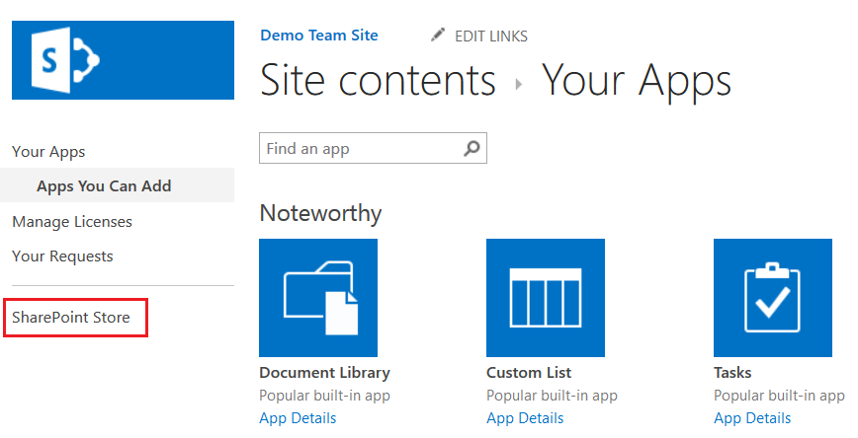
Then in the SharePoint store, search for “Nintex”
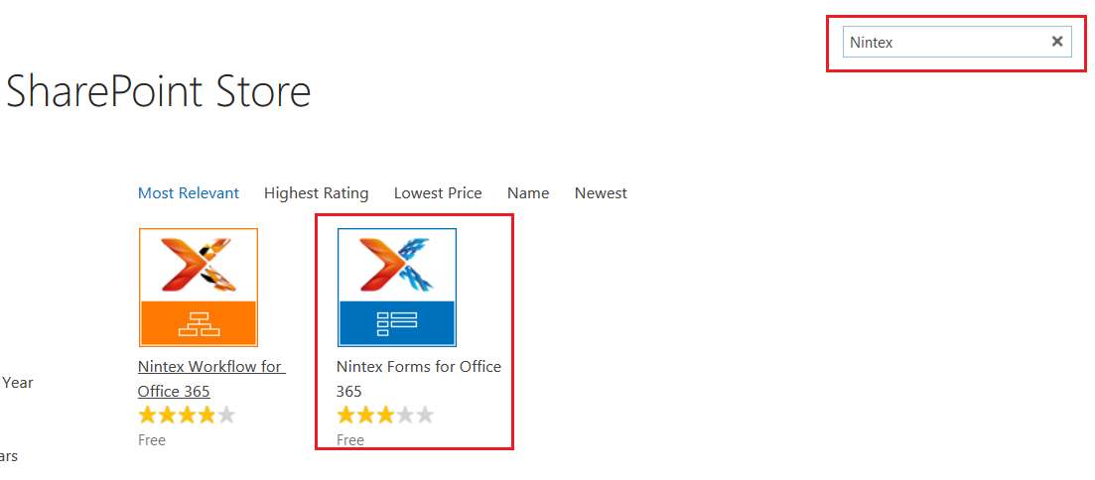
You can see two apps and one is Nintex Forms for Office 365.
Then click on ADD IT button.
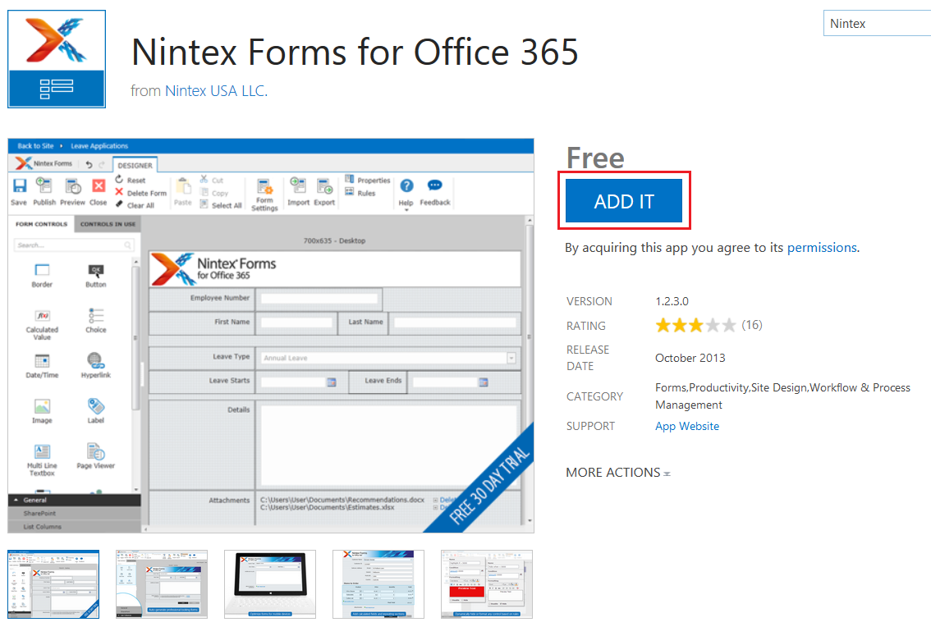
Then in the “Confirm that you wish to add the app” page click on Continue like below:
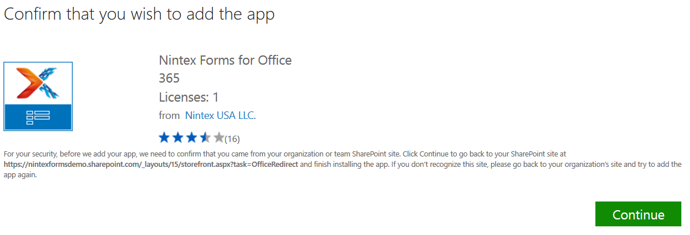
Then click on Return to the Site, but make sure you have check the check box, “Add this app to site name”.
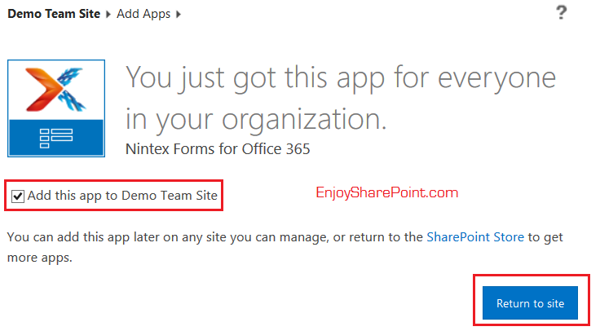
Then click on Trust It like below:
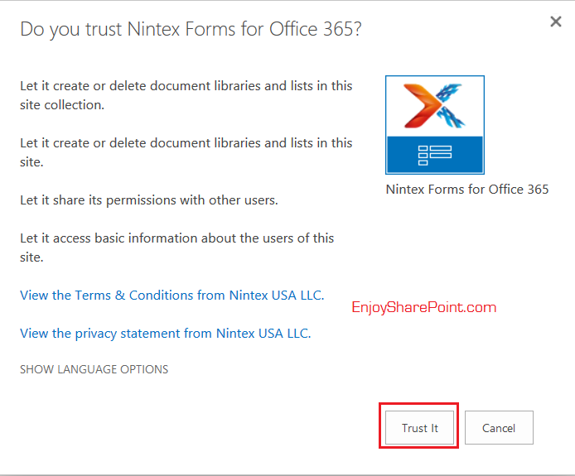
It will take some time but you can see in Site Contents page that the App has been added.
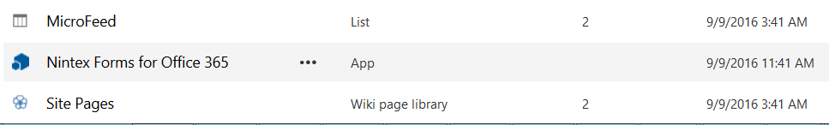
Just click on Nintex Forms for Office 365 and you can see the welcome page it will show you.
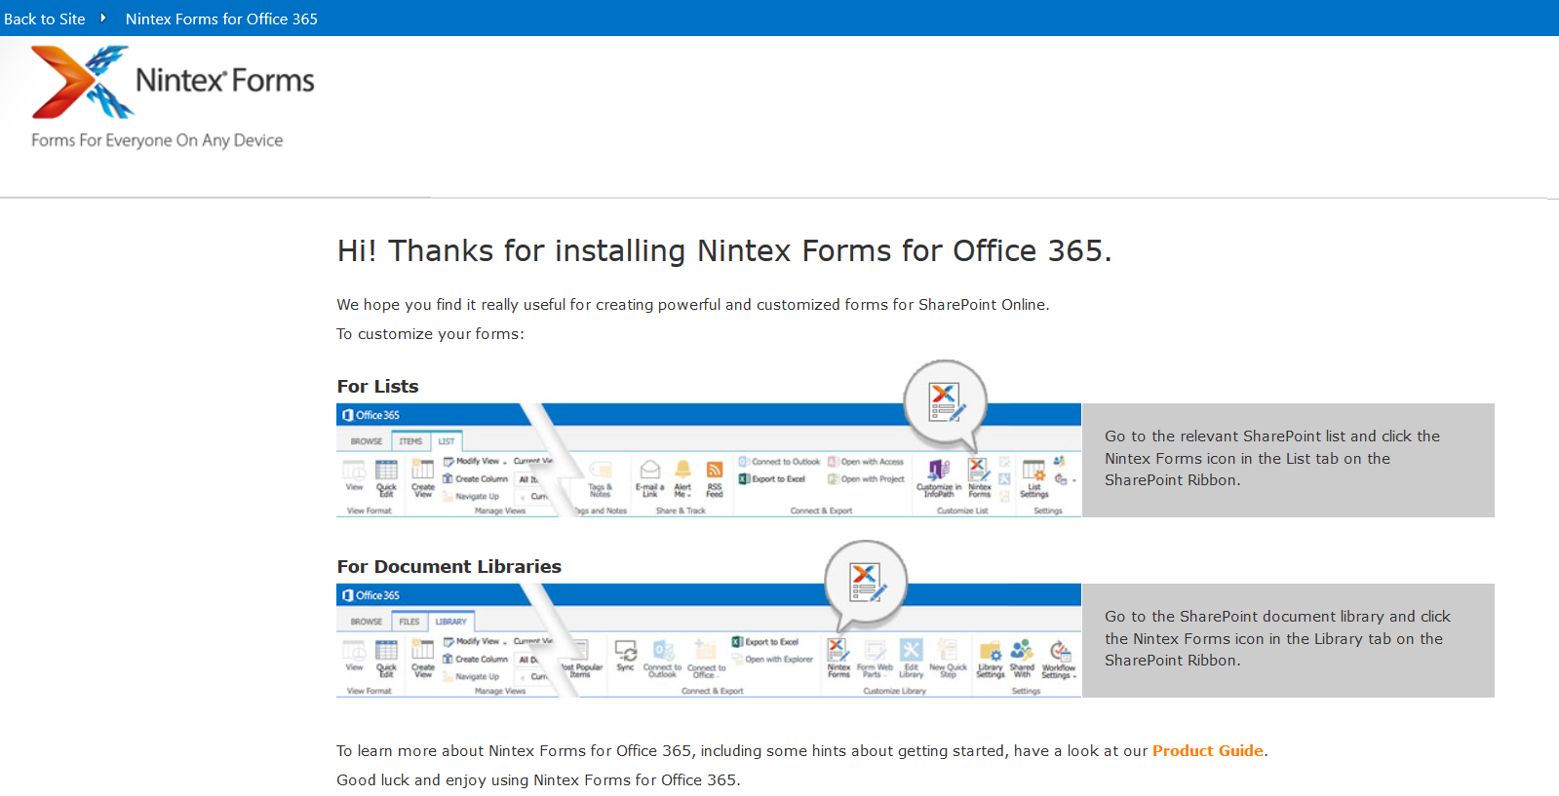

Activate “Allow Application Access to User Profiles”:
After Installing “Nintex Forms for Office 365”, as an administrator, we can allow Nintex Forms for Office 365 access to user profiles on SharePoint Online. This access is required for the “user profile lookup” runtime function.
For activating this follow the below steps:-
In our SharePoint site, go to Site contents-> click on “Nintex Forms for Office 365” app.
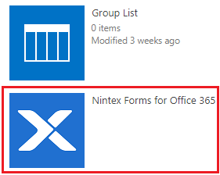
Click on “Allow Application Access to User Profiles”.
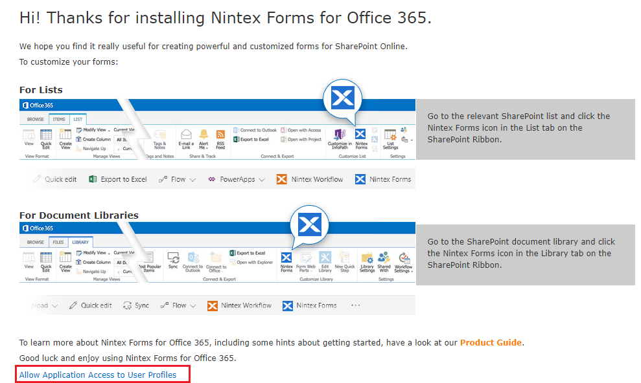
Click on ”Trust It”.
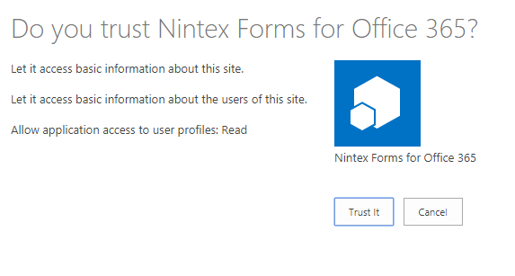
Now we can access the User Profiles.

How to Open Nintex Form Designer?
You can open Nintex form designer from List or Library ribbon tab. So before doing anything let us create a list with following fields.
Document library (new)
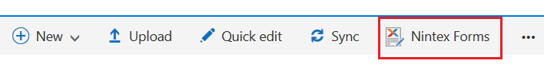
List:
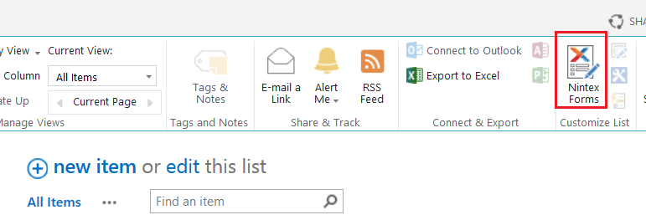
Now before starting anything let us create a list with following fields:
ITTickets
Title:
Category:
- Software
- Desktop
- Laptop
- Mobile
- Outlook
- Others
Urgency/Priority:
- Important
- High
- Medium
- Low
Due Date:
Comments:
Assigned To:
Submitter Details:
Name:
Email ID:
Contact Number:
Ticket Status:
Status: New / Assigned / InProgress/Need More Information/Resolved/Close
Additional Comments:
The site columns looks like below:
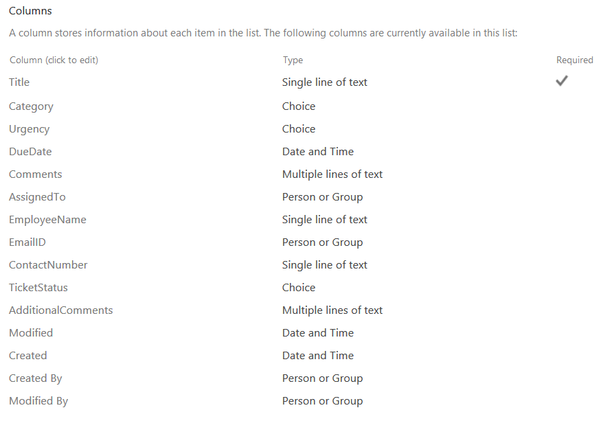
And the default list form looks like below:
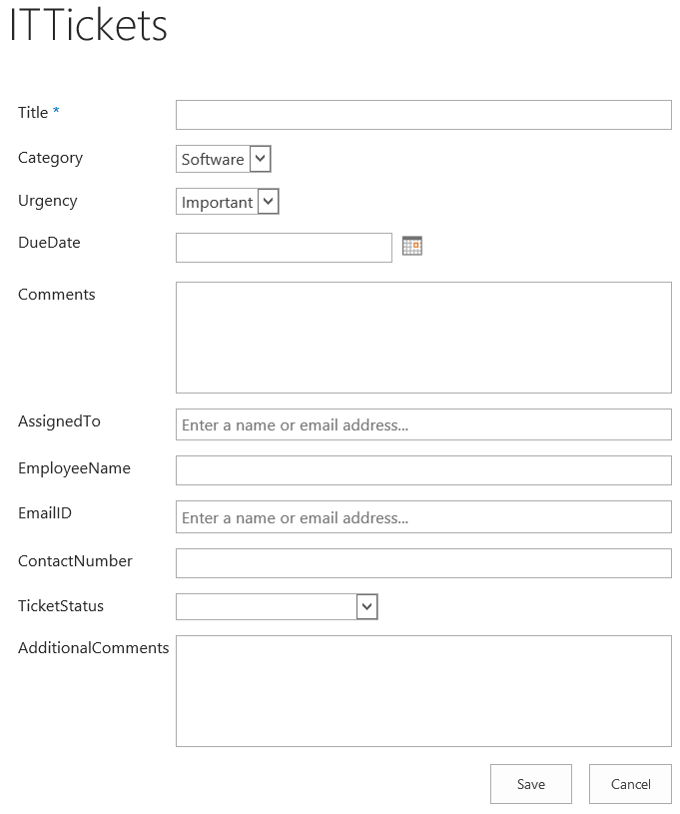
Now we can see how we can customize the form using Nintex.
Open the list, from the ribbon click on “Nintex Forms” like below:
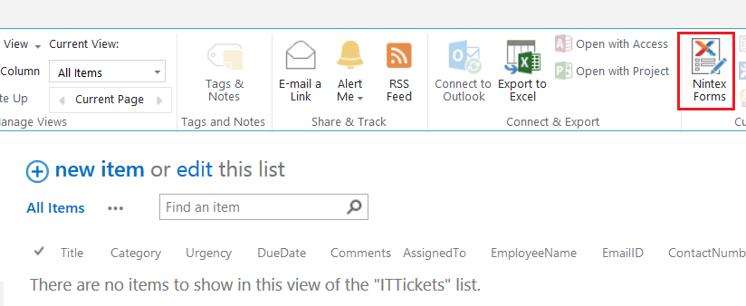
If you are first time then it will ask few information like First Name, Last Name, Email address and Country. Else if you have subscription key if you have any.
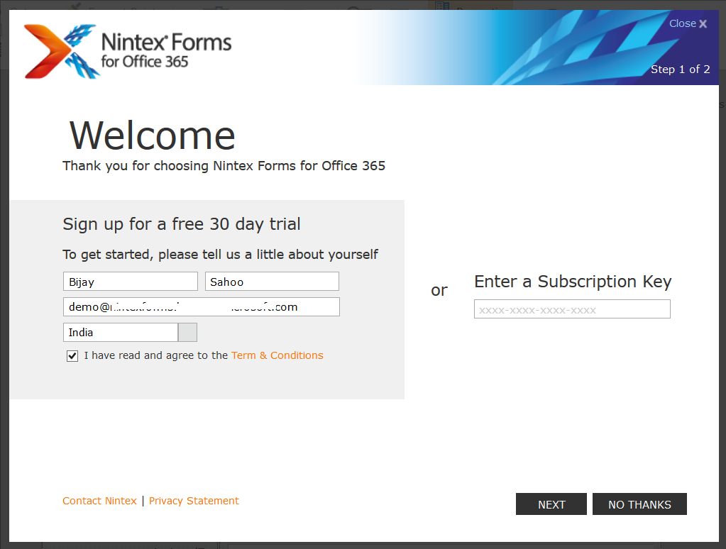
If it is a trial period it will display how many days remaining from your trial period.
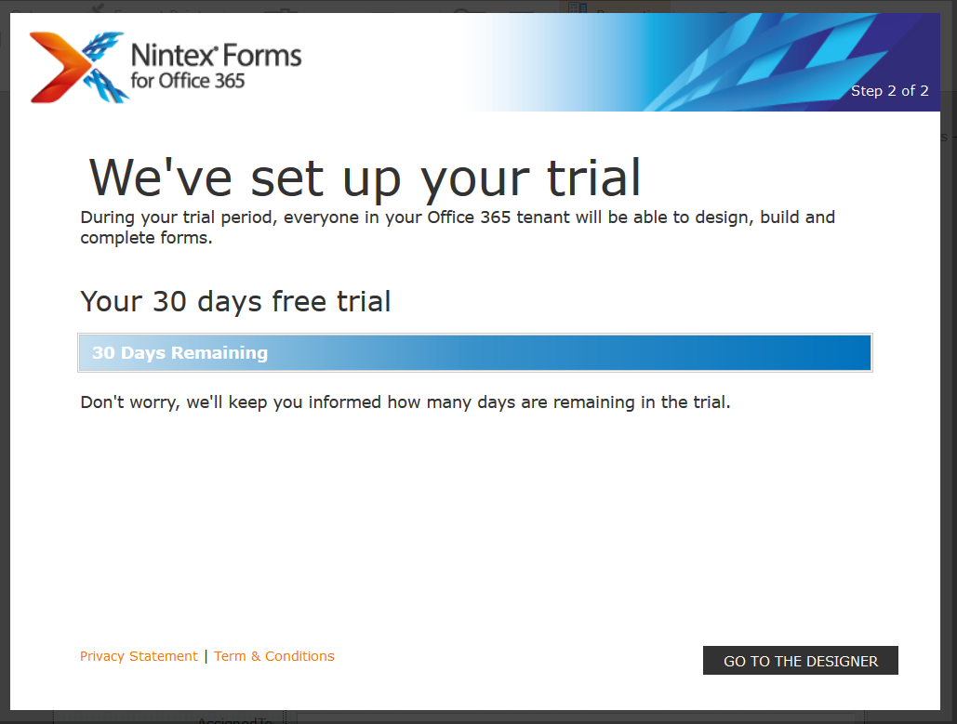
Then it will open the Nintex designer.

Types of Forms we can create using Nintex:
We can design two kind of forms:
- List Forms: We can design List forms which will be associated with the lists.
- Task Forms: The form displayed to users interacting with tasks assigned using the actions Assign a task and Start a task process. One task form exists per task action. Task forms are supported for both list and site workflows.

Various Components of Nintex Forms Designer:
When you click on Nintex Forms from the list ribbon, it will open the Nintex Forms designer and you can see various components on this.

Nintex Forms- Designer Tab:
The blow is how the Nintex forms designer tab looks like:
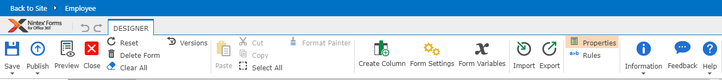
Save: Click on save. It will display two options Save and “Save and Close”.
- Save: It will save the form but not published yet. We can continue editing on the form.
- Save and Close: It will save and closed the designer immediately.
Publish: Click on save. It will display two options, Publish and “Publish and Close”.
- Publish: It will publish the form but not closed.
- Publish and Close: It will publish and closed the form.
Preview: Preview the form in different device layouts. Click on Preview button it will open up preview settings dialogue box.
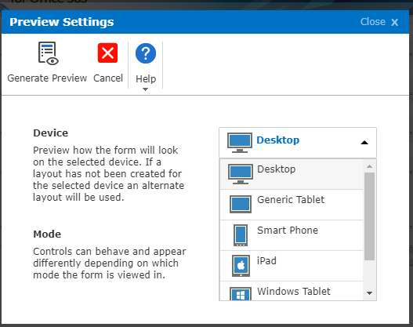
In Preview settings:
- Device: different device layouts available for the form look and feel.
- Following the device layouts:
- Desktop.
- Generic Tablet.
- Smart Phone.
- Smart Phone
- IPad.
- Windows Tablet
- Android Tablet
Mode: Controls can behave and appear differently depending on which mode the form is viewed in. Different modes available here like New, Edit, and Display. Default Mode is Edit.
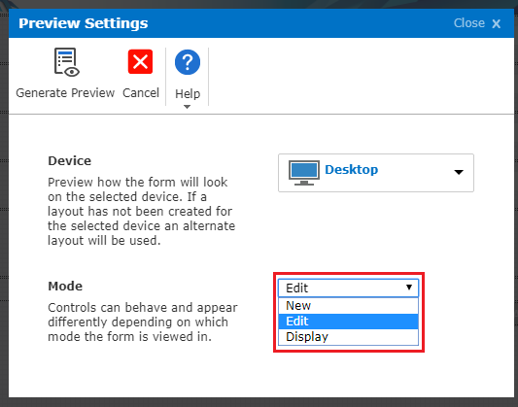
Close: Close the Nintex form designer without saving the changes. When we click on this button it will pop up the Confirm dialogue box with the message as shown below. If we want close click on Ok button (it will take to us back to our SharePoint list) or to cancel click on cancel button (continue on the Nintex designer form).
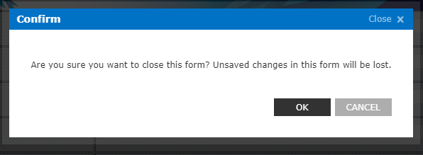
Note: First click on the “Save” button then you can click on the “Close” button on the Designer tab. It will directly close the form without any confirm dialogue box.
Reset: It will reset the current form to the original. It means whatever changes we have done everything will be gone (before/after publishing the form also).
When we click on this button it will pop up the Confirm dialogue box with the message as shown below. If we want to reset the form click on the Ok button or to cancel click on cancel button.
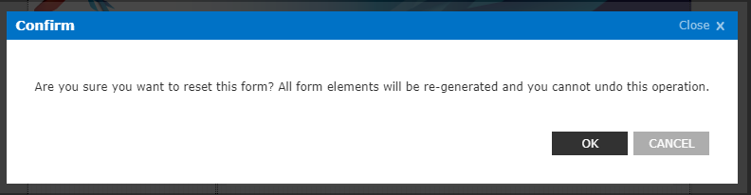
Delete Form: It will delete the current form then it will take back to the current SharePoint list which we have created a form.
When we click on Delete Form on the designer tab it will pop up a confirm dialogue box with the message “are we sure want to delete this form?” as shown below. If we want to delete click on OK or do not want to delete click on CANCEL.
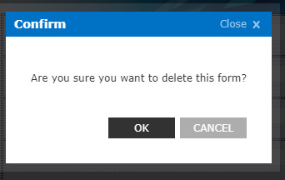
Clear All: It will clear all items from the current form. When we click on “Clear All” on the designer tab it will pop up a confirm dialogue with the message “Are we sure we want to clear this form? This form, including any layouts, will be discarded”.
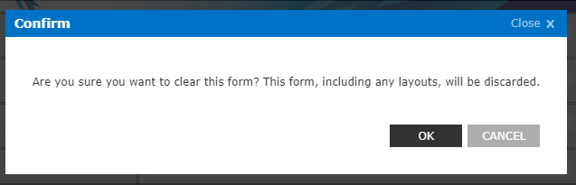
Versions: It displays the versions history of the current form. Click on “Versions” on the Designer tab. Here we can see the version history (version number, date and time) of the current form.
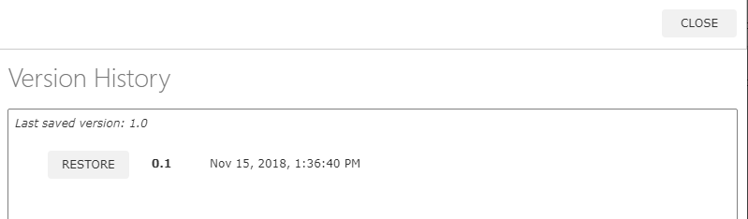
Note: Unfortunately we click on “Reset” button on the designer tab do not worry about the changes lost in the form. Click on the “Versions” button on the designer tab will show the versions history of the form with “Restore” button. Click on “Restore” (which version you want to restore the form) button will restore whatever changes you made on the form.
- When you click on the “Save” button, it will generate a “minor version” for the form like 0.1, 0.2, etc.
- When you click on the “Publish” button, it will generate “major version” for the form like 1.0, 2.0, etc.
- After publishing (it will generate the major version), if you did any changes on the form then click on “Save” button. It will generate new versions for the form like 1.1, 1.2, etc.

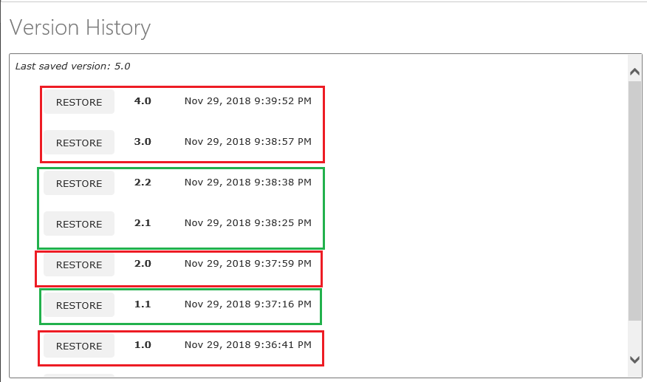
Select all: It will select all controls on the current layout (on the current form).
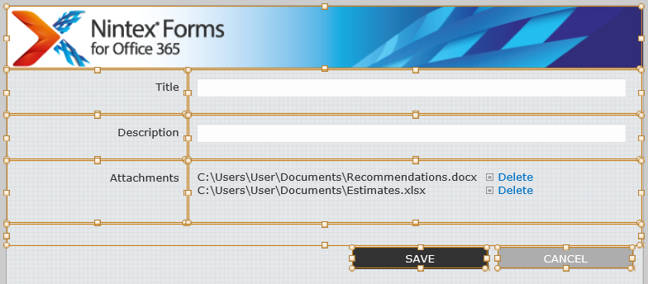
Format Painter: This can be used for copies formatting from the selected control for pasting to another control.
Example:
Select a control on the form. Designer->click on “Format Painter” or use shortcut (Cntrl+Shift+F).
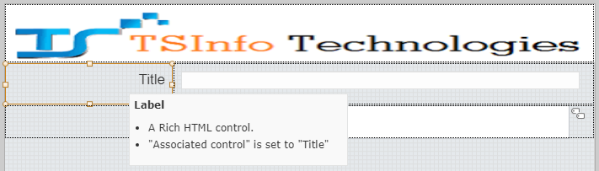
Next select other control which we want to apply the changes.
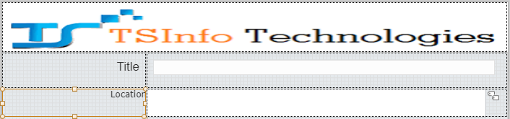
Just click on the selected control then form painter will be applied.
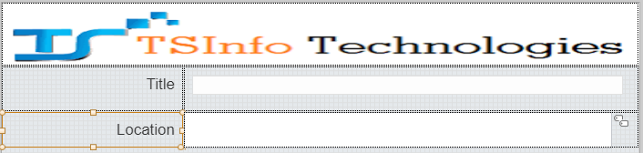
Create Column: We can create columns using Nintex forms for office 365 just click on Create Column on the Designer tab. It will open up a dialogue box and configure the details. This new column is automatically added in our SharePoint List.
From Settings: We can configure the settings for this form including from styles and custom JavaScript.
Custom CSS: Add custom CSS code in the Custom CSS section in the form settings as shown below. It has a default CSS code.
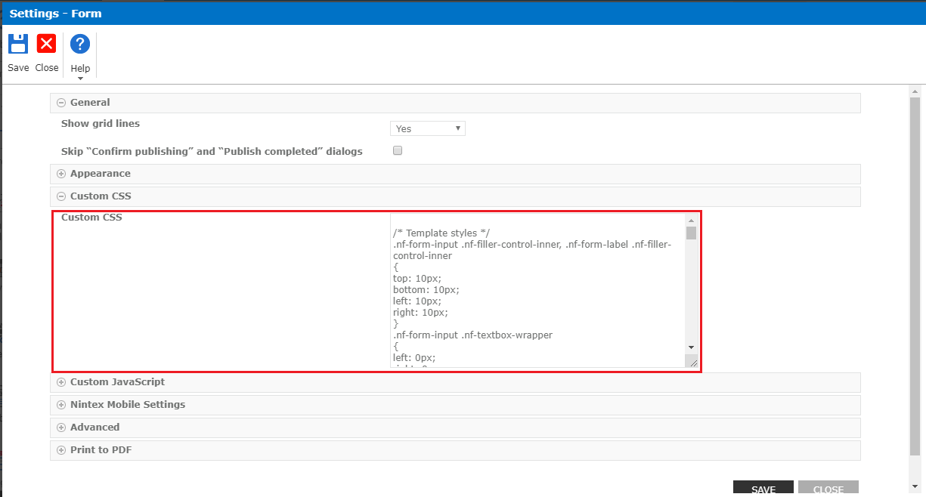
Custom JavaScript: Add custom JavaScript code in Custom JavaScript section in the Form-Settings.
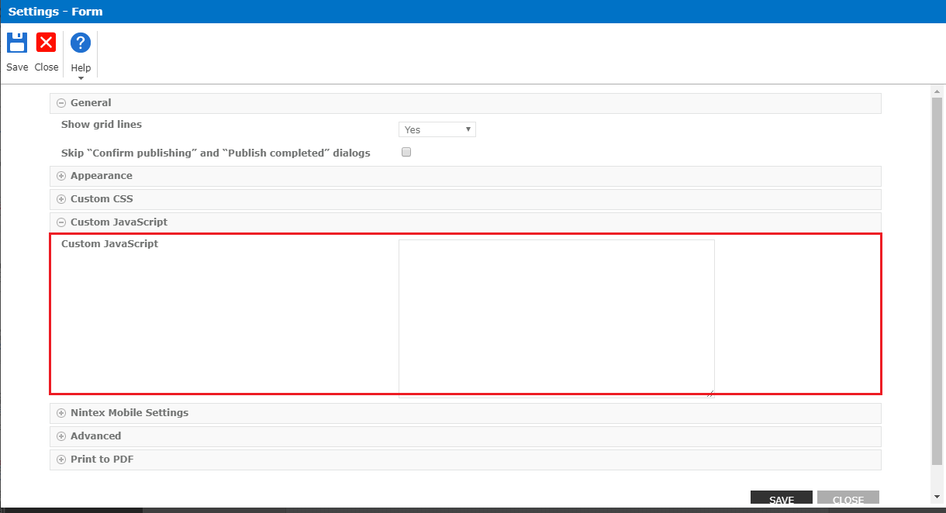
Include CSS and JAVASCRIPT URL’s: Add JavaScript and CSS reference links in the Form-Settings. For example, I have added CSS link in the Custom CSS include and Script tag in the Custom JavaScript Includes.
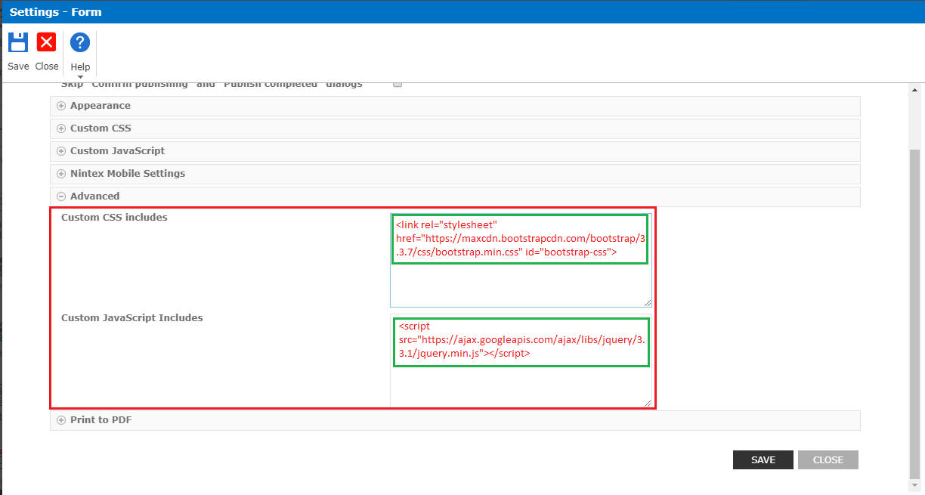
Form variable: Form variables provide the ability to manage variables on the form. They behave like just calculated value and bound to the columns list without the need to be displayed in the form itself. Click on the form variable on the designer tab.
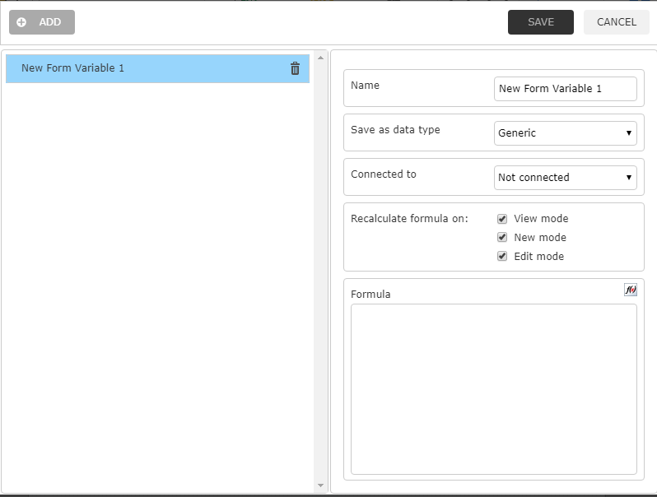
Example:
Create a form variable:
- Click on the ADD button.
- Name Enter the name of the variable.
- Formula: Select “Current User (Email)”.
- Click on “SAVE”.
Note: This variable added in the “Named Controls” of “INSERT REFERENCE” panel.

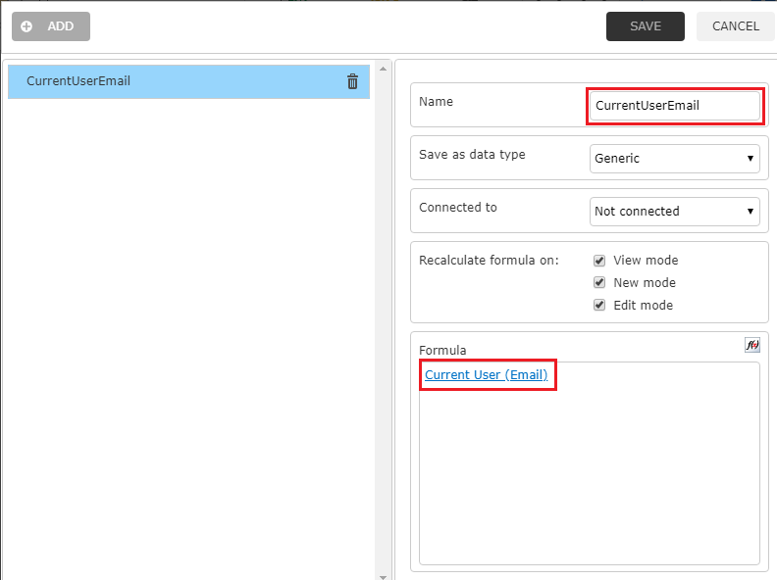
Drag and drop the control on the form.
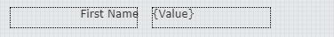
Double click on the calculated value and configure the details.
- Formula: userProfileLookup(_CurrentUserEmail, "FirstName")
- “_CurrentUserEmail” select from the Named control.
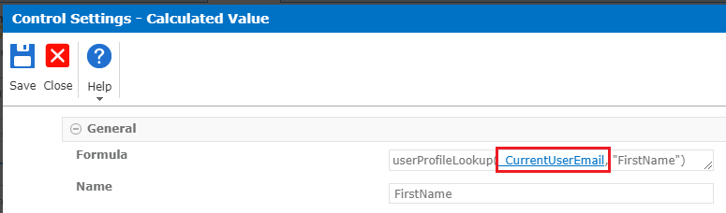
Now the First Name of the user retrieved from the user profile.
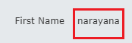

Export: This can be used to Export form definition to NFP file. Click on Export on the designer tab and saved the file with extension as”.nfp”.
Import: This can be used to import a saved Nintex forms export file (.xml, .nfp). Click on Import on the designer tab and import the file.
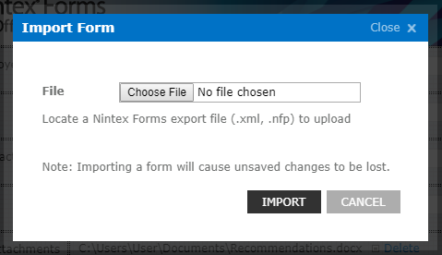
Properties: It will show or hide the property pane. Click on properties on designer tab, It will appear on the right side of the Nintex designer canvas.
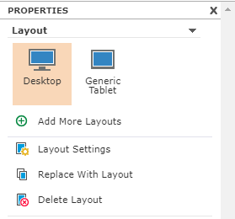

Add More Layouts: Different layouts are available. So we can add here by clicking on “Add More Layouts”.
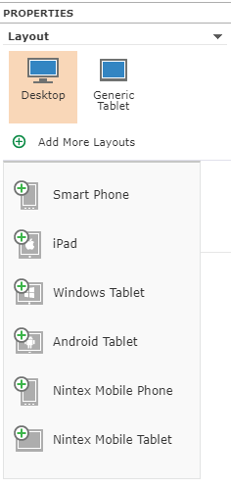
Layout Settings: This can be used for configuring the settings of the current form. Click on Layout settings it will popup Setting- Layout Dialog box. Here we can change the width and height of the current form.
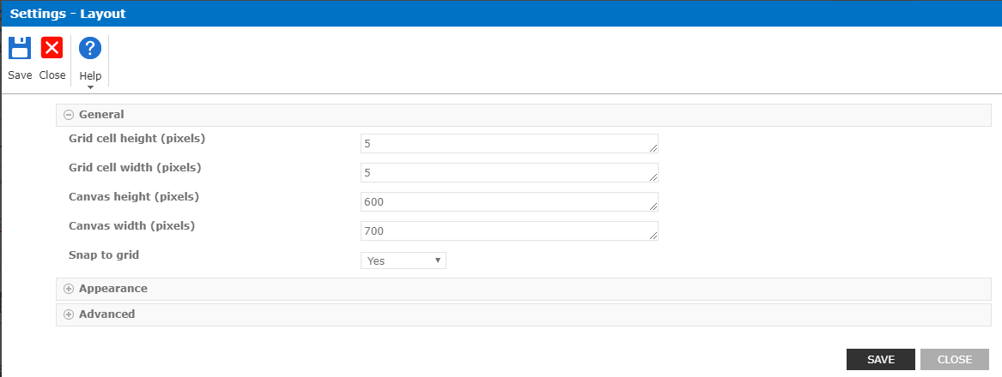
Replace With Layout: It will replace the current layout with the selected layout.
Example:
How to change the Smart Phone Layout to Generic Tablet Layout?
We have to create two New Layouts in the Properties pane like Smartphone and Generic Tablet Layouts.
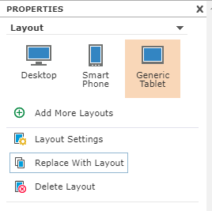
Smartphone Layout: This is a Smart Phone Layout.
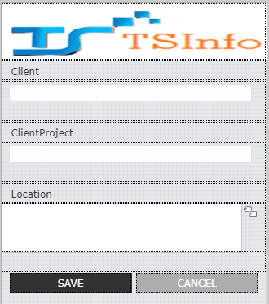
Generic Tablet: this is a Generic Tablet Layout.
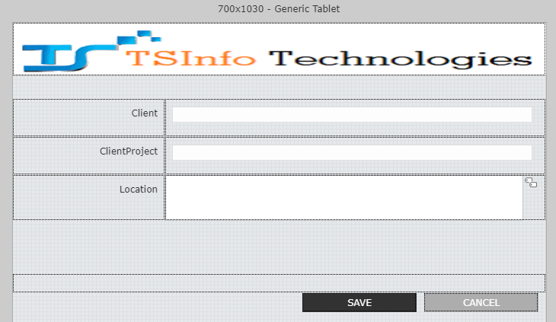
Now select Generic table and click on “Replace with Layouts” from “Add more Layouts” then it will pop up a dialogue box.
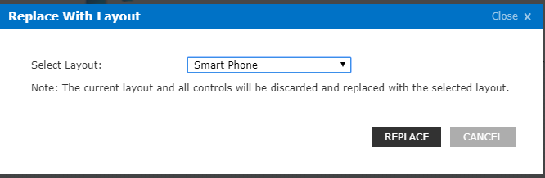
Select Layout from the drop-down which we want to replace with the layout.
- Select Layout: Smart Phone.
- Click on Replace Button.
Now it will pop up a confirm dialogue box with a message.
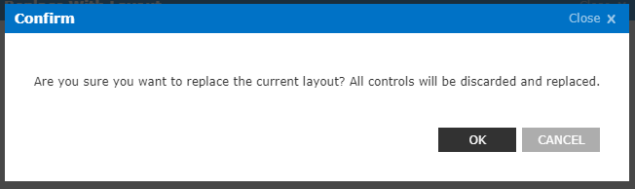
Click on OK.
Now the Generic Tablet layout Replace with Smart Phone Layout as shown below.
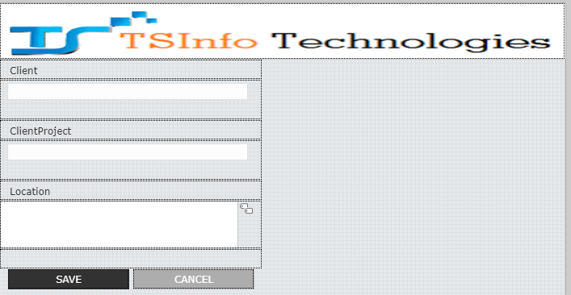
Next, go to the Properties panel -> select Generic Tablet -> Layout Settings. Change the width height of the canvas (width and height pixels are from the Smartphone device).
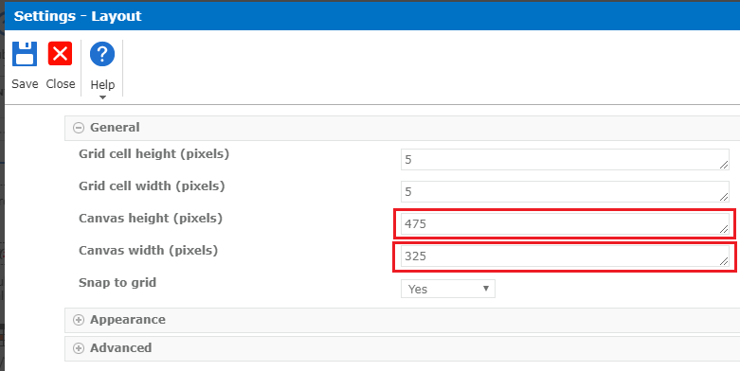
Now the Smartphone layout will be ready.
Delete Layout: It will delete the layout(s) from the properties panel. If you want to delete the layout from properties panel select the layout which you want to delete and click on Delete Layout.
a>b Rules: Show and hide the Rules task pane. It will display the Rules task pane when we click on Rules on the designer tab. To add the rules to the control, click on “Add” on the Rules.
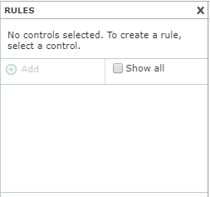

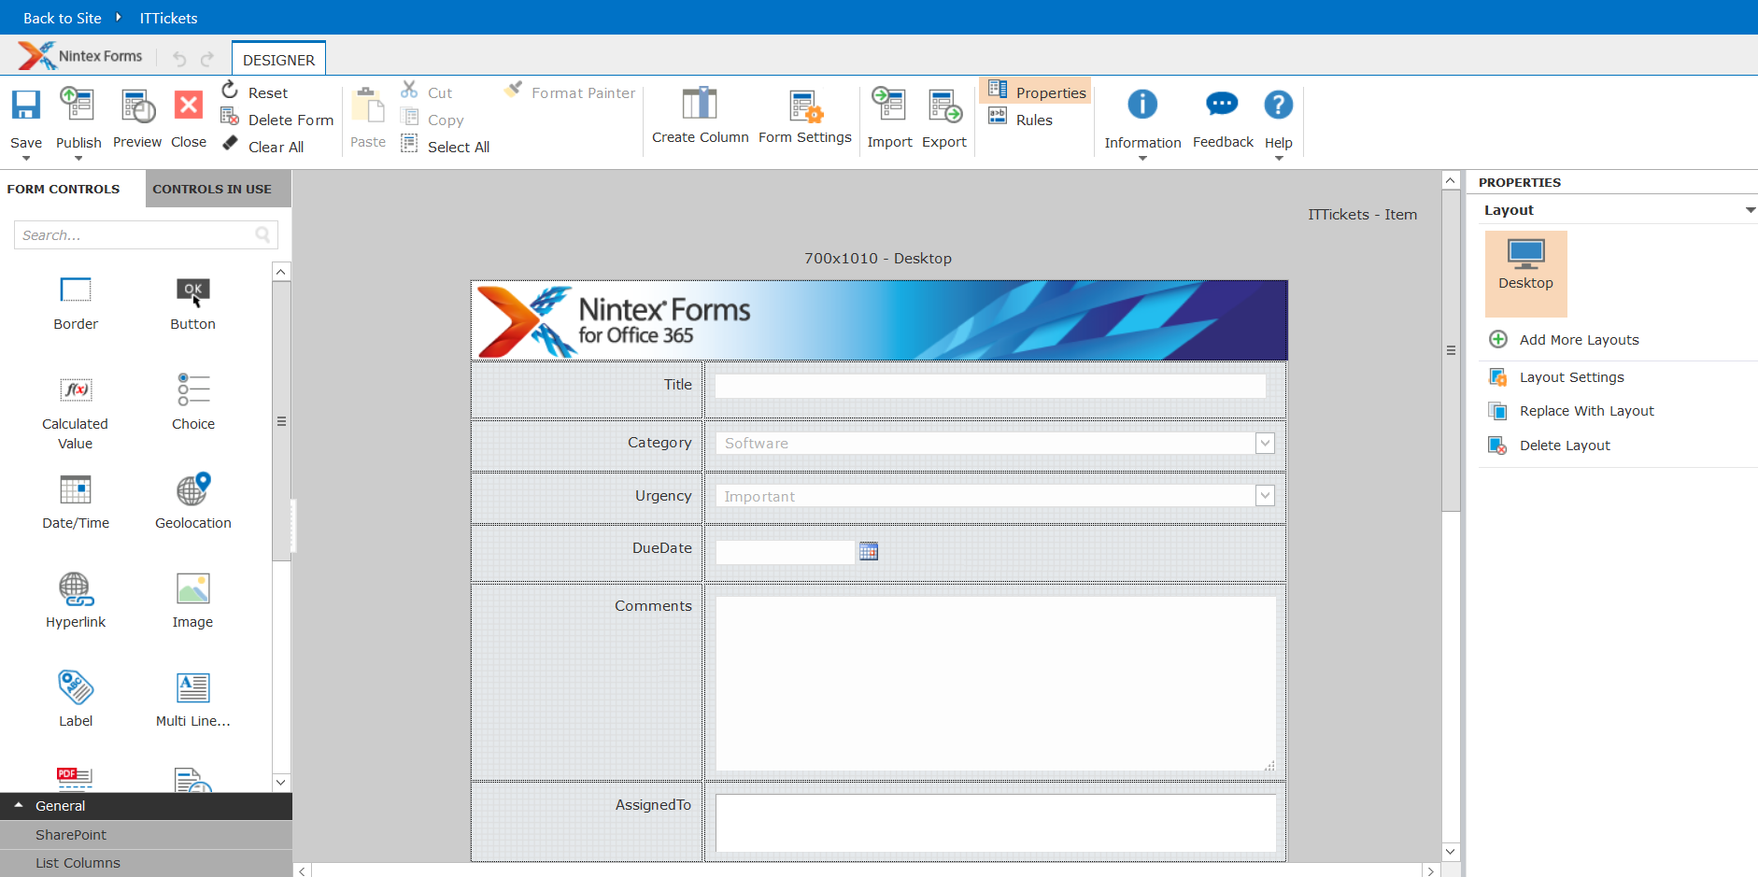

Nintex Forms Designer Forms Controls:
Form control tool is available on the left side of the Nintex from the designer. It displays the controls that can be added to forms in the designer canvas.
Follow the Default categories of Form Controls:-
Nintex Forms – General Control:
These are the unconfirmed controls means we can add or remove the control to/from the Nintex designer canvas.

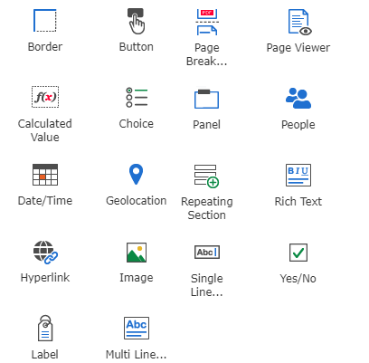

Border: It displays lines on the borders of the control. Now will see some examples how to add a border on the control.
Control settings of Border control: Double click on border control, Control Settings dialogue box will open up as shown below. It contains fields and options for this form of control.
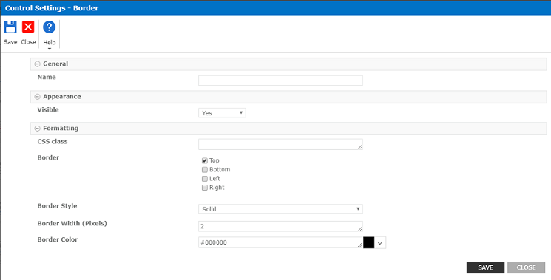
How to add borders and colors to the Label control?
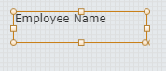
For example, drag and drop label on the form then double click on it, for adding border and colors to the label go to the “Formatting section” in the control settings of the label.
- Border: Select top or bottom or right or left to apply the border to the label on the form.
- Border Style: Select border style from the list of styles from the dropdown.
- Border Width: 2(by Default).if we want to increase the border with here.
- Border color: Select border color, click on color picker near to the textbox.
- Padding Width: none (by Default). Here Enter padding width is ‘10’.
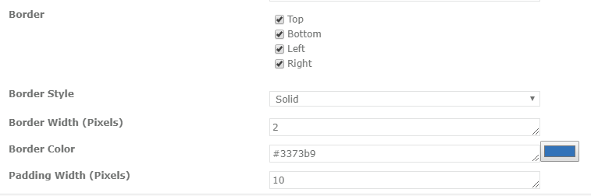
Border and colors are applied to the label as shown below.
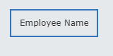
Button: it is initiating actions such as submitting a form or custom JavaScript. For example, button control is look like as shown below(drag and drop on to the form).
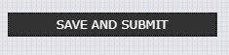
Control settings of Button control: Double click on button control, Control Settings dialogue box will open up as shown below. It contains fields and options for this form of control.
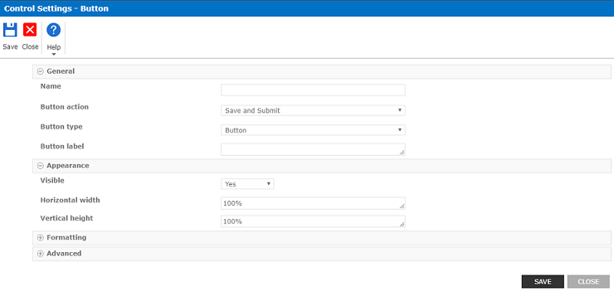
- Name: Assign a name to the control.
- Button action: Specify the function of the button. Select one of the following options.
- Save: It will save entered data to the list and closes the form.
- Save and Continue: It will save entered data to the list without validating for required controls (rule or control configuration).
- Save and Submit: It will save entered data to the list and closes the form.
- Cancel: It will discard entered data and closes the form.
- JavaScript: Option for specifying custom functionality.
- Button type: It will display the type of the button. Select one of the following options.
- Button: Superimposes the text on a clickable rectangle.
- Image: Displays the specified image within a clickable rectangle.
- Link: Formats the text as a link.
- Button label: display the text on the button control.
How to change the name of the button?
It is our Nintex button control with name “SAVE AND SUBMIT”.
Now we will see how to change the name of the button. To change name double click on the button control.
- Name Submit (enter the name of the button).
- Button action: Save (Select Button type from the drop-down).
- Button Type: Button (Select Button type from the dropdown).
- Button label: Submit (It will display the text on the button control).
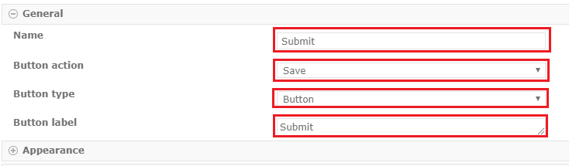
Now button name changed to “SUBMIT”.
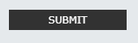
F(x) Calculated Value: It performs the calculation or concatenation and displays the result at run time.
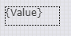
How to use Calculated value in nintex form?
For example, we need to calculate the Quantity and Unit Price of the product. So we need a calculated value control doing calculations.
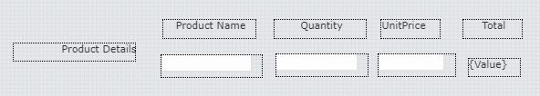
Double click on Calculated Value control, Control Settings dialogue box will open up as shown below. It contains fields and options for this form control.
- Formula: Quantity*Unit Price (name of the field controls selected from the “Named Controls” and “*” selected from the “Operators” from the “INSERT REFERENCE “panel).
- Name: enter the name of the calculated control.
- Save as data type: Currency (select from the drop down).
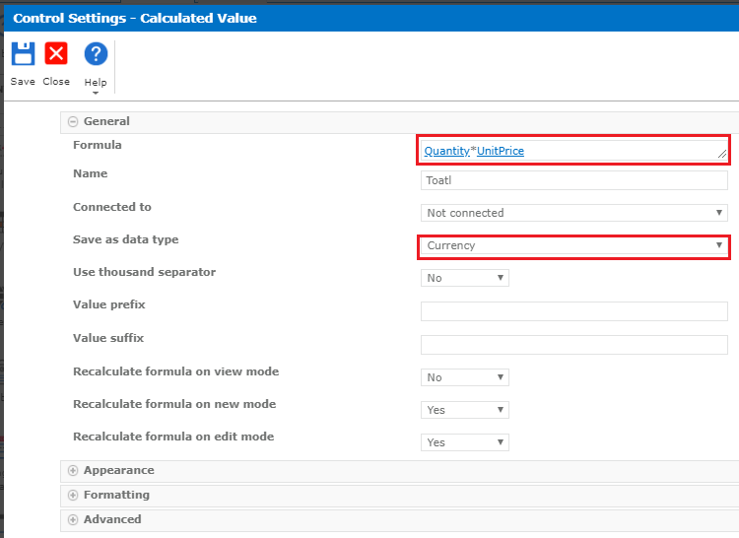
Enter values in the fields Quantity and Unit Price. Now values will be calculated and displayed on the form.
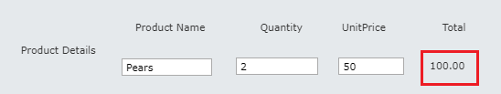
What is Value Prefix and Value Suffix in Calculated value?
Value prefix: The prefix for the value. It will display the before the value.
For example, we have to display text before the calculated Value.
Double click on Calculated Control Enter text in “Value Prefix” field.
After entering the text in the Value prefix field.
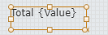
After save and publish the form it will appear like below.
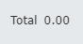
Value suffix: The suffix for the value. It will display the after the value.
After save and publish the form it will appear like below.
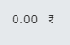
Choice: Choice control used to select one or more selections on the from.
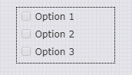
Control settings of Choice: Double click on Choice control, Control Settings dialogue box will open up. It contains fields and options for this form control.
- Name: It is used to assign a name to the control.
- Connect to: It is used for the field to bind the input control.
- Display format: It is the type of choice control to display. Select one from the following options.
- Checkboxes (Multiple-Selection)
- Drop down list
- List (Multiple-Selection)
- Option buttons
- Choices: Enter choice here to display.
- Default Value: Set the default value for the control. It is used to if no default value specified for the connected field.
- Arrange choice: Here we can specify the arrangement of the choices. Select one from the following options.
- Across then down
- Down then across(by default)
- Number of columns: used to display a number of columns to based on choice.
- Column alignment: used to specify the alignment of the columns. Select one from the following options.
- Fixed: It will align choices in fixed columns.
- Floating: It will allow choices to float.

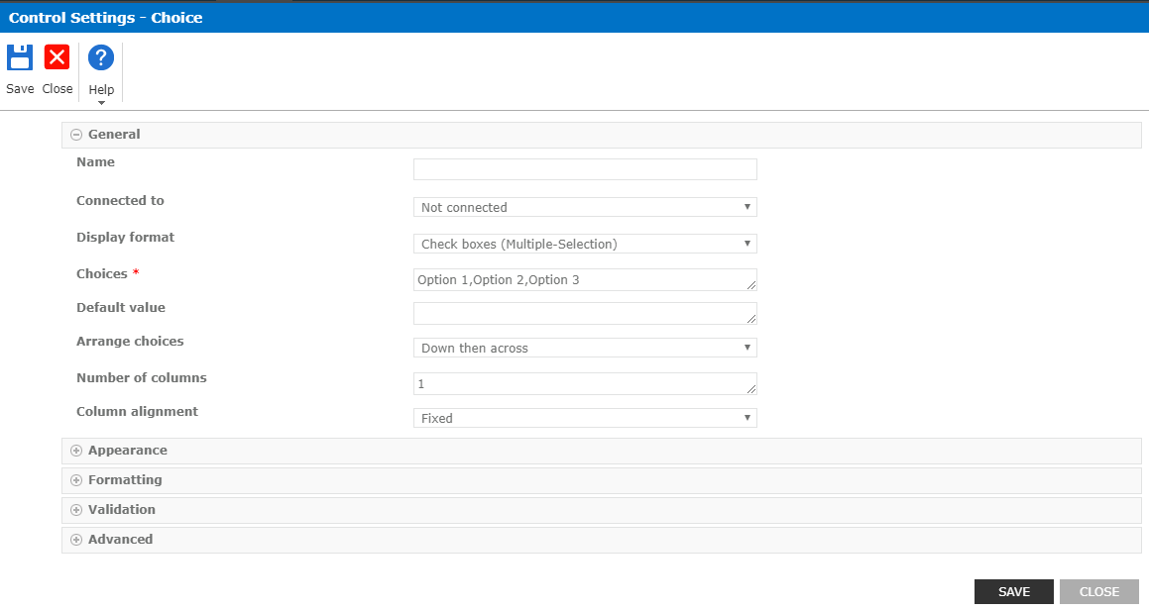
How to create a choice field?
Double click on choice control and configure the details.
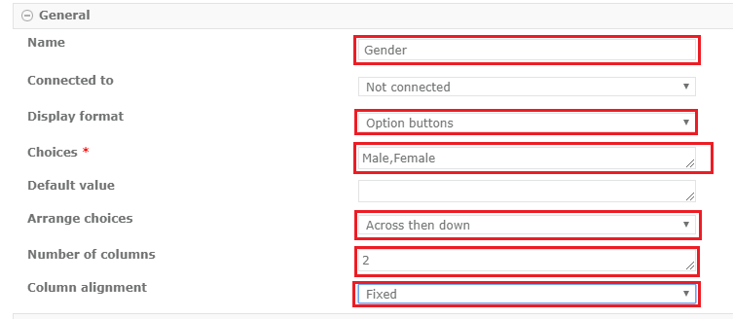
- Name: Enter a name to the control.
- Connected to: used to connect to the input control.
- Display format: Select Option buttons from the dropdown. It will appear as radio buttons.
- Arrange choice: Select “Across then down”.
- Number columns: Enter the Number in the text box to display the choice in the form.
- Choice: Remove the default options then enter our choice like Male and female separated by comma (,).
- Column alignment: Select “Fixed”.
- Save and publish the form.
Choice controls.
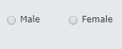
If you select Column alignment as “floating” then it will appear in two columns.
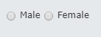
If you enter column number as “1” in the “number of columns” field then it will show in one column.
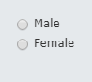
Date and Time: This control allows either we direct entry or selects from the calendar display.
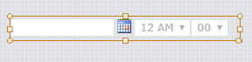
Control settings of Date and Time: Double click on Date and Time control, Control Settings dialogue box will open up as shown below. It contains fields and options for this form control.
- Name: used to assign a name to the control.
- Default value: used to set a default value for the control. Select one from the following options.
- Blank.
- Today.
- Selected Date.
- Date only: used to specify date without time. Select one from the following options.
- Yes
- No
- Expression

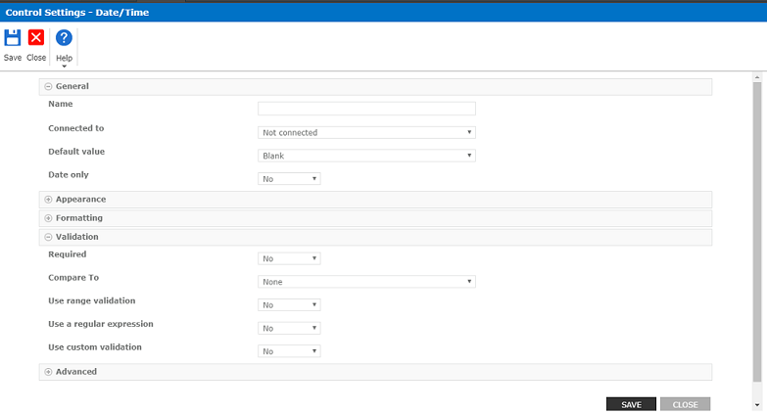
How to set only the date field in the form?
Double click on the date control and configure the details.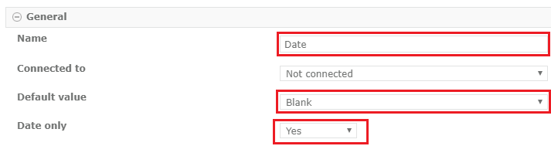
It will be appeared without time and blank date field because we selected Date only as “Yes” and “Default value“ as ”Blank”.
If you want fill date field with Today date select “Default value” as “Today”. Then the date field will appear with today date.
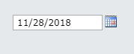
If you want to fill date field with the selected date, select “Default value” as “Selected Date”. Then the selected date field will appear then seelct date.
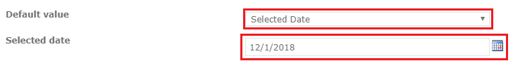
Then the date field will appear with the selected date.
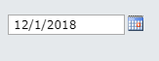
Geolocation: This control enables the user specification either by clicking or tapping a link to locate their current longitude and latitude or by manually entering coordinates
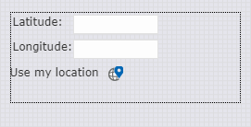
Control settings of Geolocation: Double click on Geolocation control, Control Settings dialogue box will open up as shown below. It contains fields and options for this form control.
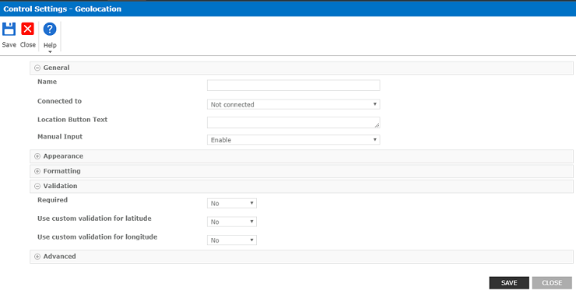
- Name: Assign a name to the control.
- Manual Input: It has three options Enable, disable, or hide. Used for the manual input fields Latitude and Longitude for manual entry of coordinate.
- Location Button Text: It will display the text on the button or link used for automatic location of coordinates. If we left it as blank, the default value of “Use my location” is displayed on the link.
How to set geolocation control in the Nintex form?
Double click on geolocation control and configure the details.
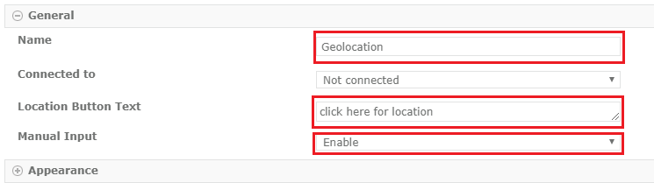
The default text on the link changed to “Click here for location”.
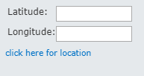
Click on “click here for location” then ”latitude” and “longitude” value will be displayed.
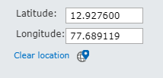
If you select “Manual Input” as “Disable” then the text box will be disabled.
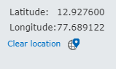
If you select “Manual Input” as “Hide” then everything will be hidden but the link will appear.
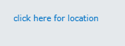
Hyperlink: This control is used to enter the hyperlink URL and its display text.
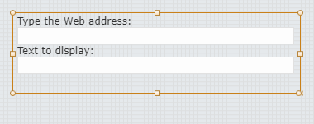
Control settings of Hyperlink: Double click on Hyperlink control, Control Settings dialogue box will open up as shown below. It contains fields and options for this form control.
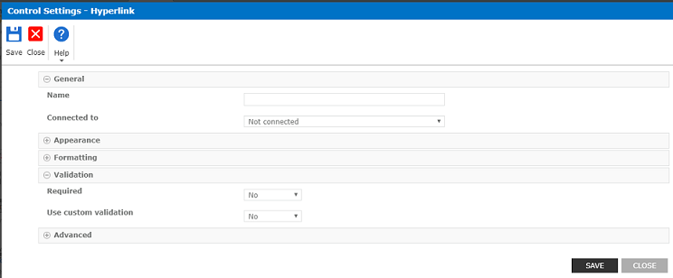
Image: This control is used to display an image on the form.
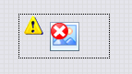
Double click on Image control, Control Settings dialogue box will open up as shown below. It contains fields and options for this form control.
- Name: Enter the name of the image.
- Image URL: Add URL of the Image.
- Alternate text: It is optional.

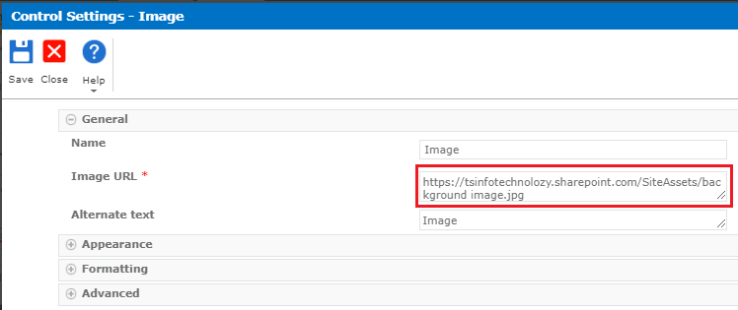
Now the image will appear on the form.
Label: This control is used to place the text on the form. For example, Image control is look like as shown below.
How to add a name to the Label control?
Drag and drop the Label control from the “FORM CONTROLS” Panel.
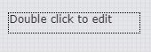
Double click on Label control, Control Settings dialogue box will open up. It contains fields and options for this form control.
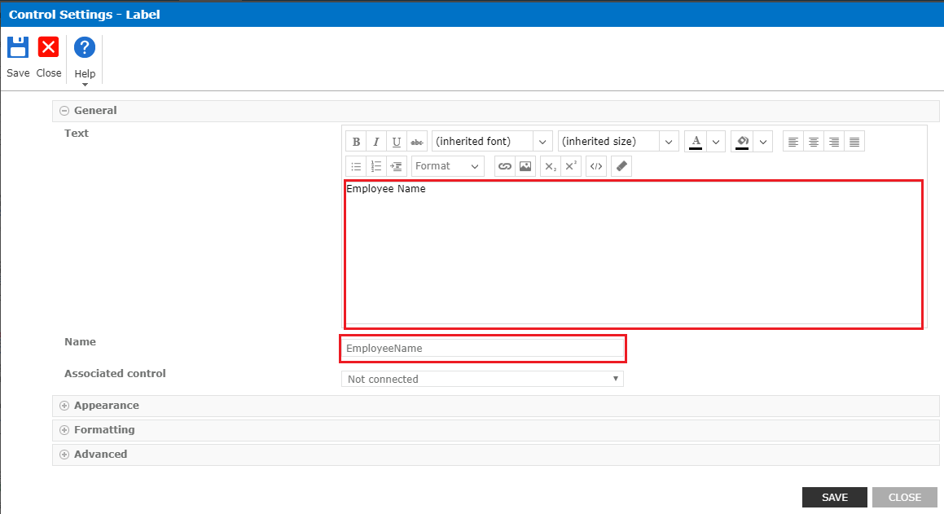
- Text: Enter the text in Textbox control. For example like “Employee Name”. This name will be displayed on the form.
- Name: Enter the name of the control. It will be the same name as the control of the Text. For example “EmployeeName”.
Click on SAVE Button.
Now the control name is changed.

Multi-Line Textbox: this control allows to enter a block of text in the form and we can also use this control to collect metadata. Like, collect metadata from apps (optional).
How to Add and change settings of Multiple Line Textbox?
Double click on the Multiline Textbox control.
- Name: Address(Enter the to the control)
- Default value: Enter the default value it will display on the MultiLine Textbox.
Click on Save button.
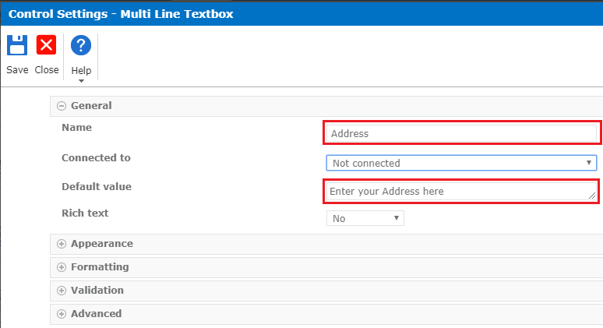
If you observe, the default text appeared in the multi-line text box.
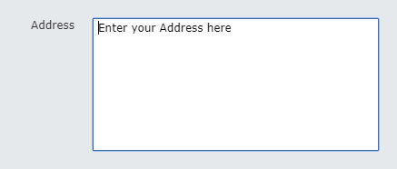
Rich Text: Specify whether or not to allow entry of rich text format. Select one of the following options.
- No
- Yes
- Expression
Select Yes for Rich text.
- “Specify the type of text to allow” control will appear. It has two options to select one of the following.
- Rich text (Bold, italics, text alignment, hyperlinks)
- Enhanced rich text (incl. pictures, tables, and hyperlinks)
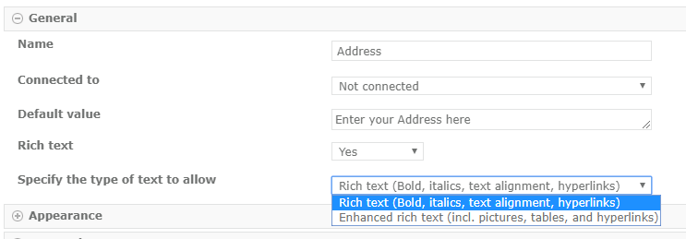
If you select Rich Text (Bold, italics, text alignment, hyperlinks), it will appear in multi-line Textbox.
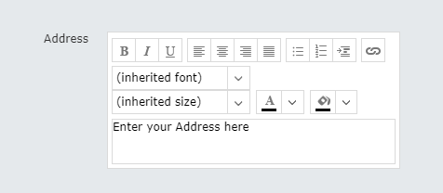
If you select Enhanced rich text (incl. pictures, tables, and hyperlinks), it will appear in multi-line Textbox.
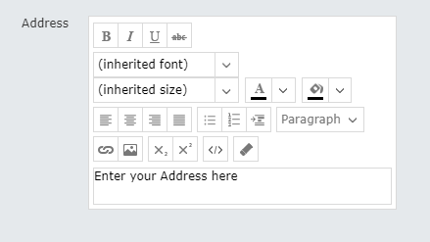
Expression: Evaluate an expression (formula) constructed from reference tokens and functions for a Yes/No value. The expression must resolve to a Yes/No value at runtime to be valid. If the expression does not resolve to a Yes/No value it will revert to the default.
If you select Expression for Rich text. It has two options to select one of the following.
- Rich text (Bold, italics, text alignment, hyperlinks)
- Enhanced rich text (incl. pictures, tables, and hyperlinks)
Page Break: This control used to force a form to break at certain points when being printed. For example, Image control looks like as shown below(drag and drop on to the form).
Control settings of Page Break: Double click on Page Break control, Control Settings dialogue box will open up as shown below. It contains fields and options for this form control.
Note: This control cannot be nested in another control and control’s width cannot be changed.
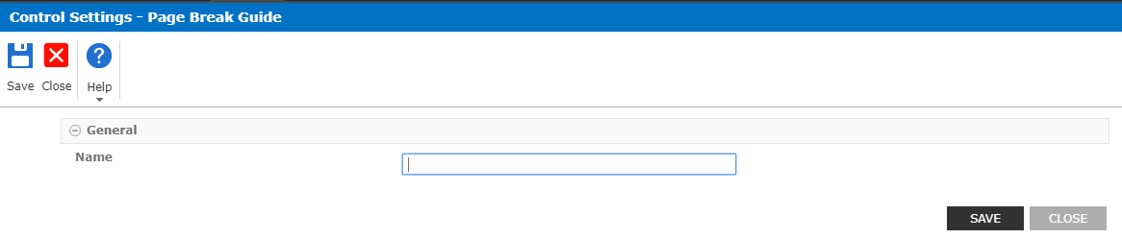
Page Viewer: This control used to display the page on the form.
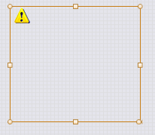
Control settings of Page Viewer: Double click on Page viewer control, Control Settings dialogue box will open up as shown below. It contains fields and options for this form control.
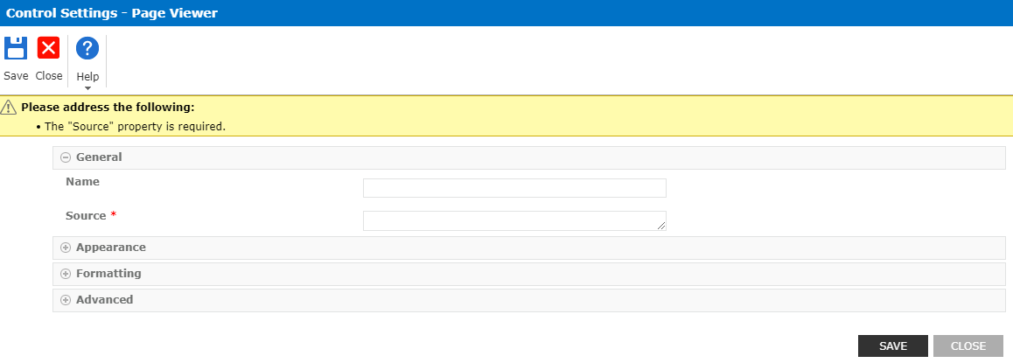
- Name: Assign a name to the control and is used for the validation and another control reference.
- Source: Add the URL of the page or document to show in the page viewer.
Panel: This control is used to group the set of controls.
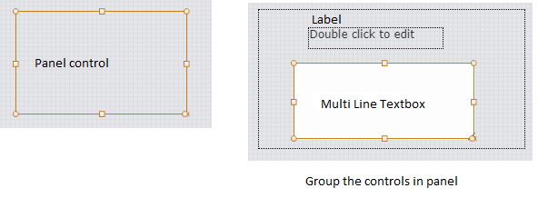
How to add Background Image on the Panel Control?
Double click on Panel control, Control Settings dialogue box will open up. It contains fields and options for this form control.
- Name: Enter the name of the panel.
- Title: It will display the title of the panel.
- Background image: Add background image URL which you want to display on the panel.

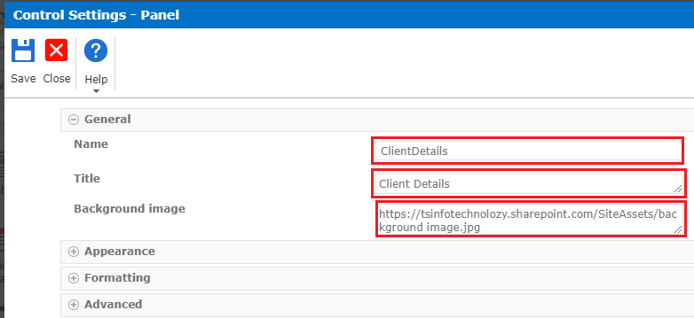
Title and Image added on the panel.
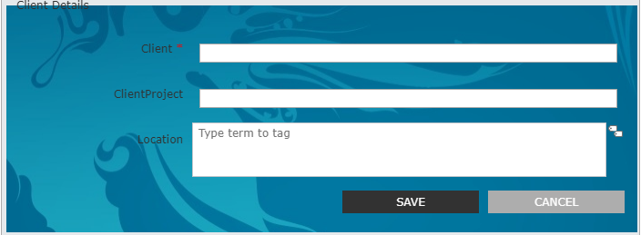
People: this control allows the users to browse and select users SharePoint profile database.
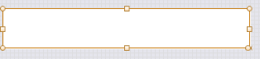

How to add users using people picker?
Double click on People control, Control Settings dialogue box will open up as shown below. It contains fields and options for this form control.
- Name: enter the name of the control.
- Multiple selections: No (it will allow us to select only one user).
- Advanced: Specify which user entity types are allowed. Select one or more of the following options.
- User
- Security Group
- SharePoint Group
- Maximum entities: 25(by Default).
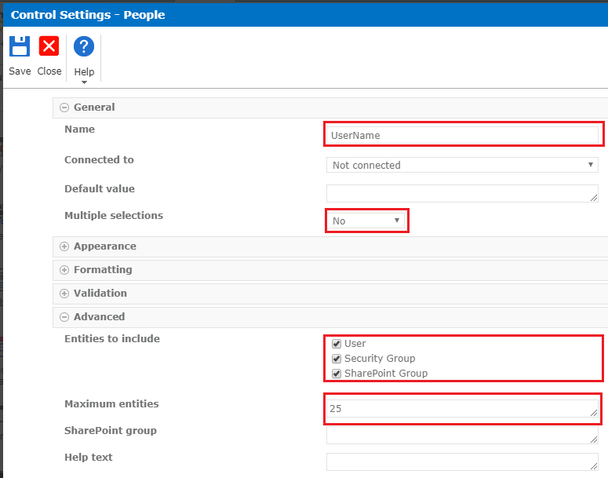
Enter the name of the user.
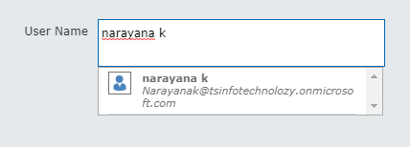
It will throw an error when we’re trying to select multiple users from people picker because we selected multiple selections as “No”.
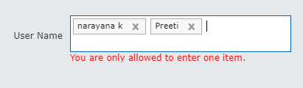
How to add multiple users in the people picker?
Double click on People control, Control Settings dialogue box will open up. It contains fields and options for this form control.
- Multiple selections: Yes (it will allow us to select multiple users).
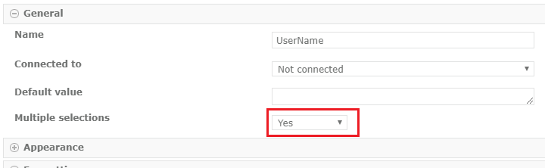
Now it will allow us to select multiple users from the people picker.
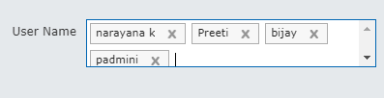
Repeating Section: This control is used to allow the users to insert multiple rows of acontained set of control. It is typically used in an expense form.
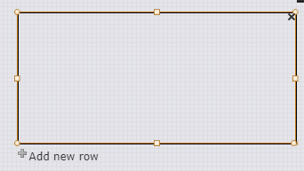
How to add Repeating section on the form?
Using repeating control we can easily add multiple items at a time. Follow the below example, drag and drop the Single Line of Textbox control into the Repeating section control on to the form.
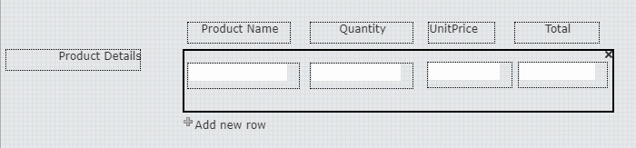
Double click on Repeating Section control, Control Settings dialogue box will open up. It contains fields and options for this form control.
- Name Enter the name of the control.
- Text for add row icon: enter the text which we want to display.
- Default rows: 1 (by Default).
- Minimum rows: 1 (by Default).
- Maximum rows: 10000 (by Default).
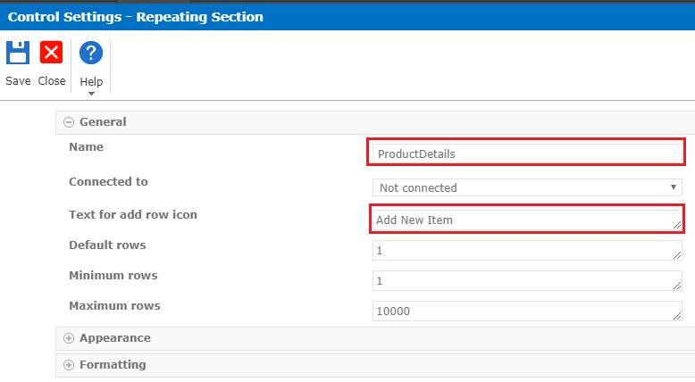
See the Repeating section of the control on the form.
- “Add new row” icon will be changed to “Add New Item”.
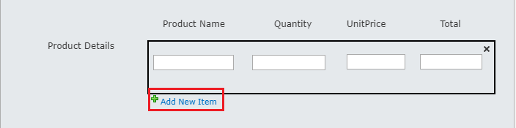
If you want to add multiple rows, click on “Add New Item” then rows should be added.
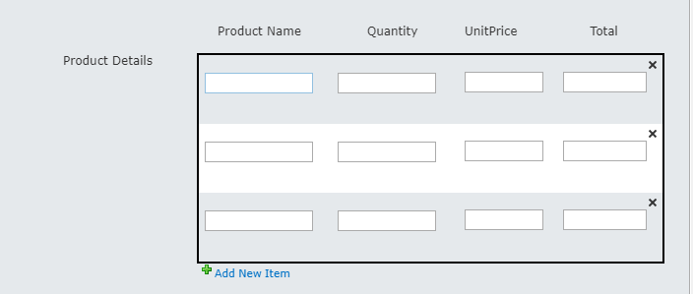

Rich Text: This can be used to display the formatted text, hyperlinks, and tables on the form.
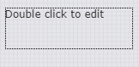
Double click on Rich Text control, Control Settings dialogue box will open up. It contains fields and options for this form control.
- We can add font size, colors, Hyperlink, image, etc. in the text box.
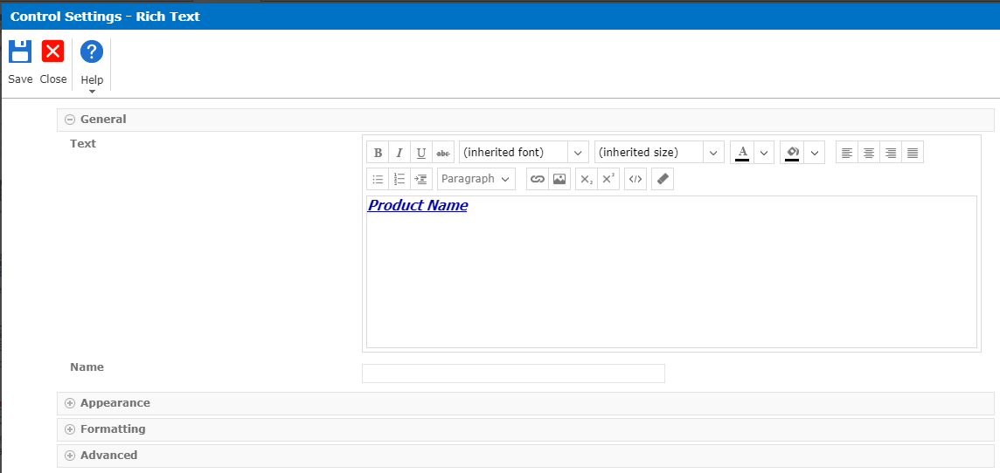
The text appeared on the form.
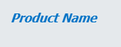
Single line of text: This control allows users to enter plain text.
Control settings of Single line of text: Double click on Single line of text control, Control Settings dialogue box will open up as shown below. It contains fields and options for this form control.
- Name Enter the name of the Textbox.
- Default value: Enter the default value displayed on the textbox control.
- Connected To: The field to bind the input control to.
- Data Type: Select data type as String or Integer or Decimal or Currency.
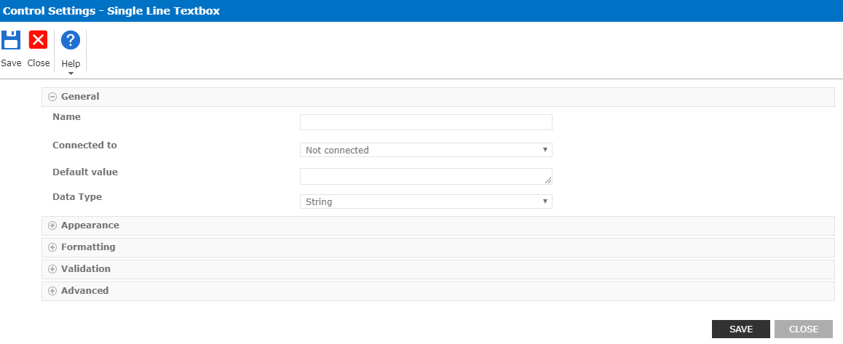
Yes/No: This control allows users to select or clear the check box to show the item has been selected.
Double click on Yes/No control, Control Settings dialogue box will open up as shown below. It contains fields and options for this form control.
- Name Enter the name of the control.
- Text: Enter the text for the checkbox. It will be displayed on the form.

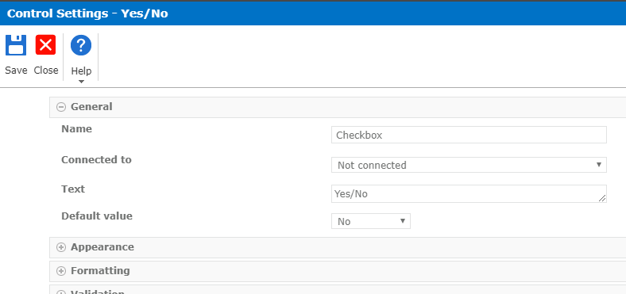
Now the Yes/No checkbox appeared on the form.
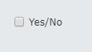
Nintex Forms-SharePoint Controls:
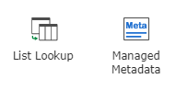
List Lookup: The List Lookup control allows users to make selections based on values in a SharePoint list. The selection the user makes can be used to filter the available values in another List Lookup control on the form.
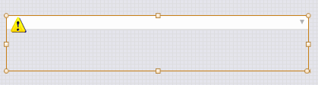

Control settings of List Lookup: Double click on List Lookup control, Control Settings dialogue box will open up as shown below. It contains fields and options for this form control.

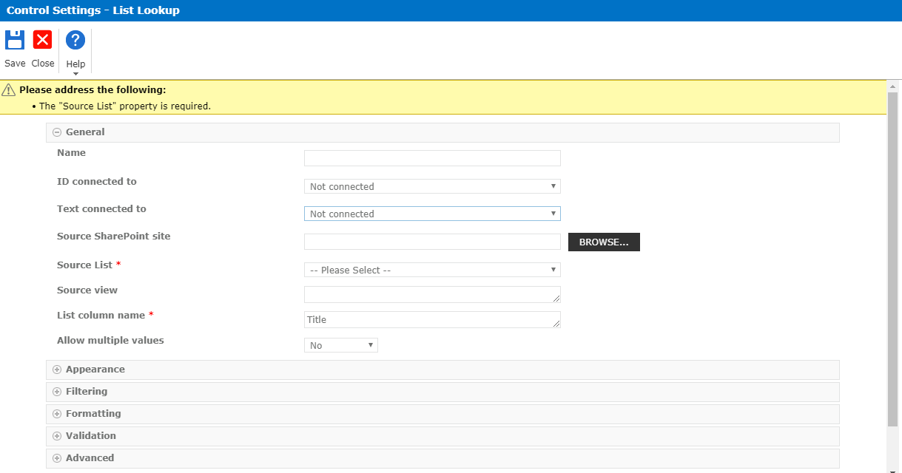
Source SharePoint Site: URL of the SharePoint source list. Click on Browser to view the list of sites for selection.
Source List: select the list name from the source SharePoint list.
Filtering: filtering the value based on selection. Select one from the following options.
- Display all items: it does not filter available selections.
- By a control's value: it does filter available sections.
- Where field: Specify the field.
- Filtered by control: Specify the control by name.
- Action when no filter applied
- By a specified value: It will filter by the specified value.
How to use a Lookup field in the form?
Example:
We have Country and state field. Based on the Country selection state will be appeared.
Double click on the State control and configure the details.
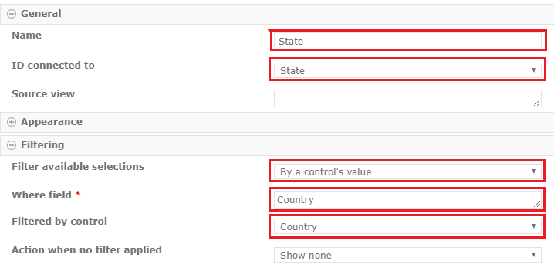
Now lookup will appear as shown below. Based on country selection, states are shown in the State field.
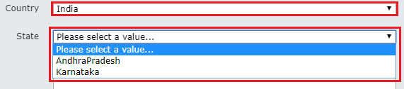
Managed Metadata: It is a collection of managed terms that must be defined within SharePoint prior to use in Nintex forms.
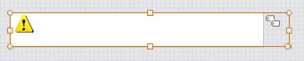
Control settings of Managed metadata: Double click on Managed Metadata control, Control Settings dialogue box will open up as shown below. It contains fields and options for this form control.
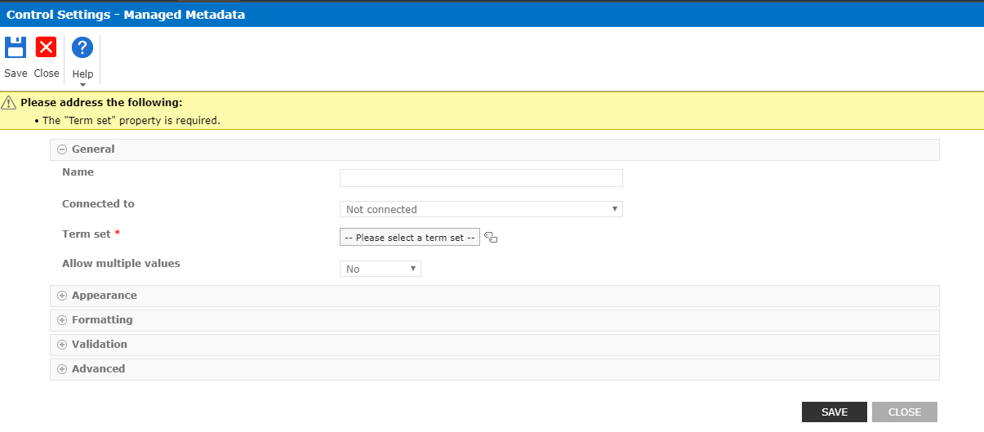
How to use managed metadata in Nintex form?
Double click on the metadata control and configure the details.
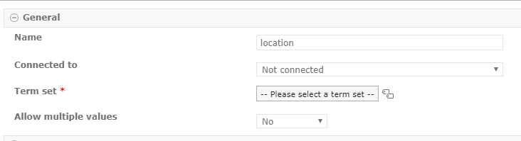
Next Click on the term set icon. It will pop up a dialog box as shown below. Select term set which you want to add and click on “Ok”.
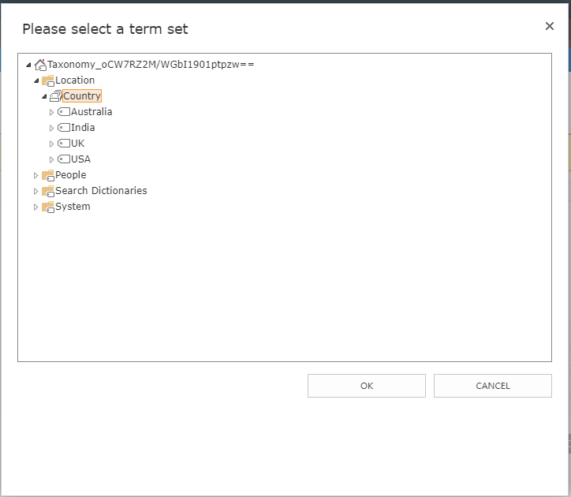
Now term set name “country” is added to the term set field.
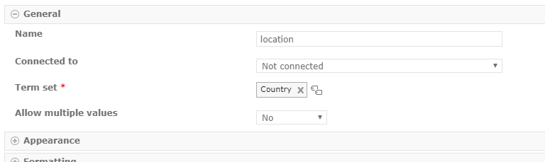
Term set will appear.
Click term set icon and select any one country and click on “Select” it will be added in the textbox.
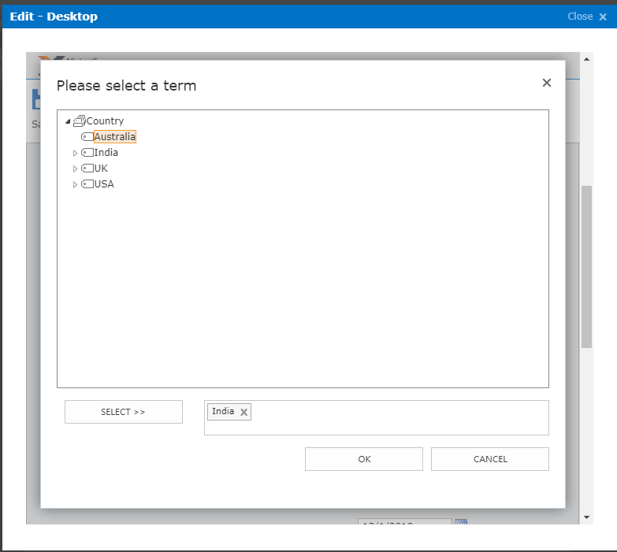
Now, the country is added in the term set field.
Nintex Forms-List columns:
- Preconfigured controls automatically generated for each column in the SharePoint list that is related to the form.
- In a preconfigured control, the Connected to the property is automatically set to the corresponding related column.

Nintex Forms Designer Properties Window:
Here you can see various form or control properties.
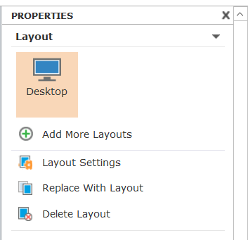
Nintex Forms Designer Middle Section:
It displays the UI of the form like below:
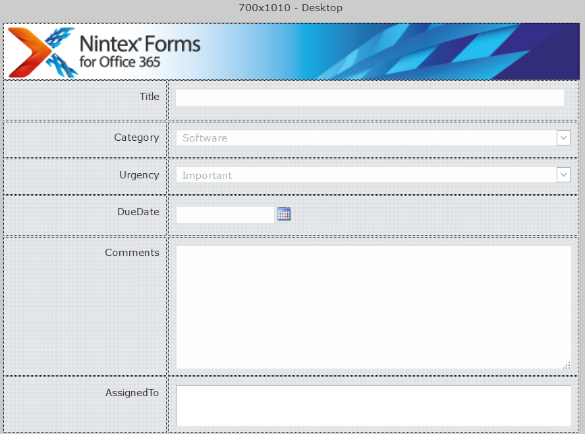
Publish a workflow:
Without doing anything if I will publish the workflow, it should appear like below when you will go and add one item to a list.
To publish a workflow from the ribbon click on Publish button.
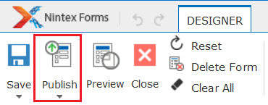
When you will click on Publish, it will ask you ask the layout and then choose the layout and click on Publish button to publish the form.
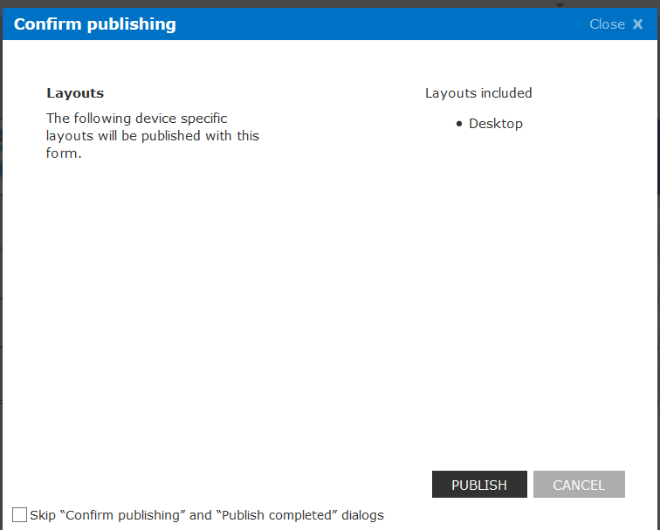
Once the form published successfully, you can see a message as the form published successfully.
Now If you will open the list and try to add new item, then add new item screen will appear like below:
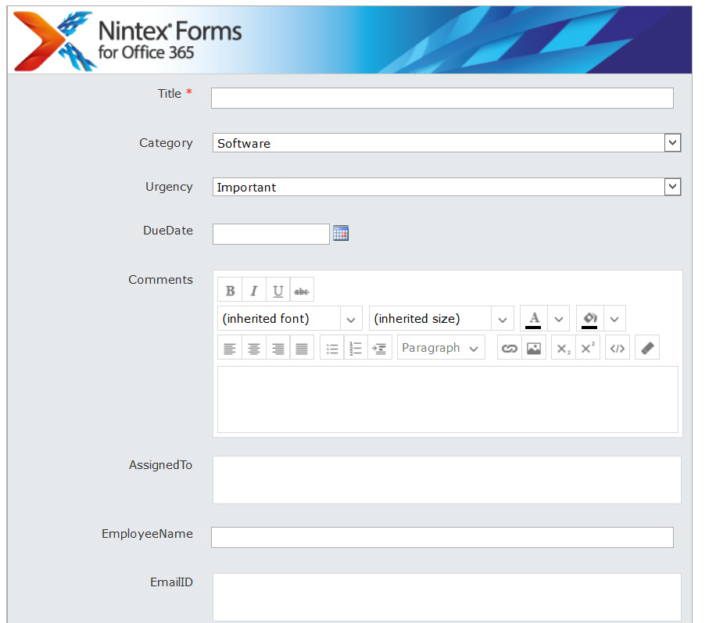
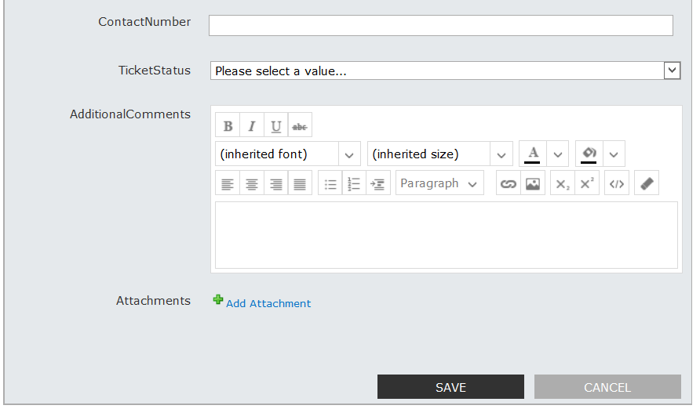
The ribbon will appear like below:
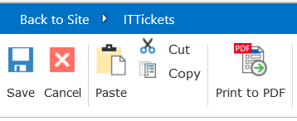

Add Item to List using Nintex Forms for Office 365:
You can fill the form and click on Save button from ribbon or Save button from the below part of the form.
Once the form inserted it will go back to the list.
If you edit an item from the list also it will open the Nintex form rather than your out of box form.
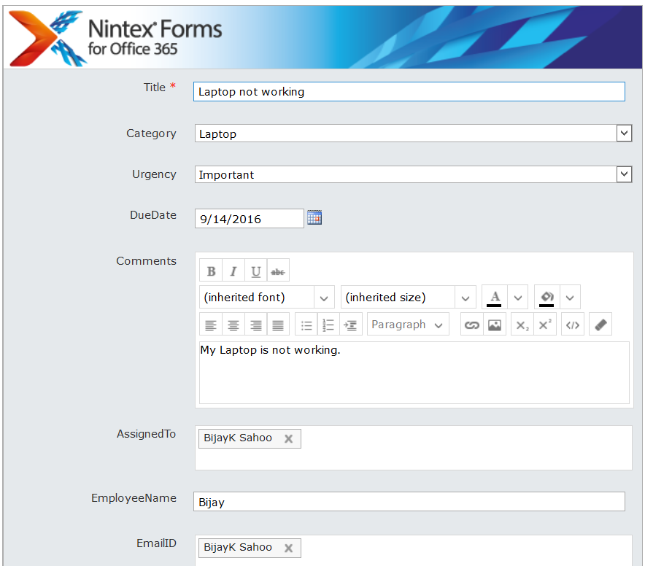

Design the Form:
Now you will see how we can design the form.
To start with open the list -> from ribbon click on Nintex Forms button which will open the Nintex forms designer.
Now suppose we have to change any label property. Then select the label from the left side and then it will open the Settings in the right side. In the Text property you can change the Assigned To like below (Assigned To).
When you will select a control, you can see the ribbon CONTROL tab where you can see various options
From the ribbon click on CONTROLS -> Control Settings. This will open the control settings page and you can see various settings thr.
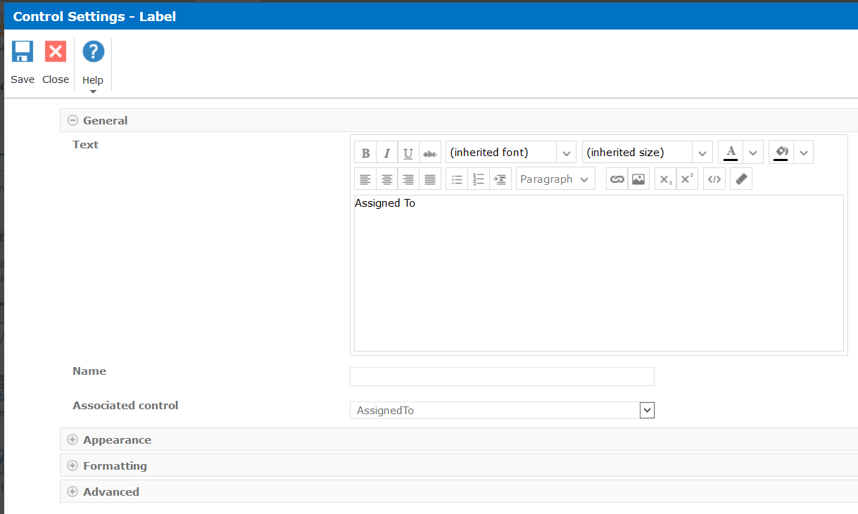

Forms Settings:
You can check the forms settings by clicking on the Forms settings button.
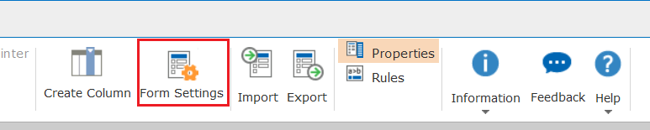
This will open forms settings page where you can check various options.
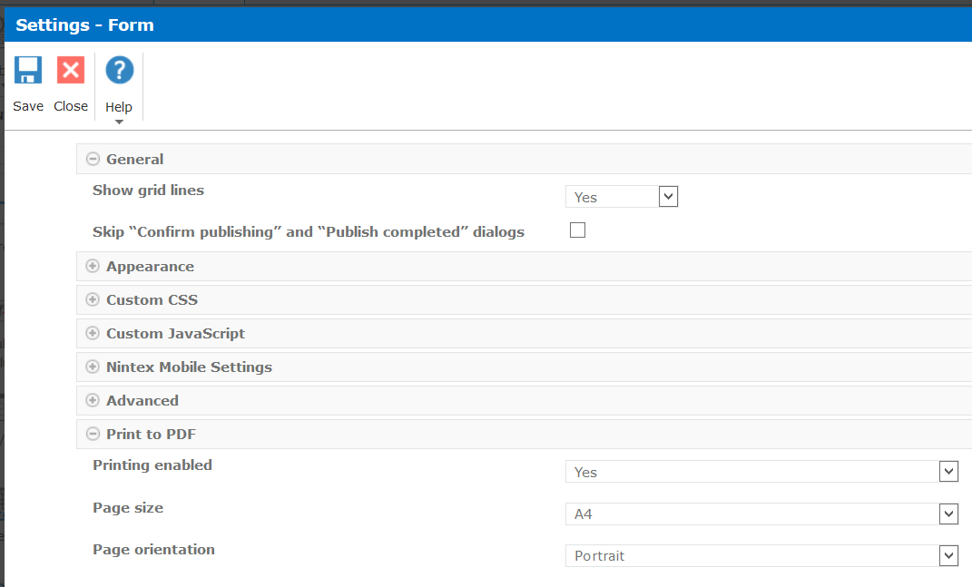
In the forms settings you can add custom css, change appearance, custom JavaScript etc.

Regular Expressions using in Nintex forms for office 365:
The Regular Expression action is an extremely powerful action for splitting text, replacing text or getting data out of the text. Here we will explain with some of the examples How to use regular expressions in Nintex forms.
- Regular Expression Validation for ID :
We were working on a form that required EmployeID validation and we know it’s possible with JavaScript, but using regular expression it is very simple and easy to use.
For example, employee id allows 7 characters only and start with First Two letters will be capital and the remaining five letters only numbers.
Double click on the Text box control, In Control Settings Dialogue box, do the following settings.
- Use regular expression: Yes
- Regular expression: ^[A-Z]{2,2}\d{5,5}$ (This will allow 7 characters with First two capital letters and remaining’s are numbers)
- Regular expression error message: Enter error message.
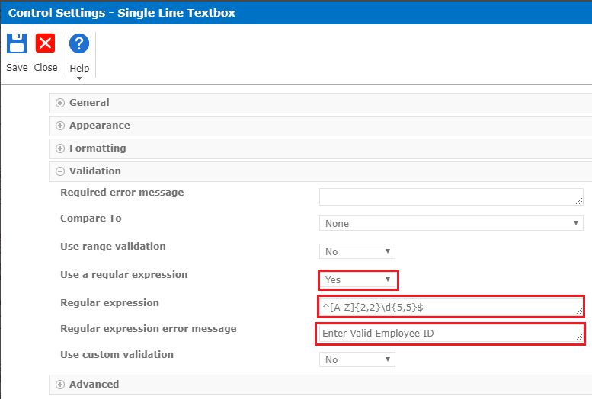
We will get an error message when we enter the first two letters small.
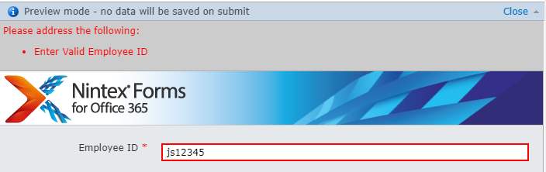
How to validate the “Name” on the form:
Validate First Name or Last Name using regular expression in Nintex forms. Allow the user to enter only letters into the Textbox.
Example:
Double click on the Textbox control enters the following regular expression in the Validation section as shown below.
- Use regular expression: Yes
- Regular expression: [a-zA-Z]+ ( It will not allow numbers and special characters )
- Regular expression error message: enter the error message as we required.
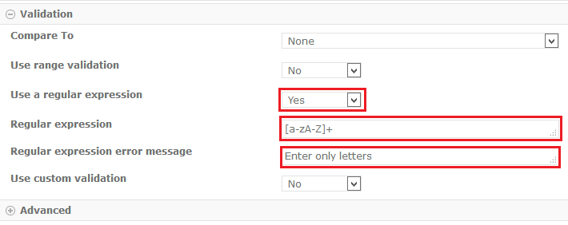
Enter the name with special characters it will throw an error message.
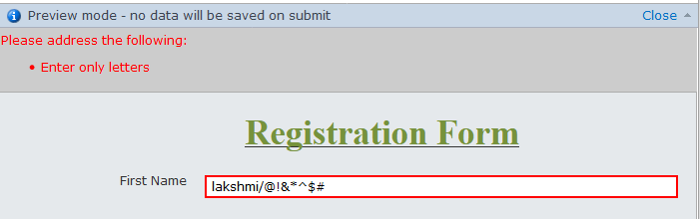
Enter the name with numbers it will throw an error message.
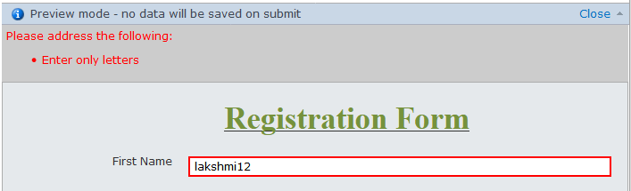

How to validate the “Email” on the form:
We can easily validate “E-mail” using regular expressions in Nintex forms for office 365. We can do this validation using javascript also, but it is very easy to do using regular expression in Nintex forms.
Example:
To check the format of the data entered into a field you will need to use the Control Regular expression formula. For that field Double click on the Textbox control, enter the Regular expression in the Validation section.
- Use a regular expression: Yes
- Regular expression:” (?:[a-z0-9!#$%&'*+/=?^_`{|}~-]+(?:\.[a-z0-9!#$%&'*+/=?^_`{|}~-]+)*|"(?:[\x01-\x08\x0b\x0c\x0e-\x1f\x21\x23-\x5b\x5d-\x7f]|\\[\x01-\x09\x0b\x0c\x0e-\x7f])*")@(?:(?:[a-z0-9](?:[a-z0-9-]*[a-z0-9])?\.)+[a-z0-9](?:[a-z0-9-]*[a-z0-9])?|\[(?:(?:25[0-5]|2[0-4][0-9]|[01]?[0-9][0-9]?)\.){3}(?:25[0-5]|2[0-4][0-9]|[01]?[0-9][0-9]?|[a-z0-9-]*[a-z0-9]:(?:[\x01-\x08\x0b\x0c\x0e-\x1f\x21-\x5a\x53-\x7f]|\\[\x01-\x09\x0b\x0c\x0e-\x7f])+)\]) ”.
- Regular expression error message: enter error message as we required.
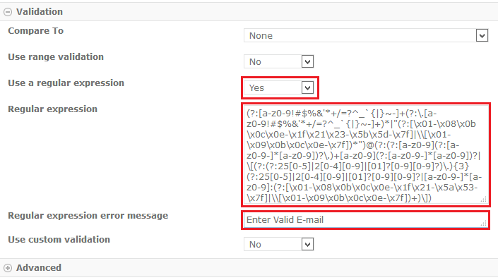
We will get an error because it will allows only the small letters in the Textbox as shown below.
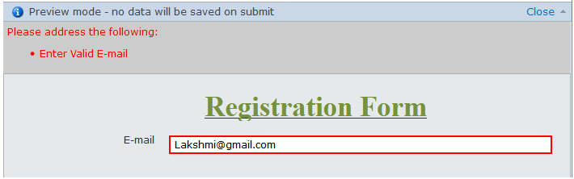
Some of the example we are giving below check out this Regular expressions for the email.
- ^[a-zA-Z0-9._%+-]+@[a-zA-Z0-9.-]+\.[a-zA-Z]{2,3}$
- ^[A-Za-z0-9](([_\.\-]?[a-zA-Z0-9]+)*)@([A-Za-z0-9]+)(([\.\-]?[a-zA-Z0-9]+)*)\.([A-Za-z]{2,})$
- ^([\w-\.]+@([\w-]+\.)+[\w-]{2,4})?$

How to validate the “Phone Number” on the form:
Validate “Phone Number” using regular expression in Nintex forms. For example, phone number should be 10 digits only, if the user will enter more or less than 10 digits it will give an error.
Example:
Double click on the Textbox control and configure the details.
- Use regular expression: Yes
- Regular expression: “ \d{10,10}$ “
- Regular expression error message: Enter error message as we required.
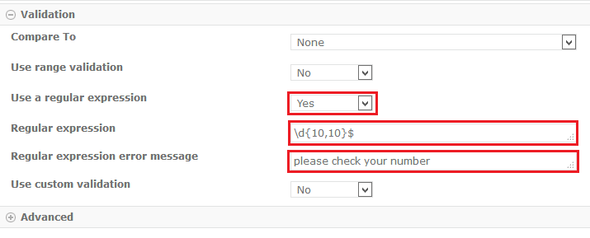It will throw an error message enter when the number is not matched.
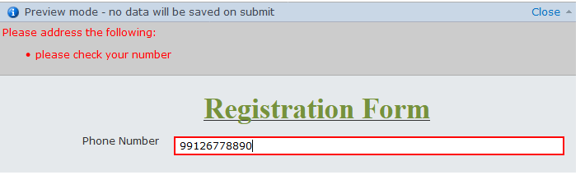
For example in USA countries having dashes or periods between the numbers. So we will need to use below Regular expression.
- Phone Number (allows either dashes or periods in between the numbers):
    - \b\d{3}[-.]?\d{3}[-.]?\d{4}\b
- Phone number (Allow the Dashes only)
    - ^\d{3}-\d{3}-\d{4}$
- Phone number (it will allow “+” then only numbers)
^\+(?:[0-9] ?){6,14}[0-9]$
- Regular expression for “Age” validation:
Double click on the Text box control and configure the Regular expression details as shown below.
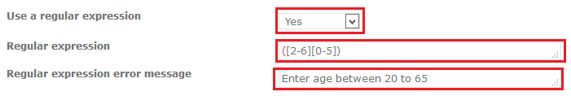
- Use a Regular expression: Select “Yes” from down.
- Regular expression: ([2-6][0-5])
- Regular expression error message: Enter age between 20 to 65.
Save and publish the form. Enter age < 20 or > 65 it will through an error as shown below.
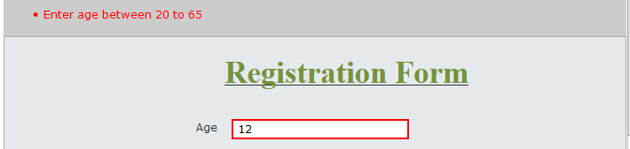
Some of the example for Age validations using a regular expression.
- ^(1[8-9]|[2-5][0-9]|6[0-5])$ (Age validate between 18 to 65)
- (1[8-9]|2[0-9]|3[0-5]) (Age validate between 18 to 35)

Add Rules to Controls:
We can add various rules to controls. Here in this form we will put a validation which will check that Due date should not be less than today.
Select the Due Date field -> Click on Add Rule button from ribbon.
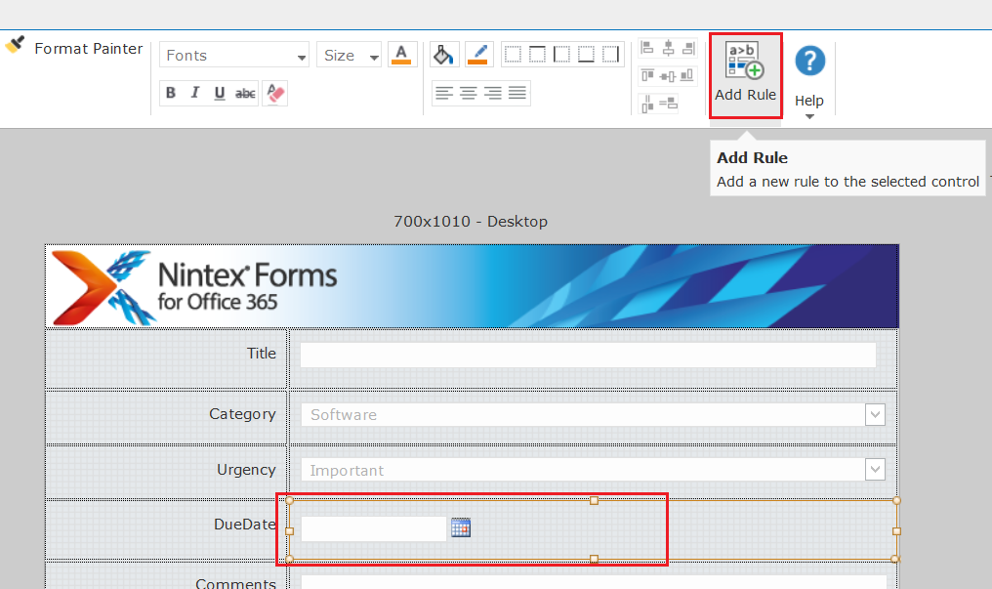

First write the rule name, Rule Type choose as Validation.
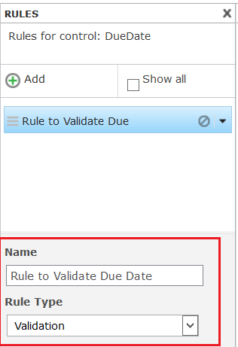
Then we will write the condition. Click on the f(x) button in Conditions textbox.
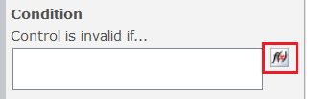
Once you click on f(x) it will open the formula builder like below:
Expand Named Controls. Choose DueDate column like below:
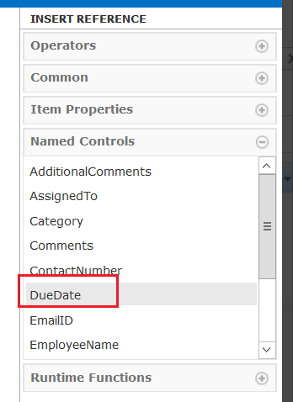
Then from Operators choose operator as “<”.
Then choose Current Date from Common section.
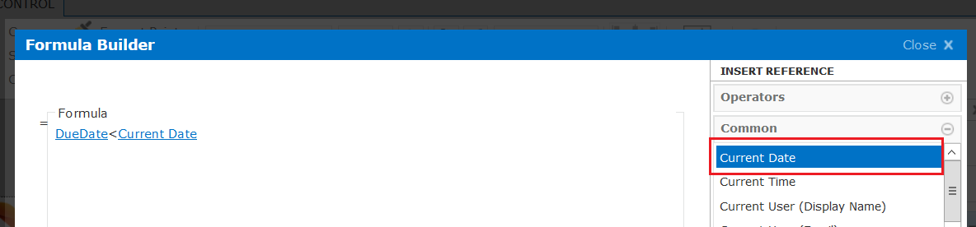
Now your form will looks like below:
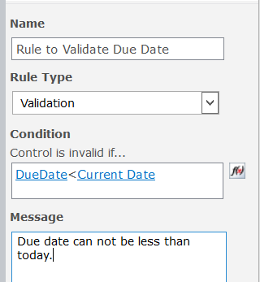
Then publish the form.
Now you can open the form, try add new item. If you choose date less than today it will give you validation message.
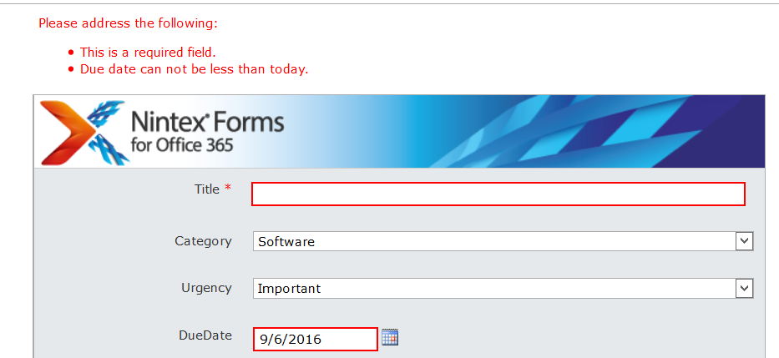

Change Mandatory Field validation message:
You can also change the message for the mandatory field. Here Title is a mandatory field. You can go to the control settings (Right click on Control -> Settings) and then write the message like below:
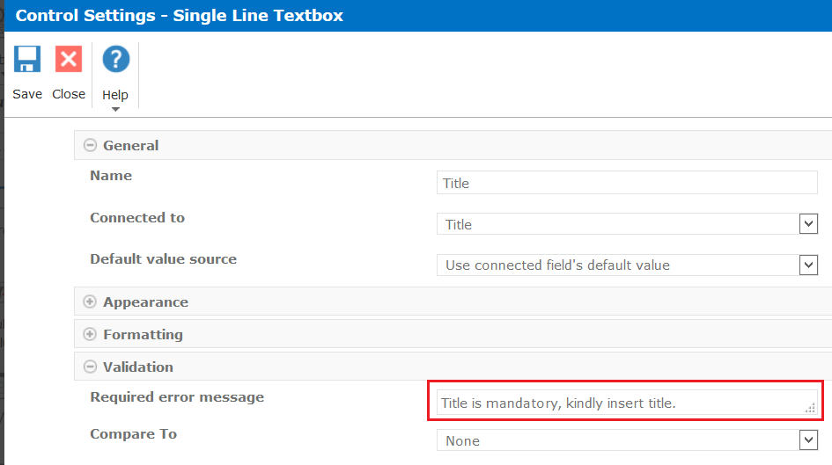
After this the validation message will appear like below:

Due Date Cannot be greater than year:

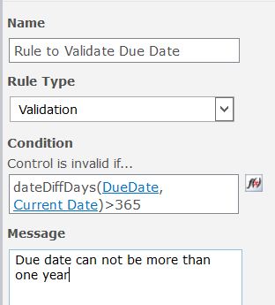

Add Rule in Nintex forms for office 365:
Add Rule can be used to validate the selected control. Use this pane to configure form behavior when defined conditions exist. We will see some example here how to add a rule to the control.
- Drop Down:
In this example, we will see how to add a rule to the Country Dropdown.
Right click on Dropdown control and click “Add Rule” or go to the Control tab there click on “Add rule” button and configure the details.
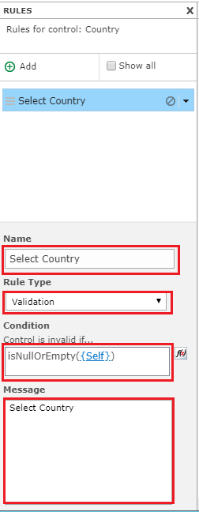
isNullOrEmpty: It returns true where value has no data content. We can use this any control on the form validating field is empty or not.
- Usage of the control is: isNullOrEmpty(value).

Click on formula builder, go to the Runtime Functions in the INSERT REFERENCE panel. Double click on the “isNullOrEmpty” will be added in the Formula canvas as shown below.
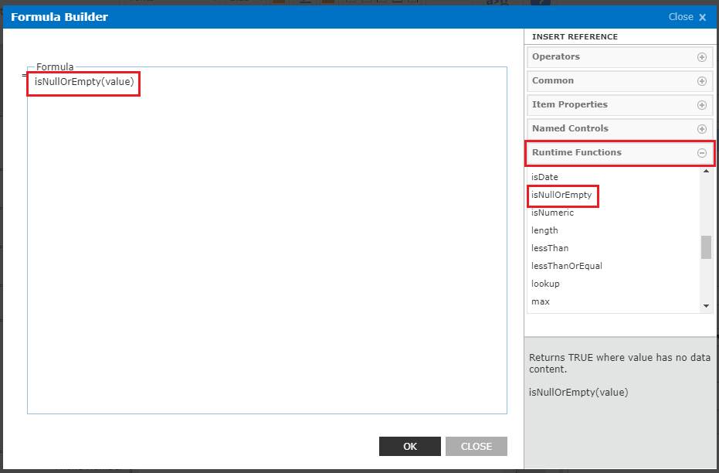
Now we have to add the name of the control which we want to validate the control on the form. To do this go to the “Named Controls” and double click on “{Self}” or select name of the control “Country ” as shown below.

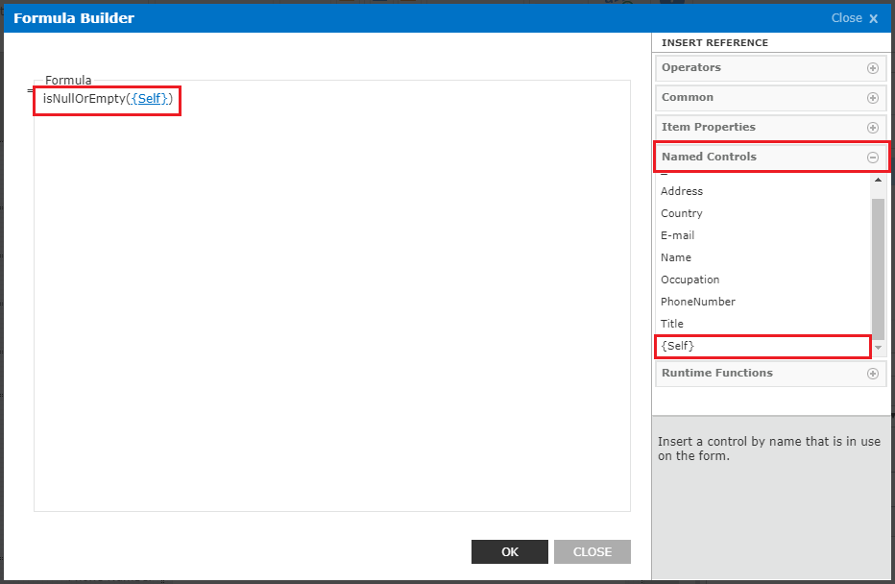
If you do not select the Country on the form you will get an error message like below.
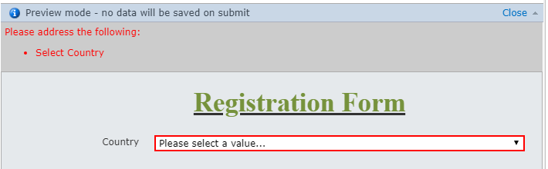
- Disable/Hide the Field control on the form:
Sometimes we need to enable or disable fields based on a Yes/No field or a checkbox. In this example, we will see how to enable/disable button before submitting the form.
Drag and Drop the” Yes/No” control from the “Form Control” on the form.
Double click on the (Yes/No) check box control enters name and text as shown below.
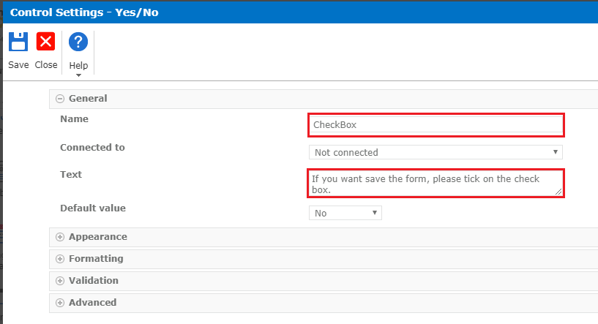
Here yes/no column check box with Title, on the selection of the checkbox, will try to enable the "SAVE" button which will be disabled by default.
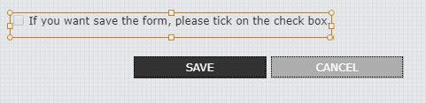
Click on Add Rule on the control tab. It will open Add Rule tab here you can click on Add and configure rules.
- Name: Provide the name of the rule.
- Rule Type: As for our case it will be ‘Formatting’. Select formatting from the dropdown.
- Condition: Our condition will be not (Enable/Disable) which means if our field is not checked in, it should be a valid rule.
- In Condition: “not(CheckBox)”.
We have checked in the ‘Disable’ checkbox so our field will be disabled unless the condition is valid.
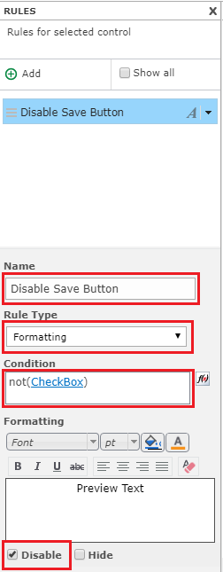
The below screen of the new form opens with the field disabled by default.
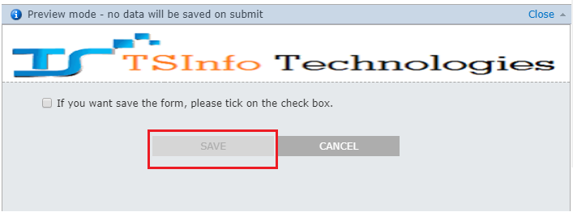
Now when you will check the checkbox, the rule will apply and our Save button control will become enabled.
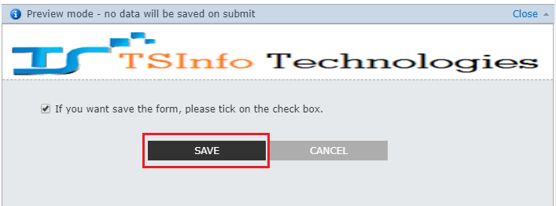

- How to hide and show the fields on the form when selected dropdown:
Example:
Disable or Hide the date and textbox fields when we selected options from the drop-down. When selected “Other” option from the drop-down Single Line of text box field will be appeared.
For example, Employee applies for a leave, when he selected leave type as “Other” option from the dropdown then Textbox will appear. In the form, we have dropdown, date and text box control.
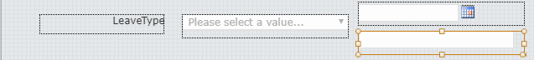
Select Date field, Right click on it and select “Add Rule”. It will open the Add Rule tab, we can click on Add and configure rules.
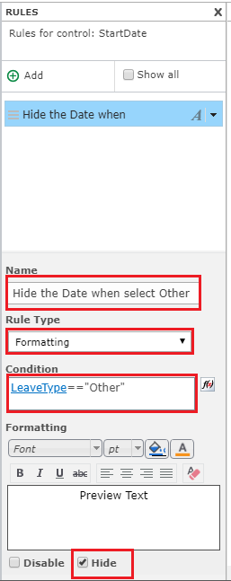
- Name Enter the name of the rule.
- Rule Type: Select the rule type as “Formatting”.
- Condition: LeaveType=="Other".
- “LeaveType” is the name of the choice control.
- Formatting: check on the Hide checkbox.
When you select the “Other” option from the drop-down then the Date field will be hidden.
Select Single Line of Textbox field, Right click on it and select “Add Rule”. It will open Add Rule Tab here we can click on Add and configure our rule.
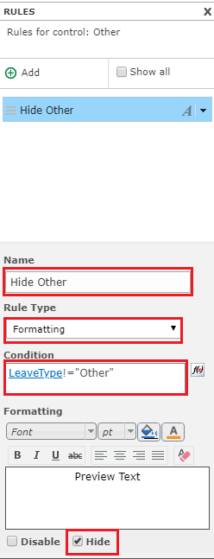

- Name Enter the name of the rule.
- Rule Type: Select the rule type as “Formatting”.
- Condition: LeaveType!="Other".
- “LeaveType” is the name of the choice control.
- Formatting: check on the Hide checkbox.
The “Other” field will be hidden, up to that select the “Other” option from the drop-down.
Textbox field is Hide by default in the form.
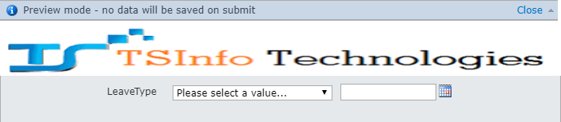
We have taken Leave type options as shown below.
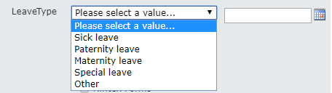
When you select the “Other” Option from the dropdown Single Line of the Text box will be appeared and the Date field will be hidden on the form.
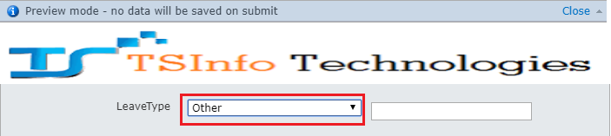

- Hide and Show the fields from the selected Multiple Checkboxes:
Example:
Selected particular leave type from the checkboxes hide and show the related date and Single line of Textbox.
We will take one dropdown control called “MedicalLeaveReason” with choices Birth of my child, Adoption Placement and Other. When we check the checkbox “Birth of My Child” then related Date field should appear and remaining “Adoption Placement” date field and “Other” text field should be Hide. Similarly, apply the same thing two other checkboxes.
We will create a choice control on the Nintex forms.
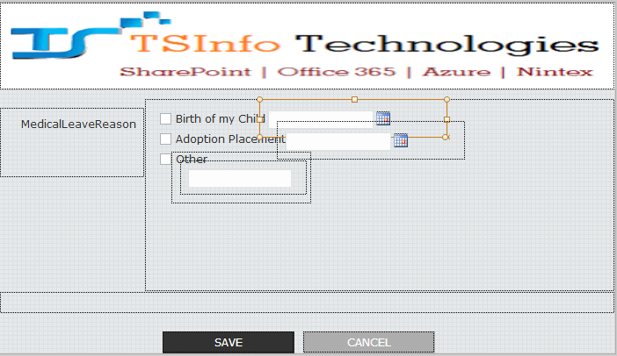
Select the date control, then right click on it and select Add Rule -> click on Add and now we configure rule here.

- Name Enter the name of the rule.
- Rule Type: Select the rule type as “Formatting”.
- Condition: not(inArray(MedicalLeaveReason,'Birth of my Child'))
- “MedicalLeaveReason” is the name of the choice control.
- Formatting: check on the Hide checkbox.

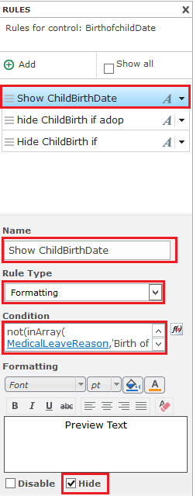
Now “Hide” adoption placement Date field when we select “Birth of my Child” date field.

- Name Enter the name of the rule.
- Rule Type: Select the rule type as “Formatting”.
- Condition: inArray(MedicalLeaveReason,'Adoption Placement')
- “MedicalLeaveReason” is the name of the choice control.
- Formatting: check on the Hide checkbox.
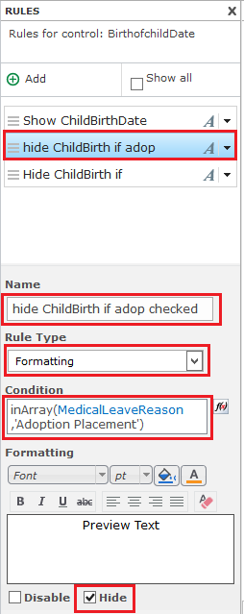
Now w “Hide” the Single Line of Textbox field of “Other” when we select “Birth of my Child” date field.

- Name Enter the name of the rule.
- Rule Type: Select the rule type as “Formatting”.
- Condition: not(inArray(MedicalLeaveReason,'Birth of my Child'))
- “MedicalLeaveReason” is the name of the choice control.
- Formatting: check on the Hide checkbox.

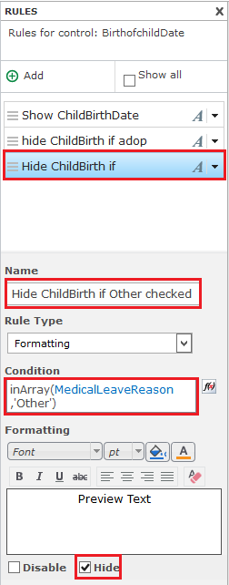

Now drop down control everything ready. No field controls appear in the form.
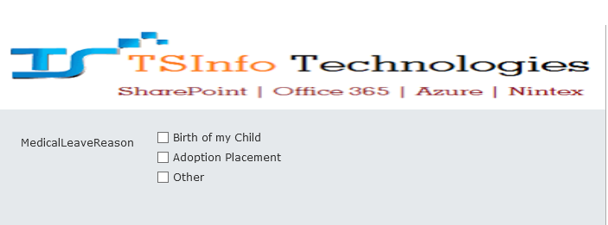

Now check on the “birth of my child” checkbox then date control will appear.
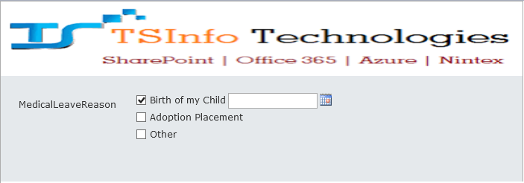

Check adoption placement then “Birth of my child” control is hidden.
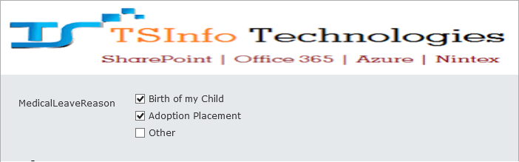

Unchecked the checkbox of “Birth of my child”, then date control will appear on the form.
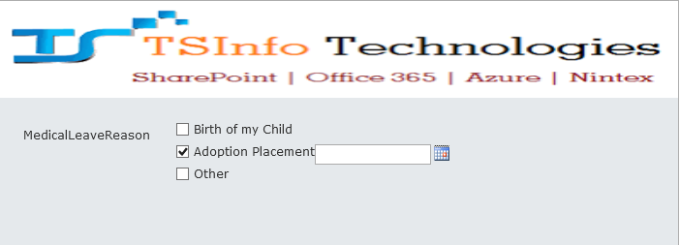
Click on “Other “checkbox then the single line of the textbox will appear.
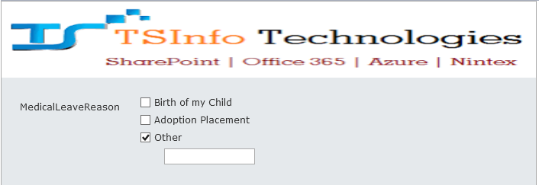

- How to validate name start with a particular String?

start with(): it will return true when specified element at the beginning of the value.

- startsWith(string, element)
Example:
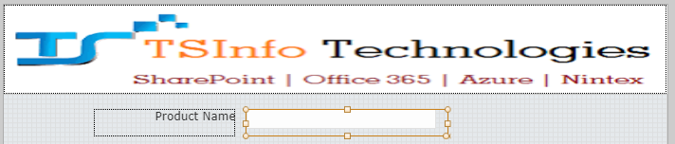
Double click on Single Line of Textbox control and configure the details.
Next Click on Add Rule-> click on Add button and configure the details.
- Rule Type: Select validation from the drop down.
- Condition: not(startsWith(ProductName, "P")).

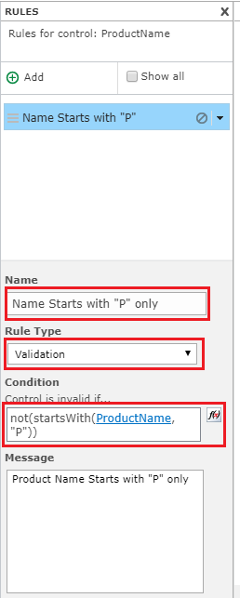
When you enter letter instead of “P” it will throw an error.
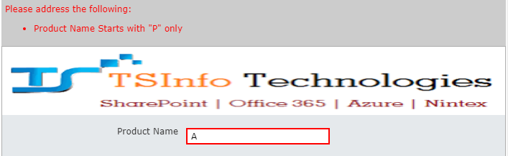
- Hide and Show the control by selecting options Buttons:

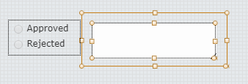
- Drag and drop the choice control on the form. Double click on it and configure the details.
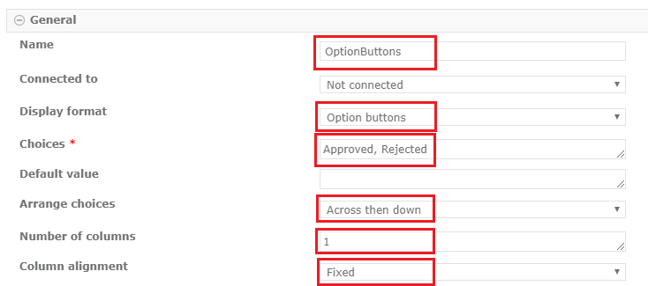
Drag and drop the panel control.
Drag and drop the MultiLine Textbox control on to the Panel Control.
Select the panel control, Right click on it->Click on Add Rule and configure the details.
- Rule Type: Select “Formatting” from the drop-down.
- Condition: not(contains(OptionButtons,"Rejected")).
- Check the “Hide” checkbox.
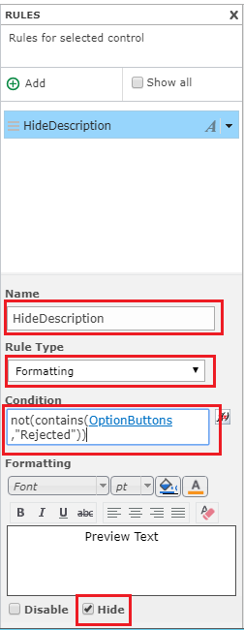
Now select the Rejected option then MultiLine Textbox will appear.

Runtime functions in Nintex forms for office 365
- toLower: It will convert a string to lower case.
Usage of this function is: toLower(string)
- toUpper: It will convert a string to upper case.
Usage of this function is: toUpper(string)
- toTitleCase: It will convert a string to title case (the first letter of each word capitalized).
Usage of this function is: toTitleCase(string)
- Substring: It will return a part of the string from the character position start for the specified length in characters. The first character position is 0.
Usage of this function is: subString(string, start, length)
- length: It will return the length of a string.
Usage of this function is: length(string)
Example:
How to convert text to lower, upper, Title case and find the length of the string, a substring of a string.
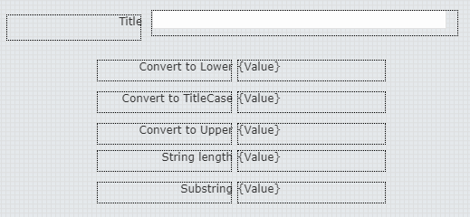
Single Line of Textbox: Name of the Textbox control is “Title”.
Calculated Value (for toLower()): Double click on the calculated control and configure details.
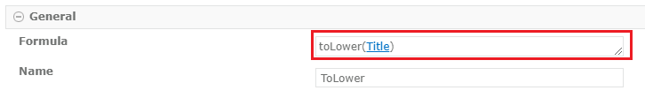
- Formula: toLower(Title)

To add Runtime function “toLower” to the Formula control. Click on the Formula control ->INSERT REFERENCE->RUNTIME FUNCTIONS. Double click on the function as shown below.
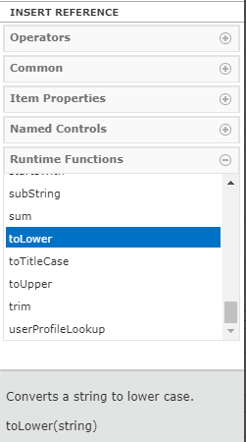
Now add Textbox name “Title” (double click on it) from the Named controls as shown below.
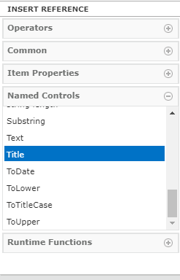
Repeat the same steps for other controls.

Calculated Value(for substring()): Double click on the calculated control and configure details as shown below.
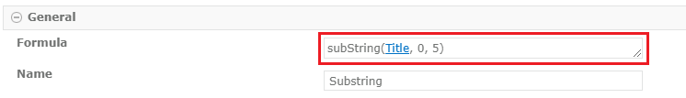
- Formula: subString(Title, 0, 5)
Now the string is converted to Specified control.

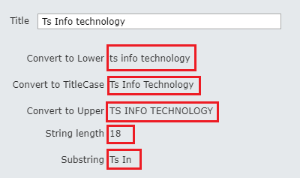

- replace: It will replace part of a string that matches a regular expression pattern (replace pattern) with the specified replacement.
Usage of this function is: replace (textToModify, replacePattern, replacement)

Example:
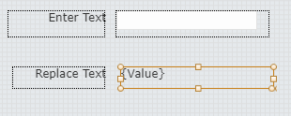
Double click on the calculated value control and configure the details.
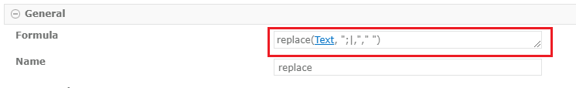
- Formula: replace(Text, ";|,"," ")
Enter the text then it will replace the”; and,” with space between the characters.
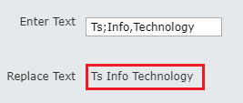

- dateDiffDates: It will return the number of whole days between the two dates.

Usage of this function is: dateDiffDays(date1, date2)

Example:
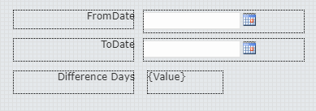
Calculated Value: Double click on it and configure the details.
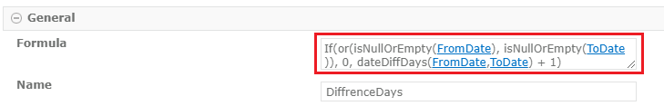
- Formula: If(or(isNullOrEmpty(FromDate), isNullOrEmpty(ToDate)), 0, dateDiffDays(FromDate,ToDate) + 1)
- Here “FromDate” and “ToDate” are DateandTime control name. Select from the Named Controls of the “INSERT REFERENCCE” panel.
Select dates from dates fields then it will show the difference between the days.
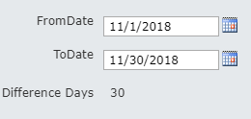
- formatDate: It will return the date in the specified format.

Usage of this function is: formatDate(date, format)

Example:
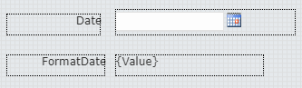
Double click on the Calculated Value control and configure the details.
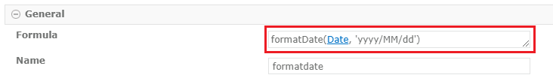
- Formula: formatDate(Date, 'yyyy/MM/dd')
- Here “Date” is the DateandTime control name. Select from the Named Controls of the “INSERT REFERENCE” panel.
Select date from date field then it will change to specified format date.
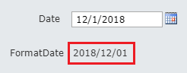
- dateAddDays: It will return the date with a specified number of days add to it.
Usage of this function is: dateAddDays(date, daysToAdd)

Example:
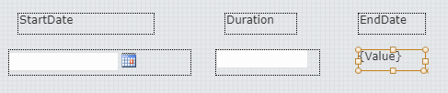
Double click on Calculated Value control and configure the details.
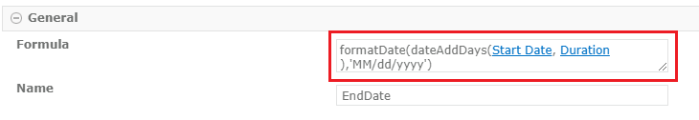
- Formula: formatDate(dateAddDays(Start Date, Duration),'MM/dd/yyyy')
Select the date and Enter Duration days then End Date will be displayed.
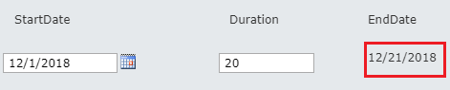

- dateAddMonths: It will return the date with the whole number add months to it.

Usage of this function is: dateAddMonths(date, monthsToAdd)

Example:
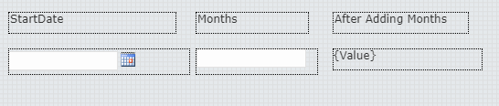

Double click on Calculated Value control and configure the details.
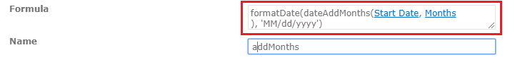
- Formula: formatDate(dateAddMonths(Start Date, Months ), 'MM/dd/yyyy')
Select the date and Enter Months then it will be displayed date after adding months.
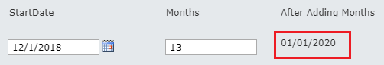

- dateDiffHours: It will return the number of whole hours between two dates(date1,date2).

Usage of this function is: dateDiffHours(date1, date2)

Example:
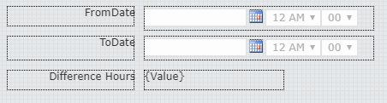

Double click on Calculated Value control and configure the details.
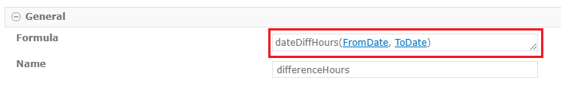
- Formula: dateDiffHours(FromDate,ToDate)
Select the dates then it will be displayed whole hours between two dates.
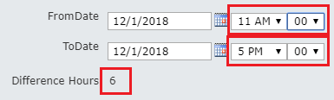

Without time control difference in hours between two dates.
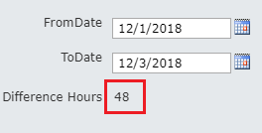

- dateDiffMinutes: It will return the number of whole minutes between Two dates (date1 and date2).

Usage of this function is: dateDiffMinutes(date1, date2)

Example:
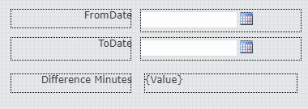

Double click on Calculated Value control and configure the details.
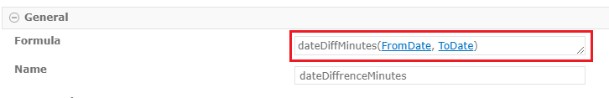
- Formula: dateDiffMinutes(FromDate,ToDate)
Select the dates then it will be displayed whole minutes between two dates.
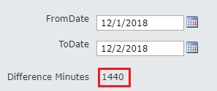

- dateAddHours: It will return the date with the specified number of whole hours added to it.

Usage of this function is: dateAddHours(date, hoursToAdd)
Example:
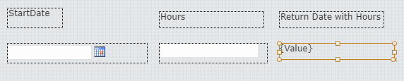
Double click on Calculated Value control and configure the details.
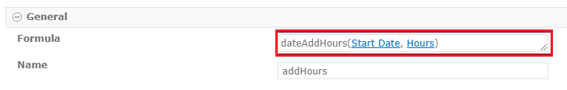
- Formula: dateAddHours(Start Date, Hours)
Select the date and enter Hours then it will be displayed date and hours.
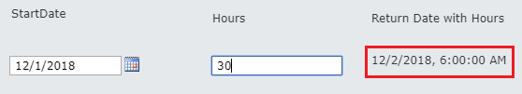

- dateAddMinutes: It will return the date with the specified number of whole minutes added to it.

Usage of this functions is: dateAddMinutes(date, minutesToAdd)

Example:
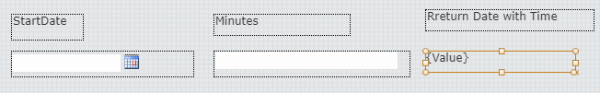

Double click on Calculated Value control and configure the details as shown below.
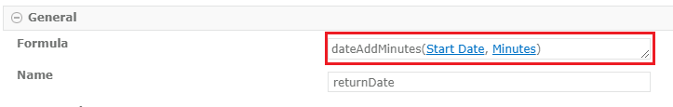

Select the date and enter minutes then it will be displayed date and time.
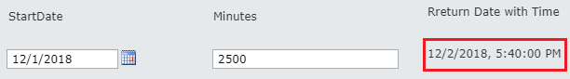

- currentRowNumber: It will return the row number of the Repeating Section that contains the control.

Usage of this function is: currentRowNumber(control)

- rows: It will return the number of rows a control appears within a repeating section.

Usage of this function is: rows(control)

- count: It will return the number of rows in which control that has a value (not blank) appears within a repeating section.

Usage of this function is: count(control)]

Example:

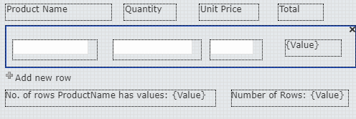
Double click on Calculated Value control and configure the details.
- Formula: rows(ProductName)
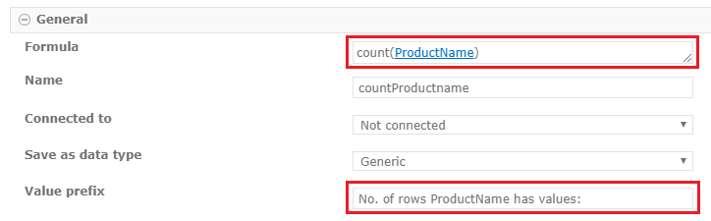
Double click on Calculated Value control and configure the details.
- Formula: rows(ProductName)
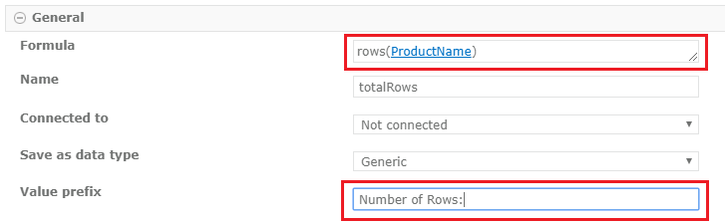
Save and publish the form.
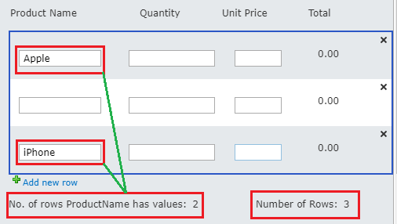

- parseLookup: It parses the value of a lookup control.

Usage of this function is: parseLookup([array or single lookup value], [optional bool showText])

- lookup: It retrieves the value from the specified column ("output column") within a SharePoint list ("list title") for use in a formula.

Usage of this function is: lookup("list title", "column to filter on", "value to filter on", "output column")

Example:

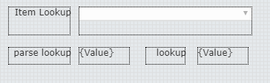
Double click list lookup control and configure details as shown below.
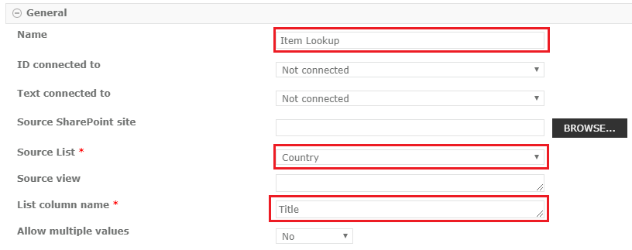
Double click on Calculated Value control and configure the details.
- Formula: parseLookup(Item Lookup,true)
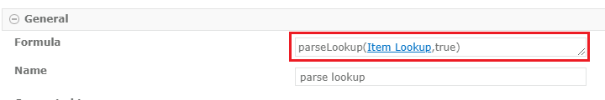
Double click on Calculated Value control and configure the details.
- Formula: Item Lookup
- Parse lookup will only show the selected option but lookup will show the id with the selected option.
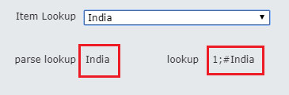

- userProfileLookup: It returns the specified SharePoint Online user profile property for the specified user. The profile property is identified by internal name while the user is identified by UPN (User Principal Name; usually the same as the user's email address).

Common internal names of user profile properties: "FirstName", "LastName","HomePhone", "Manager", "Office", "PreferredName", "WorkEmail".

Usage of this function is: userProfileLookup("UPN","InternalPropertyName")

Example:
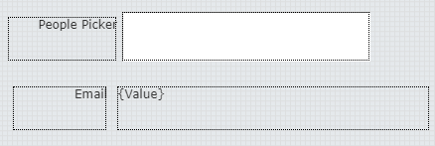
Drag drops the people picker control and Calculated Value control from the “From Control”.
Double click on Calculated Value control and configure the details.
- Formula: userProfileLookup(PeoplePicker, "WorkEmail")

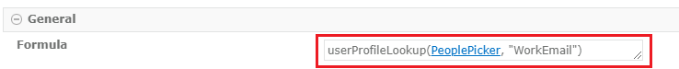
Select one of the people from the people picker then it will return related user email.
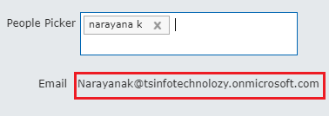

Note: For this function to run, the administrator must activate “allow application access to user profiles.” from the “Nintex forms for Office365” app.

- equals: where two items are of equal value then it will return true.

Usage of this function is: equals(value1, value2)

- greater than: where value1 is greater than value2 then it will return true.

Usage of this function is: greaterThan(value1, value2)

- greaterThanOrEqual: where value1 is greater than or equal to value2 then it will return true.

Usage of this function is: greaterThanOrEqual(value1,value2)

- lessthan: where value1 is less than value2 then it will return true.

Usage of this function is: lessThan(value1,value2)

- lessThanOrEqual: where value1 is less than or equal to value2 then it will return true.

Usage of this function is: lessThanOrEqual(value1,value2)

Example:

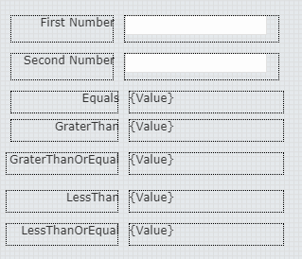
Double click on Calculated Value control and configure the details.
- Formula: equals(FirstNumber, SecondNumber)
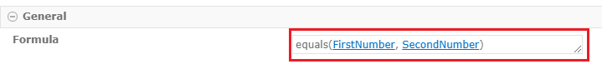
Do the same thing for other Controls.
Enter the Values in the Textbox control then we will get a result.
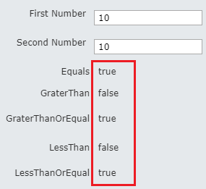

- sum: It returns the result of all the values in a set being added together.

Usage of this function is: sum([set of values])
Note: To add values in a Repeating Section control, omit the square brackets.
Example: sum(ControlName)
Example:
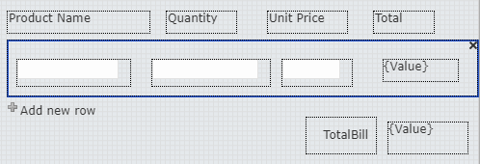
Double click on Calculated Value control (Total) and configure the details.
- Formula: Quantity*UnitPrice
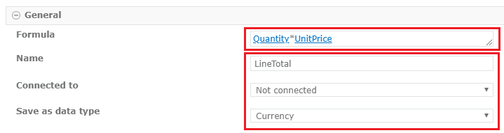
Double click on Calculated Value control (TotalBill) and configure the details.
- Formula:sum(LineTotal)
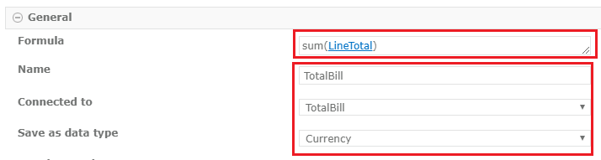
Enter Quanti and UnitPrice details then Line total is calculated and TotalBill also Calculated.
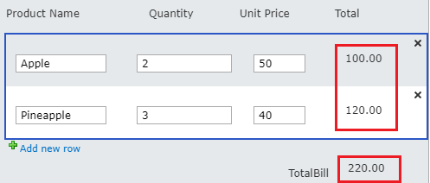

Format with DateTime field:

Auto populate Current User:
We can auto populate current user display name, Email or Login Id.
Right click on the control -> Settings.
Choose Default value source -> Default value source
And then add a formula, from Common functions choose Current User (Display Name)
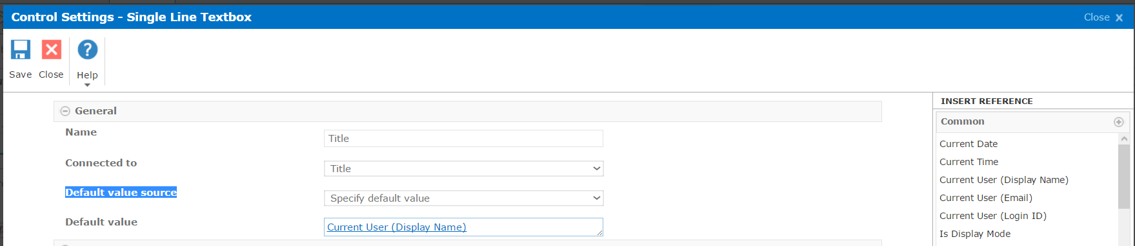
After this it will be appear like below:
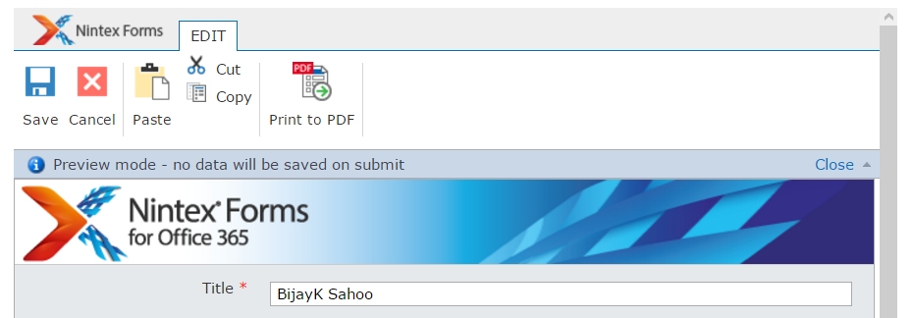

Auto populate email address:
Right click on the control -> Settings.
Choose Default value source -> Default value source
And then add a formula, from Common functions choose Current User (Email)
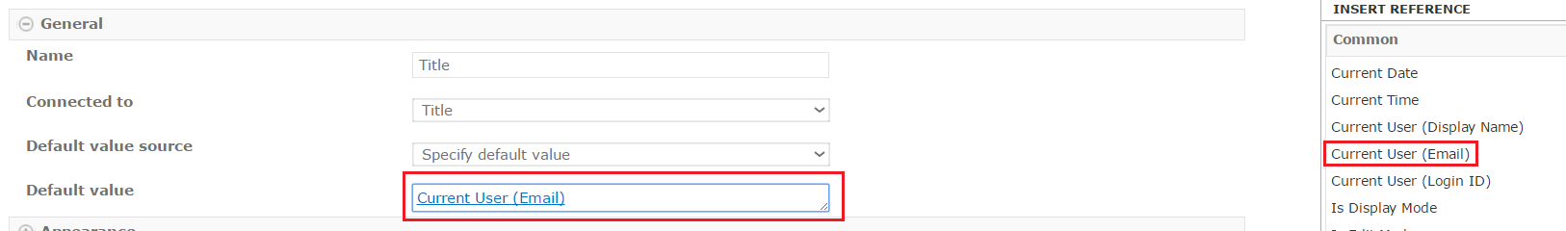
The email id will populate like below:
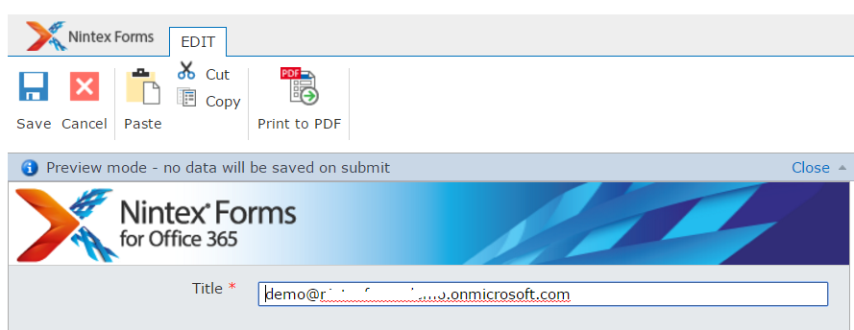

Design Form for Various Layouts:
Apart from desktop layout, you can design forms for various other layouts:
Generic Tablet
Smart Phone
iPad
Windows Tablet
Android Tablet
Nintex Mobile Phone
Nintex Mobile Tablet
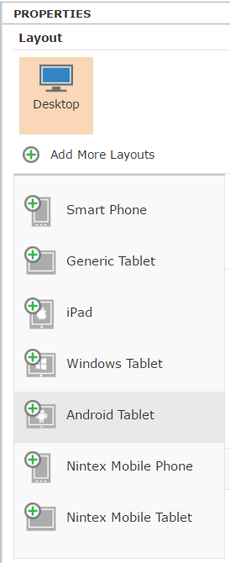

Design Form for Smart Phone
We can design different forms for the above devices.
From Properties -> + Add More Layouts -> then choose Smart Phone.
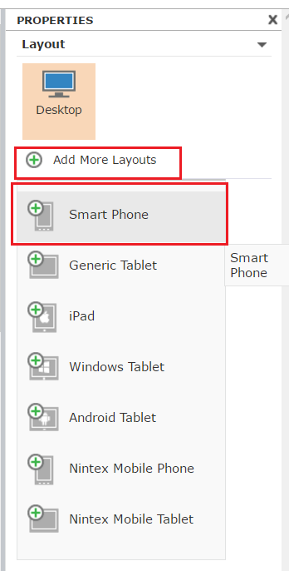
Then it will show you the form in smartphone layout.
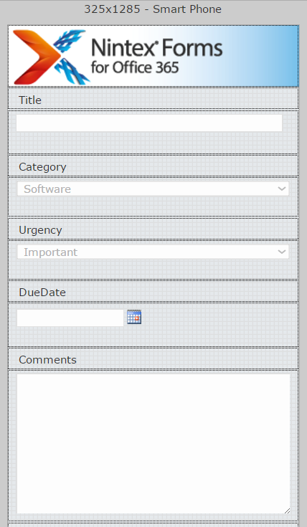
All the rules will be applied to the field which you have created in the desktop layout.
Once you publish and after that if you will open the form in a smart phone, you can see the screen like below:
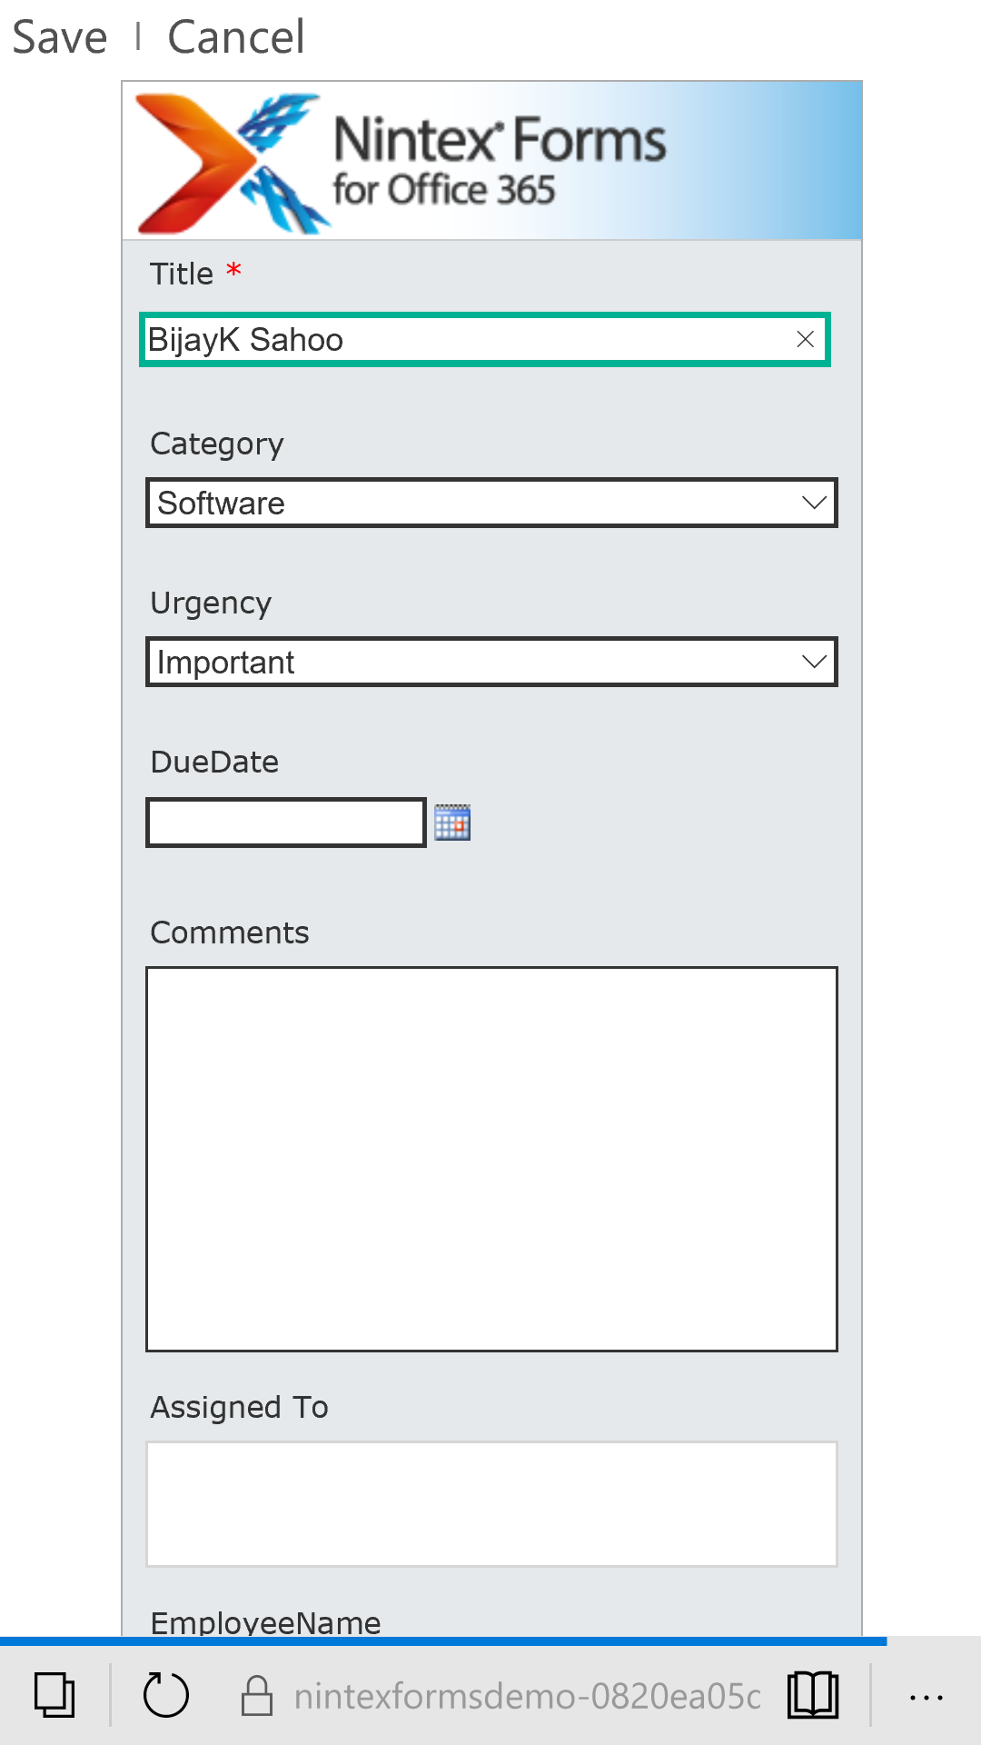

Delete Layout:
If you want to delete a layout, select the layout and then click on Delete Layout as shown in the fig below:
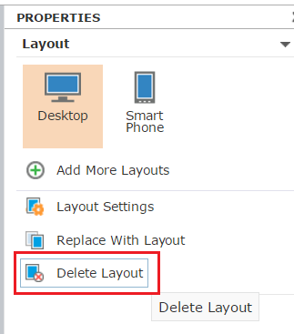

Reset Form:
You can reset the form to the original auto generate state by clicking on the Reset button.
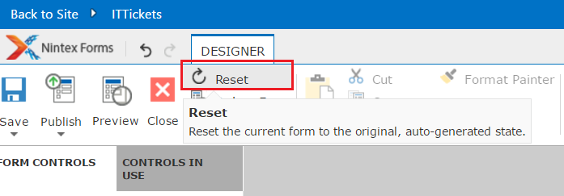

Print to PDF:
Print to PDF is a very good option which is helpful to Print the form in PDF format. Open the item and then click on Print to PDF.
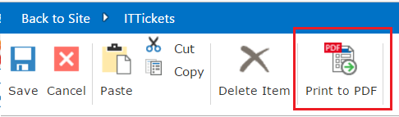
This will create the pdf form and it will allow you to save the pdf in the local desktop.
You can do the pdf setting in the Forms settings page.
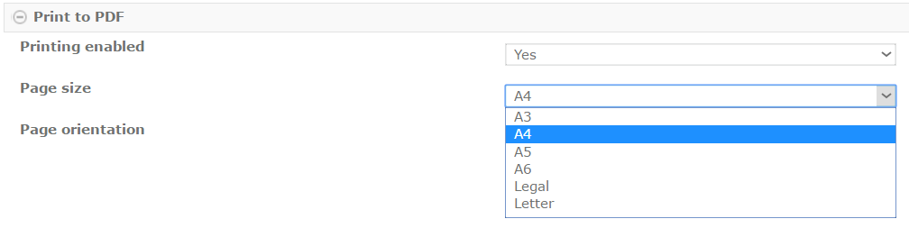

Import and Export Nintex for Office 365 Forms
If you want to copy forms from one server to another server or if you want to take back up of forms, and you want to use this forms in another SharePoint list, then we can use Importing and Exporting forms options.
The extension will be .nfp file.

Export:
We can export form using the Export Forms button from the ribbon. Open list -> Nintex Forms which will open the Nintex forms designer.
There from the ribbon click on Export button in Nintex Forms ribbon.
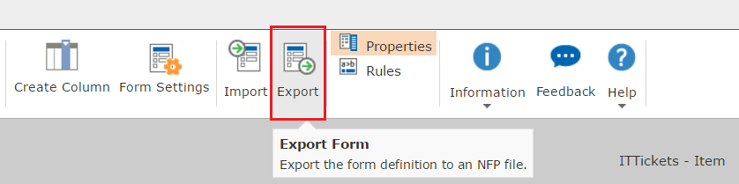
It will allow you to save the form in the local drive.

Import:
We can import the form to a different list which will override the list.
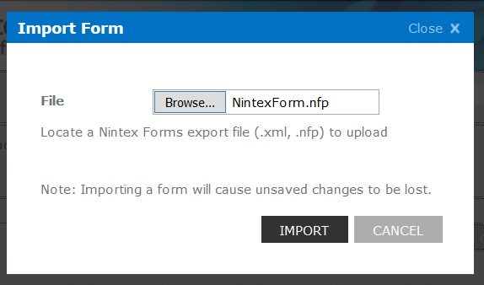

Delete Nintex Form and Reset Back to Out of box Form:
You can delete the Nintex customized form and can reset back to the original out of box form.
From the ribbon click on Delete button, it will ask you for confirmation and then it will delete the form.
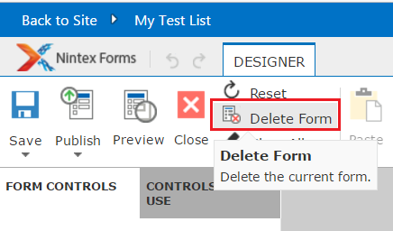

Customize Nintex Forms For Office 365:
By default when you design a form using Nintex Forms for Office 365 then you will be able to see the default banner of Nintex in the header which looks like below:
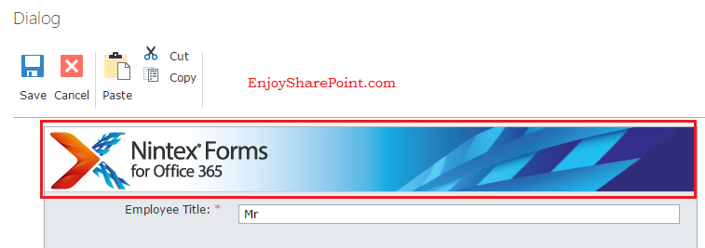
But the business requirement is to change this and to either giver a banner related to the organization or you can write simple text.
To change this, open the particular SharePoint list in the browser, then from the Ribbon, click on LIST tab and then click on Nintex Forms button in Customize List section.
This will open the Nintex Form designer.
To apply a new image, first upload the image to a picture library or you can upload to the images folder itself. Then in the Nintex form designer, select the image and then in the Properties (presented in the right side) window under Settings section, change the image page. Then you can Save and publish the form.
If you want to add some formatted text, then Right click and Delete the image control from the form. Then Right click on the header and then insert Control -> General and then select a Label control like below:
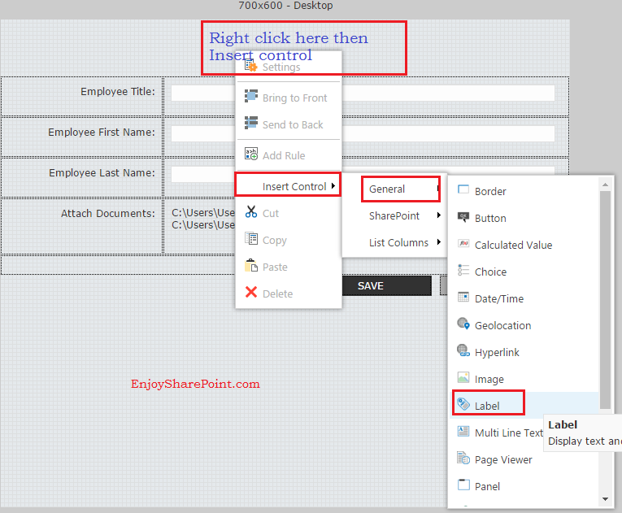
Then to write something in the Label, go to the properties windows and in the Settings -> General -> Text, you can write the text which you want.
But if you want to format the text, click on More Settings like below:
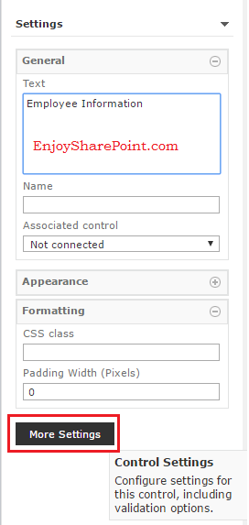
When you will go to more settings, it will provide a Rich text editor to format the text. You can format text like below:
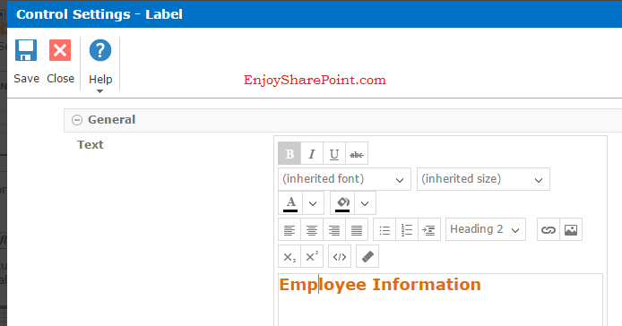
Now if you want to see the changes in preview, click on the Preview button from the designer ribbon.
To publish the form directly, click on Publish button or Publish and Close button from the Ribbon.
Now try to add one item to the list, you can see the changes in the form like below:
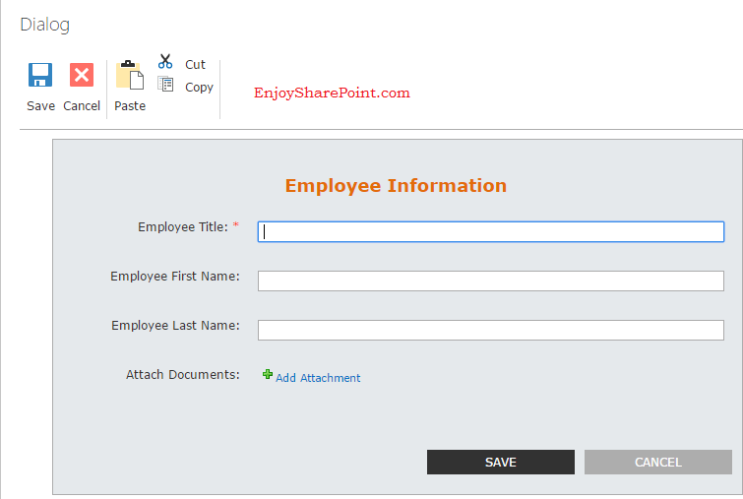

Increase width Height of the form:
You can easily increase height and width of the form easily. Open the form using Nintex designer.
Then select the Layout -> Layout Settings.
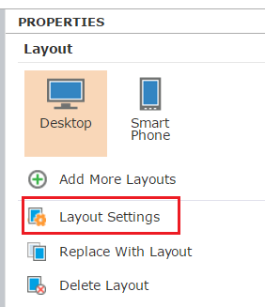
Then you can change width and height:
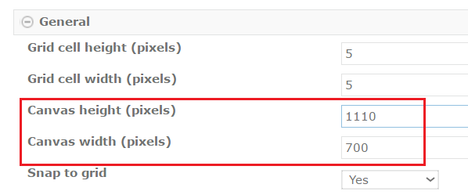

Create Columns in Nintex Forms Designer for Office 365:
We can create columns in Nintex forms designer in Office 365 SharePoint Online site. Rather creating a column in the browser through list settings we will create a column in Nintex forms designer itself.
Open your SharePoint online office 365 site in the browser, then navigate to the particular list, From the Ribbon click on Nintex Forms button which will open the Nintex forms designer.
When it open Nintex Forms designer, from the Ribbon click on Create Column as shown in the fig below:
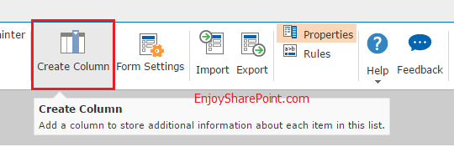
This will open the Create column dialog box which usually comes while creating a column in a list using browser. Fill the column details like Name, Type etc. Here I have just added a column with multiple lines of text type. Once you click on OK, the column will get created.
The column will be available in List Columns section which is there in left side in Nintex forms designer. If you will expand to List Columns tab you will be able to see our newly created column. In my case I have created "AboutMe" column which looks like below:
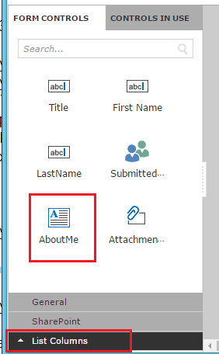
If you want to add the column to the list form, then drag the column from the Forms Control and put it in the form.
Now publish the form from the Publish button from the ribbon. Once it is published successfully, you will be able to see the column when you will try to add an item to the list.
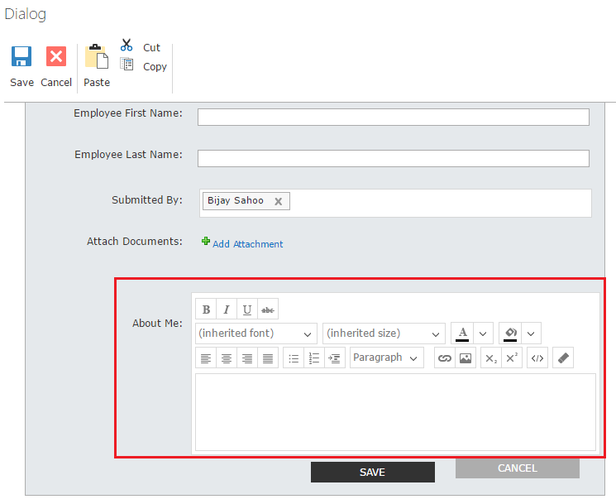

Repeating Section in Nintex forms for Office 365 SharePoint online:
Open your list form using Nintex forms for Office 365 designer. From the General section drag and drop a Repeating Section as shown in the fig below:
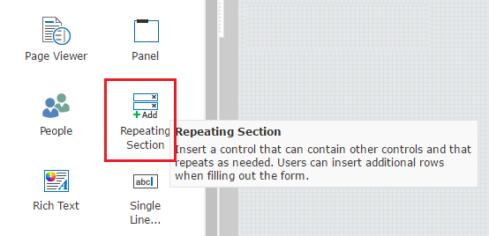
Double click on the Repeating section to go to the Control settings page. Here give a name to the control and then in the Connected to property choose the multiline text box that we have created. And also you can give a meaningful name to the "Text for add row icon" which will appear down to the repeating section. The dialog will show like below:
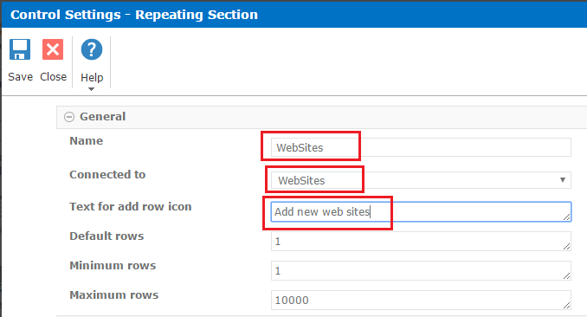
After that Add a Single line of text box inside the repeating section where users can add data as shown in the fig below:
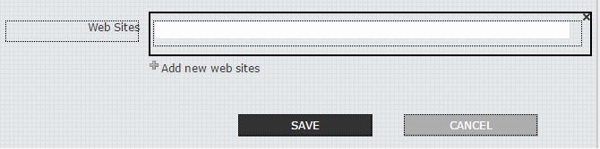
Now publish the form then you will be able to see it will appear like below, user can add more rows by clicking on the Add new web sites option.
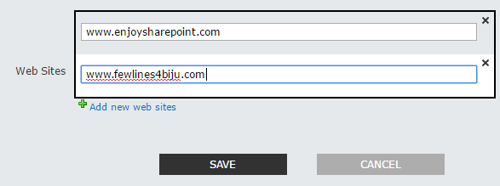

Apply rules in Nintex forms for Office 365 SharePoint online:
To do this, Open the list and from Ribbon click on Nintex Forms. This will open the Nintex forms designer and your Nintex form will open. Here i have taken a check box and based on check box checked or unchecked I am showing or hiding a section. So I have drag and drop a check box from General controls. Then double click on the check box control to change few properties of the control. Here I have given a Name and Text as "Do you want to give comment?" this will appear after the check box. So the properties will appear like below:
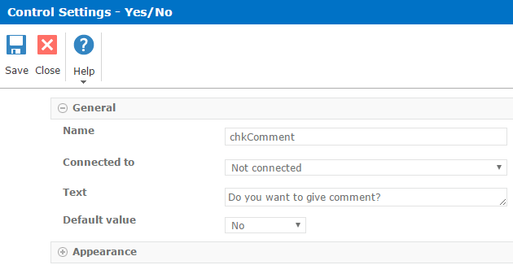
Then I drag and drop a Panel control to the form. Now Inside the panel control I have drag and drop a single line of textbox. Here the UI should look like below:
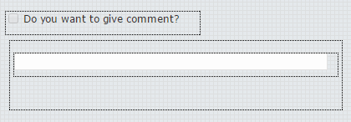
And the requirement is if user checked the check box then the panel should appear and if user uncheck the check box the panel should get hide.
Here we will write rule on the panel control. Just select the panel control and from Ribbon click on Add Rule button as shown in the fig below:
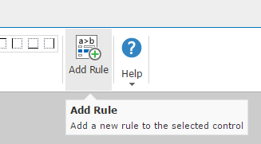
Then the Rule builder will open, give a name for the rule. Select the Rule Type as Formatting. The click on the fx icon to write the condition. This will open the Formula Builder. Here expand the Named Controls and select chkComment which is our check box name. The expand the Operators and choose != and write true. It should looks like below:
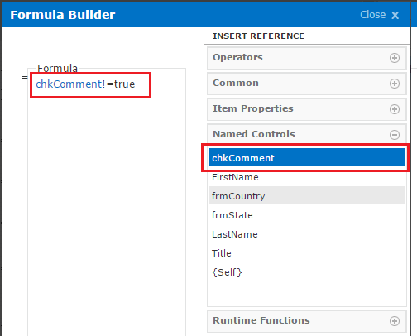
And then in the Formatting section choose "Hide" check box. So as per the formula if checked box is not true (not selected), then it will hide the control. Your rules should looks like below:
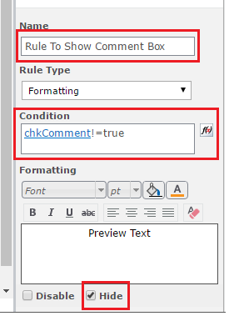
Now to try out this Publish the form and then Open the form and then check / uncheck the checkbox you will be able to see the result.
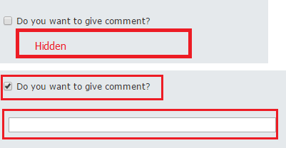

Cascading drop down in Nintex Forms for Office 365 SharePoint Online:
We can show cascading drop down in Nintex forms for Office 365 and SharePoint Online. This will be a very basic demo where a country list will be there and a state list will be there. Once user select the country, corresponding states will appear.
I have created a Country list which has only one column name as Country, Here i have renamed the Title column to Country. And I have added few items to the Country list and the list looks like below:
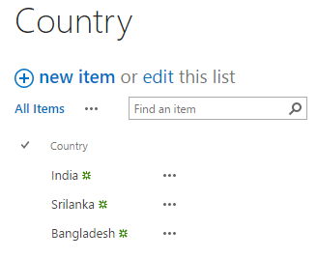
I have created another list name as "State" which has two columns, One is the State column (I have renamed the default Title column) and other one is lookup column name as "CountryName". This column is populating from the Country list which we have created above. And I have added few items to the State list also. It appears like below:
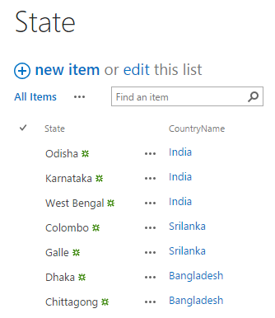
Now open the list where you want to add the cascading dropdown. From the Ribbon of the list, click on Nintex forms to customize the list form. This will open the Nintex forms designer. There first we need to add two lookup fields. So expand SharePoint section and then drag and drop List Lookup to the form.
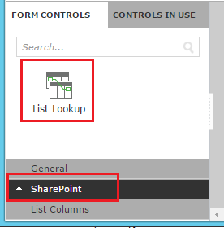
You can also add two labels for the corresponding dropdowns. Here one dropdown for Country and another dropdown for State as shown in the fig below:
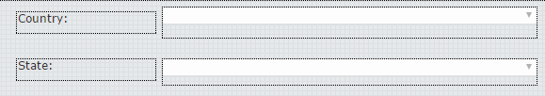
Now to let it work as per the requirement we need to do some configuration settings for both the controls. First Double click on Country dropdown, which will open the Control Settings dialog box.
Give a name for the control, the from the Source List, select the Country list. Because the data should come from here. List Column name as Title. Here I have put a validation so that user will be bound to select one country. Make required property as Yes to make it mandatory. Then you can also set the error message which you want to display if validation fails. Click OK to save and the properties should look like below:
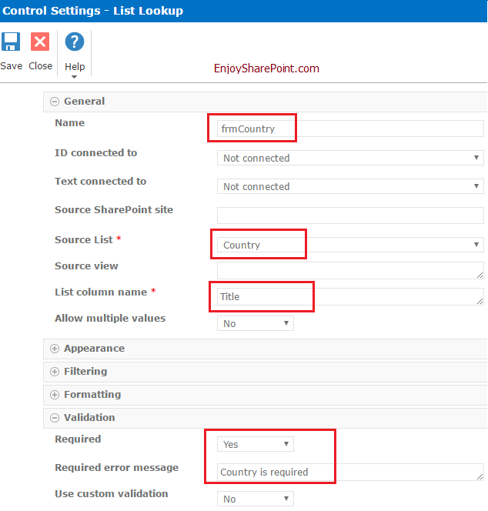
Then double click on the State dropdown to open the Control settings window. The same way we have to give a name, then the Source list as State and column name in the List is Title.
Here we need to do the filtering settings. First choose:
Filter available selections as By a control's value.
In the where field choose the Column name from the State list. Here the column name is CountryName. This is our lookup column name.
Then Filtered by control choose the Country form field name. Here we have given the name as "frmCountry". For the State field also we have choosen the Required field as Yes, so that user will bound to choose a state.
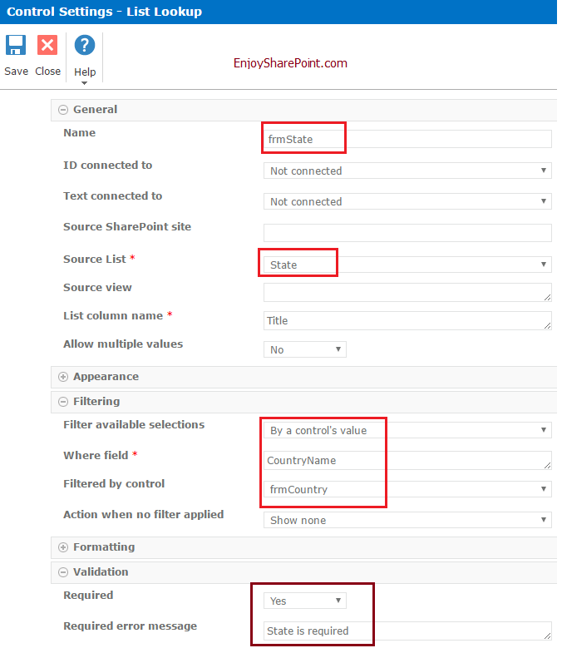

Now Publish the form and then Open new form by adding an item to the list. In the form if you will choose a country, corresponding states will appear as shown in the fig below:
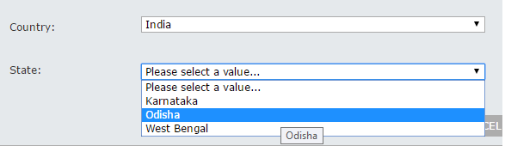

Examples of Nintex forms for office 365 Examples:
- Create a column in Nintex forms:
- Open the SharePoint list in Nintex forms.
- Designer->click on “Create Column”.
- Name: Enter the column name.
- Select type of the column.
- Click on “SAVE”.
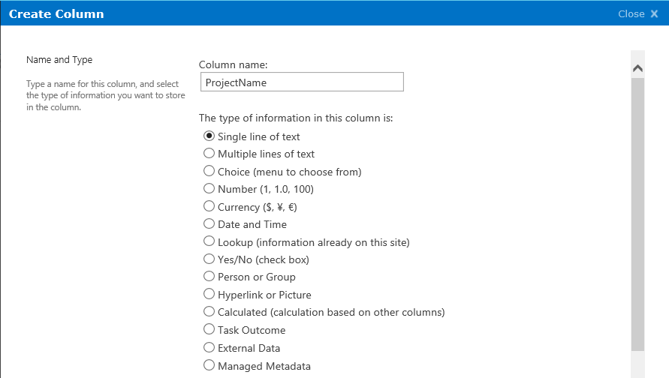
- All created columns and existing columns will be in the “List Columns” of “Form Controls” panel.
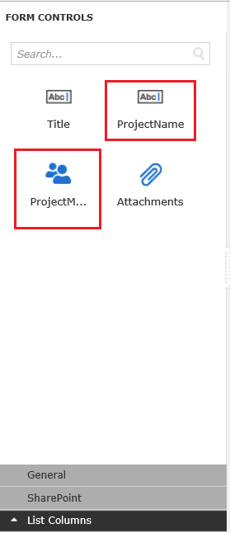
- Columns created in SharePoint list.
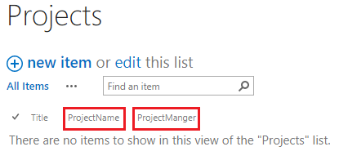
- JavaScript in Nintex forms:
In this example, we will learn how to use javascript in Nintex from. Take label control, Textbox control and calculated value control for retrieving and displaying the value from Textbox on the form.
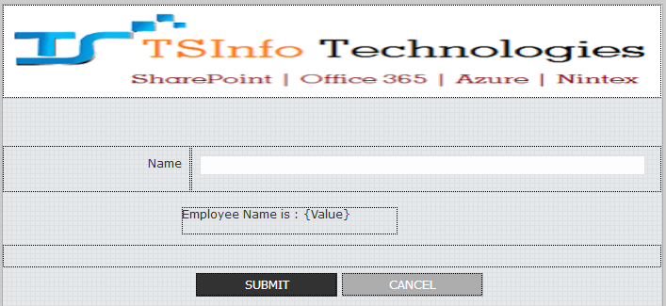
- Double click on the calculated control and configure the details.
- Formula: Add “Name” from the Named Control of the “INSERT REFERENCE” panel.
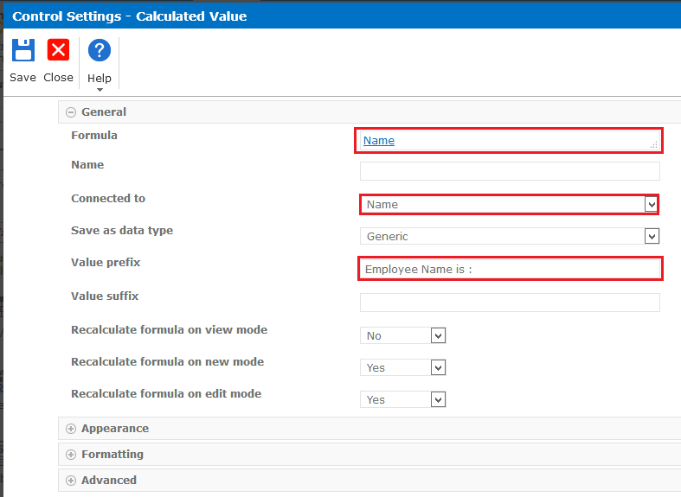

- For adding javascript go to the Designer tab click on the “Form Control”.
- In the Form Settings -> go to Custom JavaScript. Copy and paste our code.
NWF$(document).ready(function(){
NWF$("Button").click(function(){
retriveTextBoxValue();
});
});
function retriveTextBoxValue() {
var empName = NWF$("#" + varEmpName).val();
if(empName !=''){
NWF$("#" + employeeName).val(empName);
}
else{
alert("Employee Name is empty");
return false;
}
}

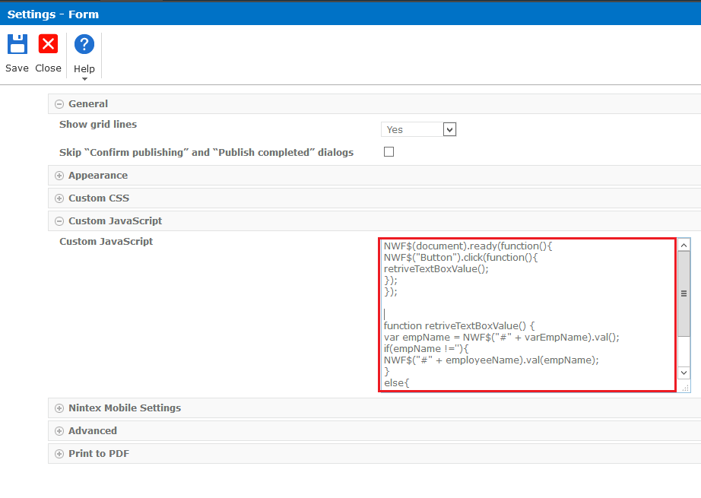
- Double click on submit button and configure the details.
- Name Enter name the button.
- Button action: Select “JavaScript” from the drop-down.
- Button type: Select “Button” from the drop-down.
- Button label: Enter the name of the button here. For my example, I have taken “SUBMIT”.
- Go to the Advanced section, call your javascript function name here.
- Client click: retriveTextBoxValue().
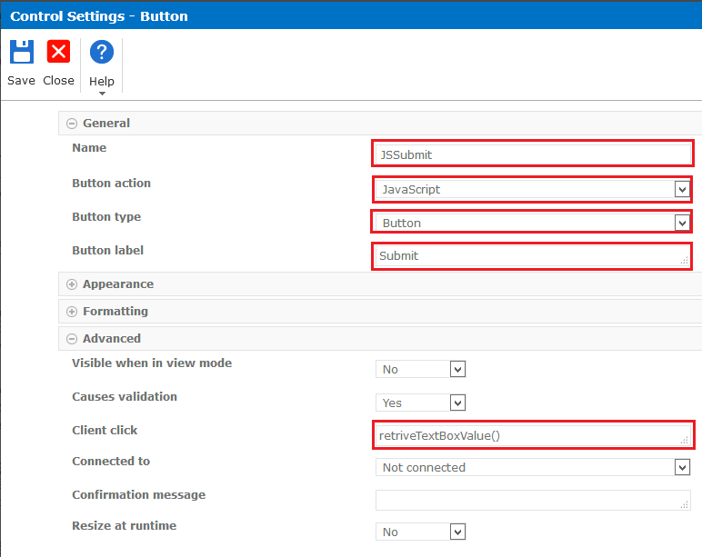
- Enter the name on the Textbox then the value will be retrieved and displayed on the form.
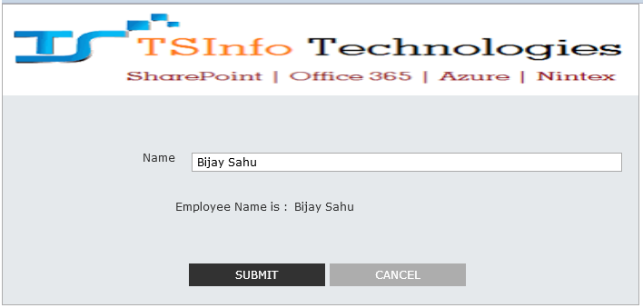
- Calculate value in Nintex form:
Retrieve the values from other SharePoint list based on value enter in the text box. We have two lists one is “Employee Info” and the second one is “Department”.
- Employee Info list has few fields like “Employee Name, DepartmentNo, DeptName, Location”.
- Department list has few columns like “Department No, DeptName, Location”.
- Open our employee list in the Nintex forms and add Calculated Value control to the DeptName and Location on the form as shown below.
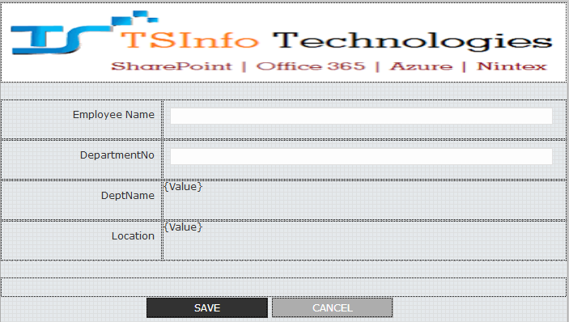
- Double click on calculated control of the “DeptName” and enter the values.
- Formula: lookup("Department", "Department No", DepartmentNo, "DeptName")
Lookup: it will returns a value form another SharePoint list based on lookup criteria and displayed on the form. Syntax of the lookup for example.
- lookup("list title", "column to filter on", value to filter on, "output column").
- To add lookup into Formula control, go to the Runtime Functions of the “INSERT REFERENCE” panel.
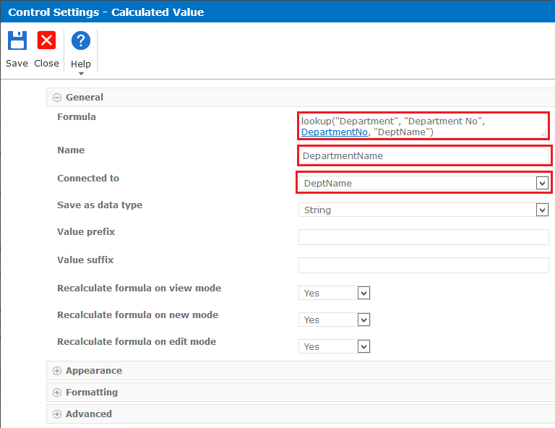

- Double click on calculated control of the “Location” and enter the values.
- Formula: lookup("Department", "Department No", DepartmentNo, "Location").

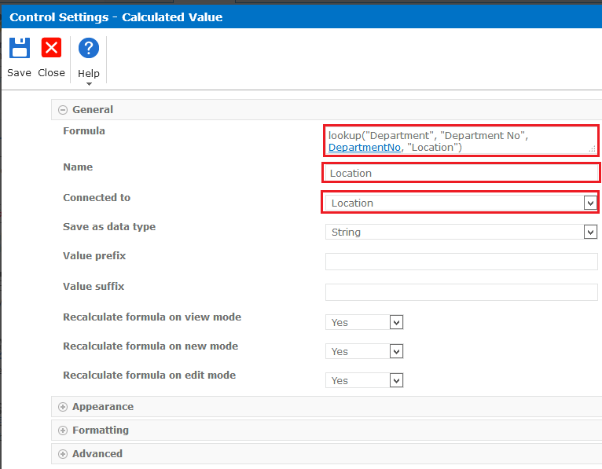
- Enter the value in the Textbox of “Department No” then it will retrieve the values from the Department list and displayed on the form.
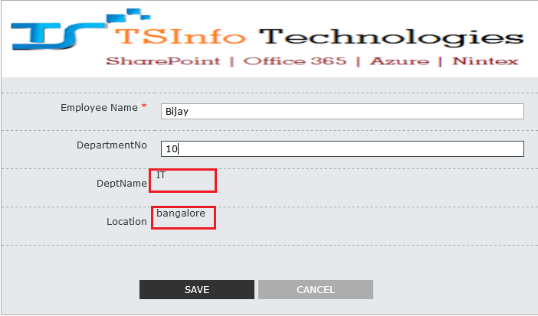

- Create Cascading Dropdown in Nintex forms for office 365:
- Create a Country, State and City lists.
- In Country lists, only Title column.
- In State list (Title, Country), create a Country as the lookup column.
- In City list (Title, Country, and State), create a Country and State as lookup columns.
- Open City list in Nintex Forms for Office 365.

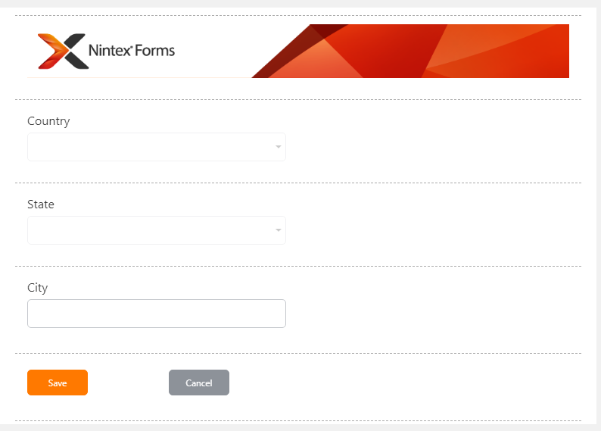

- Click on State Textbox control and configure the details.
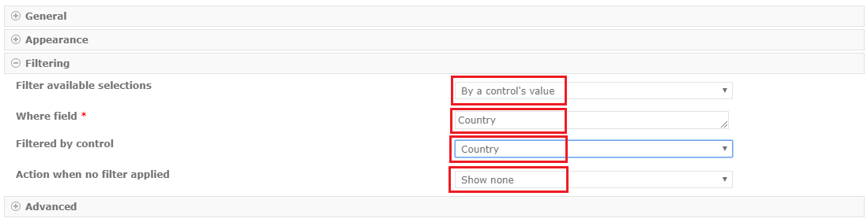
- Filter available selections: “By a control’s value”.
- Where Field: Country (Enter this field name manually, not select from the Named control).
- Filtered by control: Country.
- Action when no filter applied: Show none.
- Select Country from dropdown it will show related country state names.
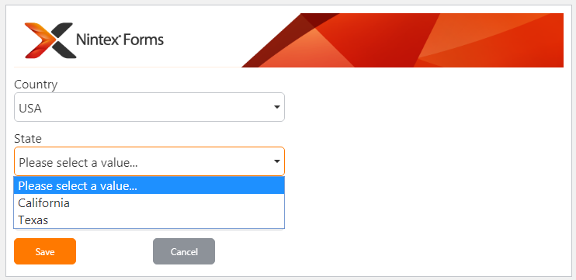

- Create Tabs in Nintex forms for Office 365:

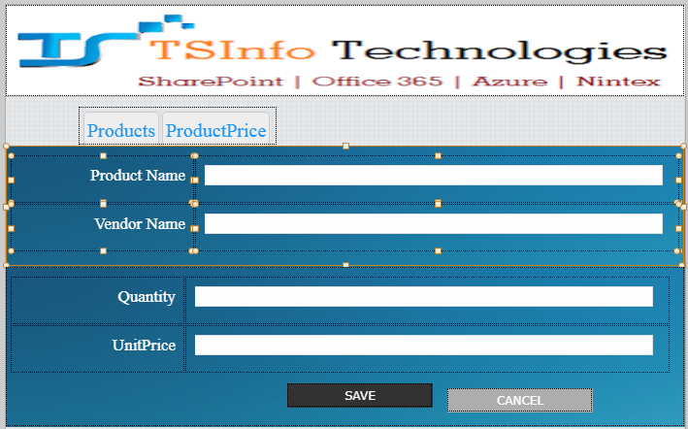

- Choice Control: Drag and drop choice control and configure the details.
- Display format: Option buttons.
- Choice: Products, ProductPrice.
- Arrange choice: Across then down.
- Number of columns: 2.
- Column alignment: Fixed.
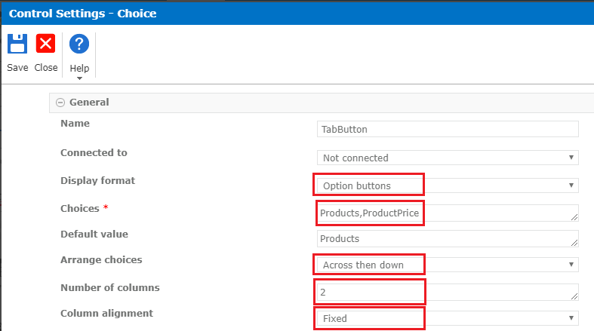

- Create a Tab using CSS for Choice Control:
- Go to the Designer tab -> click on Form settings.
- Add CSS code in Custom CSS section.
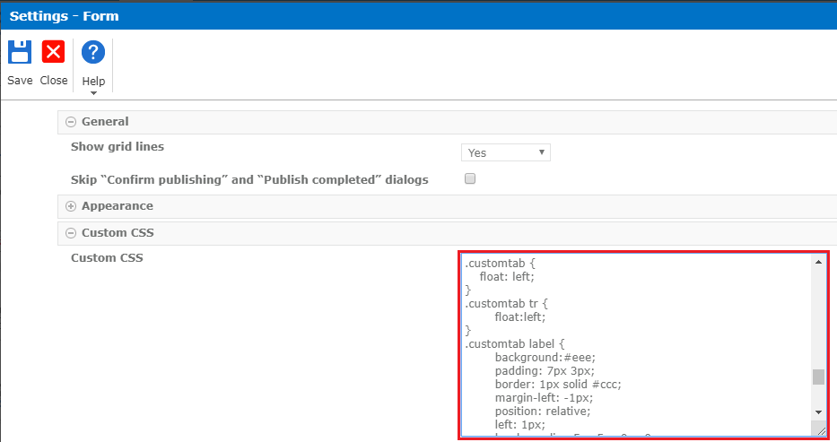
- CSS for Tab Create:

.customtab { float: left; }
.customtab tr { float:left; }
.customtab label {
background:#eee;
padding: 7px 3px;
border: 1px solid #ccc;
margin-left: -1px;
position: relative;
left: 1px;
border-radius:5px 5px 0px 0px;
cursor:pointer;
border-bottom:none;
text-align:center;
}
.customtab [type=radio] { display: none; }
[type=radio]:checked ~ label {
background:white;
border-bottom: 1px solid white;
z-index: 2;
}
- CSS for Tab font:
.tabcss{
font-family: 'Cinzel', serif;
font-size: 20px;
color:#2196F3;
}

- Add both “custom tab” and “tabcss” (give space between the classes)class names in “Control CSS class” of Choice control settings.
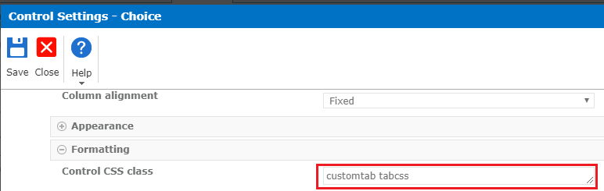
- Change the font color and styles to the field controls using CSS.
.fontcss{
font-family: 'Cinzel', serif;
font-size: 17px;
color: white;
}
- Copy CSS Class name “fontcss” and paste in every CSS class of label control settings.
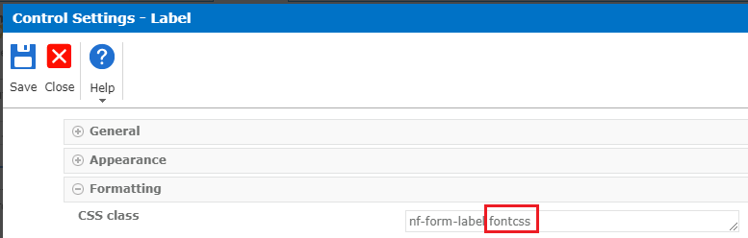
- Drag and drop two panels on the form and put controls individually in the panels.
- Click on the panel and configure the details.
- Name
- Background image
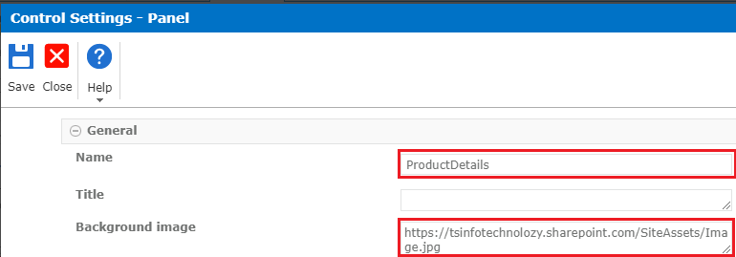
- Right, click on panel -> click on “Add Rule”.
- Rule Type: Formatting
- Condition: TabButton!='Products'
- “Products” is the tab name.
- Formatting: check on “Hide”.
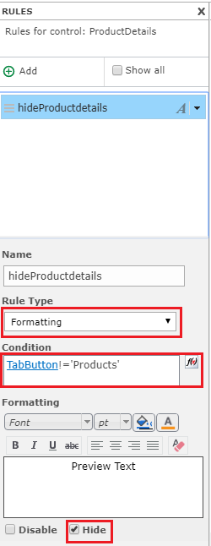
- Do the same steps for the second panel.
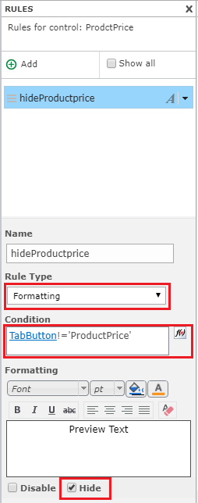
- Now tabs are created.
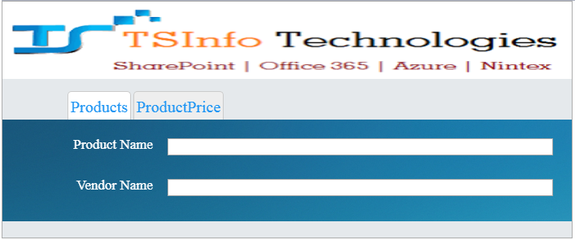
- Click on “ProductPrice” tab.
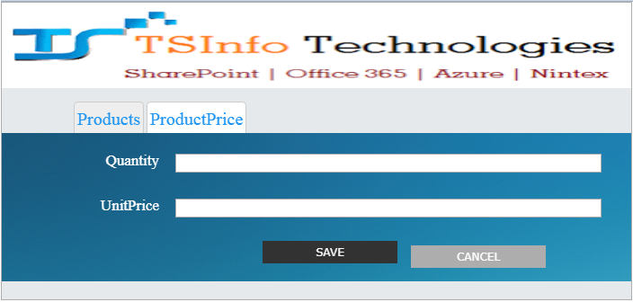
- Create a multi-step form with Nintex Forms for Office 365:

- We are going to design a simple Employee registration form with two steps.
- Step 1: Personal Information
- Step 2: Work Experience.
- We need to change the canvas height to make it longer because we need more space to keep all our form controls.
- Layout Settings->set the Canvas height (pixels) property to 1200(depends on our form controls).

- Personal Information:
- Drag and drop the Panel control from the form controls on to the canvas.
- Next drag and drop controls inside Panel.
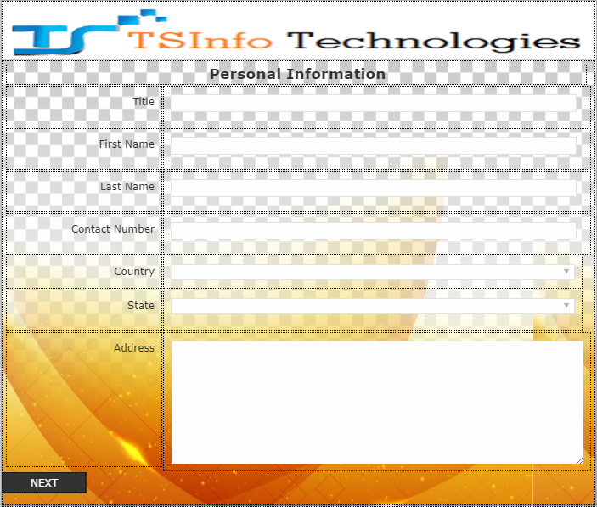

- Transfer from one page to the second page:
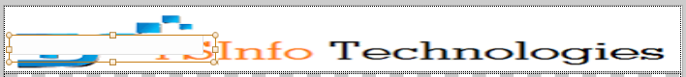
Drag and drop Single line of text control on the top of the form (put it on banner). We are going to use this textbox as a hidden field to store the active step number and then use it with rules to hide and display the correct step when the user clicks on “Next” or “Previous” buttons.
- Double click on Single line of text control and configure the details.
- In General->Name->hiddenTextBox & -> Default Value->1.
- IN Advanced-> Store Client ID in JavaScript variable -> “Yes” & Client ID JavaScript variable name -> “varhiddenTextBox”.
- Right click on hiddenTextBox and click on “Send to Back” then it sends behind the banner.
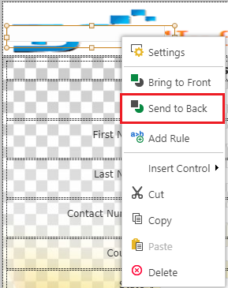
- Next Button:
- Double click on Next button and set the properties.
- In General->Button action->Select “JavaScript” from dropdown.
- In Advanced->Client click ->gotoStep(2).
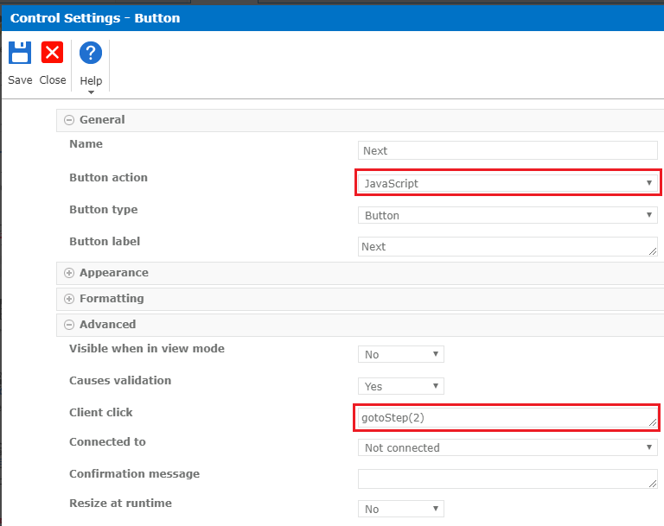
- Panel control:
- Select the panel control and Right Click on it-> click on Add Rule.
- Rule Type: Formatting
- Condition: If(Is Display Mode,false, hiddenTextBox!=1)
- Check on Hide.
By this rule we will only display the step 1 when the value of our hidden textbox is 1 or when we are in display mode; otherwise, it will be hidden.

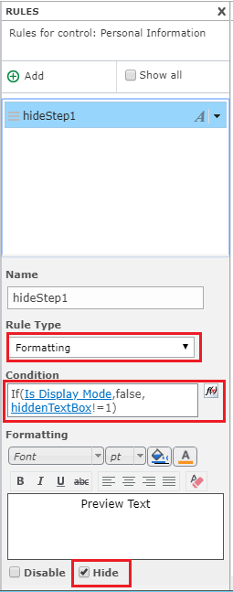
- Work Experience:
- Drag and drop the Panel control from the form controls on to the canvas.
- Next drag and drop control inside Panel.
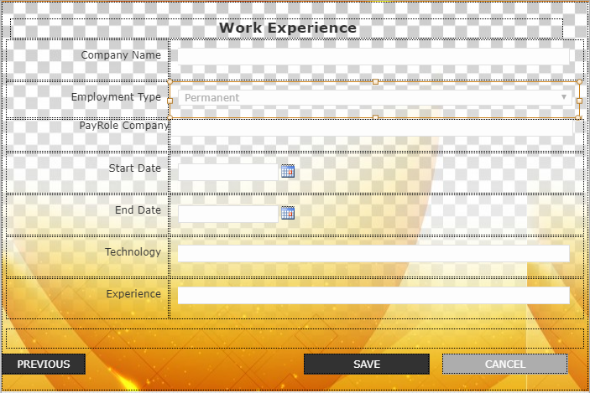
- Previous Button:
- Double click on the Previous button and set the properties.
- In General->Button action->Select “JavaScript” from dropdown.
- In Advanced->Client click ->gotoStep(1).
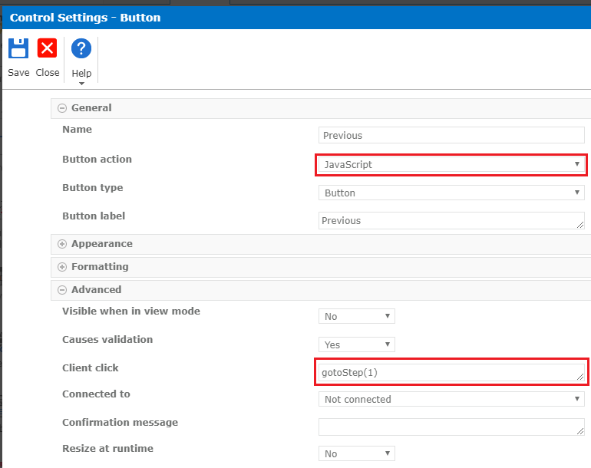
- Panel control:
- Select the panel control and Right Click on it-> click on Add Rule.
- Rule Type: Formatting
- Condition: If(Is Display Mode,false, hiddenTextBox!=2)
- Check on Hide.
By this rule we will only display the step 2 when the value of our hidden textbox is 2 or when we are in display mode; otherwise, it will be hidden.
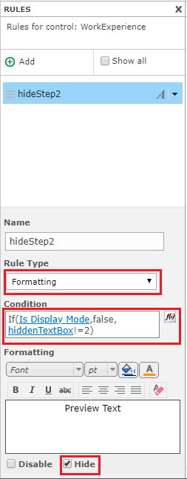

- Form Settings:

- Designer tab -> Form Settings -> go to Custom JavaScript.
- Copy and paste the below JavaScript code.
function gotoStep(nextStepNumber)
{
var hiddenTextBox = NWF$("#"+varhiddenTextBox);
hiddenTextBox.val(nextStepNumber);
NWF.FormFiller.Functions.ProcessOnChange(hiddenTextBox);
}
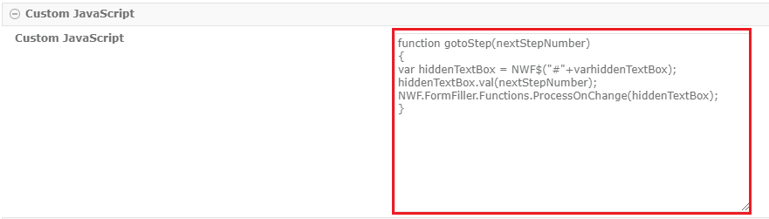
- Save and publish the form.
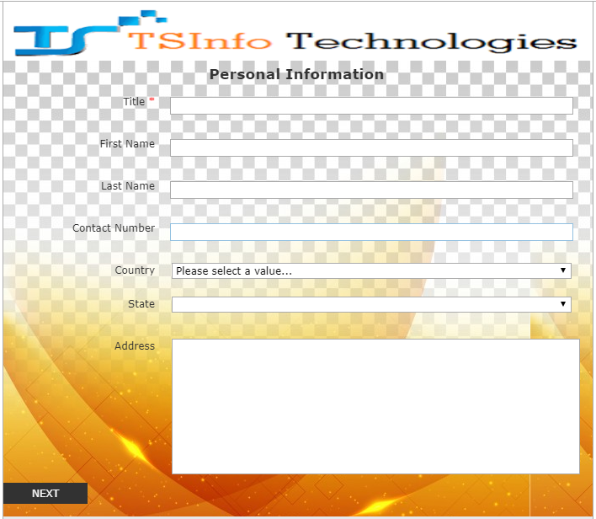
- Click on Next it will takes to us second page.
- Digital Signature Pad Using JQUERY AND SIGNATURE:
jSignature is a jQuery plugin that simplifies the creation of a signature capture field in a browser window, allowing a user to draw a signature using a mouse. We will be using the signature to create our embed signature pad within our Office 365 SharePoint Nintex Form.
- Create list->” Signature”.
- Create Column Name->Signature.
- Open Signature list in Nintex forms to customizing.
- Drag and drop the Rich Text control on to the canvas.
- Now the form consist of two fields. First one is Signature Multi Line of Textbox to store the Signature data and the second one is Rich Text Control for the Signature Pad.
- Change The Rich Text Control’s background color to white.
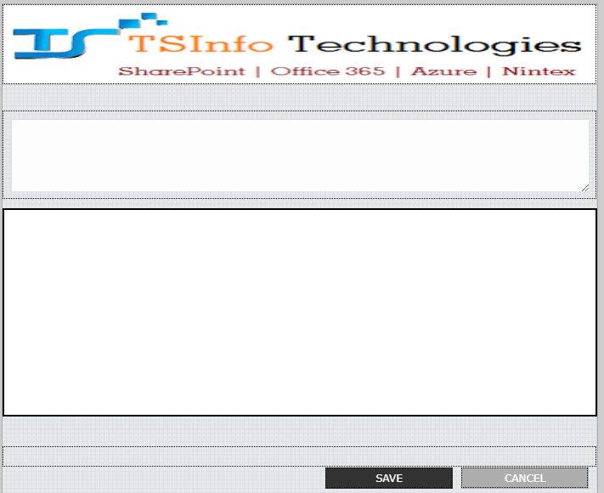
- Double click on Signature (Multi Line of Textbox) control and configure the details.
- Store Client ID in JavaScript variable: Yes.
- Client ID JavaScript variable name: signature1.
- Add an ID called signature1 to the Signature Multi-Line Text field to Store Client ID in JavaScript variable for Nintex.

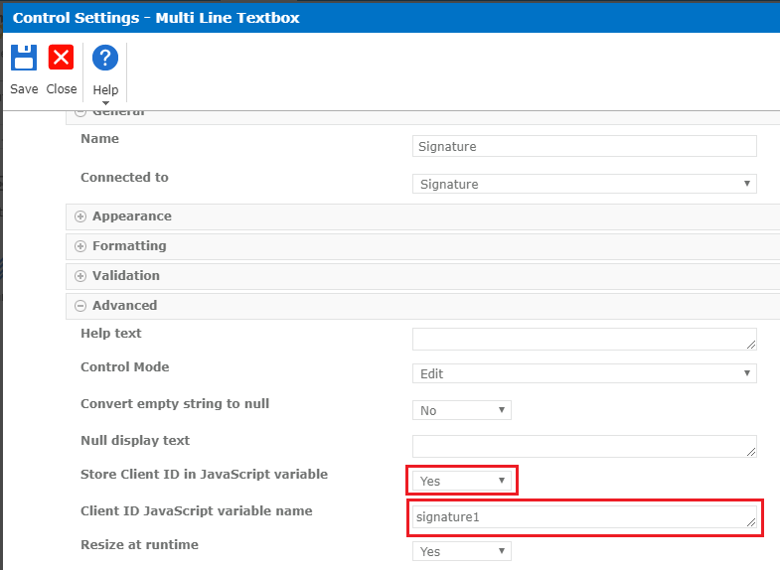
- Double click on “Rich Text Control” and then click on the (</>) “HTML” source to insert HTML div with unique ID where jSignature canvas will display for the signature.
- Past Code: <div id="Signature"></div>.
- Click on UPDATE.
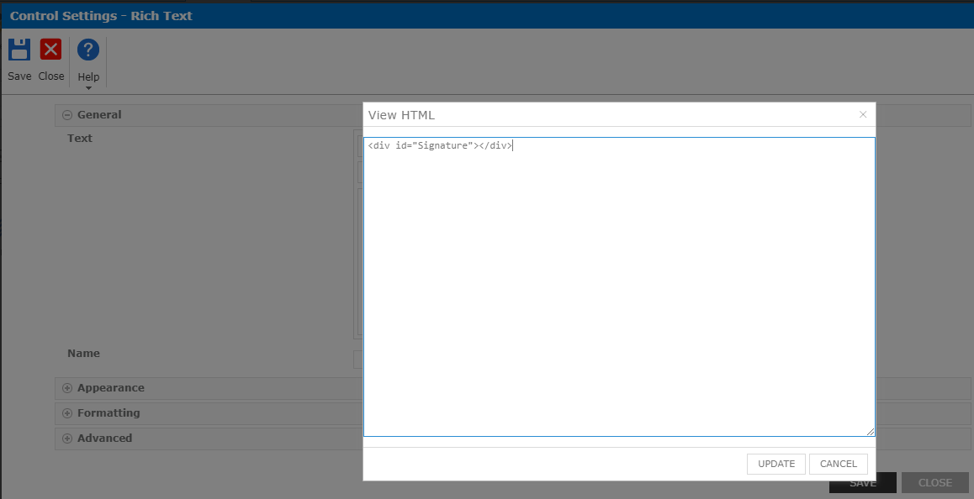

- Place “Multi Line of Textbox” control on “Rich Text” control.
- Select “Multi Line of Textbox” ->Right click on it->click on “Send to Back”.
- Hide the Signature Multi Line of Textbox where the drawing data is stored.
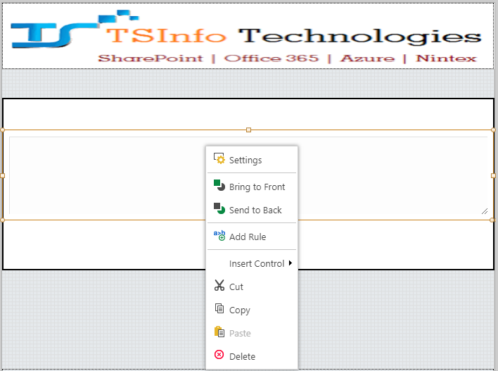
- Designer->Click on “Form Settings”.
- Now we can add the jSignature script links along with our embedded custom script.
- Download and upload the jSignature library in our Site Assets folder of the SharePoint Online site.
- Copy the Path of the jSignature and paste in Advanced-> “Custom JavaScript Includes”.
- Custom JavaScript Include: https://yoursite/SiteAssets/jSignature.min.js
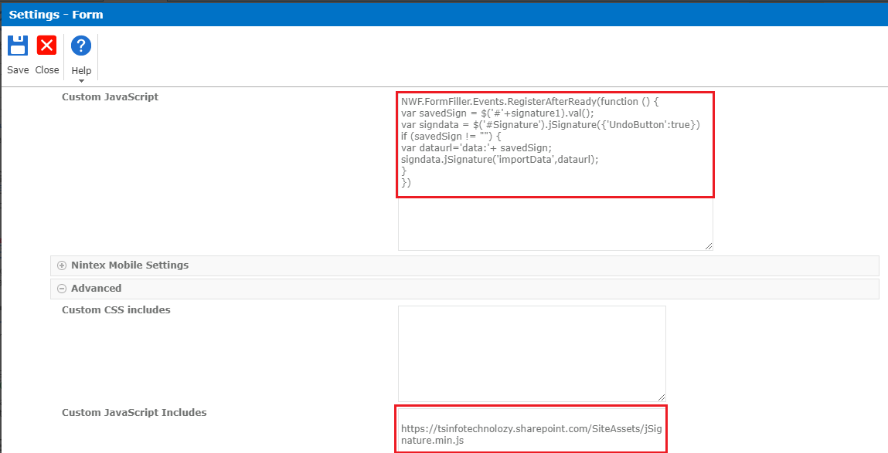
- Copy and paste code in “Custom JavaScript”.
NWF.FormFiller.Events.RegisterAfterReady(function () {
var savedSign = $('#'+signature1).val();
var signdata = $('#Signature').jSignature({'UndoButton':true})
if (savedSign != "") {
var dataurl='data:'+ savedSign;
signdata.jSignature('importData',dataurl);
}
})

- We need to update form Click on “Save” button add below JavaScript.
- NWF$('#'+signature1).val($('#Signature').jSignature('getData', 'base30'));
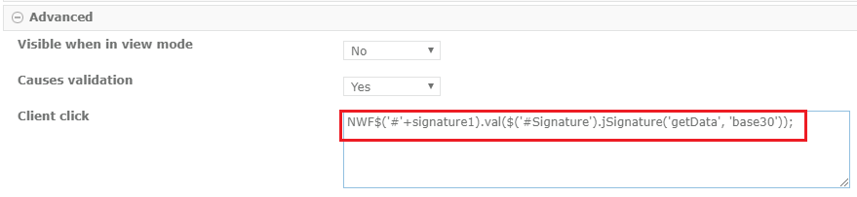
- Draw the signature on the Signature Pad then “UNDO LAST STROKE” button automatically appeared.
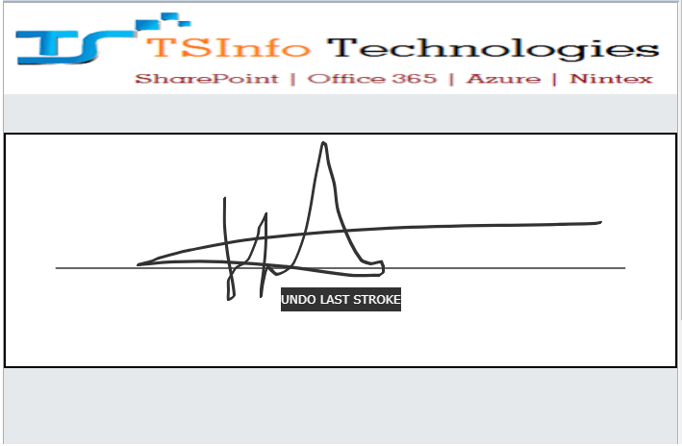
- Click on “UNDO LAST STROKE”-> it will clear the sign on the Signature Pad.

- Display Repeating Section as a table in List View:

- Created a SharePoint list with few columns.
- Product Details -> “Multiple lines of text”.
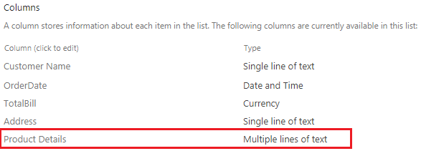

- Open SharePoint list In Nintex forms.
- Drag and drop Repeating section control on to the form and Add fields into these controls.
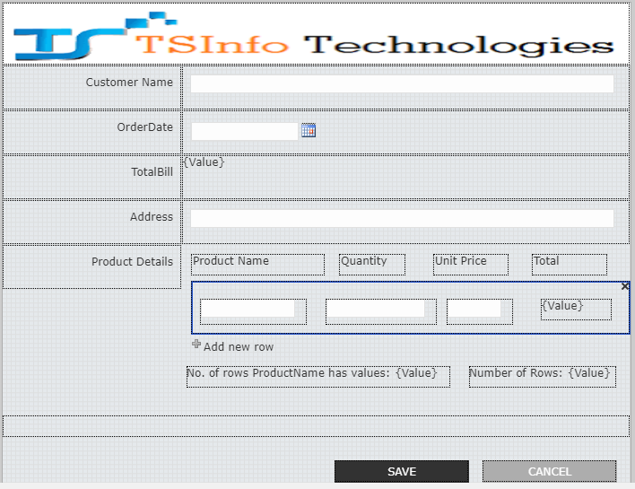
- Drag and drop the “calculated value” in repeating section control for the “Total”. Double click on it and configure the details.
- Formula: Quantity*UnitPrice.
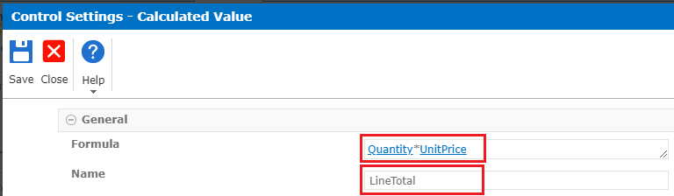
- To count Number of rows the “ProductName” has value or not, drag and drop the calculated value and configure the details.
- Formula: count (ProductName).
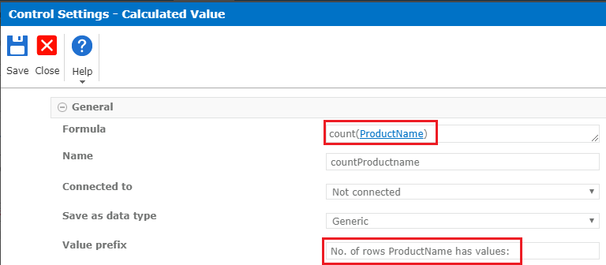
- To count the number of rows in repeating section control, drag and drop the calculated value and configure the details.
- Formula: rows (ProductName).
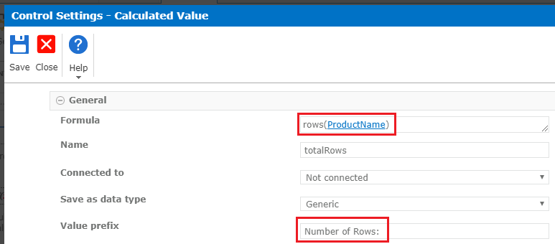
- Add calculated value on “TotalBill” and configure the details.
- Formula: Sum (LineTotal).
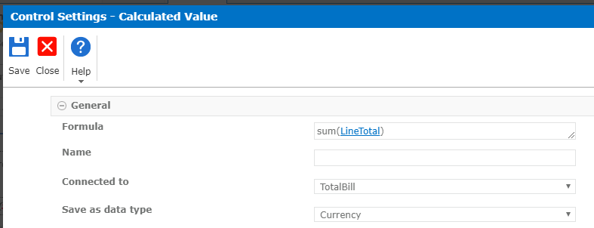
- Double click on “Repeating Section” control and configure the details.
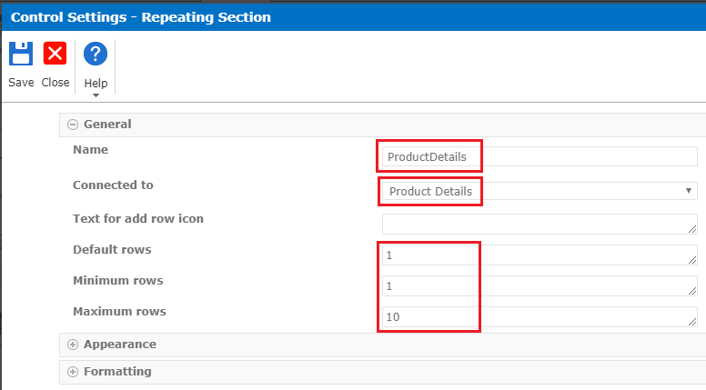
- Add an item in the list. The data of the repeating section will be saved to the linked column (i.e. in XML format). It is how the view looks like in the list.
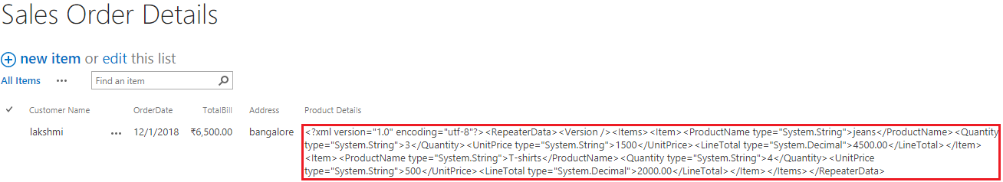
- Create web part page ->click on “Add a Web Part”->Select “Sales Order Details”->click on Add.
- Next, Add “Script Editor “ Web part and paste below code.
- We include the “Script Editor” to the same page for the CSR (Client Side Rendering) implementation.

<script src="https://code.jquery.com/jquery-3.3.1.min.js"></script>
<script type="text/javascript">
SPClientTemplates.TemplateManager.RegisterTemplateOverrides({
Templates: {
Fields: {
'Product_x0020_Deatils': {
'View': repeatingSectionViewTemplate
}
}
}
});

function repeatingSectionViewTemplate(ctx) {
var xml = ctx.CurrentItem["Product_x0020_Deatils"];
var decodedxml = xml.DecodeXMLNotation();
var html = "";

xmlDoc = $.parseXML( decodedxml );
$xml = $( xmlDoc );
$xml.find("Item").each(function() {

html = html + "<tr><td>" + $(this).find("ProductName").text() + "</td><td>" + $(this).find("Quantity").text() + "</td><td>" + $(this).find("UnitPrice").text() +"</td><td>" + $(this).find("LineTotal").text()+"</td></tr>";
});
return "<table border='1'>" + html +"</table>";
};

String.prototype.DecodeXMLNotation = function () {
var output = this;
if ($.trim(output) != "") {
output = output.replace(/&apos;/g, "'").replace(/&quot;/g, '"').replace(/&gt;/g, '>').replace(/&lt;/g, '<').replace(/&amp;/g, '&');
}
else {
output = "";
}
return output;
};
</script>
- Get the result on displaying the Repeating Section data in table format on the view, here it is looks like.
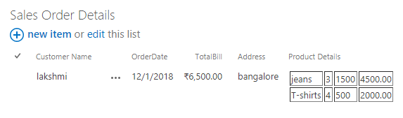

References (URLs)
Here are few useful URLs on Nintex Forms for Office 365.
How to Add Nintex forms for Office 365 to SharePoint Online Sites?
https://www.sharepointsky.com/nintex-forms-for-office-365/
How to implement Validations in Nintex forms for Office 365 SharePoint Online + 3 Nintex form validation examples
https://www.sharepointsky.com/nintex-form-validation-examples/
How to Create and Customize SharePoint Online List form using Nintex forms for Office 365 Part-1
https://www.sharepointsky.com/customize-sharepoint-online-list-form-using-nintex-forms/
How to Create and Customize SharePoint Online List form using Nintex forms for Office 365 Part-2
https://www.sharepointsky.com/create-sharepoint-online-list-form-using-nintex-forms/
Nintex Forms for Office 365: Show Hide Fields on Multiple Choices Checkbox in List Form in SharePoint Online
https://www.sharepointsky.com/show-hide-fields-on-multiple-choices-checkbox-nintex-forms-sharepoint/
Cascading dropdown in Nintex forms for Office 365 SharePoint Online
https://www.sharepointsky.com/cascading-dropdown-in-nintex-forms/
Nintex Forms: Enable or Disable Save Button Based on Checkbox (Choice field) in SharePoint Online
https://www.sharepointsky.com/nintex-forms-enable-or-disable-save-button-sharepoint/
How to use lookup function in Nintex forms for office 365 SharePoint Online
https://www.sharepointsky.com/nintex-forms-lookup-function/
How to make a field mandatory based on Dropdown selected field Value in Nintex forms for Office 365
https://www.sharepointsky.com/nintex-forms-dropdown-validation/
How to Add Custom CSS in Nintex form for Office 365 SharePoint Online
https://www.sharepointsky.com/nintex-forms-custom-css-includes/
How to Add Custom JavaScript or jQuery in Nintex forms for Office 365 SharePoint Online
https://www.sharepointsky.com/nintex-forms-custom-javascript/
Working with Nintex Forms for Office 365
https://www.enjoysharepoint.com/nintex-forms-for-office-365/
How to set default value for lookup column in Nintex forms for Office 365 SharePoint online?
https://www.enjoysharepoint.com/how-to-set-default-value-for-lookup-column-in-nintex-forms-for-office-365-sharepoint-online/
How to design multiple step forms using Nintex forms for Office 365 SharePoint Online?
https://www.enjoysharepoint.com/how-to-design-multiple-step-forms-using-nintex-forms-for-office-365-sharepoint-online/
How to implement validation rules by condition in Nintex forms for Office 365 SharePoint Online?
https://www.enjoysharepoint.com/how-to-implement-validation-rules-by-condition-in-nintex-forms-for-office-365-sharepoint-online/
Steps to show cascading drop down in Nintex Forms for Office 365 SharePoint Online
https://www.enjoysharepoint.com/steps-to-show-cascading-drop-down-in-nintex-forms-for-office-365-sharepoint-online/
How to implement mandatory field validation in Nintex forms in Nintex forms for Office 365 SharePoint Online?
https://www.enjoysharepoint.com/nintex-forms-mandatory-field-validation-rules-examples/
How to use set field value in Nintex Forms for Office 365 in SharePoint Online using JavaScript?
https://www.enjoysharepoint.com/nintex-forms-custom-javascript-set-field-value/
How to implement mandatory field validation in Nintex forms in Nintex forms for Office 365 SharePoint Online?
https://www.enjoysharepoint.com/nintex-forms-mandatory-field-validation-rules-examples/
How to use Repeating Section in Nintex forms for Office 365 SharePoint online?
https://www.enjoysharepoint.com/how-to-use-repeating-section-in-nintex-forms-for-office-365-sharepoint-online/

