The SPARK Method Case Study

Course Title | Flawless Project Management with the SPARK Method
Course Learning Goals | - Know where to start with Project Management, communicate and cooperate effectively.  - Know how to lead a team.
Case Study Check List Area | - Introduction and  - “S” – Strategy – Ways to collaborate

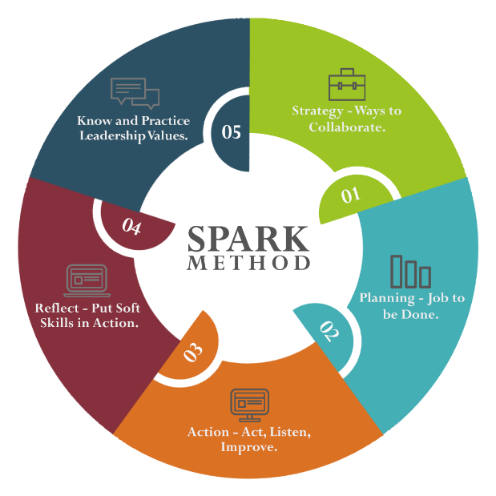
Case Study Section Title | Task Description | Training Lesson Completed | Case Study Task Completed | Tested on a Real Project | Feedback  Gathered | Wrote Comment How It Worked
“S” –  STRATEGY  Ways to collaborate | - Create a folder on your PC where you will save all needed templates.
 | - Initially, create a folder structure per our course modules and lessons.
 | - Accommodate it per your personal preferences and project needs.
 | - Add documents, templates, details from your real-life projects.
 | - Create Stakeholder Map.
 | - Download template.
 | - Copy it to your folder for the future projects.
 | - Fill in Case Study Copy with Stakeholders from the Case Study:
 | - Those who are already mentioned in Case Study.
 | - Those who you would need to complete Case Study based on your plan.
 | - Keep updating Stakeholder Map as you are progressing through Case Study.
 | - Decide on types of meetings you will need to have and with whom.
 | - Download meeting type template.
 | - Copy it to your folder for the future projects.
 | - Fill in Case Study Copy with Meeting Details.
 | - Create precise Agenda for each meeting type.
 | - Create an e-mail template for different communication purposes.
 | - Short, precise email for each meeting type.
 | - Short, precise project status report for Project Sponsor and main stakeholders.
 | - Save those email templates for future projects.
 | - Get feedback on email quality and precision.
 | - Decide on your audio conference solution.
 | - Test solutions available in your company, before organizing the first meeting.
 | - Test your audio equipment - phone, phone number, audio quality, headphones, mute control.
 | - Copy clear conference details and ways to join to your meetings.
 | - Download short Check List how to prepare conference room for audio conferences.
 | - Decide on screen sharing solution.
 | - Analyze available solutions (WebEx, Skype, Zoom etc.).
 | - Test solutions available in your company, before organizing the first meeting.
 | - Test your audio/video equipment - phone, phone number, audio quality, headphones, mute control, screen sharing software.
 | - Copy clear conference details and ways to join to your meeting Agendas.
 | - Download short Check List how to prepare conference room and computer screen for screen sharing.
 | - Decide on video conference solution
 | - Analyze available solutions (WebEx, Skype, Zoom, Telepresence etc.).
 | - Test solutions available in your company, before organizing the first meeting.
 | - Test your audio/video equipment - phone, phone number, audio quality, headphones, mute control, video/web camera, video conferencing software.
 | - Download short Check List how to prepare conference room and computer screen for video conferencing.
 | - Download short Check List how to prepare conference room for face-to-face meetings.
 | - Choose and test favorite Chat Tool
 | - Analyze available solutions (Slack, Skype, Google Hangouts).
 | - Download short Check List how to prepare for chat usage.

