Pastel to Palladium step by step guide

Before you can commence with the conversion the pastel data will need to be extracted:
- All Open batches need to updated in Pastel
- Run data integrity check within Pastel Partner
- Any issues raised will need to be fixed by a Pastel Consultant
- The option “Verify History Files” will have to be run so that any documents with missing lines can be corrected.
- The option “Verify the Data Only” will have to be run so that any documents with missing accounts can be created, imbalances on the trail balance can be corrected or any Open item corruption can be fixed.
- The data to be converted must be on Pastel Partner version 11 or higher
- All Balance Forward Customer/Supplier accounts will need to be converted to open item. This will however not prohibit you from generating balance forward statement in Palladium.
- Run the “outstanding orders/GRN” report and link all open GRV’s as Palladium cannot convert with open GRV’s

- Obtain the Pastel data for conversion. (It is important to ensure that there is no corruption within the Pastel data as his will pull through into Palladium and effect the data integrity within Palladium)

- Load the pastel folder onto the computer with Palladium software installed. The computer being used will need to have Pervasive.SQL 9 control centre.

- Open Pervasive.SQL 9 control centre. Right click, select New then Database
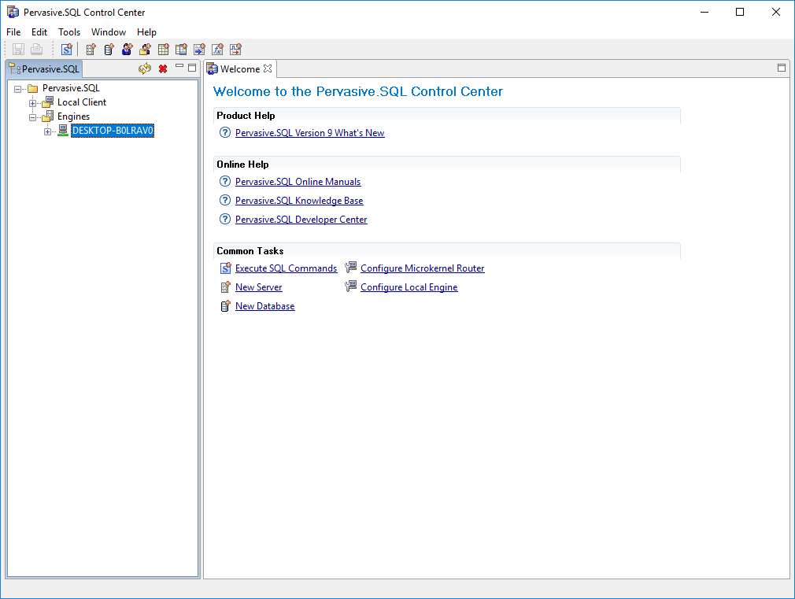

- A new database window will appear. Give the database a name (usually the company name) and select the Pastel data file. Click finish (note that when using unlicensed Pervasive you will get a 7004 error. You can ignore this and continue.

- Right click and refresh on pervasive to see database.

- Go to Tools and select ODBC Administrator. Select the System DSN tab,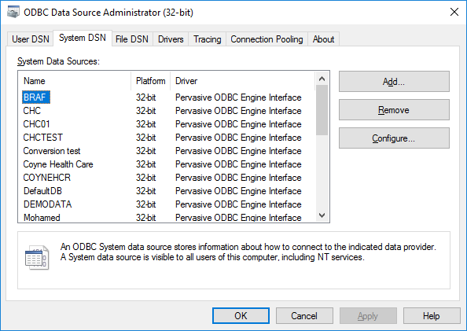
- Then Add
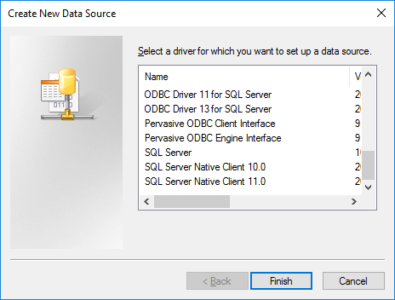
This window will appear.
Select Pervasive ODBC Engine Interface
Click finish
- Select ok

- Go into Palladium and go to Control Panel. Select Pastel Partner Data Importer
- Select database name and ODBC connection type. Use the SQL user name and password 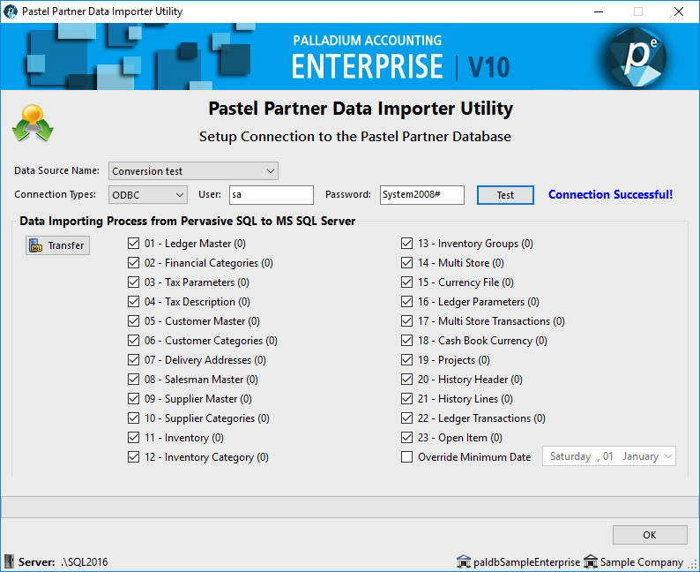
Then select Test, to check connection. Once successful click transfer. The import will begin, wait till all items have been imported then select OK.

- Open Pastel Partner Extractor Utility 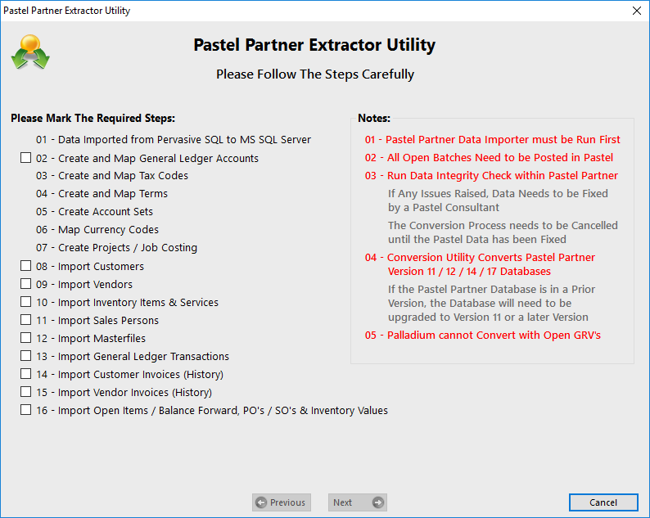

- Select all tick boxes

- Select next on Data Imported from Pervasive SQL to MS SQL Server. Will get notification can select Yes

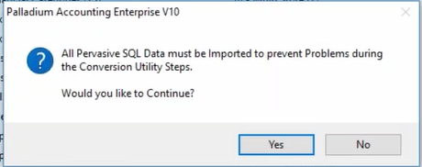

- In the Create and Map General Ledger Accounts fill in all account codes and the corresponding account class. Take special care to ensure that the account codes are within the legend.

- In Create and Map Tax Codes select the tax codes, 03 Vat on Sales inc for the sales tax code and 04 vat on purchases inc for purchases tax codes. If the tick box under Exclusive is ticked then select 01 and 02 for sales and purchases respectively.

- In Create and Map Terms client needs to select either 30 days from invoice or statement.

- In Create Account Sets, under both the inventory and services tab, if there are unassigned accounts then select the assign button to allocate to assigned. 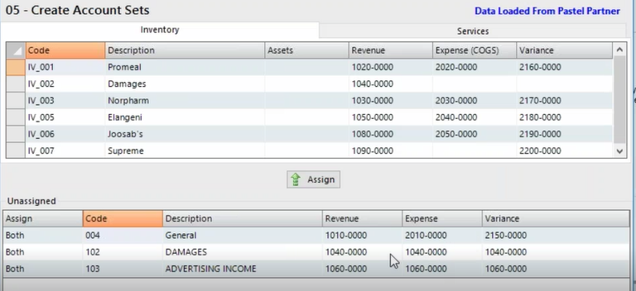
The empty spaces will need to be populated with the appropriate account codes.
- In Create Projects\Job casting do the same and fill in empty spaces.

- In Import Customers make sure that the tax code is populated and all information is correct. Do the same for Import Vendors.

- In Import Inventory Items make sure the account sets are put in.

- In Import Sales Persons make sure information is correct.

- In Import Masterfile’s select import.

- In Import General Leger Transactions, select “current” under selection and click import. A window will appear for setting the linked accounts. Link accounts for both current and previous year. Do not forget to select “history” in selection and click import.

- Import both Customer and Vendor invoices and select next.

- In Import Open items select all tick boxes and import, when complete click finish and a message will appear. Select Yes 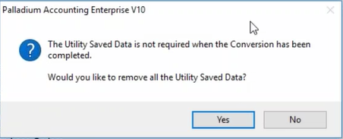

- The Data integrity check will appear. If everything was done correctly, then it should say it is in balance. You will need to compare the Pastel data with the Palladium reports, compare the trail balance, customer and vendor aged and inventory evaluation. This is helpful if there are data integrity problems.

