One Week Product Roadmap
CLASS WORKBOOK
Street Smart Product Manager

EXERCISE 1: LEARN YOUR PRODUCT

A. Write down your product’s business model.

Sales Model:

Delivery Model:

Pricing/Revenue Model:

EXERCISE 2: GATHER KEY INSIGHTS

A. What is your company / business unit / department / product’s revenue goals for the year?

B. What is your company / business unit / department / product’s primary growth strategy?

Some examples (check off any that apply):
- New customer acquisition  - Account expansion  - Up-sells, cross-sells  - New market penetration | - Innovation in existing market  - New product or market innovation  - Improving economics  - M&A and post-merger integration

Or add other ones here:

C. What other key KPIs/OKRs/metrics/goals should you be aware of?

C. What is your current product strategy?

Some examples (check off any that apply):
- Investing in the core product/platform  - Driving customer success  - Reducing churn, increasing retention  - Improving customer satisfaction or NPS  - Delivering on client commitments  - Delivering on needed features/functions to onboard new customers (for revenue recognition)  - Encouraging repeat buyers | - Investing in adjacent or extension capabilities  - Launching a new product or innovation  - Moving / upgrading to a new platform, architecture or technology  - Post-merger integration  - Integration with a 3rd party system, technology or partner  - Resolving tech debt

Or add other ones here:

D. List out the things that are top of mind for your boss.

EXERCISE 3: CREATE YOUR EVALUATION CRITERIA

A. What criteria will you use to evaluate your backlog items and what weights will you assign them?
Remember to try to keep the list to 3-6, and the weights should add up to 100%.

Criteria | Weight
1.
2.
3.
4.
5.

For the In-Class Example
Company Description:

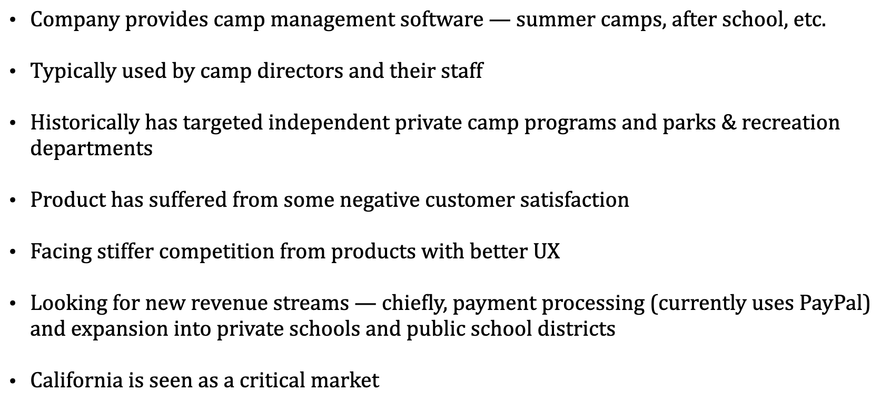

Company Goals and Product Strategy Priorities:

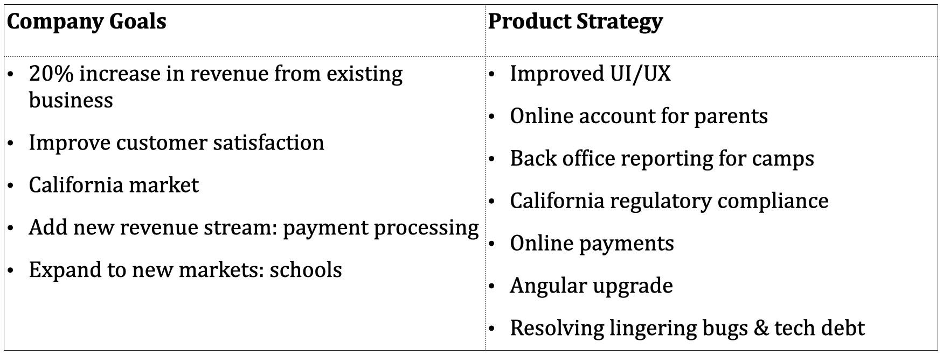

Your Notes

