- Log into your account after IB has approved your application.
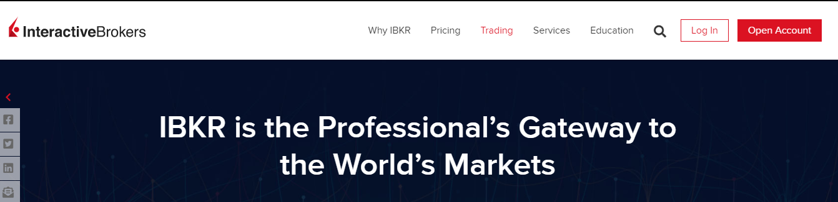

- Fund your account (Same steps for mobile app as well).
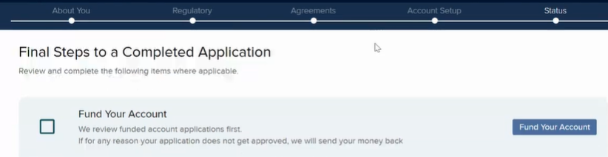
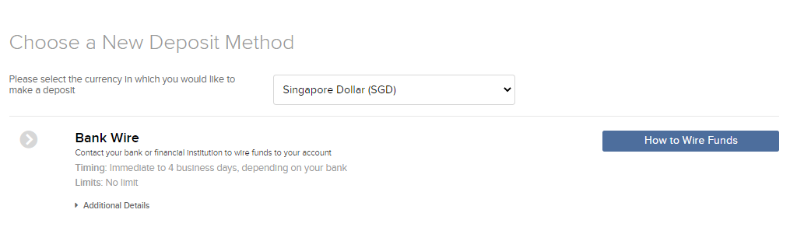
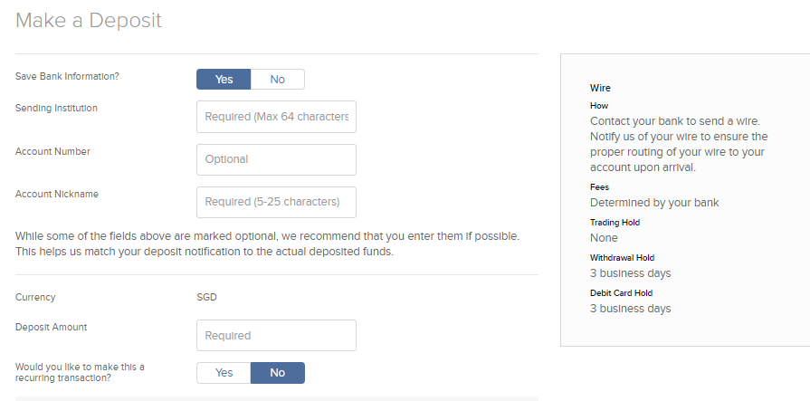
Sending institution refers to the bank you are withdrawing money from to fund your brokerage account. It can be Maybank, DBS bank etc.
If bank code is needed, you can either google your respective bank code or visit your bank website to find it.
You can set your account nickname to anything. I set it as my name and surname.
Once everything is done, click “create deposit” on the bottom right corner of the webpage

- IB will give you the information needed for FAST transfer. IB will also give you a Bank Account Number, and the Payment Reference required for you to specify in your FAST instruction. This is so that IB knows which account this money belongs to.

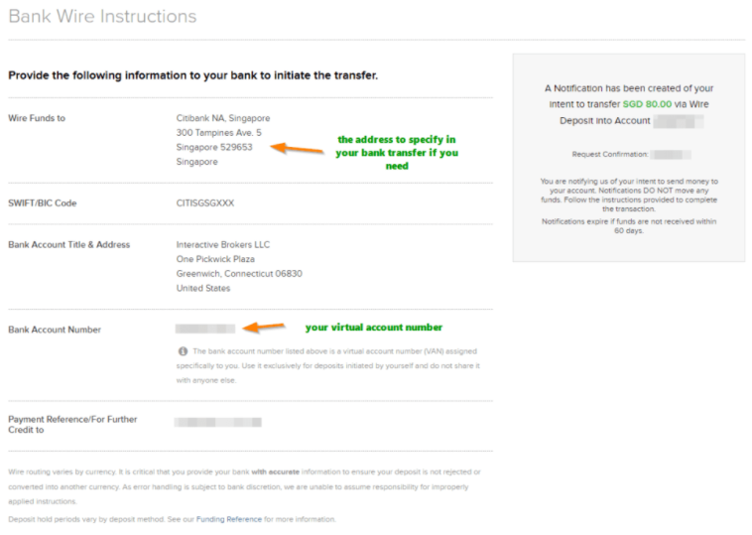

- Head over to your ibanking to set up the transfer
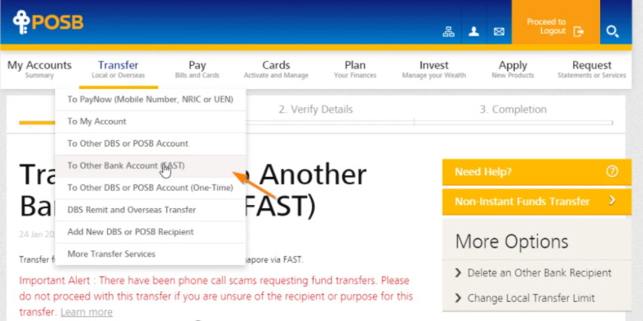
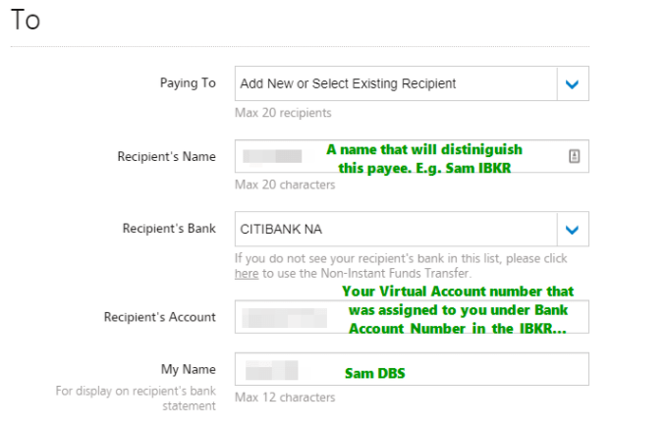
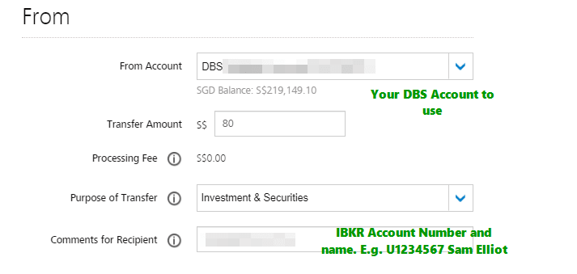
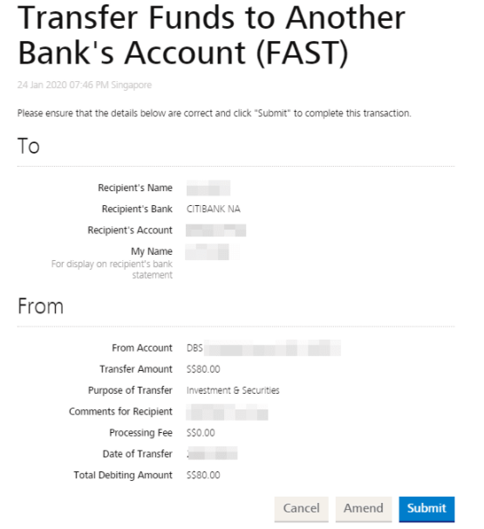
For those using DBS/POSB, the final page should look something like that.
I recommend to save the FAST setting so that you won’t have to retype everything in again.

- Now, just wait for your money to be deposited into your IB account. Fastest I experienced is within 1-2hrs, but at times 1-2days is possible as well.

Since FAST has no fee, I suggest for those who are new to transfer a small amount to try first, say $2 just in case you have done something wrong along the way.

