Introduction

S1 : Pause for 2 seconds

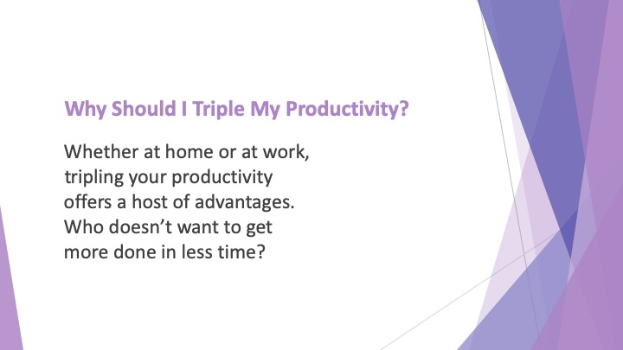
S2 : Why Should I Triple My Productivity?

Whether at home or at work, tripling your productivity offers a host of advantages. Who doesn’t want to get more done in less time?

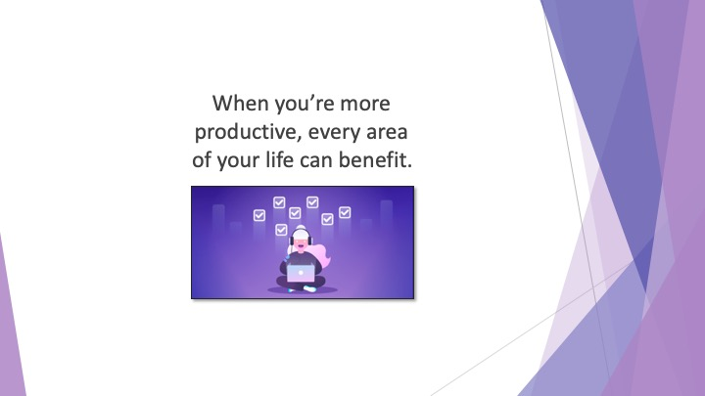
S3 : When you’re more productive, every area of your life can benefit.

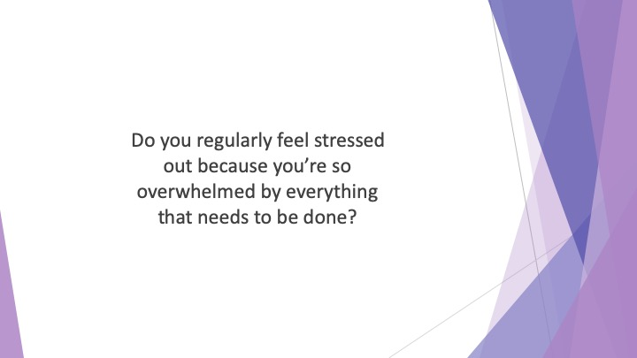
S4 : Do you regularly feel stressed out because you’re so overwhelmed by everything that needs to be done? Do you often feel as if you don’t know where to begin with all the tasks on your plate?

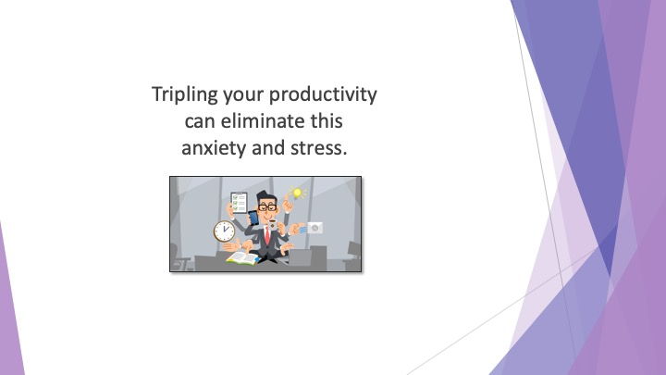
S5 : Tripling your productivity can eliminate this anxiety and stress.

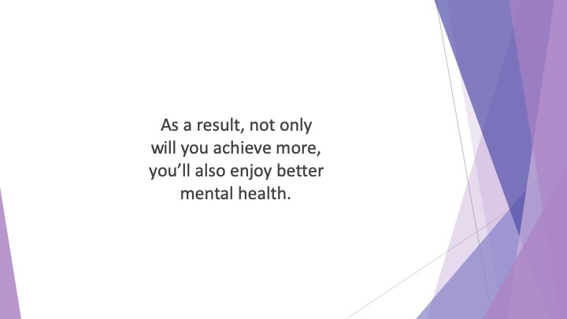
S6 : As a result, not only will you achieve more, you’ll also enjoy better mental health.

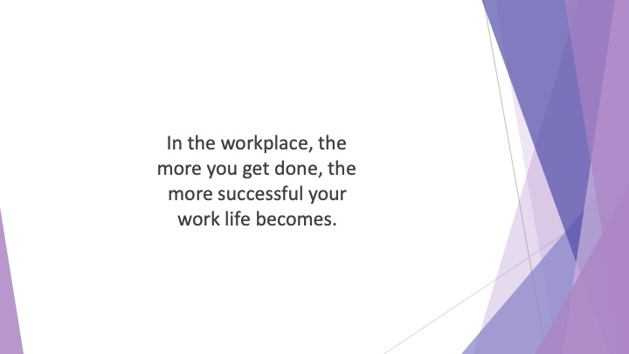
S7 : In the workplace, the more you get done, the more successful your work life becomes. If you’re running your own business, this equates to higher profits.

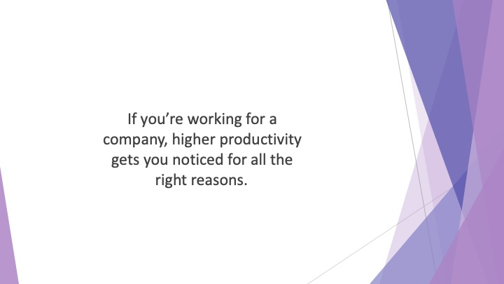
S8 : If you’re working for a company, higher productivity gets you noticed for all the right reasons. You’ll impress your managers and be first in line for promotion.

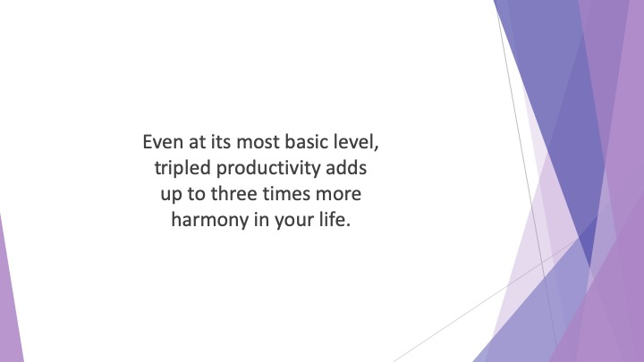
S9 : Even at its most basic level, tripled productivity adds up to three times more harmony in your life.

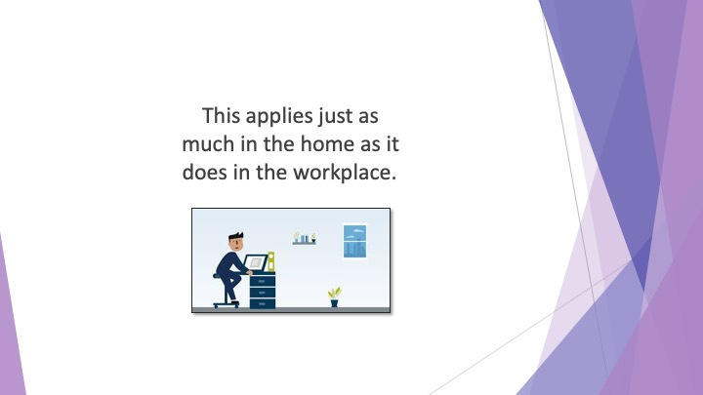
S10 : This applies just as much in the home as it does in the workplace. A lack of productivity at home can lead to stress, arguments and discontent.

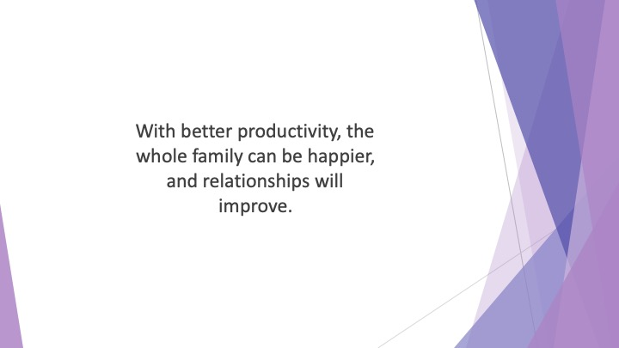
S11 : With better productivity, the whole family can be happier, and relationships will improve.

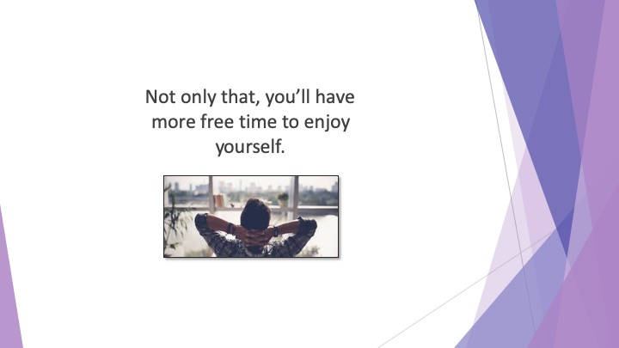
S12 : Not only that, you’ll have more free time to enjoy yourself. Who doesn’t want that?

S13 : Are you ready to experience these benefits in your own life?

S14 : Then continue watching on to discover how our expert tips are about to help you achieve your personal best.

