How to Prepare for a Wilderness Emergency

Spending a day alone in the wilderness apart from your smart phone, your computer, and the hustle and bustle of modern life is without a doubt an excellent way to take a mini-vacation and rejuvenate both your mind and your body. However, because most day hikers venture forth with the idea that they will only be out for a few hours or, a day at most, they often fail to take along the items that they need to survive an unexpected wilderness emergency. However, anyone who chooses to venture into the wilderness either alone or with a group should be prepared for a sudden emergency because the only tools and comforts that are available to you in the wilderness are those you bring with you and those that you can make yourself from the available materials. Consequently, carrying survival gear even on a day hike is imperative to your ability to survive a wilderness emergency. Therefore, a properly stocked survival kit can often make the difference between life or death in such situations as becoming lost, being bitten by a poisonous snake or poisonous insect, or experiencing a fall resulting in serious injury. Therefore, this chapter will focus on the items a person should carry with them when venturing into the wilderness.
While not technically considered a wilderness survival tool, the single most important item that a hiker can carry with them is a small, electronic device about the size of smart phone called a Personal Locator Beacon (aka PLB). PLBs are portable units that operate much the same as Emergency Position Indicator Radio Beacons (EPIRBs) or Emergency Locator Transmitters (ELTs) but are specifically designed to be carried by an individual person instead of on a boat or aircraft. In addition, these units operate by transmitting an emergency S.O.S. to a series of specialized satellites orbiting the Earth known as the SARSAT system as well as any passing military and commercial aircraft. Therefore, unlike cell phones, they will work almost anywhere. Also, unlike ELTs and some EPIRBs, they can only be activated manually and they operate exclusively on a 406 MHz emergency frequency but, like EPIRBS and ELT's, all PLBs also have a built-in, low-power, homing signal that transmits on a 121.5 MHz emergency frequency which enables rescue personnel to home in on a beacon once the 406 MHz satellite system has gotten them within the vicinity of the origin of the signal (roughly 2 to 3 miles). In addition, some newer PLBs also have integrated GPS units which transmit the exact coordinates of the operator which dramatically improves the location accuracy down to approximately 100 meters. However, these units are somewhat expensive and thus, not everyone will be willing to purchase one even though the one time that you really need it, you will undoubtedly consider it worth every penny since they immediately alert rescue personnel to your emergency and thus reduce rescue time to hours instead of days.
But, if you choose not to carry a PLB, then you should always make certain that someone knows where you intend to be venturing and when you intend to return so that they can alert local authorities to the fact that you are missing if you do not return. In addition, you should also consider carrying an alternate means of signaling rescue personnel in the case of wilderness emergency. Therefore, for this purpose, marine flares are an excellent option since they can easily be seen by any passing aircraft and they represent a universal distress signal. Also, marine flares are readily available from most any store that has a boating section and they are very inexpensive, very compact, and they are both easy and safe to operate. Another option for signaling rescue personnel is to carry a small signal mirror which can usually be found in the camping section of such stores as Wal-Mart as well as in any store that specializes in outdoor recreation. However, these tools only serve to signal passing aircraft and thus, you should also carry a coach's whistle in your pocket to signal rescue personnel once they are in the area because the piercing sound of a whistle will carry much farther than a human voice and there again, three blasts on a whistle is recognized as a universal distress signal.
However, even with the means to signal rescue personnel at your disposal, unless you carry a PLB, rescue can be several days away because it takes time for someone to realize that you are missing and report your absence and then, searchers often have to cover a wide area in order to locate you. Therefore, you should also be prepared for an extended stay in the wilderness by carrying a three part survival kit consisting of the items that you carry in your pockets, the items you carry in a waist pack, and the items you carry in a day pack. Why a three part system you may wonder? Well the answer to that question is that in the event of a fall, you may be separated from your day pack and other situations such as a tumble into whitewater can cause you make the decision to jettison both your day pack and your survival kit and thus, if you also carry essential survival items in your pockets, you will at least have some means of survival at your disposal.
Therefore, let's start with the essential items that you should carry in your pockets. For instance, in addition to marine flares, a signal mirror, and a coach's whistle, you should also carry a couple of blocks of solid fire starter and a butane lighter so that you will have the means to build a fire to stay warm and to ward off predators. Also, if you ever find yourself in such a situation and, assuming that you are still mobile, a large Stockman pattern pocket knife is an invaluable tool that will enable you to perform numerous bushcraft tasks. Furthermore, you should also carry a high quality compass since landmarks are often hard to come by in flat terrain and/or thick foliage and thus, a good compass will serve to keep you on course.
While the items listed above are the most essential items that you should carry with you when venturing into the wilderness, they are literally a bare minimum that will only allow you a modicum of comfort in the event of a wilderness emergency. Therefore, in addition to the items that you carry in your pockets, you should also carry a properly stocked survival kit. Also, while survival kits can be assembled and carried in any type of container that you find appropriate, one of the best means of doing so is to purchase a military surplus utility belt along with a military surplus pouch with ALICE (All-purpose Lightweight Individual Carrying Equipment) clips on the back so that the pouch can be easily attached or removed from your belt if necessary and, while you are at it, it is also a wise idea to purchase at least one military surplus canteen with ALICE clips to be carried on your utility belt along with your survival kit and two canteens are even better. However, before purchasing a pouch to carry your survival items in, it is best to first gather all of the items that you intend to carry in it so that you will have some idea of exactly how much room you need. Of course, that leads us to a discussion of what items you should carry in your survival kit. Therefore, you will find a list of the most necessary items listed below:

String Extra batteries Sewing kit
Cord Emergency rain poncho Heavy nylon sewing thread
Flashlight Emergency mylar sleeping bag Heavy duty needle assortment
Butane lighter Chap stick
Fire starter blocks Bandages
Waterproof matches Antibiotic ointment
Magnesium fire starter w/striker Hiker's first aid kit
Magnifying glass w/o metal rim Water purification tablets

Fishing line Swiss army knife
Fishing tackle Emergency wire saw
Wire snares
Bow string
Javelin point
Atlatl dart/arrow heads

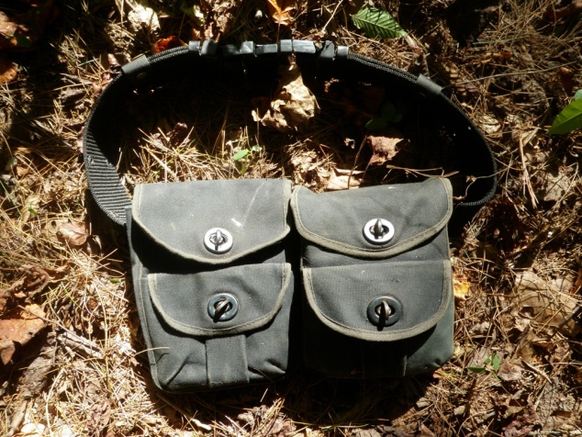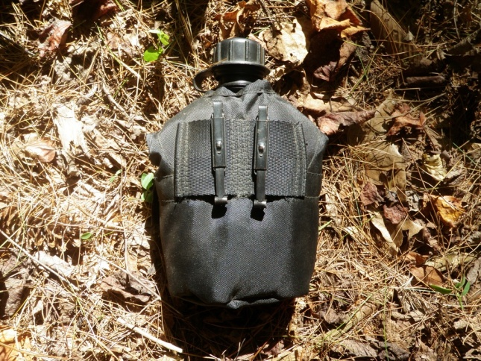
Survival Kit Canteen

In addition to the items that you should carry in your pockets and your survival kit, there are several other items that you should also carry with you but which are too bulky to fit in a survival kit. Therefore, you should also purchase a small day pack specifically designed for hiking and then stock it with the following items:
PLB Flash light/lantern Cord
Food Portable water filter Nylon wing tarp
Lighter Lightweight fleece shirt
Fire starter Lightweight fleece pants
Folding Pruning saw Ultralight Rain Jacket and Pants

So, as you can see, while the items listed in the "pocket items" section above will enable you to signal rescue personnel, build a fire, and perform small cutting tasks, they are literally a bare minimum that will enable you to survive one or two days in the wilderness without special knowledge and skills but will not provide you with the means to procure food other than edible plants and edible insects. But, with the addition of a properly stocked survival kit, your ability to survive in the wilderness is greatly expanded such that, in combination with a well designed survival knife and bushcraft knife, you will be able to build shelter, procure food, repair your clothing and make new clothing from animal hides, and perform minor first aid. Then, by adding the items listed in the "day pack" section, you will have the means to stay warm at night and dry in the rain and to purify water from most any source; all of which are essential to remaining healthy until help can arrive.

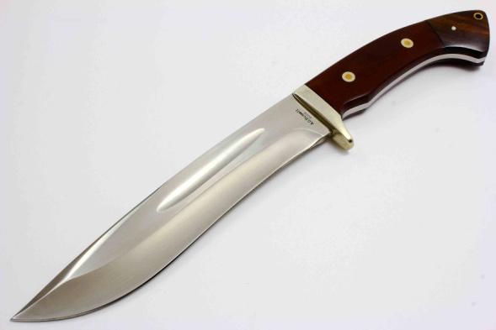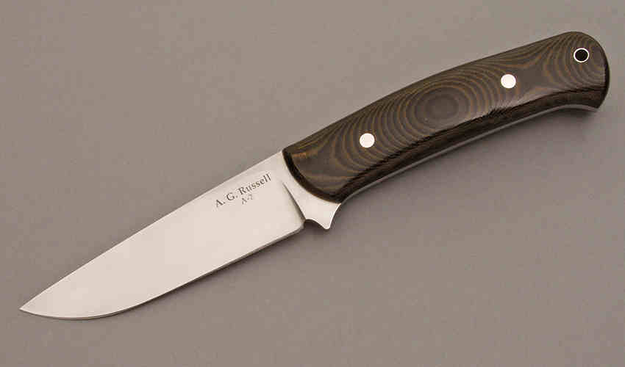
Survival Knife Bushcraft Knife

