The SPARK Method Case Study

Course Title | Flawless Project Management with the SPARK Method
Course Learning Goals | - Know where to start with Project Management, communicate and cooperate effectively.  - Know how to lead a team.
Case Study Check List Area | - “P” - Planning – Job to be Done

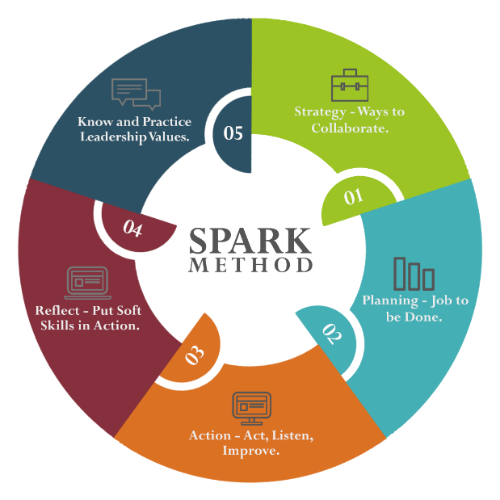
Case Study Section Title | Task Description | Training Lesson Completed | Case Study Task Completed | Tested on a Real Project | Feedback  Gathered | Wrote Comment How It Worked
“P” –  PLANNING  Job to be Done | - Create Your Work Breakdown Structure (What work has to be done?).
 | - Download xMind and Excel templates.
 | - Copy it to your folder for the future projects.
 | - Create WBS for the Case Study.
 | - Keep updating WBS as you are progressing through Case Study.
 | - Accommodate Template according to your needs.
 | - Choose your favorite tools for WBS creation (xMind, Excel, MS Project, Project Libre or Other).
 | - Create Your Schedule (When task can be completed?).
 | - Download xMind and Excel templates.
 | - Copy it to your folder for the future projects.
 | - Create Schedule for the Case Study.
 | - Keep updating Schedule as you are progressing through Case Study.
 | - Accommodate Template according to your needs.
 | - Choose your favorite tools for Schedule creation (xMind, Excel, MS Project, Project Libre or Other).
 | - Create Your Cost Estimate (How much does this project cost?).
 | - Download xMind and Excel templates.
 | - Copy it to your folder for the future projects.
 | - Create Cost Estimates for the Case Study.
 | - Keep updating Costs as you are progressing through Case Study.
 | - Accommodate Template according to your needs.
 | - Choose your favorite tools for Schedule creation (xMind, Excel, MS Project, Project Libre or Other).
 | - Execute the work (How to get it done?)
 | - Get to know processes and procedures to perform Change Management in your company.
 | - Download a change management template.
 | - Copy it to your folder for the future projects.
 | - Organize at least one Change for the Case Study.
 | - Investigate what system is used in your company for Change Management.
 | - Choose your tool for tracking the work (Wall of Work). (Ex. xMind, Excel, Gantt Chart, MS Project, Project Libre, Trello or other)
 | - Analyze Risks in your plan. (What can go wrong in your project?)
 | - Download xMind and Excel templates.
 | - Copy it to your folder for the future projects.
 | - Create Risk Response for the Case Study.
 | - Keep updating Risk Analyzes as you are progressing through Case Study.
 | - Accommodate Template according to your needs.
 | - Choose your favorite tools for Schedule creation (xMind, Excel, MS Project, Project Libre or Other).
 | - Prepare for Issue Management (Or: “When something goes wrong”).
 | - Download xMind and Excel templates.
 | - Copy it to your folder for the future projects.
 | - Prepare Issue Management template for the Case Study.
 | - Keep updating Issue Log as you are progressing through Case Study.
 | - Accommodate Template according to your needs.
 | - Choose your favorite tools for Issue Management creation (xMind, Excel, MS Project, Project Libre or Other).
 | - Write down phone numbers of team members beforehand. Add it to Stakeholders map.
 | - Download Escalation Matrix in case of issues with primary contacts. Add it to your Stakeholders map.
 | - Generate and use Lessons Learned.
 | - Download xMind and Excel templates.
 | - Copy it to your folder for the future projects.
 | - Write at least three Lessons Learned for the Case Study.
 | - Reflect Lessons Learned in WBS, Schedule, Cost Estimates and other impacted elements.

