FOTOFACIAL BBL/FYBBL ® TREATMENT SHEET
Patrick Bitter Jr. M.D.

Name_________________________________________________Date________________________________

Treatment#_________________________________Area___________________________________________
Chief Concerns_____________________________________________________________________________
Medications________________________________________________________________________________
Allergies__________________________________________________________________________________
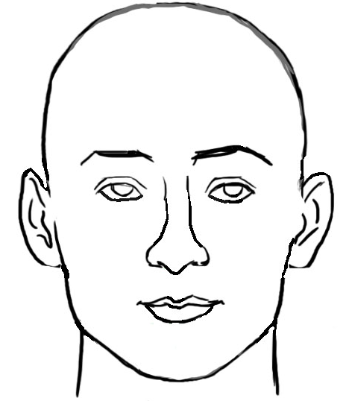
Current Skin Care___________________________________________________________________________

Skin Type: I II III IV V VI

Anesthetic Cream Applied YES NO
Photos Taken YES NO
Consent Signed YES NO
Improvement from Previous Treatment YES NO
Problems with Previous Treatment YES NO
Satisfied with Treatment YES NO
Lido23% / Tetra7%__________
Notes___________________________________________________________________________________
______________________________________________________________________________________________________________________________________________________________________________________________________________________________________________________________________________
Location  F/N/C/  Other | Device | Filter# | BBL (J/cm2) /  (w/cm2) | PD  Msec  or  Sec | Cooling  (°C) | Target  Temp  (°C) | Cryo | E(J) | Pulses | █ | ■ | ●  11mm | • 7mm | •  3mm
 |  | 1ST Pass
 |  | 2nd Pass
 |  | 3rd Pass
 |  | 4th Pass
 |  | 5th Pass
 |  | Other
 |  | Other
 |  | Other
Recommendations: __________________________________________________________________________

Signature: _________________________________________________________________________________

