Day 4 & Exercise 4:
Eliminate Your Worry

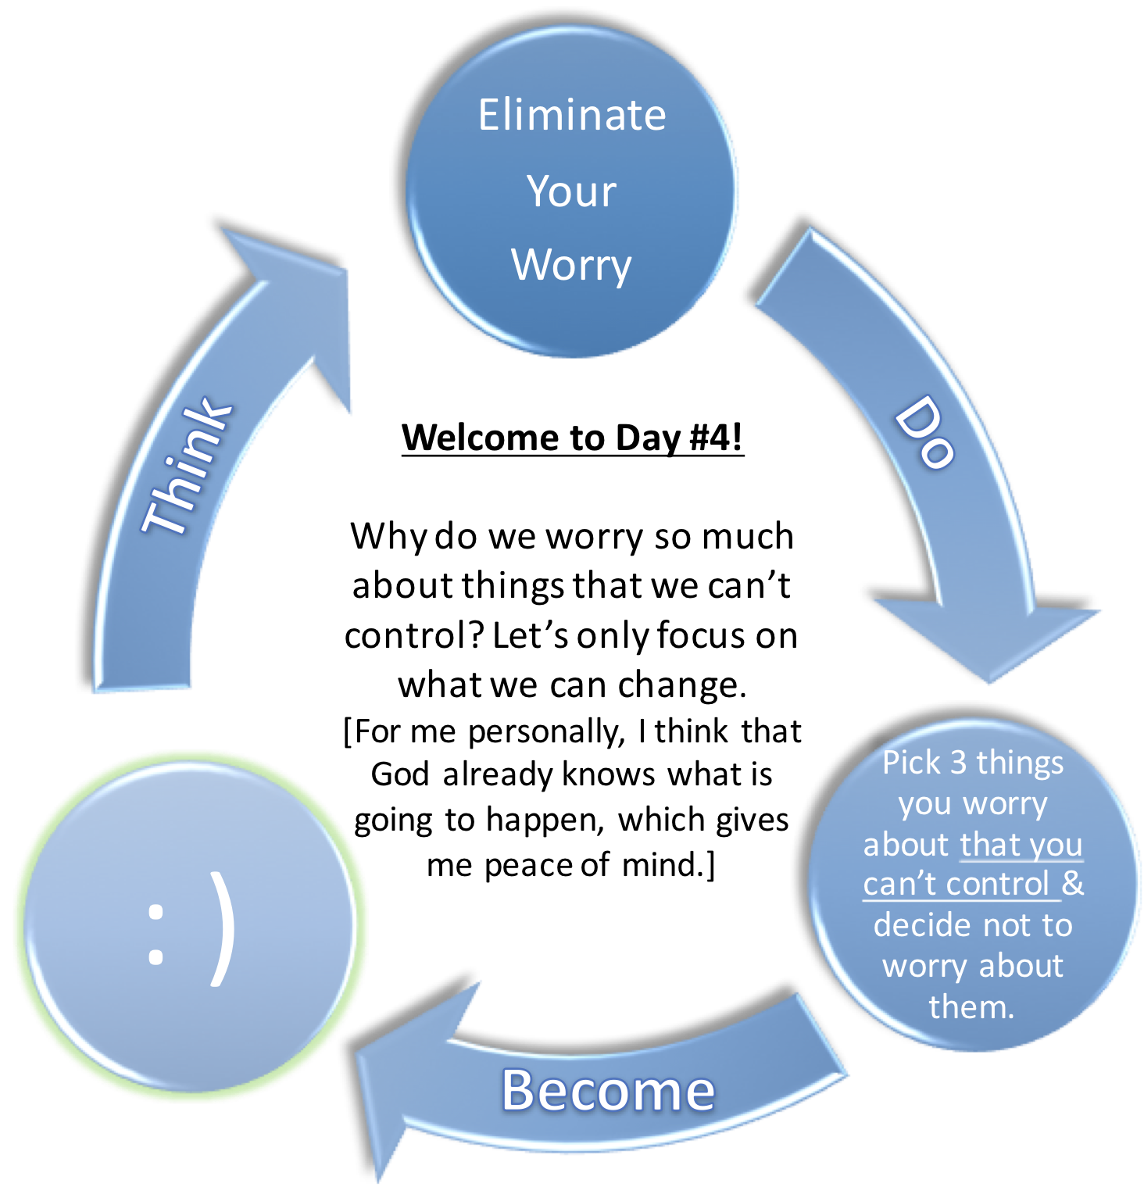

What a waste of time worrying is. Let it go. We need to focus only on what we can control in life. Focusing on what we can’t control is a waste of time. What personally really puts me (personally) at ease is the thought that God already knows what is going to happen. Worrying too much is extremely bad for our health. Worrying too much makes us incredibly unhappy. Let it go.
Picture this. You are in a car and you are driving on the side of a mountain. It’s a beautiful day. All of a sudden a few clouds appear. Then is starts raining a bit. You are ok with that because you can still see the road, the mountain and the sky.
All of a sudden more clouds appear and there is a torrential downpour. The rain turns into golf ball sized hail. You start to worry. Then you see a warning sign that there are avalanches in this area. Your heart beats faster and you literally start to age. Then even more clouds appear and you can’t see anything! You can feel the bumps on the road. Your heart beats even faster. You hear thunder and you start to panic!
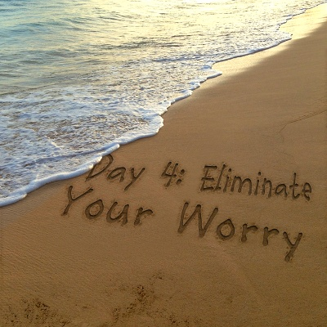
You stop worrying about the things you can’t control when you realize that either God has the wheel and you decide to let him navigate and take over or you realize that all you can control is the wheel so you stop focusing on the stuff you can’t control. You let it go and you feel peace in your heart because you realize that God already knows what is going to happen and you realize that you can’t control the weather and then you decide to never ever worry again about things that you can’t control.
You then feel even more peace in your heart because you realize that you are in fact a passenger and that God has the wheel. : )
3 Quotes About Worrying:
“The reason why worry kills more people than work is that more people worry than work.” – Robert Frost
“When I look back on all these worries, I remember the story of the old man who said on his deathbed that he had had a lot of trouble in his life, most of which had never happened.”
– Winston Churchill
“Our fatigue is often caused not by work, but by worry.”
– Dale Carnegie
Today’s Exercise: Please list at least 3 things that you will no longer worry about today or ever again because you can’t change or control them . From now on let’s just focus on what we can and/or want to control in our lives.
1: ____________________________________________________
2: ____________________________________________________
3: ____________________________________________________

