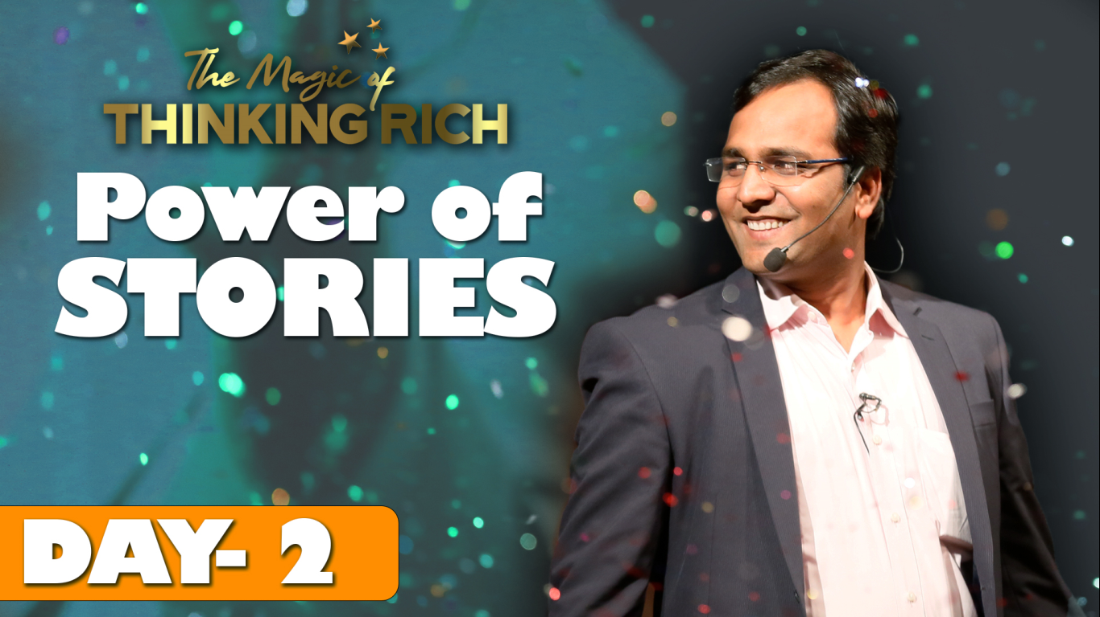

The Magic of Thinking Rich
IF YOU SUPPORT THE WORLD SELFLESSLY
THE WHOLE UNIVERSE WILL SUPPORT YOU ENDLESSLY

Summary of Day 2 - 02 Nov 2020 (Monday)
Today’s session started with celebrating life, by creating motion, because emotion can be controlled only by superb positive motion.
What kind of cloths would you like to wear?
What kind of friends would you like to have?
What kind of food would you like to have?
I am sure all of you want the best. Friends, you have 4 options, Fine, Good, Better and Best.
We always want the best of everything. So, when it comes to giving something to yourself it should be also best.
Stop saying ‘I am fine’. This is a wrong input given to our brain.
Start practicing to tell, “I am great, I am best, I am Rock star... etc.”
Once you say something about yourself that message goes to your brain. So always say the best thing about yourself. Make that a practice for rest of your life.
Today we will discuss about the Power of Words.
Friends, there is no one weak or strong. It’s only trained or untrained person. That’s why never think that you are weak in any skill, subject or field. Please understand that you need to get proper training. Stop wasting your time for silly entertainment and use it for educating yourself by getting appropriate training. As you give food to your stomach for 4 times a day, you need to give right food to your brain / mind every day.
To feed your brain, follow the principle 90:90:1. For 90 days first 90 minutes of your day feed only one thing, which is how to be positive. BSR runs a special program named “Commando Training” on this principle. Next batch for this training will start on 01-Dec-2020. If any one of you may want to know more about this training, please attend the Orientation Program for this training free of cost.
Please understand that words are most powerful in this world. You see, the power of words make a person, successful celebrity, social activist or terrorist. Please understand the power of positive and negative words make the difference. Here is a beautiful story on this context.

There was a king, very successful at the age of 35-36. Everyone was very happy with him and used to appreciate a lot. One day the Royal Priest wanted to talk to him in private and there priest told that after one month King will die. King initially was jovial about this forecast. But after few days, he started getting depressed, unhealthy, lack of hunger. In a few weeks time, he really got weak and frail.
The Head Minister was not happy with this development like all others. On the last day of King, was taken to office as per his last wish. Head Minister requested the Royal Priest to calculate the again about King. Royal Priest got angry and again declared the same forecast in front of all the people. Then Head Minister requested the Royal Priest to forecast about his own life. Again the priest got angry, but did the calculation and told that he will live for another 40 years. No sooner the priest did this forecast, the Head Minister did cut off head of the Royal Priest and shouted to people gathered that the priest was wrong and he was lying about the King. This boosted morale among people and King and King started feeling good. Finally King recovered also and was alive for many more years.
The morale of the story is that you will lead a life according to information that you feed yourself. So be cautious and careful about it. Whatever you feed your brain, that will get processed and the result will be accordingly. So please give extraordinary input to your brain. “CHANE THE INPUT TO CHANGE THE OUTPUT”.
To get money, you need to feed your brain – “Money is my best friend. Money comes to me always, whenever I want, whatever I want, how much I want and it comes always legally.”
Friends, this is called affirmation.
Let me give you some more examples of ‘Power of Words’. In 2013, BSR started his Business Coaching journey with 10 Businessman. There I told that when you say something, please say only good things. You never know what will be approved by this universe. There BSR declared that in year 2020, I will conduct session, where 20,000 people will join. Yesterday (on 01 Nov 2020) 49,000 people joined and 10,000 people attended the complete session of “The Magic of Thinking Rich”.
In 2019, BSR’s DAD got both the legs got fractured. BSR told him that this was in a way ordered by him only. His dad asked, “How?”. Then BSR reminded that “a few months ago when my brother was admitted in hospital due fracture in hand, dad used to tell, - Thank GOD Legs are fractured!”. Universe has listened to that and approved the same.
*TODAY’S LESSON – Start telling and feeling what you want to be.*
If you want to be rich at least say, “I am getting Rich”.
Don’t ever say, “I am not rich or I am poor”.
Another example is of cancer patient Mr. Sunil Kumar who was brother of one of BSR’s students. Mr. Sunil Kumar was suffering from chest cancer. On request of Sunil’s sister, BSR visited Sunil Kumar in the hospital. There BSR suggested him and his family to visualize that Mr. Sunil is cured of cancer, think only positive possibilities and to keep trust on the creator of the Universe. After 6 months Mr. Sunil Kumar got substantially cured of the pain and later got completely recovered. There is YouTube Video of Mr. Sunil Kumar showing how happy he was after recovery.
Water Crystal Experiment of Dr. Masaru Emoto did an experiment. He took water in 3 bottles and levelled them with three tags, “I love you, I thank you, and I hate you”. Then he left the bottles for 24 hours and then freezes the water. Astonishingly the two bottles onto which he wrote “I love you, I thank you”, in those bottles beautiful crystals got formed. But the bottle onto which he wrote “I hate you”, in that bottle distorted crystals got formed. Then Dr. Mashroo did same experiment in different other situations and got same result.
Similarly Cows that are taken care properly, produces more milk.
Plants that are given positive talks will grow nicely, but if they are given negative talks, they will die.
In 1993 crime rate went down by 23.3% in Washington DC as a result of mass meditation by a meditating group named ‘Transcendental Meditation’.
There are many such examples. Please go through the following contents in YouTube.
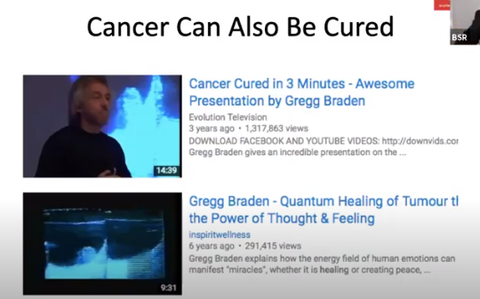

Yesterday we understood the power of physiology. Today we understood the power of words. So let us feed some positive affirmations to our brain.
- My House is Heaven
- Whatever I eat is the best food.
- I am always, fit, healthy and positive.
- My business is now improving.
- I am a leader
- I am successful
- I am great
Along with affirmations, add high positive energy.
Then BSR asked following questions to the participants. The participants were required to say ‘YES with full energy’.
- Are you the best?
- Are you powerful?
- Are you happy?
- Are you healthy?
- Etc.
Then BSR asked participants to listen to a motivational song from a film and feel each word of the song.
“Kyun Tarasta hai tu Bande , Jald hi badlega Manzar | O Shikandar O Shikandar |”

मनुष्य तू बड़ा महान है। । २
तू जो चाहे पर्वत पहाड़ों को फोड़ दे
तू जो चाहे नदियों के मुख को भी मोड़ दे
तू जो चाहे माटी से अमृत निचोड़ दे
तू जो चाहे धरती को अम्बर से जोड़ दे
अमर तेरे प्राण….२ मिला तुझको वरदान
तेरी आत्मा में स्वयम भगवान् है रे। ।
…..मनुष्य तू बड़ा महान है

Now BSR has a target to train and help 10 crores people. Because if BSR trains 10 crores people, one of them will surely become personality like Shivajee Maharaj, Rani Lakshibai, Kalpana Chawla, Indra Noi, or Indira Gandhi. Please understand you have all the power. Set your goals and work towards it continuously, you will be able to achieve anything in life. Miracles happen when you channelize your energy in achieving your dreams, instead of negative thinking.
How to get free gifts?
Take the photos of this workshop and along with photos, give your feedback in Instagram. You may add your own story of implementation of learning from this training. Please add the #ThinkRich India, #AbBadaSochegaIndia in your comments.
What are the gifts for today?
For 3 winners, gift is the Program named ‘Kick Start Millionaire”.
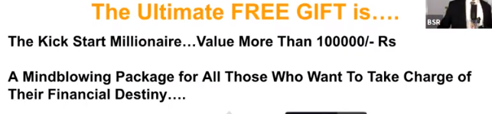
Next session of this program will be on 09-Nov-2020.
Today’s winners:
Mr. Dinesh, Ms. Sanya and Mr. Naveen
For all the participants, free Gift is a program named “Getting Ahead and Staying Ahead”.
To access this course, please visit https://learn.askbsr.com/thinkrich
Tomorrow there will be a big announcement and great discussion on a very interesting topic. Please don’t miss out.
The session ended with another motivational song:
यूँ ही चला चल राही
यूँ ही चला चल राही
कितनी हसीन है ये दुनिया
भूल सारे झमेले
देख फूलों के मेले
बड़ी रंगीन है ये दुनिया
रुम दुम दा ना ना राता दुम दा ना ना
रुम दुम दा ना ना राता दुम दा ना ना
रुम दुम दा ना ना राता दुम दा ना ना भैया
ये रास्ता है कह रहा अब मुझसे
मिलने को है कोई कहीं अब तुझसे
ये रास्ता है कह रहा अब मुझसे
मिलने को है कोई कहीं अब तुझसे (हो)

