How to Make the Hands-Free Sanitation Station

Purchase:
1 ten-foot pole of 1-inch PVC pipe
1 ten-foot pole of ½-inch PVC pipe
8 one-inch T connectors in PVC
6 one-inch elbow connectors (make sure there are no threads)
4 half-inch elbow connectors (make sure there are no threads)
For the sanitizer bottle holder- I bought a Four-inch female adapter and a Four-inch male adapter so you could adjust the size for the bottle you have. Then I bought a push-in strainer for Four-inch pipe (stainless steel)- this way it gets air flow and dries out if some of the sanitizer drips in the bottom. You’ll need some thin wire as well.
2 ½-inch male pipe adapters
2 ½-inch screw in bolt end caps that fit the pipe adapters (female)
1 jar Oatey brand, medium clear PVC cement (I ordered this from Amazon)

I cannot tell you how much this cost because Lowe’s kept bringing me out the wrong pieces to curbside pick-up. I am pretty sure I spent less than $30 for everything.

You are going to cut the PVC pipe in the following lengths:
(I suggest doing this outside as the dust is everywhere)
1-inch pipe
- (6) 4-inch pieces
- (6) 2-inch pieces
- (2) 28-inch pieces
- (1) 16-inch piece
- Save your leftovers because you will fit two pieces to make your sanitizer holder fit into the T-connector. You will measure depending on how well you screwed in your bolts. I used 2.5 inches on both sides.
½-inch pipe
- (2) 9-inch pieces
- (2) 36-inch pieces
- (2) 2-inch pieces to go in the male adapter for stabilizers
Directions:
I put it all together first before I glued just to make sure I had a clear idea of what I was doing. Be careful because the first time I did this, it was perfect- then when I glued it together I hooked one piece wrong and for the life of us we could not get it loose once the glue set. Unless I notate, I am speaking about the 1-inch width pipe.
- Start with the 16-inch piece of pipe. Attach an elbow piece to each end.
- Attach a 4-inch piece of pipe coming out of the other end of the elbows (both sides)
- Attach a 2-inch piece of pipe to both ends of a T connector (do this twice) Make sure the T connector is facing with the open end up as in the picture.
- Attach this pipe to the elbow you previously attached to the ends of the 16-inch pipe
- Put an elbow on the end of both T connectors
- Put a 2-inch piece of in the end of the elbow and connect another T connector for a stabilizer on each side
- Put a 4-inch piece of pvc pipe in the two T connectors that are sticking up in the middle of the stand.
- Attach an elbow to the pvc pipe on both sides
- Attach a 2-inch piece of pvc in the elbow on both sides
- Attach a T Connector to both 2-inch pieces of pvc pipe
- Take the (2) 28-inch pieces of PVC and put a T connector on the end of them
- Glue the other end into the T connector at the bottom into the T connector at the bottom of the stand
- I used a four-inch female drain plug as my sanitizer holder. You will see why in a minute.
- Drill two ¾ inch holes into the opposite sides of the four-inch female adapter near the top (the bottle of sanitizer will sit down in this.
- The ½ inch male adapter goes in the holes you drilled and then the end cap is screwed on in the inside to keep it secure.
- On the other side of the male adapter, I glued a 2-inch piece of ½ inch pipe coming out of it to act as a stabilizer. Then I secured the four-inch female adapter to both sides of the poles. The 1-inch pipe fits over the notched edges of the male adapters that are in the 4-inch adapter. I just put the 2-inch piece of the ½ inch pipe to act as a stabilizer from the inside. You will measure and cut a piece of the one-inch pipe to connect your sanitizer to the T connectors on each side. Mine were approximately 2.5 inches. It will depend how hard you pushed your pieces into each other etc.
- Take the ½ inch pipe and put ½ inch elbows on each end of the 36-inch pieces
- Put a 9-inch piece connecting the ½ inch pipe at the top
- Put it inside the 28-inch pipe and then attach the ½ inch elbows and the other piece of the 9 inches of ½ inch pipe on the bottom end.
- Then I glued the push-in strainer on the bottom of the male four-inch adapter and screwed it into the correct height for the bottle I had.
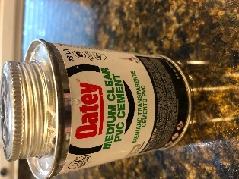
- This is the glue I used: (I ordered it from Amazon- but Lowe’s probably has it. I just had trouble getting what I ordered from Lowes curbside.)
  - Use this glue outside because it will give you a massive headache if you use it indoors.
You can clean the PVC pipe with fingernail polish remover.

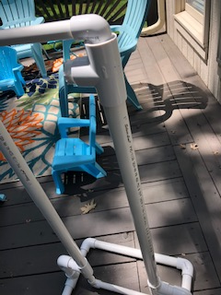
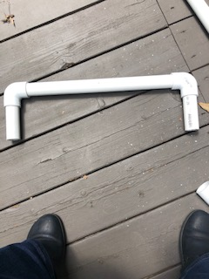
Start from the bottom up- Begin with the 16-inch piece of pipe you cut and put an elbow connector on each end.
Step One

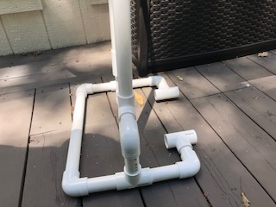
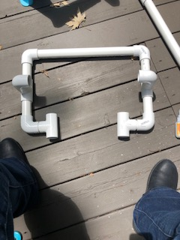
Step Two
- Attach a 4-inch piece of 1-inch pipe coming out of the other end of the elbows (both sides)
- Attach a 1-inch piece of pipe to both ends of a 1-inch T connector (do this twice)
- Attach this pipe to the elbow you previously attached to the ends of the 16-inch pipe
- Put a one-inch elbow on the end of both T connectors
- Put a two-inch piece of 1-inch pipe in the end of the elbow and connect another T connector for a stabilizer on each side

Step Three

Put a four-inch piece of the pipe in the T Connector and then attach an elbow with a two-inch piece of pipe connected to another T Connector. And then add the 28 inch of pipe going up.

Do this to both sides. I think the pictures help better than the description.

Step Four

Put a T connector on the top of both 28 inch poles. The ½ inch PVC pipe is going to fit inside this T connector as you can see in the picture.

Now to the holder:
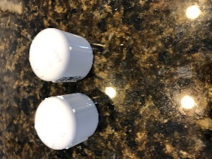
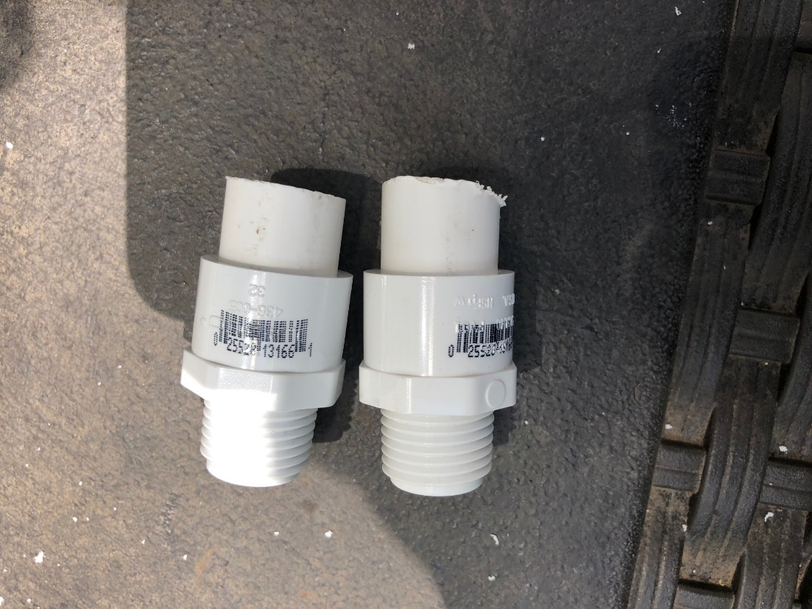
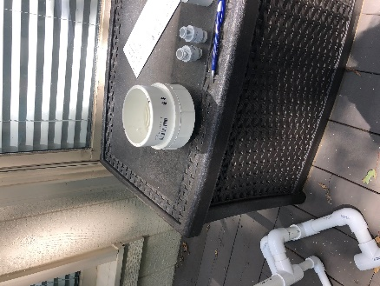
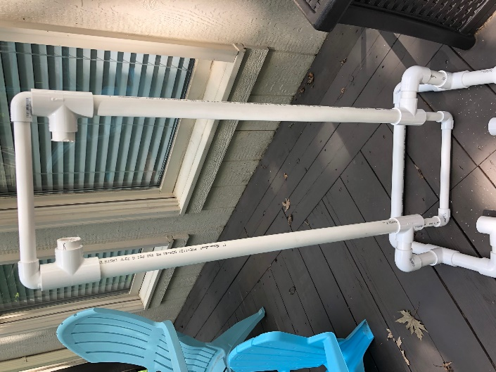
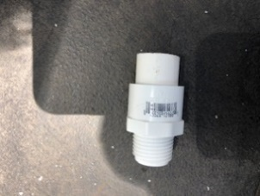
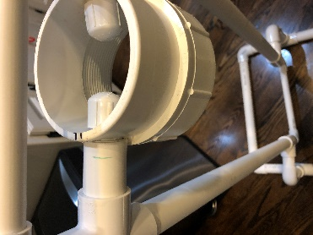
Nut ends for the male adapters.
Male adapter
There is a two-inch piece of ½-inch pipe in the end of both male adapters so I can attach it inside the T connector see below. There is a 1-inch piece of 1-inch pipe in the T connector.
I bought this four-inch drain piece with a female end and a smooth end
My husband used a drill bit that was slightly larger than the male end of the adapter on opposite sides for me. (3/4 drill bit) We had to keep working to make it big enough for it to slide in. You do not want it too big.
When you glue it into the end pieces on the bar, the 1-inch pvc fits totally over the male adapter- the 1-inch piece of ½ inch is just there to add a little more stabilization.

.
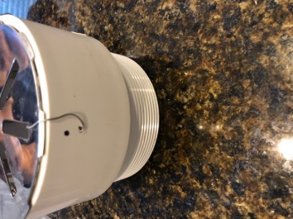
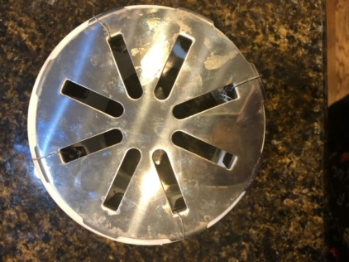
This is the bottom of the dispenser. I bought the four-inch push-in strainer (stainless steel) . We found out after I purchased it that you cannot glue metal to pvc. Using ingenuity, we drilled four holes in the bottom piece and wired the strainer to the bottom piece.

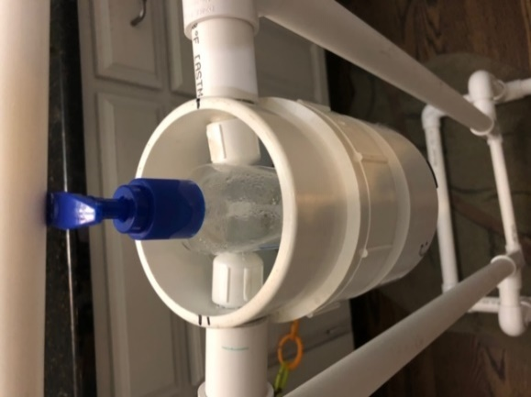
The reason for putting the screw on nut caps is to hold the bottle securely. This way it will not flop around when the bar comes down. You can put sponges inside to hold it securely in place as well. You step lightly on the foot pedal at the bottom and the top comes down and squirts liquid into your hand.

Notes:
You could adjust the height based on the ages of the students you work with. I build this one for fourth graders in mind. It works for myself and my husband and he’s 6’2’.
I am going to suggest a sandbag or something across the back, just so students do not trip on it coming into the room and accidentally knock it over. It is stable for adults, but children can be a little less careful about where they are walking, and I would feel better knowing it is really secure.
I would make a video model using a child about all you have to do is lightly tap the bottom bar. I don’t have a child to make the video at my house, so you’ll have to make one with your own children or once you have the students back at school. Here’s a video of me using it. I had to hold the phone and pump at the same time, so it’s not a great one: https://www.dropbox.com/s/qvvuau3zurlij0z/video%20of%20me%20using%20the%20stand.MOV?dl=0
I hope this was helpful.

